NAME: AWURUM IKECHUKWU CHARLES
MATRIC NUMBER: 15/ENG06/015
DEPARTMENT: MECHANICAL ENGINEERING

QUESTION 1A
commandwindow
clear
clc
close
syms x
x = 0 : 0.001 : 15
y = (0.0052*x.^2) - (0.0013*x.^3) + (0.00013*x.^4)
plot(x,y)
grid on
grid minor
xlabel('x')
ylabel('y')

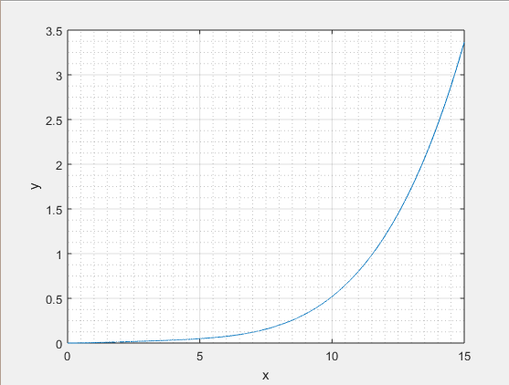

QUESTION 1B
commandwindow
clear
clc
close
syms t
t = 0 : 0.001 : 1
n = 1.285*exp(-4*t) + 3.714*exp(3*t) - 12*t.^3 + 3*t.^2 - 6.5*t
plot(t,n)
grid on
grid minor
xlabel('t')
ylabel('n')
