commandwindow
clear
clc
close all
w = 0.5;
E = 30;
I = 5;
L = 2.5;
x = 0:0.001:15;
y = ((6 * w * L.^2 * x.^2) - (4 * w * L * x.^3) + (w * x.^4))/(24*E*I);
plot(x,y)
grid on
grid minor
xlabel('X')
ylabel('Y')
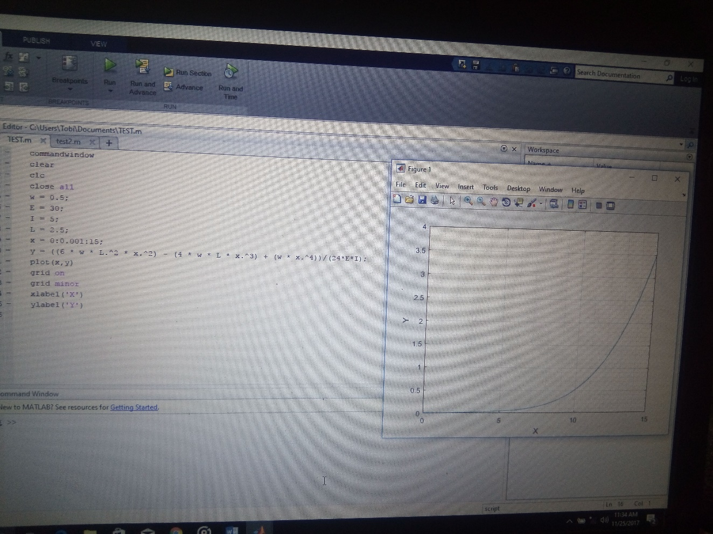

commandwindow
clear
clc
close all
t = 0:0.001:1;
n = 3 * exp(4*t) + 2 * exp(-3*t) - 12 * t.^3 + 3 * t.^2 - 6.5 * t;
plot(t,n)
grid on
grid minor
xlabel('time(hr)')
ylabel('amount(kgmol)')
