Pepple Ibim Obiedima
16/ENG06/088
Mechanical engineering

1A) commandwindow
clear
clc
close all
x=0:0.001:15
y=(1/7200)*(37.5*(x.^2)-10*(x.^3)+(x.^4))
plot(x,y)
grid on
grid minor
xlabel('x')
ylabel('y')

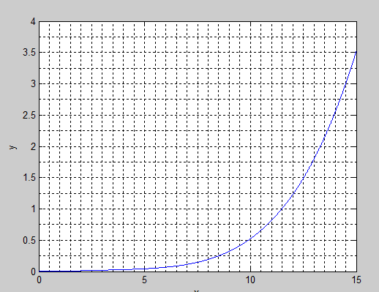

1B)commandwindow
clear
clc
close all
t = 0:0.001:1
n= ((29/14)*exp(4*t))+((41/14)*exp(-3*t))-(12*(t.^3))-(12*(t.^3))+(3*(t.^2))-((13/2)*t)
plot(t,n)
grid on
grid minor
xlabel('t')
ylabel('n')

