NAME: OLUMESE NANCY ONOSEMUDIANA
MATRIC NO. : 16/SCI15/001
COLLEGE: SCIENCES
DEPARTMENT: PHYSICS WITH ELECTRONICS
CODING AND PREFERABLE INTERFACE TO CALCULATE THE FACTORIALS OF NUMBERS USING FOR…NEXT LOOP

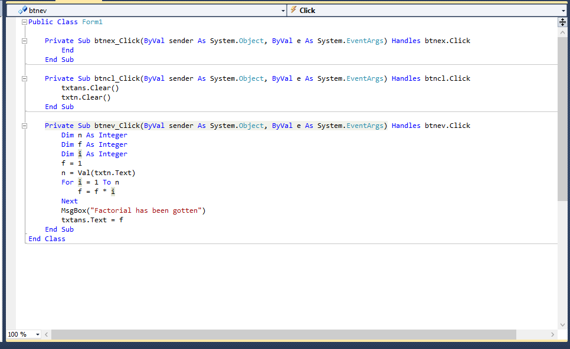
INTERFACE
btnev
btncl
Txtans.text
Txtn.text
btnex

