OKPESEYI SIMILOLUWA BLOSSOM 16/SCI01/0333
COMPUTER SCIENCE CSC201
Label3

Label1

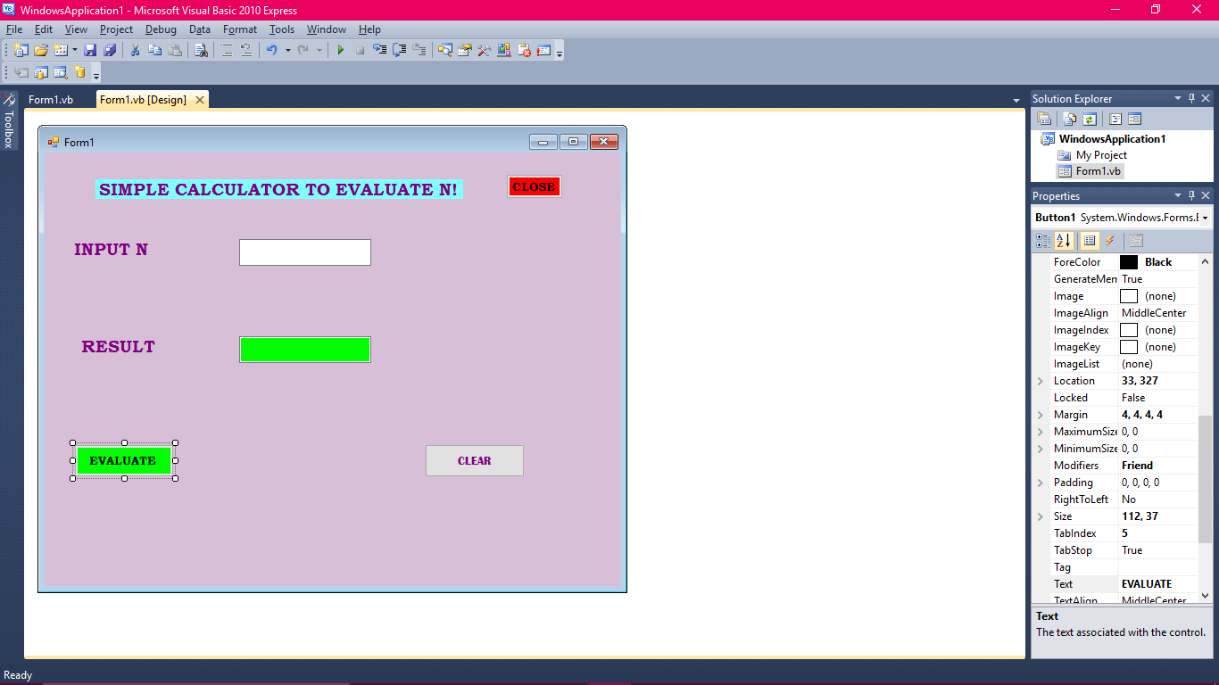
tb2

tb1

Button 3

Button1

Label2

Button 2

Public Class Form1

Private Sub Button3_Click(ByVal sender As System.Object, ByVal e As System.EventArgs) Handles Button3.Click
End
End Sub

Private Sub Button2_Click(ByVal sender As System.Object, ByVal e As System.EventArgs) Handles Button2.Click
tb1.text = ""
tb2.text = ""
End Sub

Private Sub Button1_Click(ByVal sender As System.Object, ByVal e As System.EventArgs) Handles Button1.Click
Dim n, a, d As Integer
n = Val(tb1.Text)
a = 1
For b = 1 To n
a = a * b
On Error Resume Next
tb2.Text = a
Next
End Sub
End Class

