OTEGBEYE OLORUNLEKE
16/SCI01/038
COMPUTER SCIENCE DEPARTMENT
CSC 201

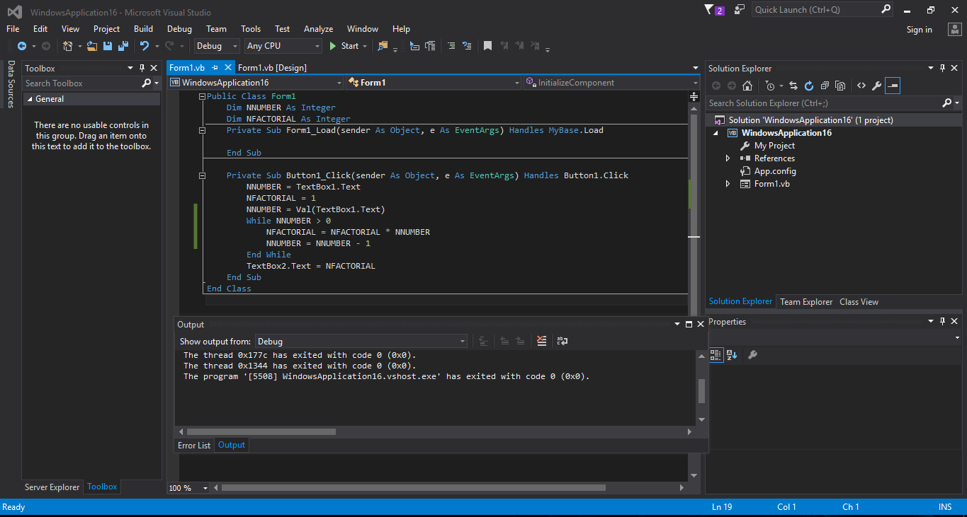

CODE

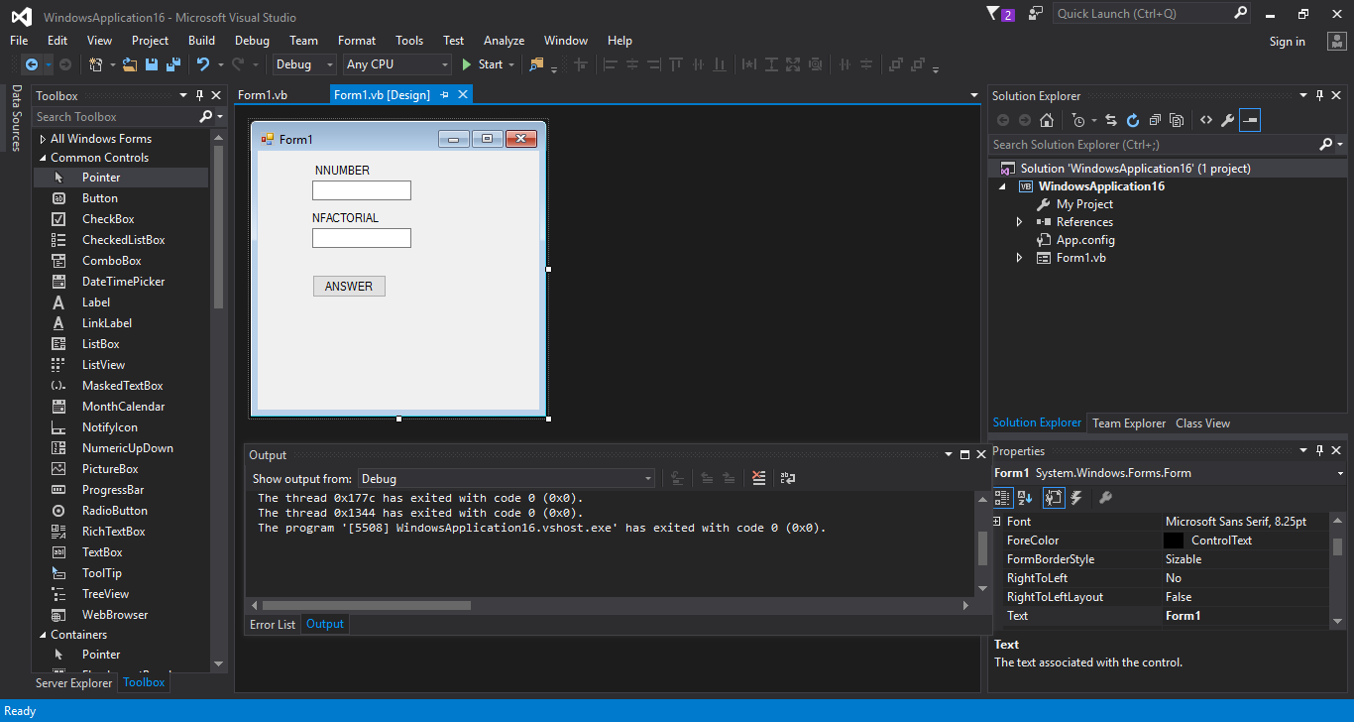

INTERFACE

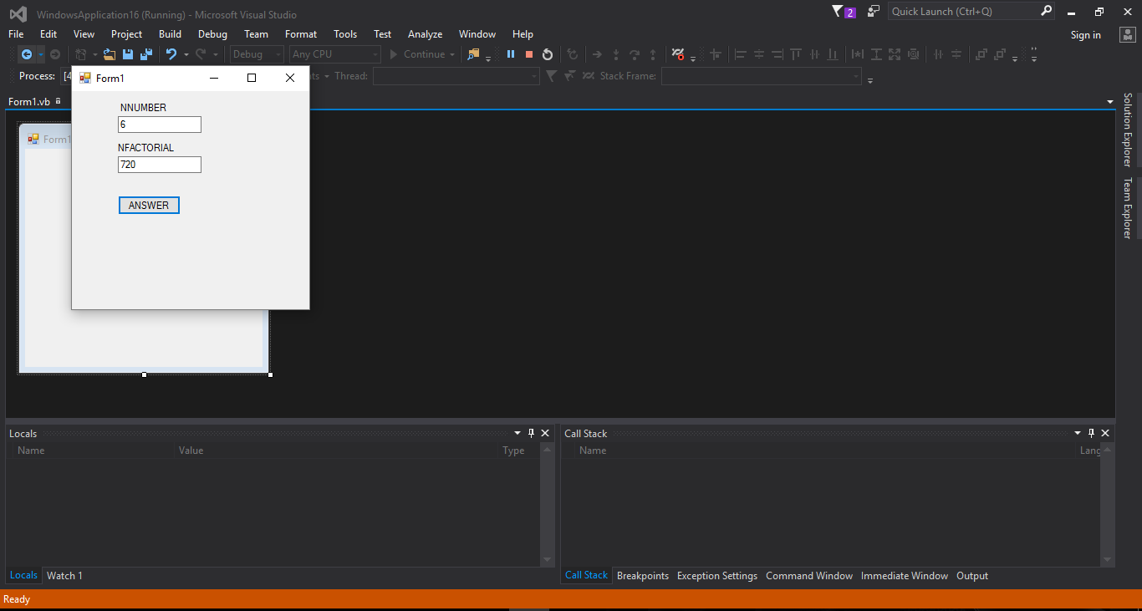

EXECUTED CODE

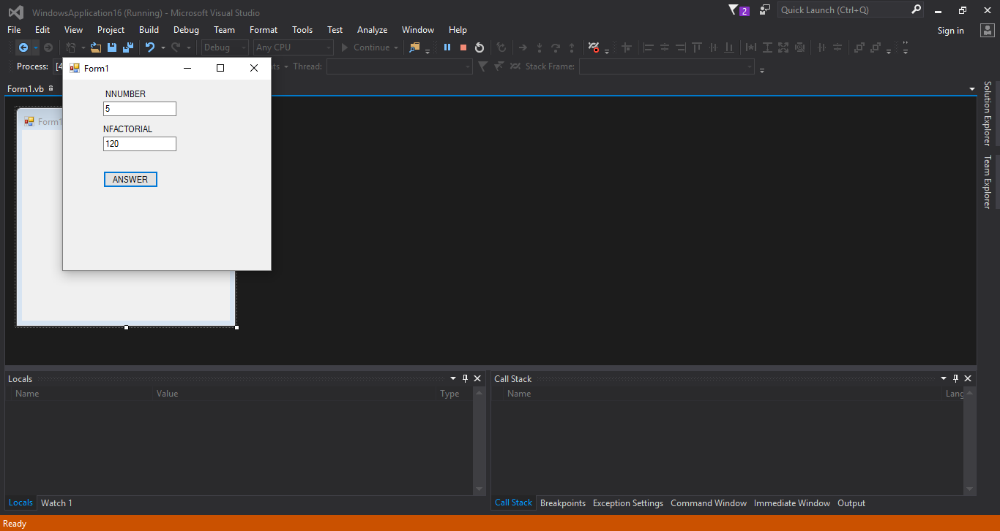

N VALUE FOR 5!

