AIMUEL EMMANUEL
16/SCI01/005
COMPUTER SCIENCE
200 LEVEL

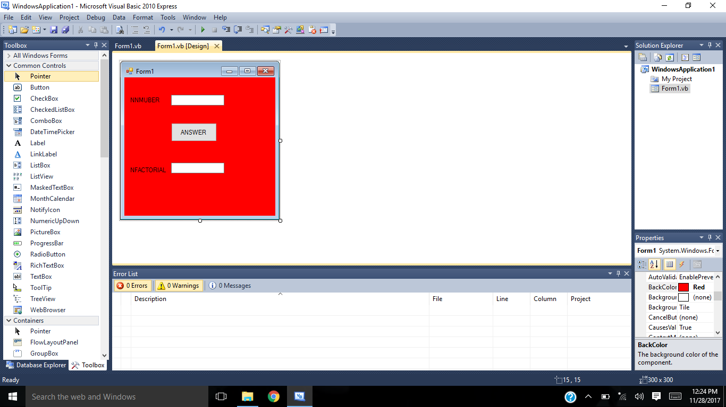

Variable (n) Factorial of (n) to be shown here.

Command to solve for factorial of variable (n)

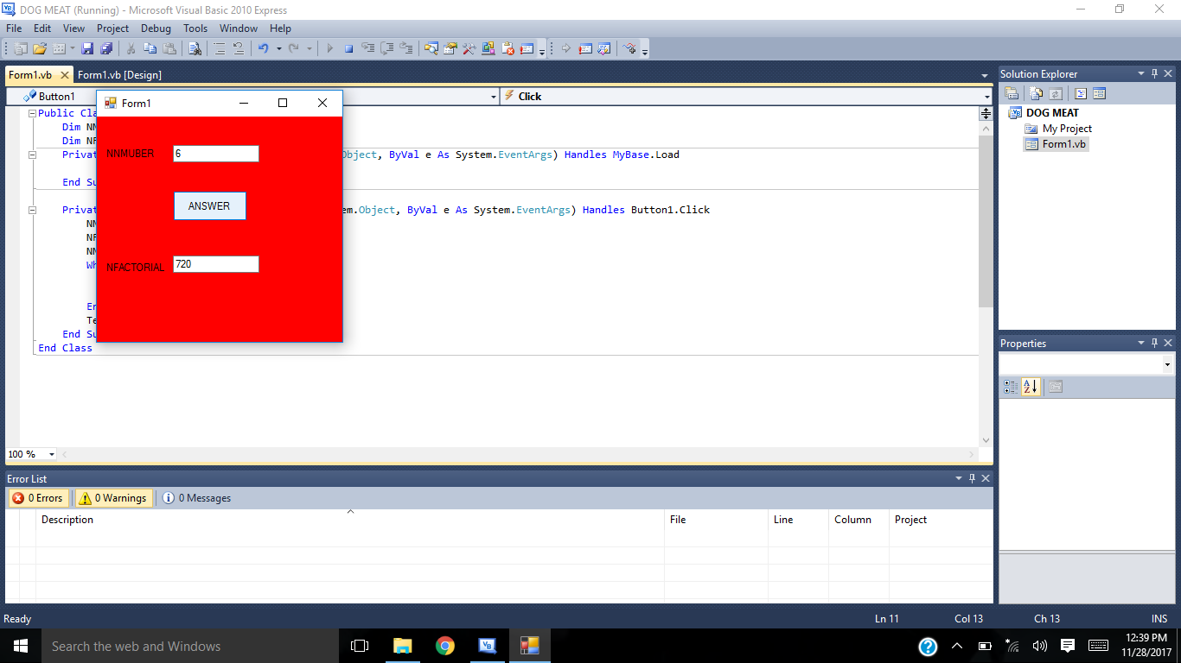

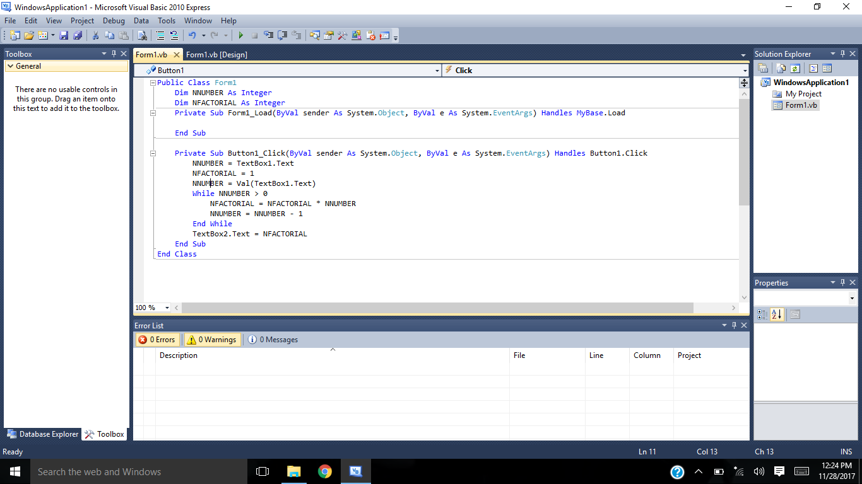

Code

