JEHU NENFORT AARON
16/SCI01/019
CSC 201
COMPUTER SCIENCE

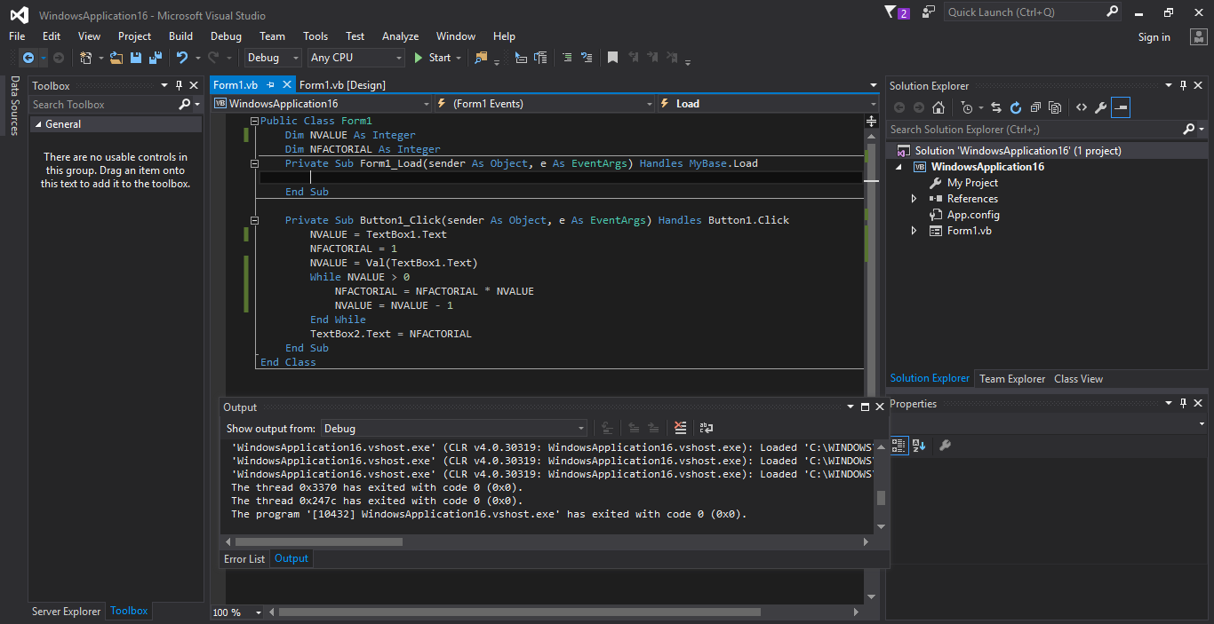

CODE

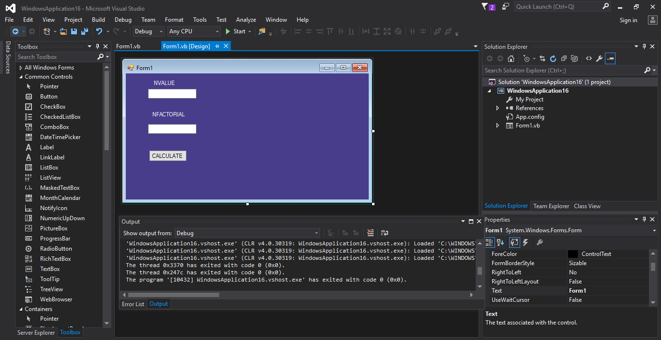

INTERFACE

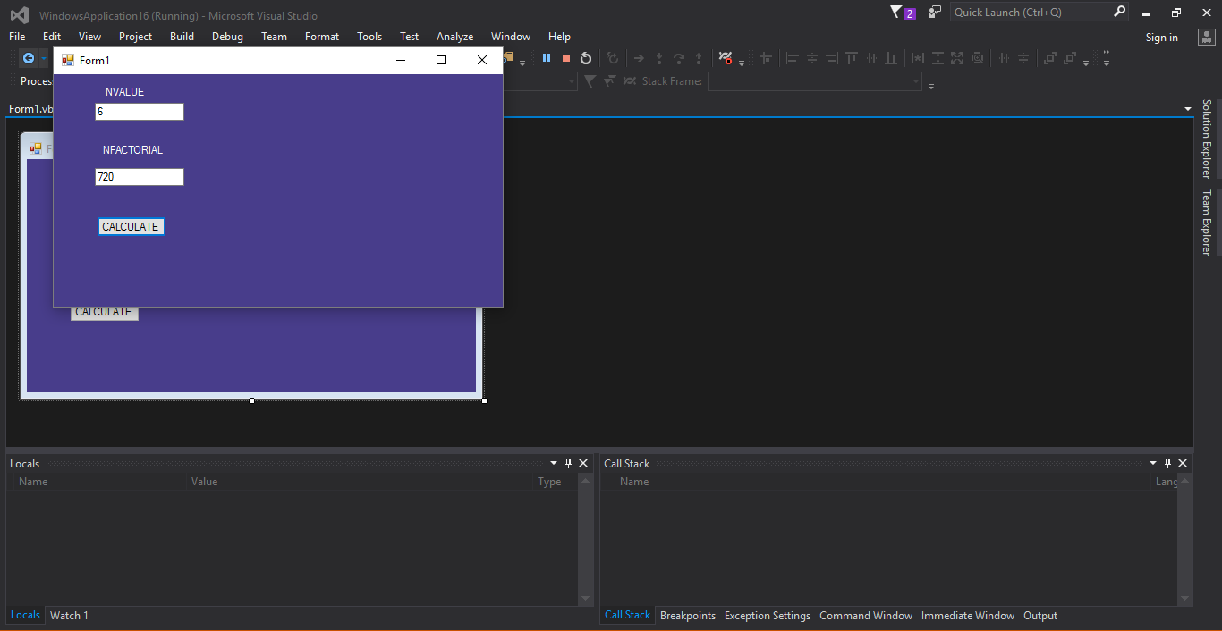

EXECUTED PROGRAM

