SHEKWOYANDU SAMUEL DAKWOYI
16/ENG02/060
CSC 201
COMPUTER SCIENCE

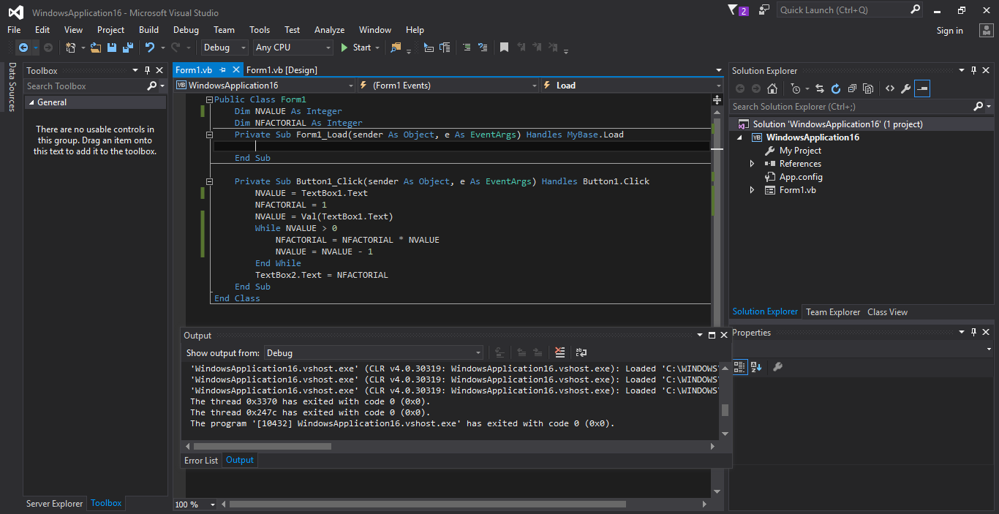

CODE

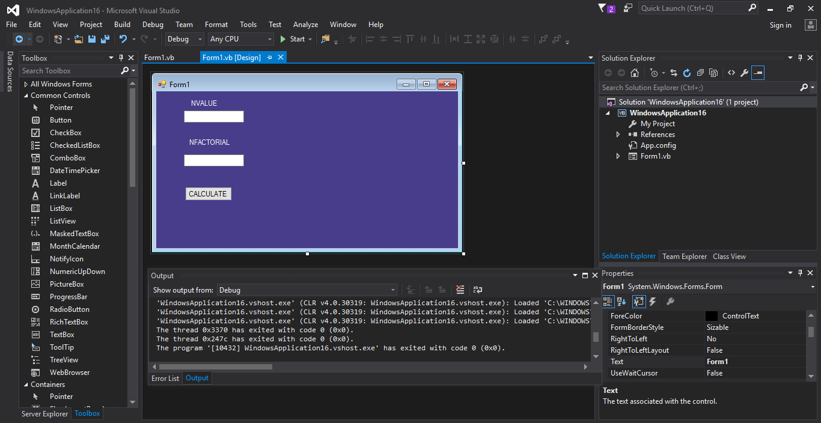

INTERFACE

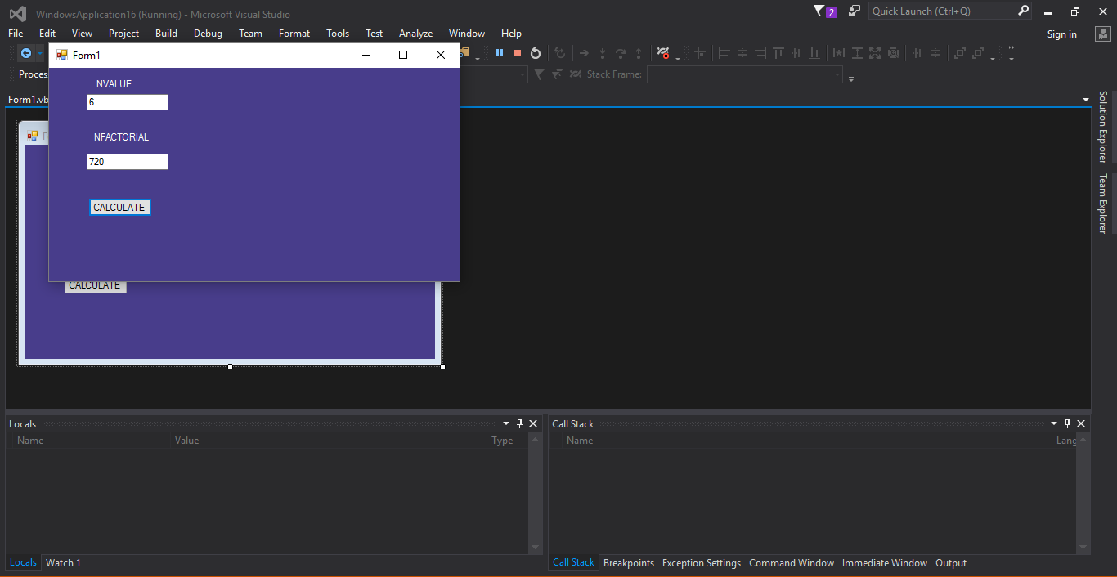

EXECUTED PROGRAM

