EZEANO NNAEMEKA PRINCE
COMPUTER SCIENCE
16/SCI01/012
200 LEVEL

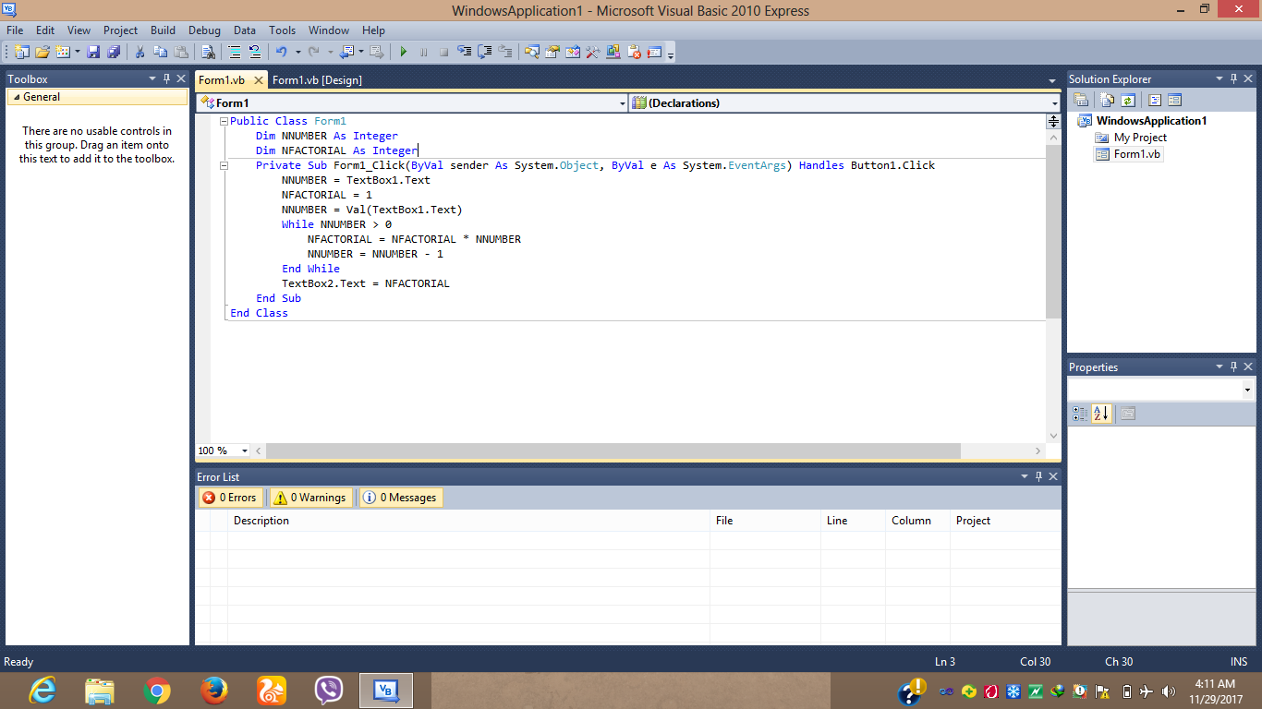
CODE

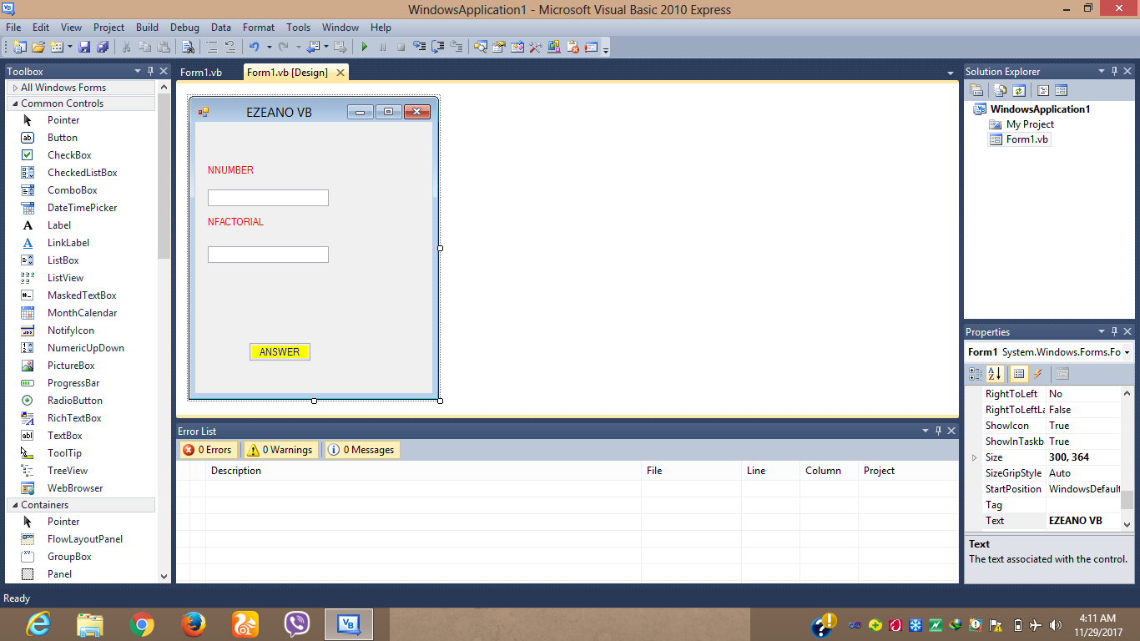
INTERFACE

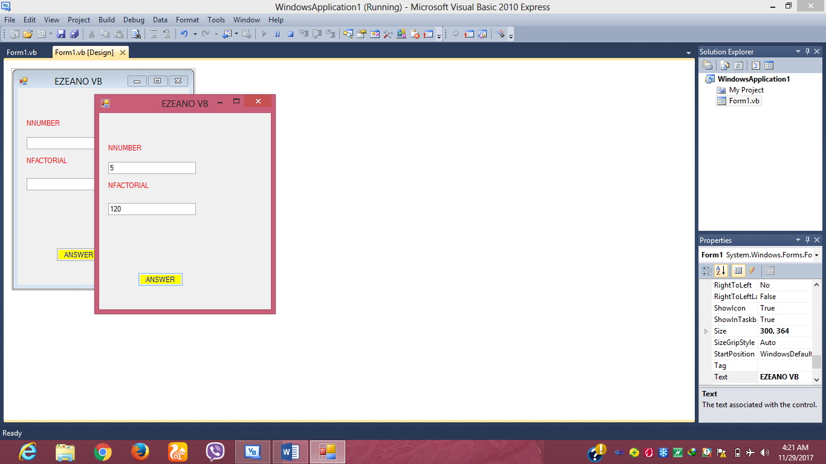

PROGRAM IN EXECUTION

