MATRIC NO: 16/SCI01/021
NAME: JOLAADE AYUBA ADENIYI
COURSE CODE: C.S.C 201

DEPARTMENT: COMPUTER SCIENCE

LEVEL: 200L

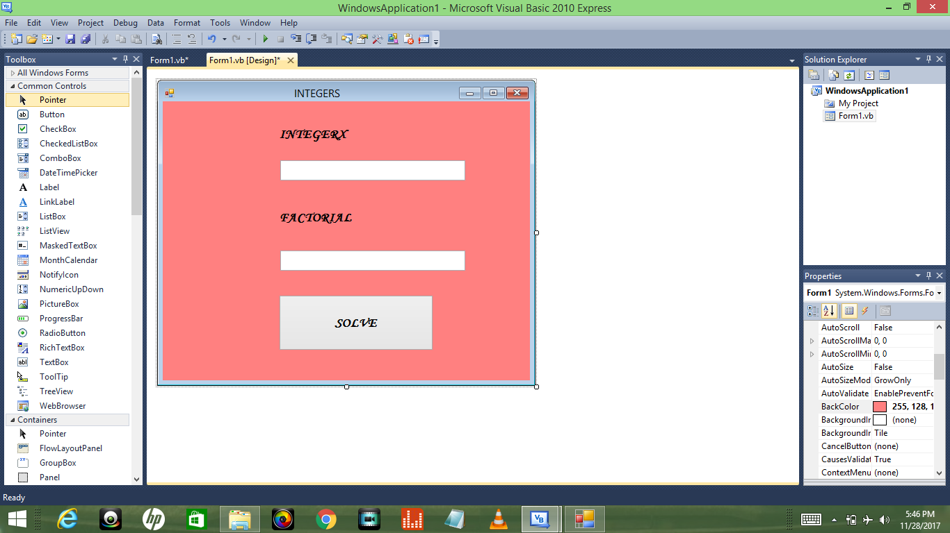
THE DESIGN
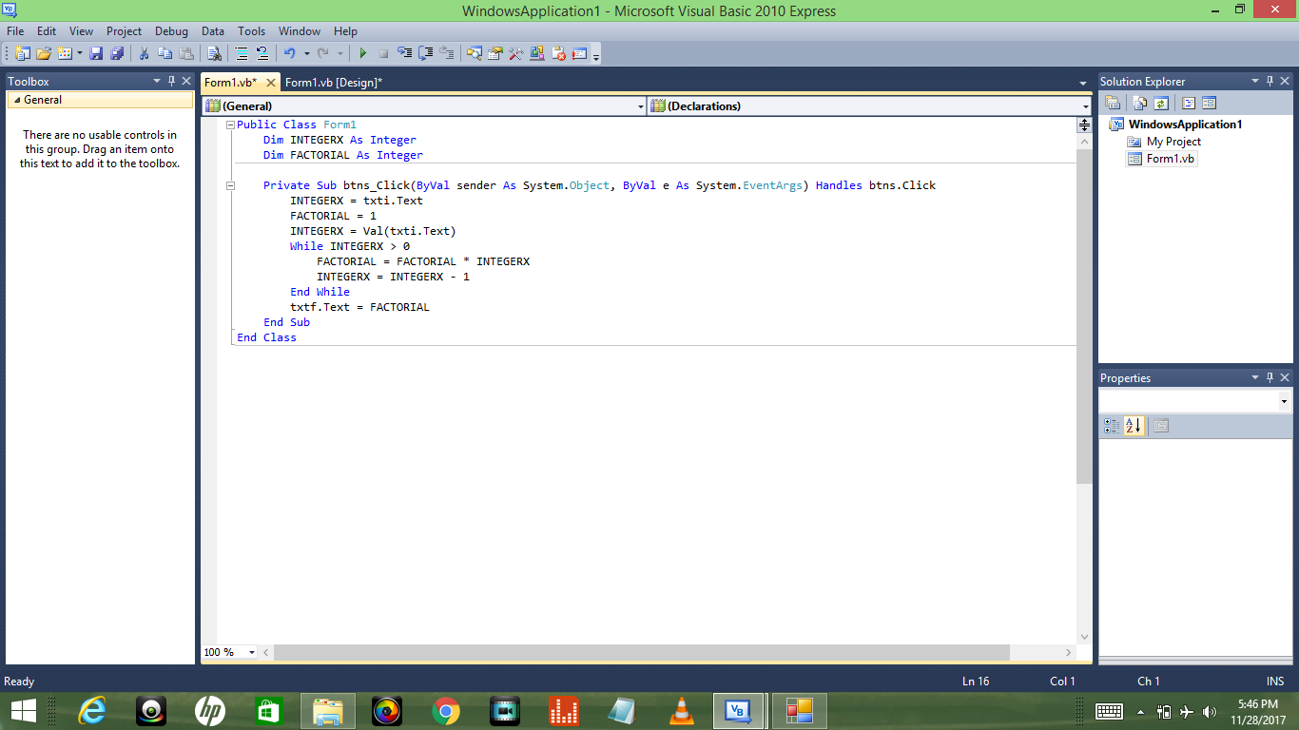
THE CODES
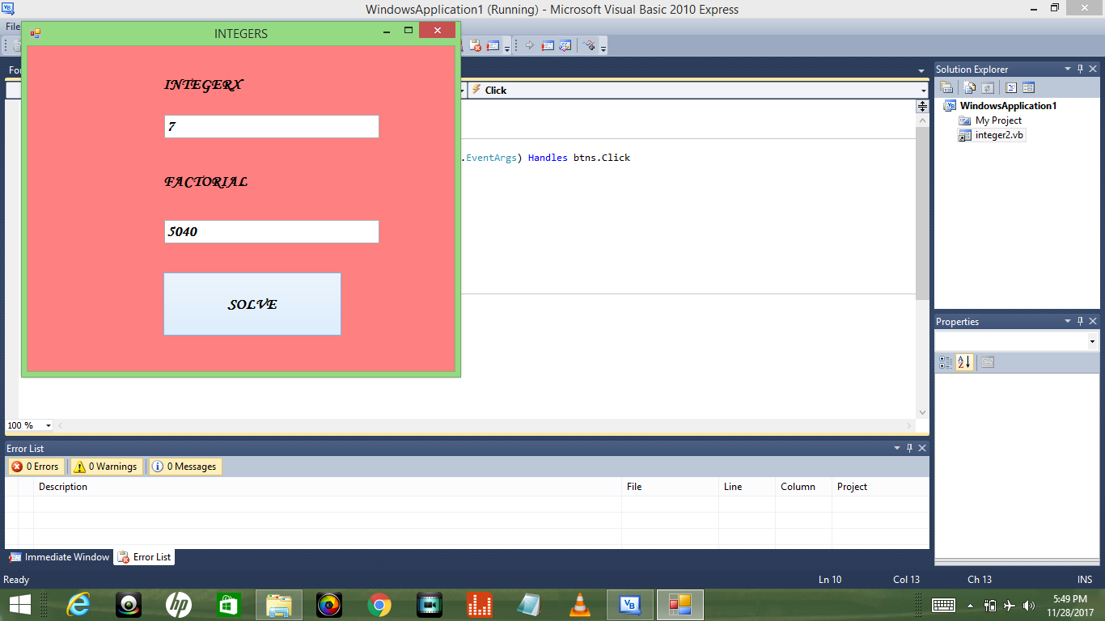
THE RUNNING PROGRAM

