NAME:Okoye Michael Emeka

DEPARTMENT:Computer Science

MATRIC:16/SCI01/032

CSC 201

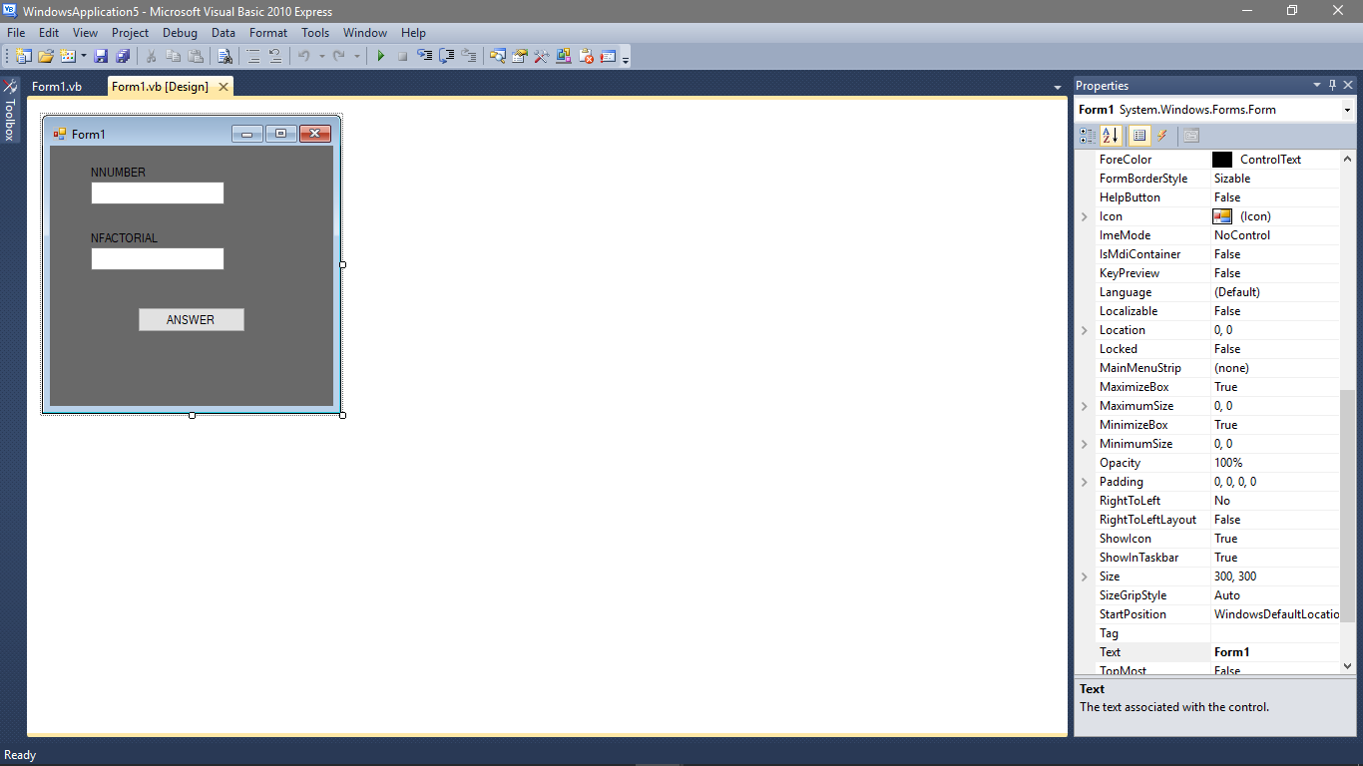

TEXTBOX 1

TEXTBOX 2

BUTTON 1

