NAME: TIMIYAN AYEMIDI NIMISINDEBOFA
MATRIC NO: 16/SCI 01/046

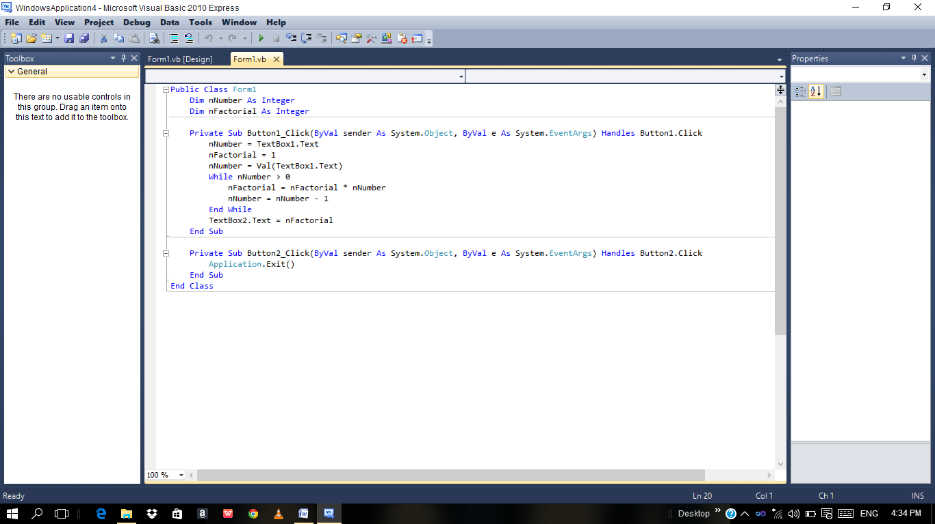

CODES

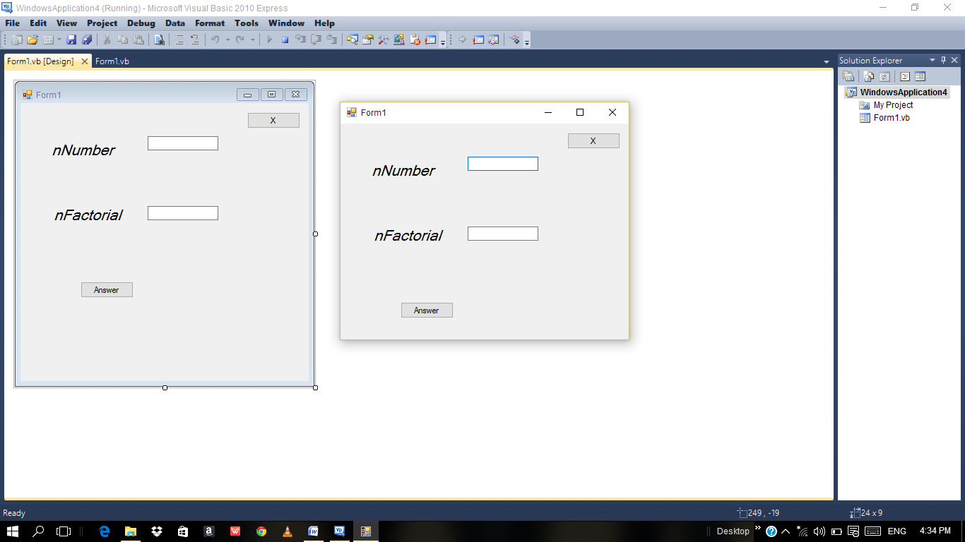

INTERFACE

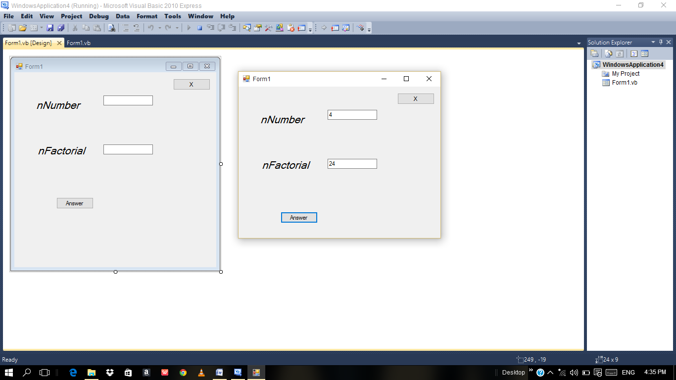

PROGRAM IN EXECUTION

