NAME: FASHINA JOSEPH

MATRIC NUMBER: 14/ENG07/032

DEPARTMENT: INDUSTRIAL CHEMISTRY

LEVEL: 400

Assignment Title: Poly cyclic compounds, Pericyclic reactions and aldol type reactivity
Course Title: Organic Synthesis
Course Code: CHM 433

Question
(1) Write a comprehensive note with relevant chemical equations on each of the following:
(i) Formation of polycyclic compounds.
(ii) Aldol type reactivity and reaction of iminium salts with nucleophile.
(iii) Pericyclic reactions
(iv) Synthesis of complex molecules

FORMATION OF POLYCYCLIC COMPOUNDS
Polyclic aromatic also polyaromatic (PAHs, hydrocarbons or polynuclear aromatic hydrocarbons are hydrocarbons—organic hydrocarbons compounds containing only carbon and hydrogen—that are composed of multiple aromatic rings (organic rings in which the electrons are delocalized). Formally, the class is further defined as lacking further branching substituents on these ring structures. The simplest such chemicals are naphthalene having two aromatic rings, and the three-ring compounds anthracene and phenanthrene.
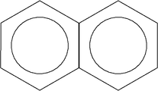
Naphthalene technically a polycyclic, more specifically a bicyclic compound,with circles showing delocalization of π-electrons (aromatic).
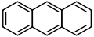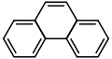
Anthracene Phenanthrene

PAHs are non-charged,non-polar molecules found in coal and in tar deposits. They are also produced by the incomplete combustion of organic matter (e.g., in engines and incinerators, when biomass burns in forest fires, etc.).
- Incomplete combustion of methane producing carbon monoxide
Methane + oxygen - carbon monoxide and water
CH₄ + 1.5O₂ CO + 2H₂O
- Incomplete combustion of methane producing soot

Burns with a yellow flame
Methane + oxygen carbon and water
CH₄ + O₂ C + 2H₂O
- Incomplete combustion:
Carbon + Oxygen ----> Carbon Monoxide
2C(s) + O2(g) ----> 2CO
GENERAL DESCRIPTION
Polycyclic aromatic hydrocarbons (PAHs) are a large group of organic compounds with two or more fused aromatic rings. They have a relatively low solubility in water, but are highly lipophilic. Most of the PAHs with low vapour pressure in the air are adsorbed on particles. When dissolved in water or adsorbed on particulate matter, PAHs can undergo photodecomposition when exposed to ultraviolet light from solar radiation. In the atmosphere, PAHs can react with pollutants such as ozone, nitrogen oxides and sulfur dioxide, yielding diones, nitro- and dinitro-PAHs, and sulfonic acids, respectively. PAHs may also be degraded by some microorganisms in the soil (1,2).
Naphthalene is an organic compound with formula C10H8. It is the simplest polycyclic aromatic hydrocarbon.
C₁₀H₈ + 4.5 O₂ → C₆H₄(CO)₂O + 2 CO₂ + 2 H₂O

SOURCES AND FORMATION
PAHs are formed mainly as a result of pyrolytic processes, especially the incomplete combustion of organic materials during industrial and other human activities, such as processing of coal and crude oil, combustion of natural gas, including for heating, combustion of refuse, vehicle traffic, cooking and tobacco smoking, as well as in natural processes such as carbonization. There are several hundred PAHs; the best known is benzo[a]pyrene (BaP). In addition a number of heterocyclic aromatic compounds (e.g. carbazole and acridine), as well as nitro-PAHs, can be generated by incomplete combustion (1).
Polycyclic aromatic hydrocarbons (PAHs) are a group of more than 100 different chemicals that are released from burning coal oil gasoline, trash tobacco, wood, or other organic substances such as charcoal-broiled meat. They are also called polynuclear aromatic hydrocarbons. They can occur naturally when they are released from forest fires and volcanoes and can be manufactured. Other activities that release PAHs include driving, agricultural burning, roofing or working with coal tar products, sound- and water-proofing, coating pipes, steelmaking, and paving with asphalt. PAHs are persistent organic pollutants (POPs).
Manufactured PAHs are colorless, white, or pale yellow solids. Some can take the form of needles, plates, crystals, or prisms.
PAHs are found in the asphalt that covers roads and parking lots and in smoke and soot. They are also found in coal tar, coal tar pitch, and creosotes, which are by-products of distilling and heating coal and some woods. Coal tar products are used in medicines for skin diseases, such as psoriasis, and in insecticides, fungicides, and pesticides. Coal tar creosote is widely used for wood preservation. Coal tar and coal tar pitch are used for roofing, road paving, aluminum smelting, and production of coke, a coal residue used as fuel.
Some PAHs are used to make medicines, dyes, plastics, and pesticides.
How might I be exposed to PAHs?
You can be exposed to PAHs primarily by breathing polluted air, wood smoke, vehicle exhaust, or cigarette smoke; eating contaminated food; or drinking contaminated water. You can breathe PAHs outside when they are attached to dust and other particles in the air. Outdoor sources of PAHs include soot, smoke, cigarette smoke, vehicle exhaust, asphalt roads, wildfires, volcanoes, agricultural or wood burning, municipal and industrial waste incineration, and releases from hazardous waste sites. You can also be exposed to PAHs in the soil near areas where coal, wood, gasoline, or other products have been burned or in the soil at hazardous waste sites, former manufactured gas factory sites, and wood-preserving facilities.
At home, you can be exposed to PAHs if you breathe cigarette smoke, burn wood, eat grilled or charred meats, drink contaminated water or milk, eat contaminated foods, use medicines made with PAHs, use pesticides, or use wood products treated with creosote. You may be exposed to creosote if you eat herbal dietary supplements which contain the leaves of the creosote bush, called chaparral.
At work, you can be exposed to PAHs if you work at a coal tar, aluminum, or asphalt production plant; smokehouse; foundry; engine repair shop; trash incinerator; coal gasification site; or farm where agricultural burning and pesticide application takes place. You can be exposed if you work in coking, mining, gas or oil refining, metalworking, chemical production, iron or steel production, wood preserving, coal tarring, roofing, transportation, cooking or catering, and the electrical industry. You can be exposed if you work as a roof tarrer, asphalt applicator, or chimney sweep, or use creosote-treated wood.
How can PAHs affect my health?
Of the more than 100 forms of PAHs, 15 are listed as "reasonably anticipated to be human carcinogens" in the Fourteenth Report on Carcinogens published by the National Toxicology Program because there is limited evidence of a relationship between exposure to the substances and cancer in humans.Exposure to large amounts of coal tar creosote may result in convulsions, unconsciousness, and even death. Breathing vapors of coal tar, coal tar pitch, and creosote can irritate the respiratory tract. Eating large amounts of herbal supplements that contain creosote leaves may cause liver damage.
ALDOL TYPE REACTIVITY AND REACTION OF IMMINIUM SALTS WITH NUCLEOPHILE
The aldol reaction is a means of forming carbon–carbon bonds in organic chemistry Discovered independently by the Russian chemist Alexander Borodin in 1864 and by the French chemist Charles-Adolphe Wurtz in 1872, the reaction combines two carbonyl compounds (the original experiments used aldehydes) to form a new β-hydroxy carbonyl compound. These products are known as aldols, from the aldehyde + alcohol, a structural motif seen in many of the products. Aldol structural units are found in many important molecules, whether naturally occurring or synthetic. For example, the aldol reaction has been used in the large-scale production of the commodity chemical pentaerythritol and the synthesis of the heart disease drug Lipitor (atorvastatin, calcium salt).
The aldol reaction unites two relatively simple molecules into a more complex one. Increased complexity arises because up to two new stereogenic centers (on the α- and β-carbon of the aldol adduct, marked with asterisks in the scheme below) are formed. Modern methodology is capable of not only allowing aldol reactions to proceed in high yield but also controlling both the relative and absolute configuration of these stereocenters. This ability to selectively synthesize a particular stereoisomer is significant because different stereoisomers can have very different chemical and biological properties.
The aldol reaction unites two relatively simple molecules into a more complex one. Increased complexity arises because up to two new stereogenic centers (on the α- and β-carbon of the aldol adduct, marked with asterisks in the scheme below) are formed. Modern methodology is capable of not only allowing aldol reactions to proceed in high yield but also controlling both the relative and absolute configuration of these stereocenters. This ability to selectively synthesize a particular stereoisomer is significant because different stereoisomers can have very different chemical and biological properties.
For example, stereogenic aldol units are especially common in polyketides, a class of molecules found in biological organisms. In nature, polyketides are synthesized by enzymes that effect iterative Claisen condensations. The 1,3-dicarbonyl products of these reactions can then be variously derivatized to produce a wide variety of interesting structures. Often, such derivitization involves the reduction of one of the carbonyl groups, producing the aldol subunit. Some of these structures have potent biological properties: the immunosuppressant FK506, the anti-tumor agent discodermolide, or the antifungal agent amphotericin B, for example. Although the synthesis of many such compounds was once considered nearly impossible, aldol methodology has allowed their efficient synthesis in many cases.
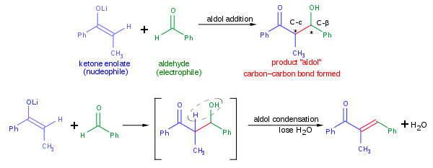

A typical modern aldol addition reaction, shown above, might involve the nucleophilic addition of a ketone enolate to an aldehyde. Once formed, the aldol product can sometimes lose a molecule of water to form an α,β-unsaturated carbonyl compound. This is called aldol condensation. A variety of nucleophiles may be employed in the aldol reaction, including the enols, enolates, and enol ethers of ketones, aldehydes, and many other carbonyl compounds. The electrophilic partner is usually an aldehyde or ketone (many variations, such as the Mannich reaction, exist). When the nucleophile and electrophile are different, the reaction is called a crossed aldol reaction; on the converse, when the nucleophile and4 electrophile are the same, the reaction is called an aldol dimerization.
REACTION OF IMMONIUM SALT WITH NUCLEOPHILE
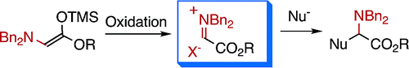

PERICYCLIC REACTIONS
In organic chemistry, a pericyclic reaction is a type of organic reaction wherein the transition state of the molecule has a cyclic geometry, and the reaction progresses in a concerted fashion. Pericyclic reactions are usually rearrangement reactions.
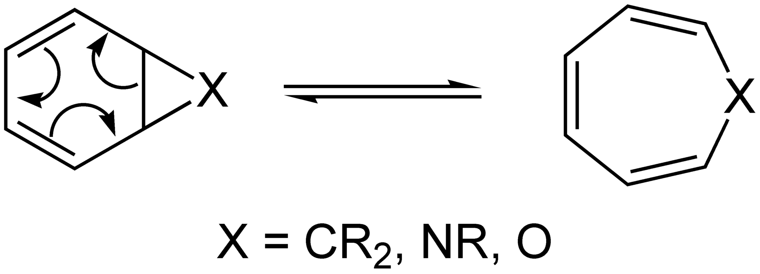
Example of a pericyclic reaction: the norcaradiene–cyclohexatriene rearrangement
Pericyclic reactions require light or heat and are completely stereospecific; that is, a single stereoisomer of the reactant forms a single stereoisomer of the product. We will consider two categories of pericyclic reactions
- electrocyclic reactions and
- cycloadditions.
An electrocyclic reaction is a reversible reaction that can involve ring closure or ring opening. An electrocyclic ring closure is an intramolecular reaction that forms a cyclic product containing one more σ bond and one fewer π bond than the reactant Pericyclic reactions: Bonding changes occur through reorganization of electron pairs within a closed loop of interacting orbitals.
In order for a reaction to be pericyclic the bonding changes must be concerted, therefore bond formation and bond cleavage occur simultaneously. If stepwise then the reaction is not pericyclic The extent of bond formation or breakage need not be equivalent at a given point along the reaction coordinate only that the process are both occurring simultaneously.

Pericyclic reactions in biochemistry
Pericyclic reactions also occur in several biological processes:
- Claisen rearrangement of chorismate to prephenate in almost all prototrophic organisms
- [1,5]-sigmatropic shift in the transformation of precorrin-8x to hydrogenobyrinic acid
- non-enzymatic, photochemical electrocyclic ring opening and a (1,7) sigmatropic hydride shift in vitamin D synthesis
- Isochorismate pyruvate lyase catalyzed conversion of Isochorismate into salicylate and Pyruvate
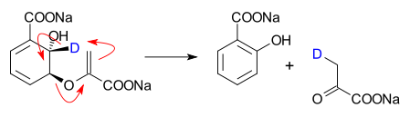

SYNTHESIS OF COMPLEX MOLECULES
Organic synthesis is a special branch of chemical synthesis and is concerned with the intentional construction of organic compounds via organic reactions. Organic molecules often contain a higher level of complexity than purely inorganic compounds, so that the synthesis of organic compounds has developed into one of the most important branches of organic chemistry. There are several main areas of research within the general area of organic synthesis: total synthesis, semisynthesis, and methodology.
TOTAL SYNTHESIS
A total synthesis is the complete chemical synthesis of complex organic molecules from simple, commercially available (petrochemical) or natural precursors. Total synthesis may be accomplished either via a linear or convergent approach. In a linear synthesis—often adequate for simple structures—several steps are performed one after another until the molecule is complete; the chemical compounds made in each step are called synthetic intermediates. For more complex molecules, a convergent synthetic approach may be preferable, one that involves individual preparation of several "pieces" (key intermediates), which are then combined to form the desired product.

Methodology and applications
Each step of a synthesis involves a chemical reaction, and reagents and conditions for each of these reactions must be designed to give an adequate yield of pure product, with as little work as possible.A method may already exist in the literature for making one of the early synthetic intermediates, and this method will usually be used rather than an effort to "reinvent the wheel". However, most intermediates are compounds that have never been made before, and these will normally be made using general methods developed by methodology researchers. To be useful, these methods need to give high yields, and to be reliable for a broad range of substrates. For practical applications, additional hurdles include industrial standards of safety and purity.
Methodology research usually involves three main stages: discovery, optimisation, and studies of scope and limitations. The discovery requires extensive knowledge of and experience with chemical reactivities of appropriate reagents. Optimisation is a process in which one or two starting compounds are tested in the reaction under a wide variety of conditions of temperature, solvent, reaction time, etc., until the optimum conditions for product yield and purity are found. Finally, the researcher tries to extend the method to a broad range of different starting materials, to find the scope and limitations. Total syntheses (see above) are sometimes used to showcase the new methodology and demonstrate its value in a real-world application. Such applications involve major industries focused especially on polymers (and plastics) and pharmaceuticals
Stereoselective synthesis
Most complex natural products are chiral, and the bioactivity of chiral molecules varies with the enantiomer Historically, total syntheses targeted racemic mixtures, mixtures of both possible enantiomers, after which the racemic mixture might then be separated via chiral resolution.

