AFE BABALOLA UNIVERSITY ADO-EKITI EKITI STATE

AN ASSIGNMENT
ON THE CULTURE OF THE BEROM PEOPLE OF PLATEAU STATE UNDER THE NORTH CENTRAL GEO POLITICAL ZONE

BY
SAMSON TEYEI GANG 16/SMS10/017
NANKYER DAWUK 16/SMS10/006 RHEMA SALAMIS 16/SMS10/O16

LECTURER; MRS LANIYO FUMI
WHY WE CHOSE THE BEROM CULTURE; Berom is a tribe found in the north central geopolitical zone in plateau state. We chose this tribe among others because we believe e have more information about the tribe. We also know people who are berom by tribe and can give us information’s about the tribe.
THEIR BACKGROUND:
Mythology has it that the Berom people are from the Congo area of Central Africa. Today, they are found in four of the seventeen local government areas of Plateau State that includes a large part of Barkin Ladi and Riyom, the whole of Jos South and some parts of Jos North. These local governments are all in the north of Plateau State, the most developed part of the state. Ethno-racial studies reveal that the entire ethnic nationalities of the world belong to different racial groups. Hence, the Berom people are said to belong to the Bantu race. The Bantu race has a migratory pattern from South West Africa, The Namibians, South Western Tanzania, Central Africa Republic, Gabon, Southern Cameroun, South Eastern Nigeria, and Central Nigeria covering Benue, part of Taraba, part of Nasarawa, South Kaduna, Southern Bauchi and Plateau State. The Berom also have it that before arriving on the Plateau, there was a small division in the migration party and so the other fraction moved through Sanga Local Government Area of Kaduna State and came through Bassa Local Government of Plateau on their way to Gabon, a settlement which produces some of the inhabitants of Du District in Jos South Local Government Area, there are today, eleven (11) Berom speaking districts namely Gashish, Ropp, Fan, Heipang, Foron, Du, Gyel, Kuru, Vwang, Bauchi, and Riyom, the cradle of Berom.
CULTURE:
According to the berom, there are some common dialectical elements that mean the same this includes Jarawa, Tiv, Anan, Efik and Ibibio. It is strongly speculated that the Berom people have not only traversed the length and breadth of Central Nigeria but must have gone beyond to places in the present Sokoto, some parts of Niger Republic and Burkina Faso. .the speak berom although different villages have their dialect
Coming to marriage according to the berom people, parents used to contract marriages between their son and a girl from a family they hold in high esteem. An esteemed family is usually one that has a tradition of industry and without any abhorrent reputation. Tall girls are seen as those with little ability to carry heavy loads, while short girls with pronounced calves are considered strong and industrious. Secondary reasons for the choice of an eventual wife are also taken into consideration. The boy could check for what, in his eyes, constitutes beauty. Once a boy has developed interest in a girl, the next thing is courtship. Courtship in native Berom culture involves a lot of commitment, usually in kind, from the side of the man. It is the reason why young Berom men in those days, often tried to shorten the period of courtship as much as possible. Part of the commitment involved cultivating a piece of land for the family of the future bride every year, while the courtship lasts. Usually, parents get informed that their daughter is involved with a young man when it comes to their notice that an outsider is cultivating a piece of land for them. They would ask their daughter who will then confirm her romance with the stranger. The commitment also involves building a house for the in-laws. All these are in addition to shouldering the needs of the girl, which could also involve her cosmetics and occasional purchases of a goat. The next step is the formal declaration of the intention of the boy. This is done through his parents who go to their in-laws-to-be to state that they have seen a “green leaf” and they have come to declare their interest in it. In Berom culture, even the declaration of intention for the wedding of a girl can be extremely expensive. There is usually a goat for the girl, and other presents to the parents that may include olive oil, goat, and a small pyramidal heap of beni-seed, potash, etc. There is also a traditional brew by the name of vwere-berom. On the wedding day, announcement is made by both families inviting their friends and relations. There will usually be food, meat, vwere-berom. The bride is dressed with native bandanna, bangles, nasal rings, spectacular earrings, shin wears and others. She is led by other women to her matrimonial home.
In the olden days, berom people usually use animal skin to cover the private parts. The men use it to cover from their waist down while the ladies use leaves to cover their private parts living their breast flapping. In modern times especially during cultural festivals, they ladies tie wrapper from their chest and then use beats as ornament. They use beats on their head and waist. For the men, they use animal skin from their armpit and tie it across their neck.
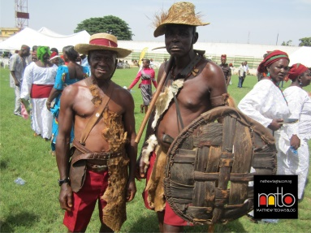
Berom traditional warriors
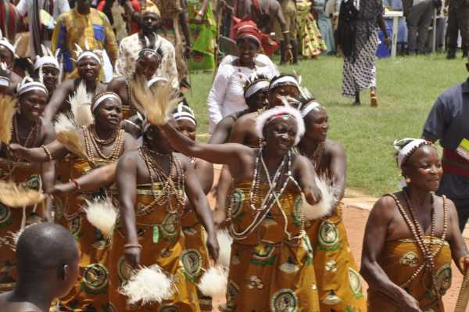
The women attire for modern days
Berom people are rich when it comes to the aspect of food. This is so because they farm a lot and have a lot of traditional meals. Some of them in include
Gwete 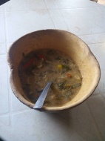

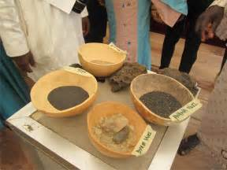
Naman ridi
Bubal [red beans with ridi]
Kunu
Tuk Chun etc.
When one dies in Beromland, his uncles are the first to be told of the sad news. As a matter of fact, uncles are so critical to the life of an individual that they are the first to be informed when he becomes critically ill. Wailing that always follows the death of an individual was the means by which such heartbreaking news often travelled far. Death persons in Berom culture are usually dressed with the coats of animals and laid in horizontal tunnels usually connected to the surface by a vertical shaft. The grave in Beromland is a means of establishing the cordiality or otherwise between a dead person and a living relations. Intimate relations would insist on reposing in the same grave. If there was a rift between a dead man and his living relation it comes to the surface when the living insists on having a private grave in the event of his death.
Cultural festivals include;
1 Mandyeng: is a major festival celebrated in Berom land to usher in the rainy season. The festival normally takes place March/ April. In the past the Berom regard Mandyeng/Nshok the most vital festivals which ensured a good farming and hunting period and harvest.
2. Nshok Festival: Nshok is a festival associated with hunting. The festival is done once a year around the month of April/May to usher in the new season just as the Mandyeng. In the pre-colonial era the Berom regards hunting as an occupation and sports. Most Berom names are derived from animals most importantly antelopes, not only because they are smart, fast or strong but because they are beautiful. Names as Pam, Dung, Chuwang, Gyang, Badung etc. for boys while girls answer Kaneng, Lyop, Chundung, Nvou, Kangyang
3. Nzem Berom: the influx of Christianity and western Education paved way for a lot of socio-cultural changes into Berom land. The changes devalued the rich culture of the people bringing serious predicament of a severe social and cultural crisis. In order to avoid the danger of losing the socio-cultural practice of the ancestor and the overall pre-colonial activities such as the Mandyeng, Nshok, worom, Chun, vwana, ceremonies were brought into a single umbrella festival call Nzem Berom. Nzem Berom festival is held within the first week of April to tally with the period when Mandyeng, Nshok and Badu Festival were held. The Nzem, is a period when different cultural display are exhibited from different part of Berom land, especially in the aspect of Music and Dance, arts and culture
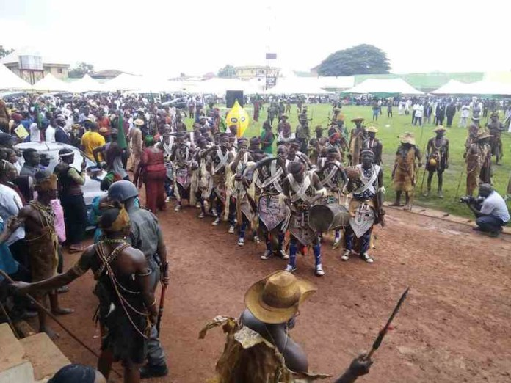
Nzem berom festival
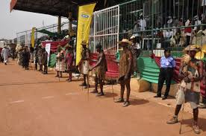
Nzem berom festival
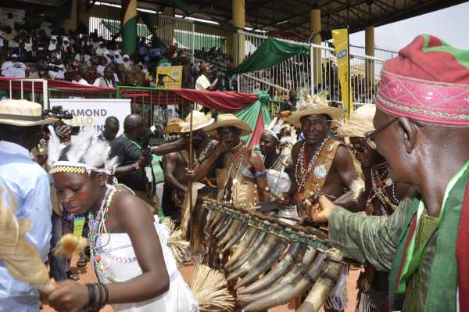
Nzem berom festival
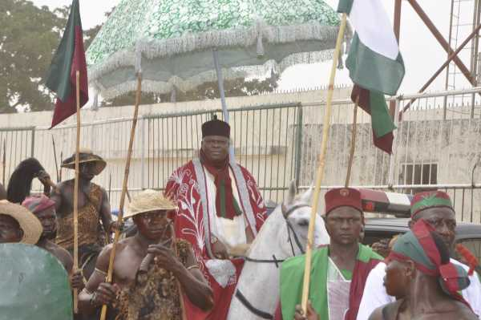
Nzem berom festival the Gbong Gwom Jos
Musical instruments among the Berom also make some interesting parts of the peoples’ lifestyle. Some of these include “Yom Nshi” a two string banjo made of calabash and skin as resonators, “Yom”- straw string instrument “kwag” or “Gwashak” a scraper made from dry cactus played with a stick slid across the sawed body of the dry cactus to produce a scrapping sound, and “Kundung” a xylophone made of cattle horns and cobwebs
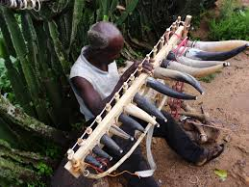
The xylophone locally called kundung
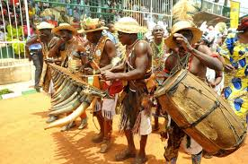
ARCHITECTURE AND TECHNOLOGY:
The traditional Architecture of the Berom people resembles that of the inhabitants of Zuru in Kebbi State and that of some inhabitants of Burkina Faso. Farming is the most common occupation of the Berom; the people use hoes and cutlasses that are locally produced. The farmers often work on a cooperative basis in preparing pieces of land for cultivation purposes. This exercise involves cutting down the bush, allowing it to dry after which it is set ablaze, this is followed by Mounding. Mounding is a laborious aspect of farming. Consequently, a lot of food is prepared for the hoeing party by the wife or wives of the owner of the new farm. Berom men do this in turns until everyone has his own farm, but apart from providing food for the work party, the wife or wives is usually responsible for subsequent weeding in order to ensure good harvest. The Berom people practice both Cereal and Tuber forms of Agriculture e.g. Millets, Sorghum, Cocoyam, Potato, Cassava and Yam. Berom farmers, men and women usually fence their farms with Cacti; this is an attempt to prevent the menace from domestic animals such as goats and sheep that often destroy crops. Apart from farming the Berom men do practice hunting to obtain protein, much of this game meat is also sold at the local markets. Hunting can be done on an individual or group basis. Some locally available game include Cane Rats, monkeys, Antelopes and Porcupines
SOCIAL VALUES
Peace; the berom people are well known for their peaceful way of life, although the sometimes have their differences when it comes to some sensitive issues. They settle their disputes within themselves and when the issue is not resolve, they take it to the traditional ruler. They place more emphasis on settling dispute within than outside.
Communal living; the berom people live as one. For instance, they believe in cooperative or team work when it comes to farming and others. They do cooperative farming.
Culture; the berom people give priority to their culture; they try to practice what has been there before the coming of the colonial masters. For instance, during their cultural festival, all the cultural activities that were done in the olden day are being carried out there. That is to show that they haven’t forgotten about their cultural practices.
Food; food has value in most culture. Due to their hardworking nature, they believe that man needs to eat to gain more energy so that he can carry out his day to day activites.
Respect; when elders are conversing, a child or a younger person is not expected to talk or make any comment even if the elders are wrong or in danger. Anyone that talks when elders are conversing is said to be a disrespectful child with no manners.
Conflict resolution
In berom land, their usually use to be dispute on land, inheritance, and also on the throne. The have the village head [dagwom], district head [gwom rwei], and the overall head [gbong gwom]. So if they have any issues or problem, they follow that hierarchy. In berom land, they do not follow kingship by inheritance. The king is being appointed/elected. Berom has a paramount ruler called the Gbong Gwom, Jos. In the pre-colonial period, the Berom were divided into autonomous political groups based on region until the colonial period that the paramount chief called the Gbong Gwom was constituted. The stool of the Gbong Gwom, Jos was established under the recognition of a colonial officer, Mr. Synge with the aim to help coordinate the activities of the natives. The first chief, Dachung Gyang, assumed leadership from 1935 to 1941 as the first Gbong Gwom, and then followed by Da Rwang Pam, 1947 to 1969, Da Fom Bot, 1970 to 2002, Victor Dung Pam, 2004 to 2008 and Da Jacob, Gyang Buba 2009.

REFERENCE
Wikipedia
http://blackrootsentertainment.blogspot.com.ng
leadership.
https://www.thisdaylive.com
http://newstoweronline.blogspot.com.ng

