Adeyemi Gbenga Mayode -Internship report
Internship report on the training programme which took place at National Human Rights Commission, off Jebba road Ilorin, kwara state, Nigeria.
BY
Adeyemi Gbenga Mayode
Matric No: 16/sms10/001
Department of peace and conflict studies
Social and Management science
Afe Babalola University, Ado Ekiti
Submitted to Dr Ademola for Peace work Field Experience Scheme (PFES) in fulfillment of the requirement for completion of 200 level internship.
SUBMISSION LETTER FOR INTERNSHIP REPORT.
Dear Sir,
Having completed the six weeks training program required by peace work field experience scheme (PFES) which started on 5th July, 2017 and ended on 15th august, 2017.
I hereby write to inform you that the report work was compiled and completed by me; I therefore submit the report work as partial fulfillment of the requirement for the students Peace work field experience scheme (PFES) of ABUAD.
The National Human Rights Commission kwara state branch has a total of 9 staffs as its organizational structure; I was the only internship student there. The staffs are:
1) Mr Patrick-National Human Rights Commission state coordinator
2) Barrister Ahmed-National Human Rights Commission lawyer
3) Mrs Tope-secretary
4) Barrister Adio-National Human Rights Commission lawyer (investigation)
5) Mrs Gida-Mediation and monitoring
6) Mr Twyce-conflict resolution
7) Mr Omodara-Director
8) Mr. Abiola-Project and research manager
9) The last staff works in the mediation department
In the general sense I worked with the department of Human Rights which had broad activities done under it.National Human Rights Commission is one of the very few organization that is well established in the aspect of Human rights most especially. The organization is staffed with resilent, hardworking, hospitable ,and intelligent personnel’s.
The National Human Rights Commission was established by the National Human Rights Commission (NHRC) Act, 1995, as amended by the NHRC Act, 2010, in line with the resolution of the United Nations General Assembly which enjoins all member States to establish national human rights institutions for the promotion and protection of human rights.
The Commission serves as an extra-judicial mechanism for the enhancement of the enjoyment of human rights. Its establishment is aimed at creating an enabling environment for the promotion, protection and enforcement of human rights. It also provides avenues for public enlightenment, research and dialogue in order to raise awareness on human rights issues.
The Commission is headed by the Executive Secretary who is also the Chief Executive Officer (CEO).
There are six departments in the administrative structure of the Commission namely: Admin, LID, Finance and Accounts, Public Affairs and Communications, Planning, Research and Statistics, and Monitoring and External Programs.
There are three Units under the Executive Secretary's Office, namely, the Council Secretariat, Audit and Public Interest litigation Units.
The Commission also has six zonal offices representing the six geo-political zones of the country, namely; North West Zone (Kano), North East Zone (Maiduguri), North Central (Jos), South West (Lagos), South East (Enugu) and South South (Port Harcourt).
A great deal of knowledge and tremendous skills related to promoting peace through protection of human rights was imbibed in me during the few weeks of rigorous training that I went through at National Human Rights Commission in kwara state, An enormous amount of physical and intellectual strength is required to survive at National Human Rights Commission because most cases involves the critical case of life and death.
As we all know, our society needs peace, this accounts for the call of human rights experts to monitor human rights issues.
ACKNOWLEDGEMENTS.
Mr. Patrick the state coordinator of National Human Rights Commission taught me how to write official letters especially international letters,Mr omodara the director taught me how to receive complains from complainants,Mrs Gida taught me more about mediation process,Barrister Ahmad taught me more about how to manage conflict and conflict resolution,Mr Twyce taught me more about the skill of resolving conflict and promoting equal human treatment to lead to a win win situation, My internship was worthwhile because it was a success through the help of my supervisors and co workers
During the period of my internship I learnt the mode of operation of National Human Rights Commission by reading some National Human Rights Commission books like: Acts and amendments, standing orders and rules of procedure of National Human Rights Commission of Nigeria and I read the hand bill called About us.
I was present in all cases brought to the commission and I contributed through my opinion, there was a case of land dispute that I contributed to by receiving the complaint and the complainant was happy and thanked me for writing the complaint in the right way, I also learnt more about ICT through typing cases, I was also present in all mediation cases and violation of rights.
I together with the commission visited the civil defense office kwara state to visit the commandant to follow up a particular case.
I also wrote international proposal letters requesting for funds for various projects and sponsoring of programs like poverty alleviation in children, for this I wrote a letter to CHESTRAD international and the letter was later edited and approved by the state coordinator, I also wrote a letter to ABILIS foundation, Global Rights and red cross voluntarily. The ABILIS foundation letter was to promote disabled persons rights and equal treatment of disabled persons.
Furthermore, there were cases where I signed on behalf of the commission, also I received some complains, received and stamped it.
. Through my participation in this internship, I learnt more about respect, privacy and confidentiality, safety, equal health care, dignity, job security, nondiscrimination/stigmatization
The cases dealt with at at National Human Rights Commission are:
1) Right of the child
Right to education
Right to survival and development
Child labour (commercial and formal sector)
Child marriage
Child trafficking
Sexual abuse
Child custody and other abuses
2) Civil and political rights.
Unlawful arrest and detention
Torture
Cruel, inhuman and degrading treatment
Extra judicial killings
Access to justice
Appeal for prerogative mercy
Enforced disappearance
Participation in political affairs
Rights to freedom of religion, thoughts and conscience
Right to peaceful assembly and association
3) Economic, cultural and social issues
Land and landed properties
Labour rights
Right to education
Right to health
Right to food
Right to shelter
Right to private and family life
4) Discrimination
Ethnics
Religious
Medical
Disability and others
5) Environmental rights
6) Ethnic religious and communal crises
7) Protection of Internally Displaced persons camp
8) International matters and other cases on compassionate grounds
The Internship program undergone at National Human Rights Commission gave me an in-depth insight exposure to the practical aspect of peace and conflict studies profession and this has really motivated me because I was opportune to know and have more experience about human rights issues, I also acquired the knowledge and skill of how National Human Rights Commission writes official letters. The program was highly enlightening, beneficial, interesting and successful. I strongly believe and know that the objective of the Peace work field experience scheme (PFES) was however achieved.
REFERENCES
1) NHRC acts and amendments
2) Standing orders and rules of procedure of National Human Rights commission in Nigeria.

Adeyemi Gbenga Mayode -Field trip report
Field trip report on the experience programme which took place at Abuja, Nigeria.
BY
Adeyemi Gbenga Mayode
Matric No: 16/sms10/001
Department of peace and conflict studies
Social and Management science
Afe Babalola University, Ado Ekiti
Submitted to Dr Ademola for Peace work Field Experience Scheme (PFES) in fulfillment of the completion of 100 level field trip experiences.
SUBMISSION LETTER FOR FIELD TRIP REPORT.
Dear Sir,
Having completed the three days field trip experience program required by peace work field experience scheme (PFES) which started on 2nd may, 2017 and ended on 5th may, 2017 at National Human Rights Commission, Global Rights, Nigerian Red cross, Institute for peace and conflict resolution.
I hereby write to inform you that the report work was compiled and completed by me; I therefore submit the report work as partial fulfillment of the requirement for the students Peace work field experience scheme (PFES) of ABUAD.

On 3rd may, 2017 we went to National Human Rights commission and I learnt about the National Human Rights Commission, The National Human Rights Commission was established by the National Human Rights Commission (NHRC) Act, 1995, as amended by the NHRC Act, 2010, in line with the resolution of the United Nations General Assembly which enjoins all member States to establish national human rights institutions for the promotion and protection of human rights.
The Commission serves as an extra-judicial mechanism for the enhancement of the enjoyment of human rights. Its establishment is aimed at creating an enabling environment for the promotion, protection and enforcement of human rights. It also provides avenues for public enlightenment, research and dialogue in order to raise awareness on human rights issues.
The Commission is headed by the Executive Secretary who is also the Chief Executive Officer (CEO).
There are six departments in the administrative structure of the Commission namely: Admin, LID, Finance and Accounts, Public Affairs and Communications, Planning, Research and Statistics, and Monitoring and External Programs.
There are three Units under the Executive Secretary's Office, namely, the Council Secretariat, Audit and Public Interest litigation Units.
The Commission also has six zonal offices representing the six geo-political zones of the country, namely; North West Zone (Kano), North East Zone (Maiduguri), North Central (Jos), South West (Lagos), South East (Enugu) and South South (Port Harcourt).

Activities of the Commission

Since its establishment the Commission has demonstrated an expansive capacity to tackle issues of human rights through various activities, ranging from public enlightenment and education, investigation of complaints, mediation and conciliation, conflict resolution, peace building, research advocacy and training programmes on contemporary issues in the field of human rights. These were given effect through an effective complaint treatment mechanism, regular hosting of enlightenment seminars, workshops, rallies and continuous reengineering of strategies which culminated in the National Action Plan (NAP) for the promotion and protection of human rights. The NAP has been deposited with the office of the United Nations High Commissioner for Human Rights (UNHCHR) as a benchmark for assessing Nigeria's human rights records, as well as government's commitment towards the promotion and protection of human right.

HUMAN RIGHT PROMOTION

The Commission, realizing that human rights campaign cannot be achieved solely through the development of protective laws or establishment of mechanisms to implement those laws, engages in series of educational and public enlightenment programmes to raise public awareness on human rights issues. The Commission regularly holds workshops, seminars, conferences and interactive sessions with relevant stakeholders. The Commission has also engaged in continuous media advocacy and periodic publications aimed at disseminating appropriate human rights messages. Sensitization, education and enlightenment programmes have also been carried out by the Commission in collaboration with NGOs and CBOs, to raise awareness on human rights throughout the country. Village Square meetings are also held across the country to discuss the mandate of the Commission and other issues of relevance to specific local environments.

Furthermore I learnt the stages of conflict which are:
- Latent Stage: Participants not yet aware of conflict.
- Perceived Stage: Participants aware a conflict exists.
- Felt Stage: Stress and anxiety.
- Manifest: Conflict is open and can be observed.
- Aftermath: Outcome of conflict, resolution or dissolution.
The commission also consists of 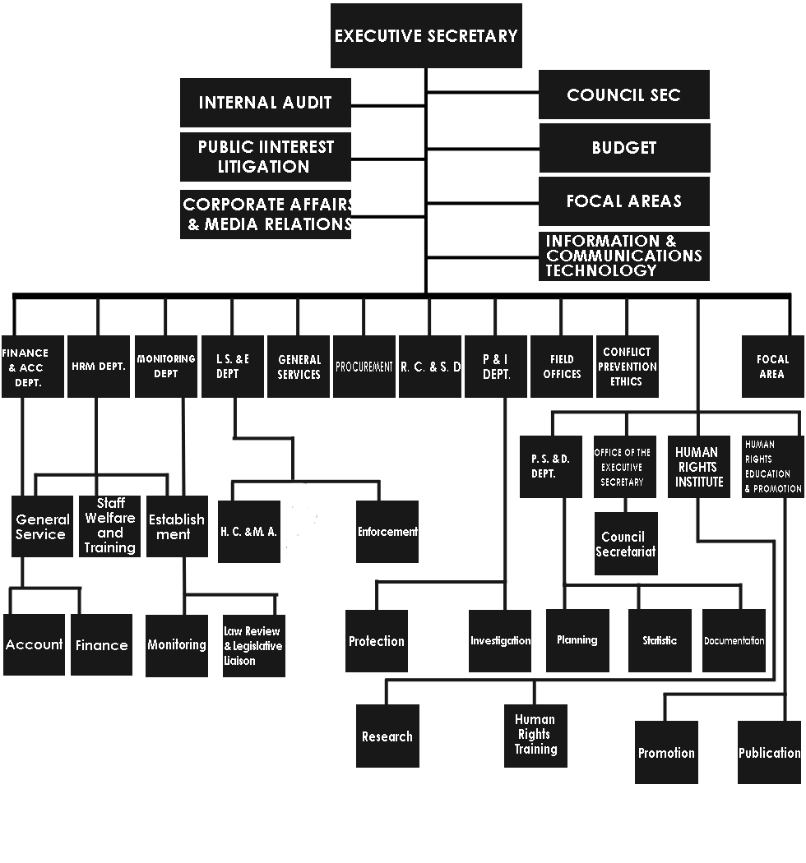
In conclusion I learnt about how to provide remedies to issues in order for them to be resolved totally.
We also went to global rights Global Rights challenges injustice and amplifies the voices of grassroots activists to promote, protect, and fulfill human rights. Hand in hand and side by side, we work with individuals and groups to:
- At the community level, build knowledge, skill and advocacy expertise for those with the greatest vulnerability and need for parity of opportunity for all
- Gain access to resources and decision making bodies
- Become participants in democratic life through an on-going continuum of education, skill development and feeling of vested interest to create social change
vision is a just society for all built on the universal principles of human rights and guaranteed by access to justice. Human rights cultures are built by individuals and groups whose rights are threatened, suppressed or do not exist. They are strengthened by allied organizations such as ours, working collaboratively, creatively and with integrity.
We believe that social change begins at the community level and gains effectiveness through partnership with people who share similar needs, values and expertise. We are guided by a strong commitment to equality and diversity in our work to build social and legal change that is long-term and sustainable.
I learnt that Global Rights exists to:
- Document and expose violations,
- Conduct community education and mobilization,
- Advocate for legal and policy reform,
- Use the courts as well as traditional means of dispute resolution on behalf of disadvantaged populations, and
- Engage the international community, including the United Nations and regional bodies in critical human rights issues
- Shift power imbalances through access to justice
Global Rights’ programs address governance failures that exacerbate the disenfranchisement and the violations of the rights of the poor and marginalized, women and victims of discrimination. While the need for action is universal, no one model is uniformly applicable and all programs are customized to local needs and conditions.
We also visited the Institute for peace and conflict resolution In a deliberate move to fulfilling parts of its mandate as contained in its Establishment Act Number 34 of 2007, the Institute for Peace and Conflict Resolution (IPCR) which was established in the year 2000 by the Nigerian Government consequently set up the National Peace Academy (NPA).
The rationale for the NPA predicated on the fact that conflict is intrinsic in human society and in its worst, is violence which negatively affects individuals, communities, social groupings, institutions and the larger society - the nation states; its unconstructiveness results in loss of human lives, destruction of property, general insecurity and economic losses causing untold hardship. Knowledge and skills are as well fundamental therefore, for human persons to manage challenges of conflicts and insecurity. The quest for peace has led to series of studies and researches culminating into various conflict-solving trainings.
IPCR in the first place was established to conduct in-depth researches on peace, security and conflict issues, provide quality advice to the federal and state governments, and the designing of intervention strategies for the prevention, management and resolution of conflicts in Nigeria and Africa.
In order to build Nigeria’s and indeed Africa’s capacity in the areas of peace-building, peacemaking and peace enforcement, conflict prevention and management - all these forming parts of IPCR’s intervention strategies, the NPA introduced Conflict Resolution, or Management Courses. It is worth mentioning that security personnel, top government officials, the media and Civil Society Organizations (CSOs) among others have since key-into these certificated courses to acquire requisite skills of mainstreaming peace in their interventions and activities.
Perhaps launching into the continental rostrum to open up access for all Africa countries as indicated in its mandate, the IPCR through its NPA has in collaboration with the Institute for Security Studies (ISS) commenced training of foreign countries; the training is on African Peace-building Innovation for Change - West Africa Skills Training for Youth-led CSOs.
Twenty-three (23) participants from Ghana and Cameroon on the sponsorship of ISS have already started a 2 weeklong course at IPCR in Abuja with some Nigerian participants; 6 Ghanaians, 6 Nigerians, and 11 Cameroonians. The course is being run with the ISS’s African Centre for Peace Studies and Training. The IPCR-ISS partnership is to build capacities for peace promotion and conflict mitigation in order to reel out many ambassadors of peace across West Africa and Africa as a whole in way that will reconfigure people’s mentality towards appreciating regional and ethno-religious tolerance. The youths who represent the future of every country must conscientiously be made to imbibe the spirit of tolerance for a more peaceful and stable state; every policy in Nigeria, West Africa and in the entire continent must become a driver for this to be achieved.
I quite agree with the Director General of IPCR, Professor Oshita O. Oshita who while addressing participants of the course pointed out that African youths need programming experience to prepare them towards contributing usefully as game changers in the continent, and that it was high time for African’s Governments to ensure that the capacity of the youths be developed so that they would fit well into leadership responsibility for the good of Africans and the world. Speaking in the same vein, the Programme Manager for ISS’s African Centre for Peace Studies and Training, Mrs. Golda Keng disclosed that ISS is a Pan-African think-tank-and-do, but non-profit organization that has been involved in improving human security in Africa and the attention on the youths is paramount.
ISS has been working with UN, AU, Governments, strategic agencies and civil societies among others to impact policy change, better skills and accountability in Africa. It has been in the business of training the police, investigators, judicial workers, peace builders on conflict analysis and prevention.
IPCR and ISS are in partnership to promote peace, robust human security and better delivery in Nigeria and Africa. The partnership is an indication that IPCR is already being appreciated, and seen as Nigeria’s truncheon of annihilating adverse sentiments from the minds of the people of Nigeria and Africa.
It is the more reason why Dr. Bose Awodola, the Coordinator of the Peace Academy enjoined state governments and organizations as well as individuals in the country to avail themselves the opportunity provided by IPCR to train themselves and their employees in order to mainstream peace generally in our entire system for us to attain enviable peace, national unity and sustainability.

- Finally we visited the Nigerian Red cross The International Committee of the Red Cross (ICRC) is a private humanitarian institution founded in 1863 in Geneva, Switzerland, by Henry Dunant and Gustave Moynier. Its 25-member committee has a unique authority under international humanitarian law to protect the life and dignity of the victims of international and internal armed conflicts. The ICRC was awarded the Nobel Peace Prize on three occasions (in 1917, 1944 and 1963).^{[3]}
- The International Federation of Red Cross and Red Crescent Societies (IFRC) was founded in 1919 and today it coordinates activities between the 190 National Red Cross and Red Crescent Societies within the Movement. On an international level, the Federation leads and organizes, in close cooperation with the National Societies, relief assistance missions responding to large-scale emergencies. The International Federation Secretariat is based in Geneva, Switzerland. In 1963, the Federation (then known as the League of Red Cross Societies) was awarded the Nobel Peace Prize jointly with the ICRC.^{[3]}
- National Red Cross and Red Crescent Societies exist in nearly every country in the world. Currently 190 National Societies are recognized by the ICRC and admitted as full members of the Federation. Each entity works in its home country according to the principles of international humanitarian law and the statutes of the international Movement. Depending on their specific circumstances and capacities, National Societies can take on additional humanitarian tasks that are not directly defined by international humanitarian law or the mandates of the international Movement. In many countries, they are tightly linked to the respective national health care system by providing emergency medical services.
- The Nigerian Red Cross Society (NRCS) was founded in 1960 and it has its headquarters in Abuja.
- It has over 500,000 volunteers and 300 permanent employees. The Nigerian Red Cross Society was established by an Act of Parliament in 1960 and became the 86th Member – National Society of the League of Red Cross and Red Crescent Societies (Now International Federation of Red Cross and Red Crescent Societies) on 4 February 1961.
- Its mandate originates from:
- - The Movement Statutes - Main Movement Resolutions - RCRC Statutes and Byelaws - Geneva Conventions and - Nigerian Red Cross Act 1960
- Its driving principles are humanity, impartiality, neutrality, independence, voluntary service, unity and universality.
In conclusion through my participation in the field trip I have learnt more about working in partnership through the teachings of Mr. Paul, Miss Cynthia etc. and I have gained more idea about how to promote peace in the society to allow for sustainable development and peace in the society. The field trip program undergone at National Human Rights Commission gave me an in-depth insight exposure to the practical aspect of peace and conflict studies profession and this has really motivated me because I was opportune to know and have more experience about peace and conflict studies, I also acquired the knowledge and skill of how organisations in peace and conflict studies work. The program was highly enlightening, beneficial, interesting and successful. I strongly believe and know that the objective of the Peace work field experience scheme (PFES) was however achieved through the great knowledge impacted on me.
REFERENCES
My field trip note
Wikipedia
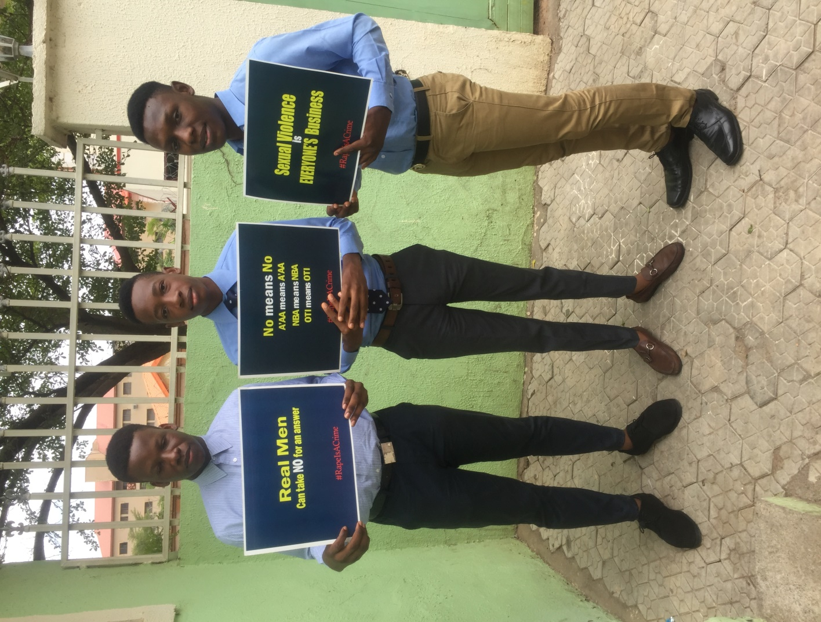
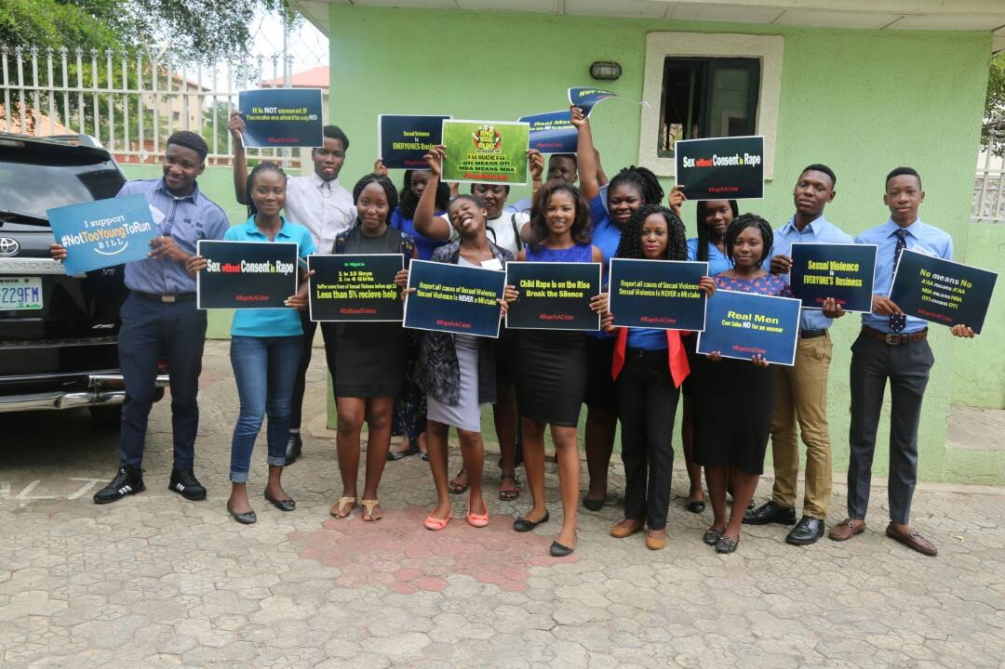
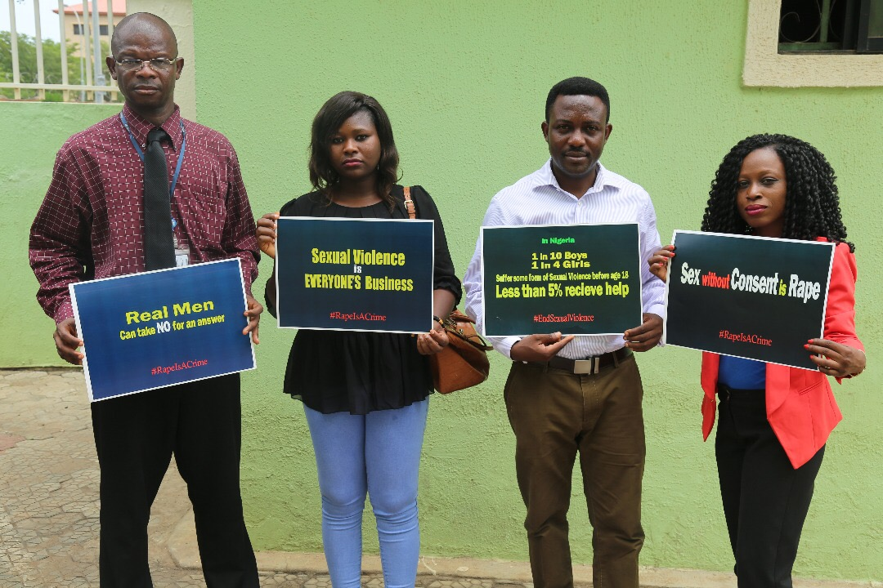
COMMUNITY ENGAGEMENT CONCEPT
1, PROJECT NAME: CHILD RIGHTS
2, PLATFORM: INSTAGRAM@Child_rights_education
3, GOAL: To raise awareness, understanding and acceptance of children's rights standards and principles as outlined in the 1989 United Nations Convention on the Rights of the Child.
To develop a universal culture of children's rights where every child is aware of his or her own rights and responsibilities regarding the respect of the rights of others.
To promote the development of the child as a responsible member of a free, peaceful, pluralistic and inclusive society.
To ensure equal opportunities for all children through access to quality children's rights education, without any discrimination.
To pursue the effective realization of all children's rights as outlined in the 1989 United Nations Convention on the Rights of the Child.
To promote tolerance, non-discrimination and equality.
To protect children's rights and fundamental freedoms.
To contribute to the prevention of children's rights violations and abuses. Like rape, trafficking etc
To combat and eradicate all forms of discrimination, racism, stereotyping and incitement to hatred, and the harmful attitudes and prejudices that underlie them.

4,TARGET AUDIENCE : Human Rights organisations,Individuals who trample on child rights, and everyone

5) Expected outcome: TO make the society a better and peaceful place free from abuse against children in the society.

6) DATE OF ESTABLISHMENT: 18th November 2017
7) NO OF CURRENT MEMBERS OF AUDIENCE: 1560 ,But I am looking forward to getting 5000
8) SOURCES OF INFORMATION TO SHARE OR BROADCAST
Aj news
Save the children
National Human Rights Commission Articles
Myself
UN Articles

