AFE BABALOLA UNIVERSITY
ADO-EKITI, EKITI STATE
A REPORT ON THE FIELD TRIP TO ADUJA
PRESENTED BY
SOETAN OLAMIPO ADETOSIN- 16/SMS10/018
TO
THE DEPARTMENT OF PEACE AND CONFLICT STUDIES

INTRODUCTION
100 and 200 level Students of Afe Babalola University, Ado-ekiti, Ekiti state, Peace and Conflict department went on a field trip to Abuja. We visited various organization relating to our field of study such as national human right commission, global right, institute for peace and conflict resolution and finally Red Cross.
The purpose of this field trip was to enlighten us on the importance’s of our field of study i.e. peace and conflict studies and create awareness in us on the different job opportunities we have in this department. The purpose of this was to boost our interest in the department.
The field trip experience started on the 2nd of May and end on the 5th of May, it was a memorable and impactful experience.
2nd may (day one)
We stayed in 3js hotel, in utako, boy and girls stayed in separate rooms, we were two each in a room. Images of the hotel room we stayed in;
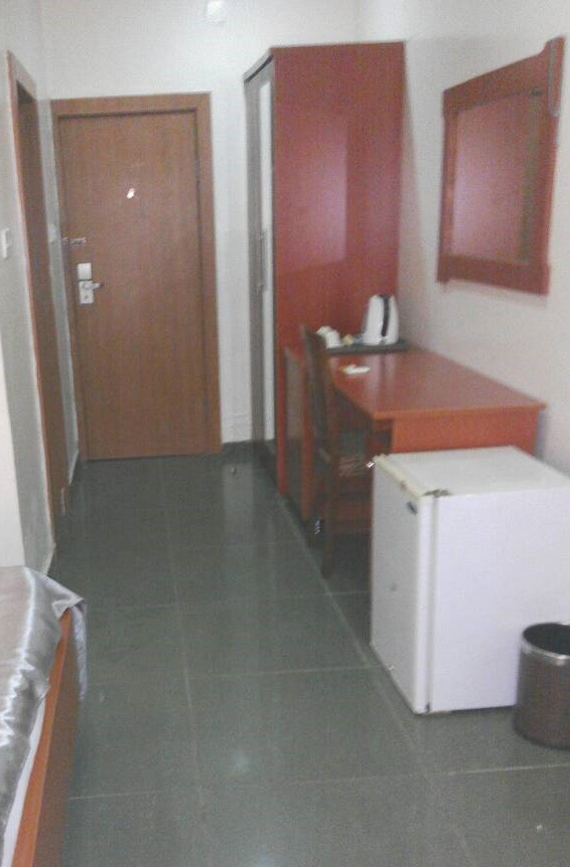
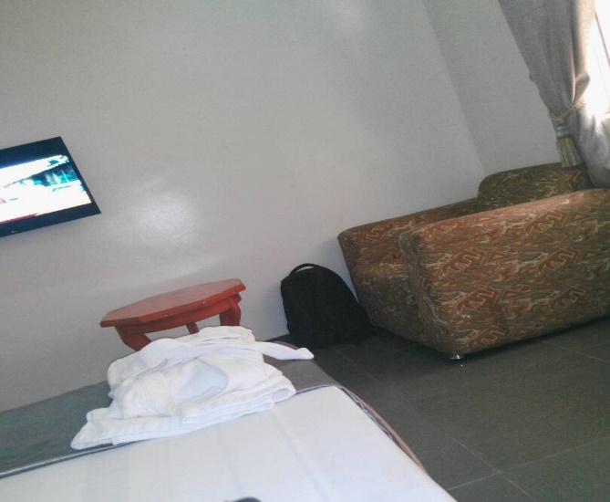
3rd may (day two)
We visited the NATIOAL HUMAN RIGHT COMMISSION
The National Human Rights Commission (NHRC) was established in 1995. They have branches in 23 states of Nigeria including Ekiti State. Members of the board include the following;
Mrs Nwakamma; Head of Human Rights education
Mr. Saka Azimazi; Assistant Director Human Rights education and Chief Legal Rights.
Uche Okoli; Education Department.
Mr Saka Azimazi spoke on the education of human rights he further said that it is divided into two PROJECTION and PROTECTION. Which involves teachings and education. Human Rights each day expands, it has expanded technically and even normatively. He also spoke about conflict transformation and conflict resolution. He placed emphasis on how a good conflict manager should be able to view from both sides, most especially the angle that will prevent the loss of lives and properties.
HUMAN RIGHTS DEPARTMENT OF CONFLICT RESOLUTION.
Conflict cannot be prevented, but it can be managed from escalating. NHRC conducts mediation at every level e.g.; level of resource issue. One of the major causes of conflict in Nigeria, is the problem of resource allocation. Lack of communication is sometimes a major fuel of conflict. At NHRC they peace school.
CAREER PROSPECTS by BARRISTER GOGO promote interface. Another aspect of the NHRC is the voluntary: A PCS student can work in any organization as a mediator, and even under the department of protection and investigation.
DEVELOPMENT GOALS: To achieve the comfort of the disputants, set goals that have a better view of the complexity of the situation.
NEGOTIATING TECHNIQUES: Introduction of complaints, avoidance of expansion of conflict, give and receive feedbacks, negotiation, being very tolerant, give and receive feedbacks.
There are two types of people that are involved in conflict situation: PASSIVE and AGGRESSIVE: When you know these types of people, you need to work with their personalities. Identify the needs of the parties in conflict.
MONITORING DEPARTMENT
This department is headed by Arinze Okoro, it was established in 1995. This refers to the activities of observing, collecting, cataloguing and preserving of data to address human rights problems. Human Rights play major roles in resolving conflicts worldwide.
When data is collected, it is used to prevent and improve human rights conditions in the country. They use some standards set by the UN to carry out their activities or works.
NHRC has two major functions; 1) under take research in tropical human rights issues, collection and analysation of conflict situations, gather info as to why women and infants die.
2) Training. They train their staff, both in-house and outsiders. They train the armed forces to be human rights friendly. They are responsible for publications of reports. They are expected to produce a report at the end of the year known as “human rights annual report”.
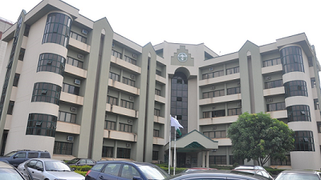
This is a picture of the human right headquarters in Abuja.
These are some of the picture we took there with their staffs.
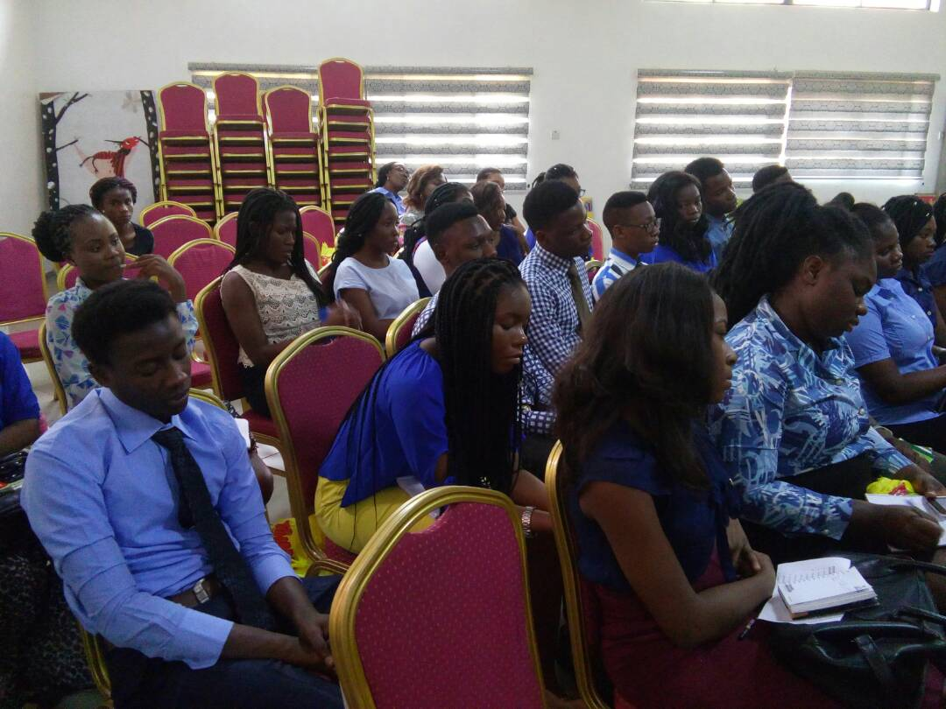

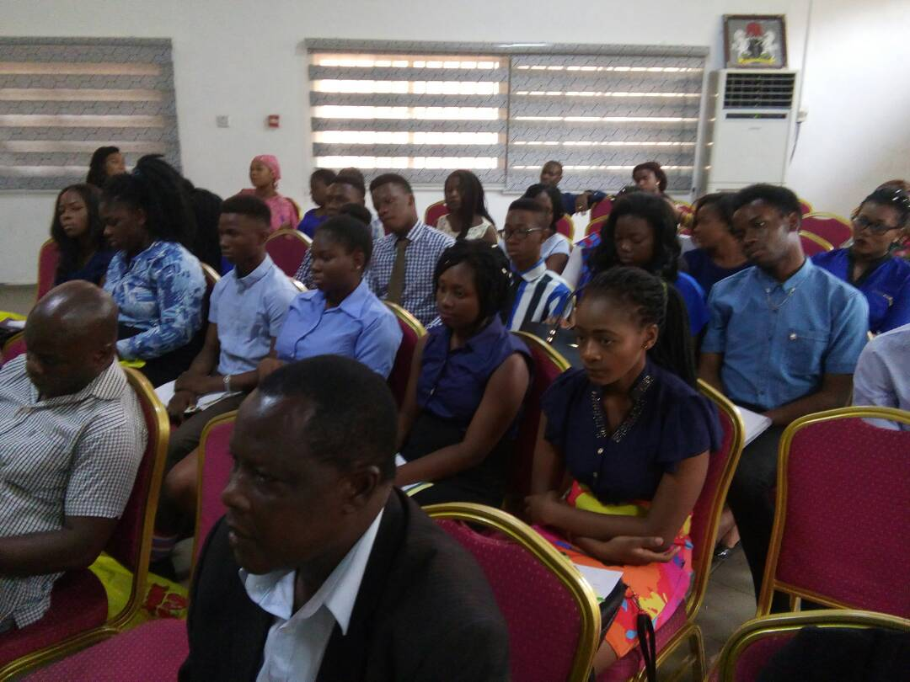
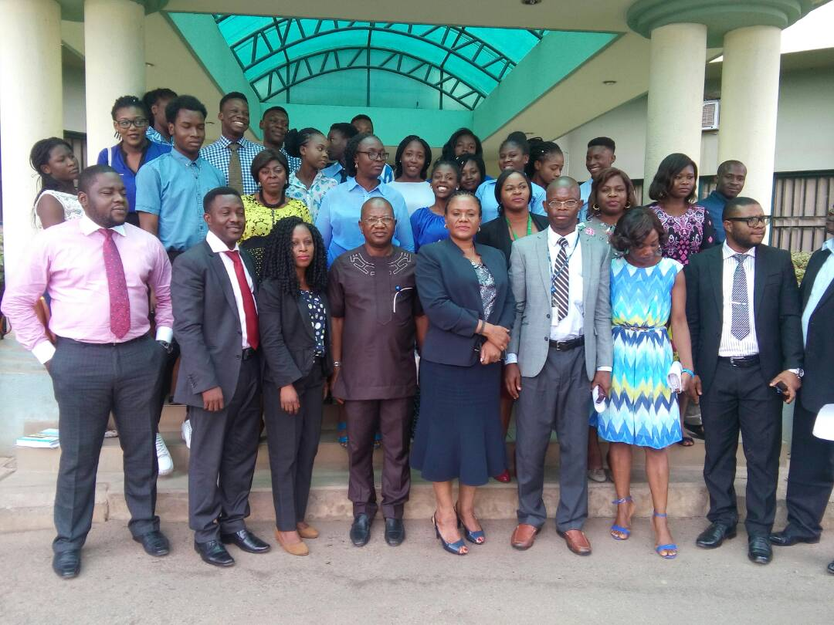
GLOBAL RIGHTS
Global Rights is an exceptional human rights capacity building organization that works side by side local activists to advance justice. We visited global right the same day after we left the humans right commission. We met different people that spoke to us on what the global right is about. We were asked to introduce ourselves one after the other by one of the staffs working there. We were enlighten on how we could use the mass media do promote peace and do different activities. We learnt different things for example how to look at conflict in a whole new perceptive and how we all have different world views which attend to affect how we do thing in our own different way , even if we are given the same instruction . At the end we were given refreshment also. We snapped pictures with some papers that had printed captions. Some were on women and child abuse, rape, sexual violence, and so on. We also participated in different games /activities, one of which is showed below.
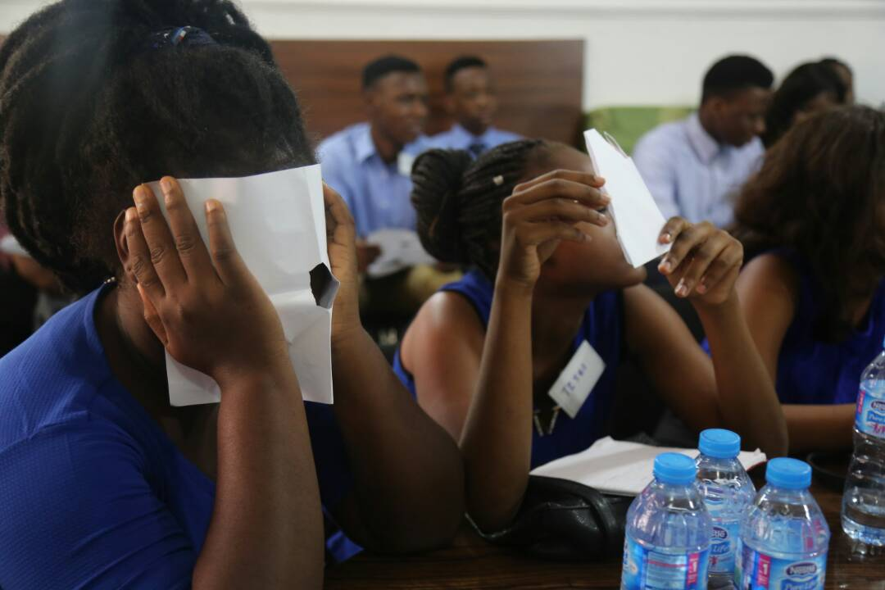

INSTITUTE FOR PEACE AND CONFLICT RESOLUTION
The Institute for Peace and Conflict Resolution (IPCR) was established in February, 2000. The Institute is under the Ministry of Foreign Affairs and is primarily a research Centre, a think-tank and an agency to strengthen Nigeria’s capacity for the promotion of peace and conflict prevention, management and resolution.
We arrived at the organization later than we programmed for. The officials in the organization expressed their displeasure. They were annoyed and we ended up having the program in a haste. The said that they have internship programs there, after attending the internship, you will be given a certificate. Base on their explanations, anybody interested can participate in the internship not necessarily peace and conflict students. On the other hand, peace and conflict student have higher advantage. We asked questions and answers we given. We also went to their library. There, we were given peace and conflict related books. We didn’t really enjoy ourselves because we were tired and exhausted at that point. These are some of the members of management;
Director General, Prof. Shita. O. Shita.
Leader of Delegation: Dr. Badmus Isika
FUNCTIONS of the IPCR by (Andy Nkeneme)
- It is a research institute established in 200 February.
- Promoting peace and security in Nigeria.
- Getting involved in the task of mediation, conflict management and resolution.
- Promotion of peace in Nigeria and within Africa.
- Varying out other relevant activities that may be assigned to the organization.
IPCR (Institute for Peace and Conflict Resolution)
This is a government parastatal. The technical support unit; library. Focus; is research publications.2) policy 3) capacity building 4) intervention.
Major achievement is National Peace Committee led by former military head Gen. Abdul salami. They also touch conflict affected areas.
- Reintegration of IDPs into their communities.
- Support to counter terrorism center and Establishing state peace and management organizations.
- Conflict intervention.
- Community mediation and Reconciliation initiative.

IPCR: 1st federal organization under Est. Act 75(May 2005), FGN Official Gazette No 129nvol.94 of 31st December.
CHALLENGES of IPCR
- Weak governance structures and institutions to enforce peace techniques.
- Lack of implementation of research findings and policies.
- No commitment/ interest in guiding preventive peace initiatives by local and international organizations.
- Shortage of key experts in peace building and conflict management.
- So many international protocols or practices are not adhered to in Nigeria.
- Lack of funding.
At the end of the day, our parent were allowed to come and visit us.
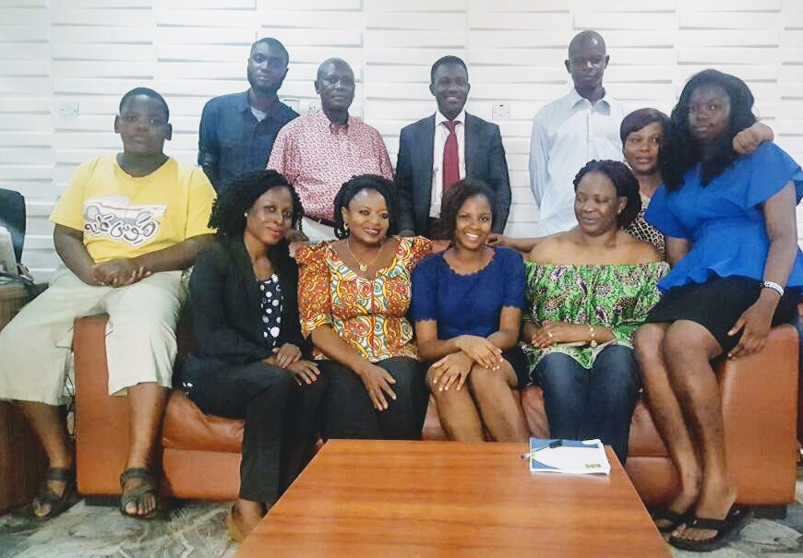

4th may (day three)
THE NIGERIAN RED CROSS SOCIETY.
The International Red Cross is an international humanitarian movement with approximately 97 million volunteers, members and staff worldwide which was founded to protect human life and health, to ensure respect for all human beings, and to prevent and alleviate human suffering.
A BRIEF HISTORY
Until the middle of the 19th century, there were no organized and well-established army nursing systems for casualties and no safe and protected institutions to accommodate and treat those who were wounded on the battlefield. A devout Reformed Christian, the Swiss businessman Jean-Henri Dunant, in June 1859, traveled to Italy to meet French emperor Napoléon III with the intention of discussing difficulties in conducting business in Algeria, at that time occupied by France. When he arrived in the small town of Solferino on the evening of 24 June, he toured the field of the Battle of Solferino, an engagement in the Austro-Sardinian War. In a single day, about 40,000 soldiers on both sides died or were left wounded on the field. Jean-Henri Dunant was shocked by the terrible aftermath of the battle, the suffering of the wounded soldiers, and the near-total lack of medical attendance and basic care. He completely abandoned the original intent of his trip and for several days he devoted himself to helping with the treatment and care for the wounded. He succeeded in organizing an overwhelming level of relief assistance by motivating the local villagers to aid without discrimination.
We went to the Nigerian Red Cross society. The spoke to us about the history of the Red Cross; how the red cross was formed which I gave the brief history above. We were told than the train people that are willing to help. It is a non-profitable organization. At the end of it all, the appreciated us for coming. To took pictures and left. The logo of Red Cross;
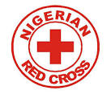
5th May (day four)
On the 5th of May we finally departed to Afe Babalola University Ado-ekiti, Ekiti state but before we commenced the journey fully we stop at Shoprite to pick some few things for ourselves.

