NAME: YELLOWE GOODNESS NWOBIANDU
MATRI NO: 17/SMS02/071
DEPARTMENT: ACCOUNTING
COURSE TITLE: INTRODUCTION TO BUSINESS
COURSE CODE: BUS 206

QUESTION 1a:
What is management by objectives (MBO)?
Management by objectives (MBO) is a management model that aims to improve performance of an organization by clearly defining objectives that are agreed to by both management and employees. According to the theory, having a say in goal setting and action plans should ensure better participation and commitment among employees, as well as alignment of objective across the organization.
A key tenet of management by objectives is the establishment of a management of a management information system to measure actual performance and achievements against the defined objectives. Practitioners claim that the major benefits of MBO are that it improves employee motivation and commitment, and ensures better communication between management and employees. However, an oft-cited weakness is that MBO unduly emphasizes the setting of goals to attain objectives, rather than working on a systematic plan to do so.
Basic principles, Peter Drucker set forth several principles. Objectives are determined with the employees and are challenging but achievable. There is daily feedback, and the focus is on rewards rather than punishment. Personal growth and development are emphasized, rather than negativity for failing to reach the objectives.
Question 1b:
Describe the MBO process
- Define organizational goals
- Define employees objectives
- Continuous monitoring performance and progress
- Performance evaluation
- Providing feedback
- Performance appraisal

- Define Organizational Goals:
Goals are critical issues to organizational effectiveness, and they serve a number of purposes. Organizations can also have several different kinds of goals, all of which must be appropriately managed. And a number of different kinds of managers must be involved in setting goals. The goals set by the superiors are preliminary, based on an analysis and judgment as to what can and what should be accomplished by the organization within a certain period.
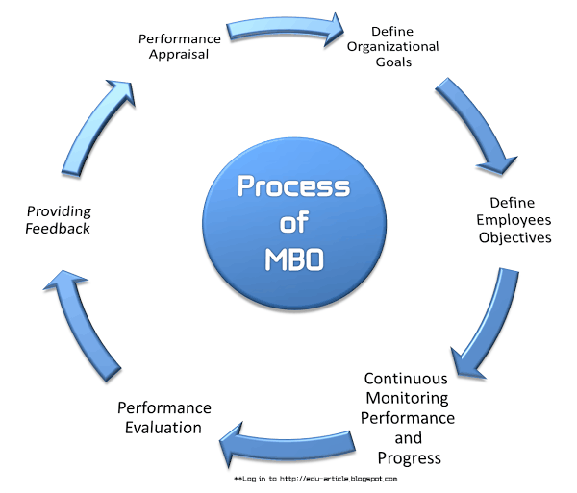
- Define Employees Objectives:
After making sure that employees managers have informed of pertinent general objectives, strategies and planning premises, the manager can then proceed to work with employees in setting their objectives. The manager asks what goals the employees believe they can accomplish in what time period, and with what resources. They will then some preliminary thought about what goals seem feasible for the company or department.
- Continuous Monitoring Performance and progress:
MBO process is not only essential for making line managers in business organizations more effective but also equally important for monitoring the performance and progress of employees.
For monitoring performance and progress the followings are required;
- Identifying ineffective programs by comparing performance with pre-established objectives,
- Using zero-based budgeting,
- Applying MBO concepts for measuring individual and plans
- Installing effective controls.
- Performance Evaluation:
Under this MBO process performance review are made by the participation of the concerned managers.
- Providing Feedback:
The filial ingredients in an MBO program are continuous feedback on performance and goals that allows individuals to monitor and correct their own actions. This continuous feedback is supplemented by periodic formal appraisal meetings which superiors and subordinates can review progress towards goals, which lead to further feedback.
- Performance Appraisal:
Performance appraisals are a regular review of employee performance within organizations. It is done at the last stage of MBO process.

Question 2c:
What is the usefulness of MBO to a business organization?
Management by objectives-MBO is a practice in which the employees take part in goal setting process which enables them to be aligned with organization and in the attainment of their goals. MBO is aimed at increasing organizational performance by setting the goals of managers and subordinates together providing motivation and commitment while ensuring better communication between the superiors and the subordinates.
There are many benefits of management by objectives:-
- Planning is an essential part of management
It enables the organization to design the activities in such a manner that the goals and objectives can be attained effectively while providing the sense of involvement and team spirit among the employees. Thus, MBO, being extremely result oriented, involves making realistic plans and participative decision making which enables to attain the goals and objectives in a way as intended and planned.
- MBO, aiming at effective utilization of human resource seeks to achieve the coordinated structure of activities by integrating the individuals with the organization provides harmony of objective by making every employee more effective that in turn leads to attain the predefined objectives effectively and efficiently.
- The process of MBO leads to greater motivation and commitment.
- MBO facilitates effective control and monitoring the activities of the employees.
- MBO can boost the employee morale greatly. Since the employee play an important role in the setting the goals, this makes sense as to how they can perform better by finding their goals clearer. It also leads them to be more efficient and effective thereby increasing their morale.

Question 2a
Define Decision
The thought process of selecting a logical choice from the available options .
When trying to make a good decision, a person must weight the positives and negatives of each option, and consider all the alternatives. For effective decision making, a person must be able to forecast the outcome of each option as well, and based on all these items, determine which option is the best for that particular situation.

Question 2b
Describe the rational decision-making process in business
Rational decision making is a method for systematically selecting among possible choices that is based on reason and facts. In a rational decision making process, a business manager will often employ a series of analytical steps to review relevant facts, observations and possible outcomes before choosing a particular course of action.
The rational decision making process is a cognitive process is a cognitive process which is made up of a logical step by step process. In this process the emphasis is on thinking things through and also on weighing the outcomes and alternatives before arriving at a final decision.
Fives process of decision making process:
- Identify the decision: To make decision, you must first identify the problem you need to solve or the question you need to answer. Clearly define your decision. If you misidentify the problem to solve, you’ll knock the decision train off the track before it even leaves the station. If you need to achieve a specific goal from your decision, make it measurable and timely so you know for certain that you met the goal at the end of the process.
- Gather relevant information: once you have identified your decision, it’s time to gather the information relevant to that choice. Do an internal assessment, seeing where your organization has succeeded and failed in areas related to your decision. Also, seek information from external sources, including studies, evaluation from paid consultants.
- Identify the alternatives: With relevant information now at your fingertips, identify possible solutions to your problem. There is usually more than one option to consider when trying to meet a goal.
- Weight the evidence: Once you have identified multiple alternatives, weigh the evidence for or against said alternatives. See what company have done in the past to succeed in these areas, and take a good hard look at your own organization’s wins and losses.
- Choose among alternatives: Here is a part of the decision-making process where you, you know, make the decision. You have identified and clarified what decision needs to be made, gathered all relevant information, developed and considered the potential paths to take. You are perfectly prepared to choose.
- Take action: Once you’ve made your decision, act on it. Develop a plan to make your decision tangible and achievable.
- Review your decision: After a predetermined amount of time- which you defined in step one of decision-making process-take an honest look back at your decision. Did you solve the problem? Did you answer the question? Did you meet your goals? If so, that note of what worked for future reference. If not, learn from your mistakes as you begin the decision-making process again.

