NAME: AKEREDOLU ORINAMI

DEPARTMENT : ACCOUNTING

COURSE CODE: BUS206

MATRIC NO: 16/SMS02/009

What is 'Management By Objectives - MBO'
Management by objectives (MBO) is a management model that aims to improve performance of an organization by clearly defining objectives that are agreed to by both management and employees. According to the theory, having a say in goal setting and action plans should ensure better participation and commitment among employees, as well as alignment of objectives across the organization. The term was first outlined by management guru Peter Drucker in 1954 in his book "The Practice of Management."
Top of Form
Bottom of Form

6 Stages of MBO (Management by Objectives) Process
MBO or management by objectives is defined as a comprehensive managerial system that integrates many key managerial activities in a systematic process and that is consciously directed toward the effective and efficient achievement of organizational and individual objectives.
The practical importance of objectives in management can best be seen by summarizing how successful managing by objectives works in practice.
The six steps of MBO process are shown below graphically;
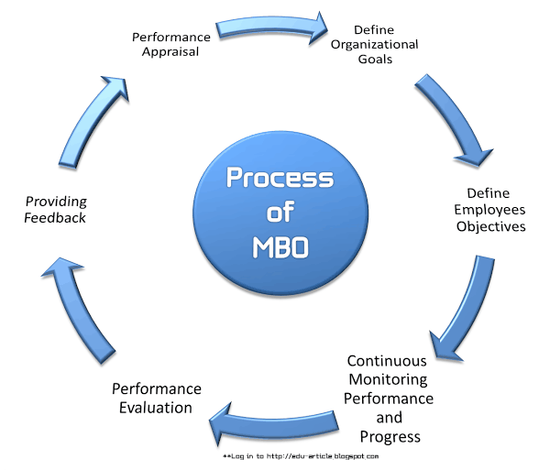

Define organizational goals
Define employees objectives
Continuous monitoring performance and progress
Performance evaluation
Providing feedback
Performance appraisal
Let’s briefly look at each of these;

Define Organizational Goals
Goals are critical issues to organizational effectiveness, and they serve a number of purposes. Organizations can also have several different kinds of goals, all of which must be appropriately managed.
And a number of different kinds of managers must be involved in setting goals. The goals set by the superiors are preliminary, based on an analysis and judgment as to what can and what should be accomplished by the organization within a certain period.

Define Employees Objectives
After making sure that employees’ managers have informed of pertinent general objectives, strategies and planning premises, the manager can then proceed to work with employees in setting their objectives.
The manager asks what goals the employees believe they can accomplish in what time period, and with what resources. They will then discuss some preliminary thoughts about what goals seem feasible for the company or department.
Also, Read Four Common Ingredients that makes up an MBO Program.

Continuous Monitoring Performance and Progress
MBO process is not only essential for making line managers in business organizations more effective but also equally important for monitoring the performance and progress of employees.
For monitoring performance and progress the followings are required;
- Identifying ineffective programs by comparing performance with pre-established objectives,
- Using zero-based budgeting,
- Applying MBO concepts for measuring individual and plans,
- Preparing long and short range objectives and plans,
- Installing effective controls, and
- Designing sound organizational structure with clear, responsibilities and decision-making authority at the appropriate level.

Performance Evaluation
Under this MBO process performance review are made by the participation of the concerned managers.

Providing Feedback
The filial ingredients in an MBO program are continuous feedback on performance and goals that allow individuals to monitor and correct their own actions.
This continuous feedback is supplemented by periodic formal appraisal meetings which superiors and subordinates can review progress toward goals, which lead to further feedback.

Performance Appraisal
Performance appraisals are a regular review of employee performance within organizations. It is done at the last stage of MBO process.
DECISION
A decision is a conscious choice which has been selected among competing alternatives and directed towards a definite purpose. A decision is defined as a conscious choice among alternative courses of action followed by activities to implement the choice.

RATIONAL DECISION MAKING PROCESS
The rational decision making process is a cognitive process which is made up of a logical step by step process. In this process the emphasis is on thinking things through and also on weighing the outcomes and alternatives before arriving at a final decision.
In general there are 5 broad steps in rational decision making process, through different models follow different methodologies.

- First we must identify the situation and the decision that is needed to be made.
- Second all the important criteria must be discussed and identified.
- All possible situations must be carefully considered.
- All possible situations must be considered along with their outcomes to see which best fits the bill.
- The best option is then chosen.
The presumption in the rational decision making process is that there is only ONE BEST solution to every problem and it focuses on trying to find that solution. Sometimes we just need a solution that works versus the best solution at that moment. This model is also based on prediction of outcomes based on different solutions; however our ability to predict the future is often limited and hence skewed.
This process also requires a great deal of time and thought along with information, it also negates the emotional aspect of decision making.
There is also an eight step decision making process which has been outlined below:
Step 1: Identification of the Problem
Step 2: Identification of decision criteria
Step 3: Allocation of weights to criteria
Step 4: Development of Alternatives
Step 5: Analysis of Alternatives
Step 6: Selection of Alternatives
Step 7: Implementation of the Alternatives
Step 8: Evaluation of the Decision Effectiveness
The rational decision making process is highly effective when used in team decision making and also when making decisions regarding important business outcomes. When dealing with any situation where the decision will affect the companies’ future or financials or employee and customer satisfaction, it is best to follow the rational decision making process.
In order to facilitate the rational decision making model there are many forms and templates available both on and offline to help your team make a decision effectively such as Decision matrix, Pugh matrix, decision grid, Selection matrix, and criterion rating form along with many others.

