NAME: JIMOH AYOTOMIWA OLAOLUWA
MATRIC NUMBER: 16/SMS02/033
DEPARTMENT: ACCOUNTING
COURSE CODE: BUS206

ASSIGNMENT
1a. what is Management by Objective (MBO)?
1b. Describe the MBO Process
1c. what is the Usefulness of MBO to a business Organisation?
2a. Define Decision
2b. Describe the Rational Decision-Making Process in Business

1a. Define MBO
MBO stands for Management by objective, is a management model that aims to improve performance of an organization by clearly defining objectives that are agreed to by both management and employees. According to the theory, having a say in goal setting and action plans should ensure better participation and commitment among employees, as well as alignment of objectives across the organization.

1b. Management By Objective Process
The process of MBO involves six key steps that incorporate managerial activities in such a systematic way, which is directly influenced towards efficient and effective achievement individuals and organizational objectives
- Determining Organizational Goals
The entire development of an organization depends on the set goals. A goal is the most critical and necessary factor behind the effectiveness and efficiency of an organization, so it is important to effectively manage set goals either single or many of different kinds. Prior to start working on the set goals, the managers should determine organizational goals with the aim to create a potential management that must be capable of handling different kinds of goals easily. Determining goals don’t mean creating goals, as the preliminary goals are set by the top level supervisors on the basis of in-depth analysis and judgment about what should be accomplished and how to do so in a certain period.

- Determining Employees’ Objectives
After determining the organizational goals, the next thing to do is to know the individual’s goals or more clearly employees’ goals. It is the responsibility of the manager to ask employees about what goals they can accomplish within a specific time period and what resources will they use to achieve the goal. Also, if needed, then managers and employees can classify the goals from the most important to the least one in order to make the goal achieving process more easily and in favor of the organization.
- Constant Monitoring Progress and Performance
The process of MBO is not just set for providing additional effectiveness to managers across the organization, but it is also equally important for constantly monitoring the progress and performance of the employees. There are certain things stated below that can help managers to monitor performance and progress.
- Checking less-effective or ineffective programs by performing a comparison of performance with already prepared objectives.
- Using ZBB (Zero Based Budgeting)
- For measuring plans and individuals, implementing MBO concepts
- Defining short and long term plans and objectives
- Installing efficient and effective controls
- Eventually, composing completely sound structure of the organization with all things at appropriate places such as responsibilities, decision making and so on.
- Performance Evaluation
As per the basic concept of MBO, the performance evaluation comes under the responsibility of concerned managers and is made by their participation. Keep in the mind, performance evaluation is one the most important factors of the organization that can help operating certain objectives smoothly.
- Providing Feedback
The psychologically influential factor of MBO is constantly providing feedback to employees regarding their performance and individual goals, so that they can monitor, correct and extra improve their skills and mistakes. Mostly, the feedback is provided in periodic meetings where supervisors and their subordinates review the performance and progress towards achievement of goals. At one point, feedback helps individuals know their weakness. While on the other hand, it also motivates already potential individuals to enhance and develop their performance additionally.
- The Performance Appraisal
Performance appraisals are the final step of the process of Management by Objectives. By definition, a day by day review of the employee’s performance across the organization can be called as performance appraisal. Performance appraisal is associated with the term performance evaluation, but in some cases, both differ from each other.

1c. what is the Usefulness of MBO to a business Organisation?

Accurate Appraisals:
MBO replaces trait based appraisal by performance based appraisal. Quantitative targets for every individual enable him to evaluate his own performance. Performance under MBO is innovative and future oriented.

Motivation and Commitment:
Participation of subordinates in goal setting and performance reviews tend to improve their commitment to performance.

Organizational change and Development:
MBO provides a frame work for planned changes. It enables managers to initiate and manage change.

Improved Planning:
MBO involves participative decision-making which makes objectives explicit and plans more realistic. It focuses attention on goals in key result areas. MBO forces managers to think in terms of results rather than activities. It encourages people to set specific pleasurable goals instead of depending on hunches or guesswork.

Coordination:
MBO helps to clarify the structure and goals of the organization. Harmony of objectives enables individuals at various levels to have a common direction.

Executive Development:
The MBO strategy is a kind of self-discipline whereby shortcomings and development needs are easily identified. It stresses upon a long term perspective and self-development. MBO releases potential by providing opportunities for learning, innovation and creativity.

2a. Definition of Decision
Decision can be defined as a thought process of selecting a logical choice from the available options. When trying to make a good decision, a person must weight the positives and negatives of each option, and consider all the alternatives. For effective decision making, a person must be able to forecast the outcome of each option as well, and based on all these items, determine which option is the best for that particular situation.

2b. The Process of Rational Decision Making
Rational decision making is a multi-step process for making choices between alternatives. The process of rational decision making favours logic, objectivity, and analysis over subjectivity and insight. The word “rational” in this context does not mean sane or clear-headed as it does in the colloquial sense.
The approach follows a sequential and formal path of activities. This path includes:
- Formulating a goal(s)
- Identifying the criteria for making the decision
- Identifying alternatives
- Performing analysis
- Making a final decision.

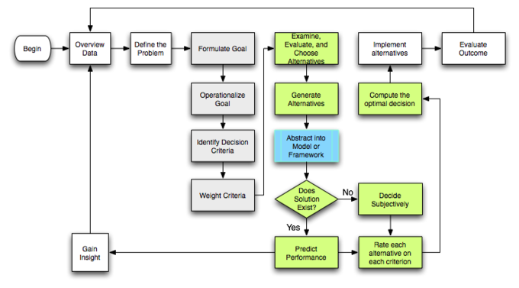
Rational-decision-making model: This flowchart illustrates the process of rational decision making.

