NAME Adelegbe Bolanle Mercy
MATRIC NUMBER 16/sms02/004
DEPARTMENT ACCOUNTING
COURSE CODE BUS206
COURSE TITLE INTRODUCTION TO BUSINESS
- WHAT IS MANAGEMENT BY OBJECTIVES (MBO)
Management by objectives (MBO), also known as management by results (MBR) is the process of defining specific objectives within an organization that management can convey to organization members, then deciding on how to achieve each objective in sequence. This process allows managers to take work that needs to be done one step at a time to allow for a calm, yet productive work environment. This process also helps organization members to see their accomplishments as they achieve each objective, which reinforces a positive work environment and a sense of achievement. An important part of MBO is the measurement and comparison of an employee's actual performance with the standards set. Ideally, when employees themselves have been involved with the goal-setting and choosing the course of action to be followed by them, they are more likely to fulfill their responsibilities. In addition, following criticism of the original MBO approach, a new formula was introduced in 2016, aiming at revitalizing it, that is the OPTIMAL MBO, which stands for its components, namely: (O) Objectives, Outside-in; (P) Profitability (budget) related goals; (T) Target Setting; (I) Incentives & Influence; (M) Measurement; (A) Agreement, Accountability, Appraisal, Appreciation; and (L) Leadership Support.
Management by objectives at its core is the process of employers/supervisors attempting to manage their subordinates by introducing a set of specific goals that both the employee and the company strive to achieve in the near future, and working to meet those goals accordingly.
PROCESS OR STEPS:
- Review organizational goal
- Set worker objective
- Monitor progress
- Evaluation
- Give reward

- DESCRIBE THE MBO PROCESS
The six steps of MBO process are shown below graphically;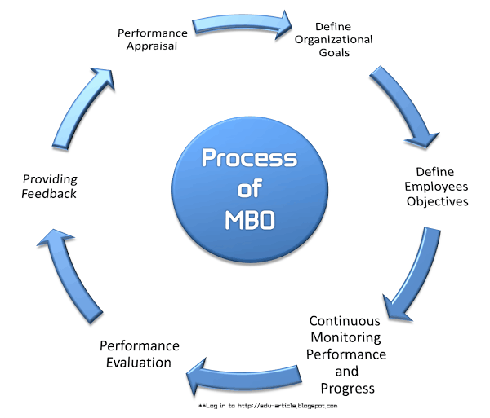
- Define organizational goals
- Define employees objectives
- Continuous monitoring performance and progress
- Performance evaluation
- Providing feedback
- Performance appraisal

Define Organizational Goals
Goals are critical issues to organizational effectiveness, and they serve a number of purposes. Organizations can also have several different kinds of goals, all of which must be appropriately managed. And a number of different kinds of managers must be involved in setting goals. The goals set by the superiors are preliminary, based on an analysis and judgment as to what can and what should be accomplished by the organization within a certain period.

Define Employees Objectives
After making sure that employees’ managers have informed of pertinent general objectives, strategies and planning premises, the manager can then proceed to work with employees in setting their objectives.
The manager asks what goals the employees believe they can accomplish in what time period, and with what resources. They will then discuss some preliminary thoughts about what goals seem feasible for the company or department.

Continuous Monitoring Performance and Progress
MBO process is not only essential for making line managers in business organizations more effective but also equally important for monitoring the performance and progress of employees.
For monitoring performance and progress the followings are required;
    - Identifying ineffective programs by comparing performance with pre-established objectives,
    - Using zero-based budgeting,
    - Applying MBO concepts for measuring individual and plans,
    - Preparing long and short range objectives and plans,
    - Installing effective controls, and
    - Designing sound organizational structure with clear, responsibilities and decision-making authority at the appropriate level.

Performance Evaluation
Under this MBO process performance review are made by the participation of the concerned managers.

Providing Feedback
The filial ingredients in an MBO program are continuous feedback on performance and goals that allow individuals to monitor and correct their own actions.
This continuous feedback is supplemented by periodic formal appraisal meetings which superiors and subordinates can review progress toward goals, which lead to further feedback.

Performance Appraisal
Performance appraisals are a regular review of employee performance within organizations. It is done at the last stage of MBO process.
- WHAT IS THE USEFULNESS OF MBO IN BUSINESS ORGANISATION
ADVANTAGE AND BENEFITS OF MBO
- Motivation – Involving employees in the whole process of goal setting and increasing employee empowerment. This increases employee job satisfaction and commitment.
- Better communication and coordination – Frequent reviews and interactions between superiors and subordinates help to maintain harmonious relationships within the organization and also to solve problems.
- Clarity of goals.
- Subordinates tend to have a higher commitment to objectives they set for themselves than those imposed on them by another person.
- Managers can ensure that objectives of the subordinates are linked to the organization's objectives.
- Common goal for whole organization means it is a unifying, directive principle of management.
- Effective Control and Appraisal
- Personal Commitment
- Better Management
- Organizational Change and Development

  - DEFINE DECISION Decision can be defined as the act or process of deciding, it can also be defined as a choice made between alternative courses of action in a situation of uncertainty. It is a conclusion or resolution reached after consideration the action or process of deciding something or of resolving a question. Decision can be a conclusion or judgment reached after consideration, it is the act of reaching a conclusion or of passing of judgment on an issue under consideration

- DESCRIBE THE RATIONAL DECISION MAKING PROCESS IN BUSINESS
The rational decision making process is a cognitive process which is made up of a logical step by step process. In this process the emphasis is on thinking things through and also on weighing the outcomes and alternatives before arriving at a final decision. In general there are 5 broad steps in rational decision making process, through different models follow different methodologies.
- First we must identify the situation and the decision that is needed to be made.
- Second all the important criteria must be discussed and identified.
- All possible situations must be carefully considered.
- All possible situations must be considered along with their outcomes to see which best fits the bill.
- The best option is then chosen.
The presumption in the rational decision making process is that there is only ONE BEST solution to every problem and it focuses on trying to find that solution. Sometimes we just need a solution that works versus the best solution at that moment. This model is also based on prediction of outcomes based on different solutions; however our ability to predict the future is often limited and hence skewed. This process also requires a great deal of time and thought along with information, it also negates the emotional aspect of decision making.
There is also an eight step decision making process which has been outlined below:
Step 1: Identification of the Problem
Step 2: Identification of decision criteria
Step 3: Allocation of weights to criteria
Step 4: Development of Alternatives
Step 5: Analysis of Alternatives
Step 6: Selection of Alternatives
Step 7: Implementation of the Alternatives
Step 8: Evaluation of the Decision Effectiveness
The rational decision making process is highly effective when used in team decision making and also when making decisions regarding important business outcomes. When dealing with any situation where the decision will affect the companies’ future or financials or employee and customer satisfaction, it is best to follow the rational decision making process.
In order to facilitate the rational decision making model there are many forms and templates available both on and offline to help your team make a decision effectively such as Decision matrix, Pugh matrix, decision grid, Selection matrix, and criterion rating form along with many others, nominal group technique, fishbone diagram etc.
When selection a model and a form it is best to select on that appeals to your style and level of comfort with this leadership tool.

