Adeoluwaseye Adeniyi
BUS 206 - Business Organisation Theory & Practice
17/SMS03/020
Business Administration
1a. What is Management by Objective (MBO)?
Management by objective can be defined as a management system in which the objectives of a business are agreed upon so that management and employees understand a common way forward.
Management by objectives aims to serve as a basis for
- Greater efficiency through systematic procedures.
- Greater employee motivationand commitment through participation in the planning process.
- Planning for results instead of planning just for work. In management by objectives practice, specific objectives are determined jointly by managers and their subordinates, progress toward agreed-upon objectives is periodically reviewed, end results are evaluated, and rewards are allocated on the basis of the progress.
The objectives must meet this criteria:
(1) arranged in order of their importance,
(2) expressed quantitatively, wherever possible,
(3) realistic,
(4) consistent with the organisation's policies, and
(5) compatible with one another.
Suggested by the management guru Peter Drucker (1909-2005) in early 1950s, management by objectives enjoyed huge popularity for some time but soon fell out of favor due to its rigidity and administrative burden. Its emphasis on setting clear goals, however, has been vindicated and remains valid.

1b. Describe the MBO Process
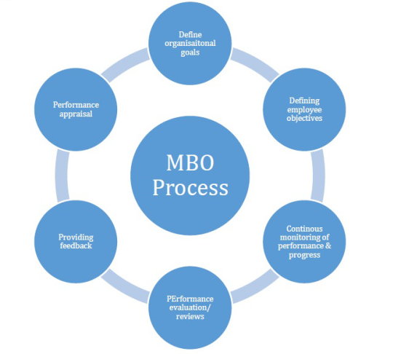
The process of management by objective involves six key steps that integrate managerial activities in such a systematic way, which is directly influenced towards efficient and effective achievement individuals and organisational objectives. The six steps involved in the process of MBO are:
1. Determining Organisational Goals
The entire development of an organisation depends on the set goals. A goal is the most critical and necessary factor behind the effectiveness and efficiency of an organisation, so it is important to effectively manage set goals either single or many of different kinds.
2. Determining Employees’ Objectives
After determining the organisational goals, the next thing to do is to know the individual’s goals or more clearly employees’ goals. It is the responsibility of the manager to ask employees about what goals they can accomplish within a specific time period and what resources will they use to achieve the goal.
3. Constant Monitoring Progress and Performance
The process of MBO is not just set for providing additional effectiveness to managers across the organisation, but it is also equally important for constantly monitoring the progress and performance of the employees.

4. Performance Evaluation
As per the basic concept of MBO, the performance evaluation comes under the responsibility of concerned managers and is made by their participation.
5. Providing Feedback
The psychologically influential factor of MBO is constantly providing feedback to employees regarding their performance and individual goals, so that they can monitor, correct and extra improve their skills and mistakes.
6. The Performance Appraisal
Performance appraisals are the final step of the process of Management by Objectives. By definition, a day by day review of the employee’s performance across the organisation can be called as performance appraisal.
1c. What is the Usefulness of MBO to a business Organisation?
Improved Planning:
MBO involves participative decision-making which makes objectives explicit and plans more realistic. It focuses attention on goals in key result areas.
Coordination:
MBO helps to clarify the structure and goals of the organisation. Harmony of objectives enables individuals at various levels to have a common direction
Organisational change and Development:
MBO provides a frame work for planned changes. It enables managers to initiate and manage change. It helps to identify short-comings in organisational structure and processes. In this way, MBO improves the capacity of the organisation to cope with its changing environment. When an organisation is managed by objectives, it becomes performance-oriented and socially-useful.
Accurate Appraisals:
MBO replaces trait based appraisal by performance based appraisal. Quantitative targets for every individual enables them to evaluate his/her own performance. Performance under MBO is innovative and future oriented. It is positive, more objective and participative. Emphasis is on job requirements rather than on personality.
Motivation and Commitment:
Improved communication and sense of involvement provides psychological satisfaction and stimulates them for hard work Conversion of organisational goals into personal goals helps to integrate the individual with the organisation. MBO ensures performance by converting objective needs into personal goals and by providing freedom to subordinates.

2a. Define Decision
A decision can be defined as a course of action purposely chosen from a bunch of alternatives to achieve organisational or managerial objectives or goals. Decision making process is continuous and indispensable component of managing any organisation or business activities.
2b. Describe the Rational Decision-Making Process in Business
This is a method for systematically selecting among possible choices that is based on reason and facts. In a rational decision making process, a business manager will often employ a series of analytical steps to review relevant facts, observations and possible outcomes before choosing a particular course of action.

