A TERM PAPER ON
OIL FIELD DEVELOPMENT PLANNING
PRESENTED BY
GROUP A
SAMBO AMINA CHAT 13/ENG07/019
MAGAJI MAXENDEH 13/ENG07/014
ODJUGO TEGA BERNARD 13/ENG07/015
OGADI HILLARY EMEKA 14/ENG07/033
AMIETUBODIE OTONYE 14/ENG07/035
AJAYI AYOMIDE 13/ENG07/002
PTE 514(PETROLEUM ECONOMICS)
SUBMITTED TO
THE DEPARTMENT OF CHEMICAL & PETROLEUM ENGINEERING
(PETROLEUM ENGINEERING)
COLLEGE OF ENGINEERING
AFE BABALOLA UNIVERSITY, ADO EKITI. EKITI STATE. NIGERIA.
26TH MARCH, 2018

ABSTRACT

This paper discusses general guidelines to determine the feasibility of petroleum projects in terms of field appraisal, subsurface development planning, and facilities options.

TABLE OF CONTENT
Contents
ABSTRACT 2
TABLE OF CONTENT 3
CHAPTER 1 4
INTRODUCTION 4
CHAPTER 2 5
2.1 EXPLORATION AND EVALUATION 5
2.2 FIELD DEVELOPMENT 6
2.3 PRODUCTION 8
2.4 FIELD ABANDONEMENT 9
CHAPTER 3 10
3 CASE STUDY USING OFFSHORE DEVELOPMENT 10
3.1 DEVELOPMENT PLANNING PROCESS 11
3.1.1 SUBSURFACE DEVELOPMENT PLAN 17
CONCLUSION 20
REFERENCES 21

List of Tables
Table 1 Feasibility and design studies for offshore petrleum projects 12
Table 2 Cost Estimates 15

List of Figures
Figure 1 steps in oil and gas field planning and development process…………………………………………………….4
Figure 2 Feasibility study: data flow and organisation 13
Figure 3 Budget Sheduleand Control 15
Figure 4 NPV per barrel of an FPSO project 17

CHAPTER 1

1.1 INTRODUCTION
The life of every oil and gas field begins with its discovery. Almost immediately, we want to know what its potential is (in terms of reserves and monetary value) and what the development options are in terms of subsurface plan and facilities. To answer these questions, a systematic approach is required to evaluate the discovery, to forecast the reservoir behavior under expected producing conditions, and to design the optimum facilities to meet forecasted production. Upon the discovery of hydrocarbons in a reservoir, basic procedures are carried out before the production of the hydrocarbons.
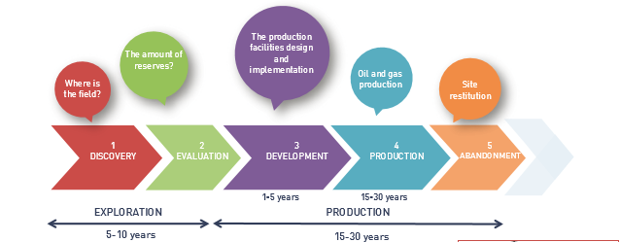
Fig 1 steps in oil and gas field planning and development process
A petroleum development project typically is divided into a number of major phases:
- Exploration and evaluation (including permit acquisition)
- Field appraisal (primary and possibly secondary)
- Feasibility study, project implementation (construction)
- Field production (operation and maintenance, management, and facilities upgrades, including secondary development phases).
- Site abandonment

CHAPTER 2

EXPLORATION AND EVALUATION
Exploration involves the search for rock formations associated with oil or natural gas deposits and involves geophysical prospecting and exploratory drilling. The search for oil and gas requires a knowledge of geography, geophysics and geology. Crude oil is usually found in certain types of geological structures, such as anticlines, salt domes and fault traps which lie under carious terrains and in a wide range of climates.
There are different types of geophysical surveys which are carried out after an area of interest has been selected and measurements are performed in order to obtain a precise evaluation of the subsurface formation and they include:
- Seismic surveys: seismic studies provide information on the general characteristics of the subsurface structure. Measurements are obtained from shock waves generated by setting off explosive charges in small-diameter holes, from the use of vibrating or percussion devices on both land and in water, and from underwater blasts of compressed air. The elapsed time between the beginning of the shock wave and the return of the echo is used to determine the depth of the reflecting substrata. The recent use of super-computers to generate three-dimensional images greatly improves evaluation of seismic test results.
- Aerial photogrammetric surveys: photographs taken with special cameras in airplanes, provide three-dimensional views of the earth which are used to determine land formations with potential oil and gas deposits.
- Magnetometric surveys: magnetometers hung from airplanes measure variations in the earth’s magnetic field in order to locate sedimentary rock formations which generally have low magnetic properties when compared to other rocks.
- Gravimetric surveys: because large masses of dense rock increase the pull of gravity, gravimeters are used to provide information regarding underlying formations by measuring minute differences in gravity.
- Radiographic surveys: radiography is the use of radio waves to provide information similar to that obtained from seismic surveys.
When the surveys and measurements indicate the presence of formations or strata which may contain petroleum, exploratory wells are drilled to determine whether or not oil or gas is actually present and if so whether it is available and obtained in commercially viable quantities.
Exploratory wells which are drilled in areas where neither oil nor gas has been previously found are called wildcats whereas those wells strike oil or gas are referred to as discovery wells. Other exploratory wells known as appraisal wells are drilled to determine the limits of a field following discovery, or to search for new oil- and gas-bearing formations next to, or beneath those already known to contain product. A well which does not find any oil or gas or finds it too little to produce economically is called a dry hole.
Once discovery has been confirmed, 3D numerical reservoir simulation models are built:
- To estimate the initial volume of oil and gas in the reservoir,
- To simulate the reservoir fluid flow behavior and optimize the field development scenario (number, type and location of wells, level of field production, etc.).
Appraisal wells are drilled to improve the field description through further data acquisition.
An economic assessment is performed taking into account revenue according to production forecasts and the estimated development costs. If the required economic criteria are met, the field is developed and then produced.

FIELD DEVELOPMENT
Extensive field development is required to bring a new oil or gas field into production. The field access may be limited or constrained by both climatic and geographic conditions. The requirements include transportation; construction; maintenance, housing and administrative facilities; oil, gas and water separation equipment; crude oil and natural gas transport; water and waste disposal facilities; and many other services, facilities and kinds of equipment.
A field development plan establishes the following:
- The number of wells to be drilled to reach production objectives
- The recovery techniques to be used to extract the fluids within the reservoir
- The type and cost of installations, such as platforms, depending on the marine environment (tides, storms, waves, winds, corrosion)
- The separation systems for gas and fluids
- The treatment systems needed to preserve the environment.
Field development involves the construction of one or more wells from the beginning to either abandonment if no hydrocarbons are found, or to well completion if hydrocarbons are found in sufficient quantities.
A development well is drilled to produce gas and oil. The number of development wells to be drilled is determined by the expected definition of the new field, both in size and in productivity. Because of the uncertainty as to how reservoirs are shaped or confined, some developmental wells may turn out to be dry holes. Occasionally, drilling and producing occurs simultaneously.
Most of these are not readily available at the site and must be provided by either the drilling or producing company or by outside contractors.
Contractor activities
Contractors are typically used by oil and gas exploration and producing companies to provide some or all of the following supporting services required to drill and develop producing fields:
- Site preparation - bush clearing, road construction, ramps and walkways, bridges, aircraft landing areas, marine harbor, wharfs, docks and landings
- Erection and installation - drilling equipment, power and utilities, tanks and pipeline, housing, maintenance buildings, garages, hangers, service and administration buildings
- Underwater work - installation, inspection, repair and maintenance of underwater equipment and structures
- Maintenance and repair - drilling and production equipment preventive maintenance, vehicles and boats, machinery and buildings
- Contract services - food service; housekeeping; facility and perimeter protection and security; janitorial, recreation and support activity; warehousing and distribution of protective equipment, spare parts and disposable supplies
- Engineering and technical - testing and analyses, computer services, inspections, laboratories, non-destructive analysis, explosives storage and handling, fire protection, permits, environmental, medical and health, industrial hygiene and safety and spill response
- Outside services - telephone, radio and television, sewerage and garbage
- Transportation and material handling equipment - aircraft and helicopter, marine services, heavy-duty construction and materials handling equipment.

PRODUCTION
This is the process of extracting the hydrocarbons and separating the mixture of liquid hydrocarbons and separating the mixture of liquid hydrocarbons, gas, water and solids, removing the constituents that are non-saleable, and selling the liquid hydrocarbons and gas. Production sites often handle crude oil from more than one well. Oil is nearly always processed at a refinery; natural gas may be processed to remove impurities either in the field or at a natural gas processing plant.
The time period over which hydrocarbons may be extracted varies between 15 to 30 years and may be extended up to 50 years or more for giant fields.
The lifetime of a reservoir is composed of different successive phases:
- A period of production increase.
- A stabilization phase or plateau.
- Injection phases (water, gas or chemical products) to assist the hydrocarbon recovery and thus maintain a satisfactory volume of produced resources.
- The depletion period when hydrocarbon production declines progressively.
There are various types of wells used during production some of which include;
Developmental wells: After a discovery, the area of the reservoir is roughly determined with a series of step-out or appraisal wells. Developmental wells are then drilled to produce gas and oil. The number of developmental wells to be drilled is determined by the expected definition of the new field, both in size and in productivity. Because of the uncertainty as to how reservoirs are shaped or confined, some developmental wells may turn out to be dry holes. Occasionally, drilling and producing occurs simultaneously.
Geopressure/geothermal wells: Geopressure/geothermal wells are those which produce extremely high-pressure (7,000 psi) and high-temperature (149 °C) water which may contain hydrocarbons. The water becomes a rapidly expanding cloud of hot steam and vapours upon release to the atmosphere from a leak or rupture.
Stripper wells: Stripper wells are those which produce less than ten barrels of oil a day from a reservoir.
Multiple completion wells: When multiple producing formations are discovered when drilling a single well, a separate string of pipe may be run into a single well for each individual formation. Oil and gas from each formation is directed into its respective piping and isolated from one another by packers, which seal the annular spaces between the piping string and the casing. These wells are known as multiple completion wells.
Injection wells: Injection wells pump air, water, gas or chemicals into reservoirs of producing fields, either to maintain pressure or move oil toward producing wells by hydraulic force or increased pressure.
Service wells: Service wells include those used for fishing and wire-line operations, packer/plug placement or removal and reworking. Service wells are also drilled for underground disposal of salt water, which is separated from crude oil and gas
Producing oil is basically a matter of displacement by either water or gas. At the time of initial drilling, almost all crude oil is under pressure. This natural pressure decreases as oil and gas is removed from the reservoir, during the three phases of a reservoir’s life.

FIELD ABANDONEMENT
When the hydrocarbon production rate becomes non economical, the reservoir is abandoned. Before abandoning the field, the oil companies:
- dismantle facilities such as platforms
- put the well in a safe state
- preserve the field’s residual hydrocarbon reserves of the field
- Clean, depollute and rehabilitate the site.

CHAPTER 3

CASE STUDY USING OFFSHORE DEVELOPMENT
While the development sequence is similar for all fields, there are notable differences between onshore and offshore projects. Most significantly, the engineering requirements and capital expenditure tend to be one or two orders of magnitude greater for offshore projects than onshore developments. Furthermore, offshore developments tend to have a much longer development schedule before they come on stream. Reserves and well productivity need to be substantially greater for offshore projects to cover the greater capital expenditure and operating cost, respectively.
To demonstrate this cost/benefit relationship, consider the approximate average historic costs, in round terms, for North Sea oil developments: U.S.$2/bbl.* [money of the day (MOD)] for finding costs (exploration), U.S.$4/bbl. (MOD) in development costs, and U.S.$2/bbl. (MOD) for operating cost. If an average oil price of U.S.$20/bbl. is assumed, only U.S.$12Ibbl in revenue for producing companies and government remains. This must be adjusted further for the time value of money (costs occur up front and revenue comes later). Stated differently, the net present value (NPV) at 15% nominal is about U.S.$6/bbl to the producer. Furthermore, for major North Sea oil projects, petroleum companies require an average return of20% to 30% (nominally) on their money (forward-look economics from the time of the development decision) to cover the large expense of risky exploration and to be left with a reasonable profit. For offshore projects in other areas, the average figures given above may be only slightly different; more significantly, however, the scope and capital expenditure of projects may differ substantially. Finally, note that offshore projects generally require more detailed planning, particularly for data acquisition and resource deployment.
For the exploitation of a hydrocarbon field the process of identifying the concepts technically feasible and associated to the best economic performance is called field development planning process. Oil and gas exploration and exploitation require a large amount of economic resources mainly in offshore environments thus, field development planning has the main objective of maximizing the revenue for a given investment, this is maximizing the utility index (UI) defined as UI = NPV/NPI, where NPV is the net present value and NPI is the net present investment value.

DEVELOPMENT PLANNING PROCESS
Strategy and Philosophy: Petroleum companies have an obligation to return reasonable short- and long-term profits to their shareholders. Thus, in the absence of other internal or external constraints, the monetary value in terms of NPV should be maximized for every project. Furthermore, from a particular company's availability of capital and interest rate on loans, a minimum hurdle rate needs to be confirmed before a development project may be approved. With no cash constraints or other resource limitations, a project should have a return on investment that at least exceeds the interest rate on loans for the developer. Although hurdle rates change over time, typical rates are 15% to 25% (nominal), depending on the perceived risk of the project and other available investment opportunities.
To maximize project value, certain strategic elements may be briefly mentioned. The overall strategy usually is to maximize risked NPV through several steps.
- Minimizing the number of wells.
- Maximizing reserves.
- Optimizing the production profile (maximum early production, short production life).
- Minimizing capital and operating expenditures.
- Implementing a short construction schedule.
- Having regard for safety and the environment.
- Minimizing the time between discovery and development.
- Minimizing risk.
- Incorporating flexibility, simplicity, and contingency.
- Building on previous experience (competitive edge).
- Understanding the value of information (optimum field appraisal, need for 3D seismic).
- Acknowledging external factors.
Several of these aspects oppose or compete with each other, and that is where a particular company's values come into play. Outside influences can play a major role e.g., oil-price variations and, to a lesser degree, changes in inflation and exchange rates. Constraints may be technical, geographical, environmental, legal, fiscal, political, or related to marketing or safety. Finally, facilities should be designed for the most likely subsurface plan in terms of reserves and wells, with some provision (depending on cost) to cater for upside. If the facilities are designed for the proven case, they are suboptimal. It is just as detrimental to under-design as to overdesign; both situations lead to a reduction in NPV.
Feasibility Studies: Table 1 shows field development considerations important at various points in the life of a project. The engineering/design studies are listed in the table in order of increasing amounts of detail, resources, duration, and cost. The pre-exploration conceptual study is intended to rank exploration prospects for drilling. One petroleum engineer, using a prospect description from an exploration geologist, performs this type of evaluation with a relatively simple cost database. The post discovery study aims at defining the development potential and may identify further appraisal needs. This study typically involves several exploration and petroleum engineers. Screening studies, performed to identify the most suitable development options, require a larger team effort and include facilities engineers.
Table 1 Feasibility and design studies for offshore petrleum projects
 | Duration | Portion Of Capital Expenditure (%)
Pre-exploration drilling(conceptual) | Hours | 0.001
Post-discovery (determination of approximate potential) | Days or weeks | 0.01
Post-primary appraisal(screening of options) | Weeks or months | 0.1
Post-primary/secondary appraisal(full feasibility study) | Months or years | 1
Detailed design (after project approval) | Months or years | 10

A full feasibility study involves a large multidisciplinary team and advice from contractors and consultants. Fig.2 outlines the major aspects requiring study. Finally, detailed design during project implementation involves internal and external specialists and consultants.
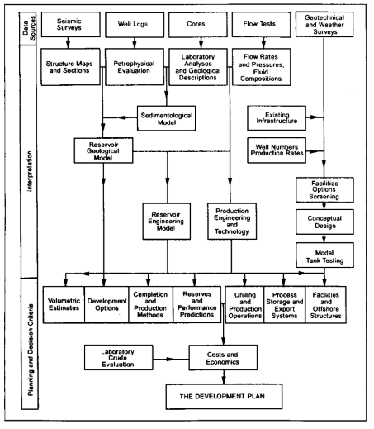
Figure 2: Feasibility study data flow and organisation

Cost Estimating and Scheduling: Cost estimators usually use company databases of historic costs of operated and other projects. These data usually are organized into basic units-e.g., jacket weight or separator capacity. Unit costs are subsequently adjusted by scaling rules to reflect differences in capacity (size, weight, volume, stages) and location (sourcing and installation). Scaling rules for size normally follow certain power laws;
For example; Separator capacity - Cost l / Cost 2 = (Capacity l /Capacity 2)^{n}, where n = 0.5.
In some cases, unit rates are estimated according to the amount of steel content; for example, a first-order estimate of platform jacket cost could be derived by multiplying the estimated weight times the unit steel price (U.S.$5,000/tonne, including fabrication). We must differentiate between material, fabrication, and installation costs and quotes involving a combination of these. Note also that costs depend on time, location (source), and quality. When older cost data are used, care must be taken to escalate costs properly, adjusting for inflation and market conditions. In terms of location (factor), the Gulf of Mexico or North Sea often is chosen as a reference. Finally, quality is important. A compromise could escalate costs if expensive remedial work is required later. The accuracy of cost estimates tends to vary, depending on the information available and the purpose, reflected in the type of cost estimate (Table2). For preliminary situations, order-of-magnitude estimates are based on very general information, using costs from existing and similar projects and incorporating appropriate scaling rules and adjustments for seismic acquisition and processing; drilling and completion; major facilities (separation, gas treatment, compression, water injection, etc.); platform substructure; and evacuation transport (pipelines etc.), storage, and loading. Of further importance is the disbursement and control of costs. During project implementation or execution, expenditure is monitored constantly by an S curve (Fig.3), and a possible overrun can be identified in time for remedial action. Costs may exceed the original budget by minor amounts. (less than 10 %) or may "blowout" by more substantial amounts as a result of incentive payments, unexpected difficulties related to natural events (e.g. weather) or manpower (strikes), or changes in the development plan. Cost overruns often are associated with delays and schedule blowouts. Accurate estimates also need to reflect proper consideration for allowances and contingencies. There are two types of allowances: those related to associated costs expressed as a percentage (e.g., the paint for piping) and those that are more variable and subject to chance but likely to occur on average, judging from past performance or statistics (e. g., manpower disputes or cyclones, leading to downtime). Finally, contingencies are added to the final cost estimate to cover expected but undefinable cost elements, usually amounting to 10% to 15 % of the basic budget. Contingencies reflect the inherent accuracy of the estimate and thus are greater for rough estimates and novel designs. In summary, the budget estimate is established as follows:
Estimate of firm items + allowances = base estimate + contingency (typically 10% to 15% of base = median estimate or budget proposal.

Table 2 Cost Estimates
Type of Estimate | Purpose | Accuracy (%)
Order of magnitude | Ranking of prospects and alternatives | 25 to 50
Feasibility study | Selecting of optimum development | 15 to 25
Budget | Estimating cost for project approval | 10 to 15
Control | Monitoring cost during project implementation | 5 to 10

In addition, the usual overrun allowance on authorities for expenditure issued typically amount to 10%. As mentioned, adhering to the implementation schedule is critical to staying within budget. Because certain components or activities often depend on others, it is vital that "slippage" is avoided, particularly for critical-path items, which should be identified clearly. For example, for a floating production, storage, and offloading (FPSO) facility using a converted tanker, the critical item may be construction of a mooring/riser system. If this activity slips, first oil is delayed.
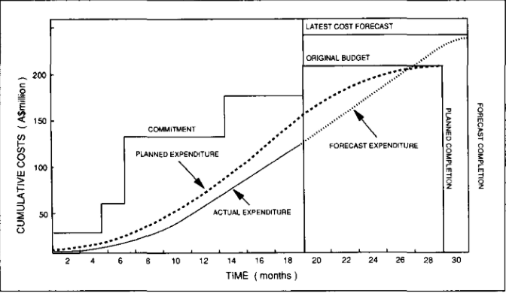
Figure 3: Budget Schedule and Control
- Economic Evaluation and Risk Analysis: From economic evaluation of a project, the best option from several development alternatives is selected. There may be more than one choice in terms of the subsurface plan (water or gas injection), facilities type (fixed platform or floating facility), or export method (pipeline or tanker). Generally, the NPV of the various options is the most important aspect in the final decision-making process. Economic analysis typically involves a fiscal model that considers key quantities: petroleum revenue, operating cost, depreciation, royalty or other secondary levies [e. g., resource rent tax (RRT)], and primary (corporate) tax.
The dominant cost item during the early years is the capital expenditure required to build and install the facility and to drill, complete, and tie in the wells. The remaining technical costs are associated with operating the facility (operating expenditure): expenses for maintenance, lifting, treatment, transportation, insurance, and overhead. These costs are dominant during the last years of the venture and eventually lead to field abandonment, the final major expenditure. The various cash-flow streams are calculated on a yearly basis and on a cumulative basis, indicating the relative magnitude of the various cash-flow items. The cumulative cash-flow curve also illustrates several so-called profitability indicators.
The more meaningful economic analysis uses a discount factor, reducing the impact (value) of cash flows in later years. Ideally, the discount factor should reflect the cost of capital. The present-value cash surplus is the sum of the discounted cash flows and represents project value. The earning power or internal rate of return is the effective rate of return on capital and can be compared with such factors as cost of capital, interest rates of a commercial bank, government bonds, or earning powers of alternative projects. To appreciate the effects of uncertainties and risks, two methods sensitivity and risk analysis are commonly used. Sensitivity analysis tests the effects of variation in key input parameters on economic robustness.
Sensitivities are used most often to evaluate downside scenarios: reserves estimates (decrease), production behavior (less favorable), capital expenditure (overrun), operating expenditure (increase), project delay, and oil price (downturn). A study of these sensitivities reveals how vulnerable the project is to changes in quantities. Measures then can be taken to reduce the effect, or the probability of occurrence, of the most damaging aspects. For instance, if the project is marginal and very sensitive to the reserves estimate, a suitably positioned appraisal well could limit this risk. If a capital expenditure overrun is the dominant risk, realistic budgeting and tight budget control could be the remedy. The results of a sensitivity analysis usually are displayed in a spider diagram. The more risk-prone parameters have the steepest slope. For very large projects, a statistical approach that combines distributions of variables by the Monte Carlo method is often used. The possible outcomes are expressed as an expectation curve, with the expectation value often called the expected monetary value of the project.
Finally, Fig. 4 shows the typical tendency for a project (type) to approach an asymptotic value in terms of NPV per barrel as a function of reserves

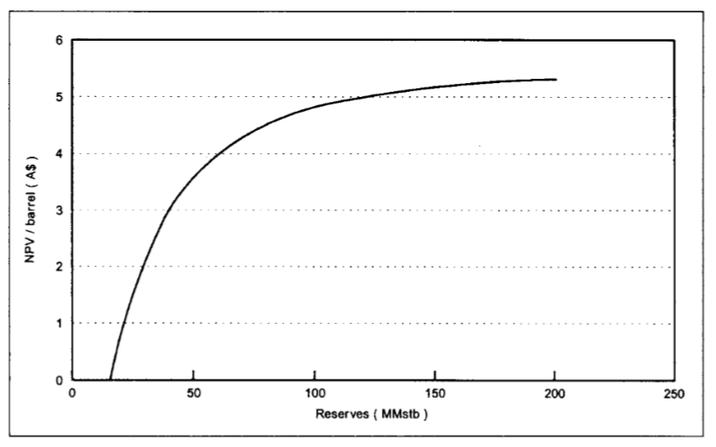Figure 4: NPV per barrel of an FPSO project

SUBSURFACE DEVELOPMENT PLAN
The main objective in determining an optimum subsurface development plan (well plan, production profile, and policy) is to maximize economic reserves. The most important elements are:
- Geological model which includes; structure, lithology, stratigraphy, diagenesis
- Volumetric which include; in-place volumes
- Reservoir behavior under production
- Well productivity and performance
- Field production profile (reserves).
Consideration of these and related aspects will determine optimum well requirements in terms of type, number, and location in the reservoir. For m~or projects, a numerical model study of the reservoir, including wells, is used most often to forecast production profiles and associated reserve.
Geology and Field Appraisal: It should be stressed that proper determination of the geological model, in terms of major structural elements, stratigraphy, and lithological variations including diagenesis, is of paramount importance. Many petroleum accumulations have been developed sub optimally or projects have been economic failures as a result of insufficient early geological knowledge. Reservoir engineering calculations are critically dependent on geological understanding. Geological information comes at a cost, and it is important to assess the value of incremental information.
Volumetric (Reserves): Volumetric, or the determination of hydrocarbons initially in place, can be carried out to different degrees of sophistication. The effort should be in proportion to the amount and accuracy of available information and the impact that the estimated volumes may have on the overall project.
Well Productivity: The production performance of future development wells is predicted primarily from test results of exploration and appraisal wells because this information is rather vital. Tests can reveal reservoir pressure and temperature, fluid samples, overall productivity (PI),wellbore parameters (skin factor), formation characteristics, particularly permeability, type of formation (dual porosity or naturally fractured, nonhomogeneous, layering, areal variation), reservoir geometry and the presence and nature of boundaries (location and sealing capacity of faults), pressure depletion for limited reservoirs; length and width of hydraulic fractures and other stimulation evaluation, formation strength (sand failure test), and communication with other wells (interference/pulse testing).
Reservoir Performance: Reservoir performance prediction for an offshore oil field before production determines the overall project scope. Reservoir performance depends on the following key aspects:
- Geological depositional environment including structure, lithology, and sediment lithology and microscopic formation characteristics, most notably permeability.
- Natural drive mechanisms (or lack thereof), specifically aquifers and the extent of likely gas caps (i.e., the relative oil, gas, and water volumes).
- Reservoir shape and geometry; the thickness of likely oil rims, particularly in relation to the proximity of gas caps and the effects of likely dynamic phenomena, such as coning and cusping.
- Fluid properties, particularly oil gravity and the degree of saturation of the crude, the amount of solution gas, and related properties (shrinkage, compressibility, viscosity, etc.).
Well Plan: The subsurface development plan consists primarily of well details (number, location, type, and phasing), the associated production forecast (hence reserves estimate), and 'the production policy. Determining the optimum subsurface plan usually involves extensive use of reservoir simulation models. Before these sophisticated tools are used, it is important to carry out analytical calculations to get a feel for the situation. The optimum plan will have been chosen after studies of numerous scenarios involving alternative well situations and production policies, possibly including secondary recovery methods. Again, the subsurface plan is not chosen in isolation but is determined from feedback from the facilities and economics engineers.
Well Technology: Well technology comprises drilling and production technologies. Specific technical challenges offshore are horizontal and long-reach wells and deep-water drilling. Production technology plays an important role in ensuring safety and well productivity and life. There are, of course, the normal concerns of formation strength (gravel packing)' scale formation (inhibition and treatment), and corrosion and erosion (alloy tubulars), except incorrect measures in these areas have greater consequences offshore in terms of cost (remedial work) and safety. Particularly in regard to safety and restricted-access situations, backup systems and redundancy should be incorporated into the completion design.
CONCLUSION
Oil field development planning provides the best technical solution and roadmap for optimizing the development and production of a field. Field development plan (FDP) studies provide the necessary guidance and information for establishing whether or not a project is economic considering all possible development project options, risks and uncertainties in order to define the most optimal development concept. The oil field development planning process typically identifies:
- The subsurface, commercial and operational environment for the project.
- The client’s objectives, constraints and drivers.
- The range of value adding applicable technologies, accounting for their state of maturity.
- The key areas of technical and commercial uncertainty.
Oil field development planning is carried out for good estimates in order to give a solid foundation for decision in all phases of the petroleum activity.

REFERENCES
- Arps, 1.1.: "Estimation of Primary Oil Reserves," Trans., AIME (1956), 207,182.
- Behrenbruch, P., Azinger, K.L., and Foley, M.V.: "Uncertainty and Risk in Petroleum Exploration and Development: The Expectation Curve Method," paper SPE 19475 presented at the 1989 Asia-Pacific Conference, Sydney, September 10-13.
- Behrenbruch, P., Turner, G.J., and Backhouse, A.R.: "Probabilistic Hydrocarbon Reserves Estimation: A Novel Monte Carlo Approach," paper SPE 13982 presented at the 1985 SPE Offshore Europe Conference, Aberdeen, Sept. 10-13.
- Behrenbruch, P. and Mason L.T.: "Optimal Oilfield Development of Fields With a Small Gas Cap and Strong Aquifer," paper SPE 25353 presented at the 1993 SPE Asia-Pacific Conference, Singapore, Feb. 8-10.
- Behrenbruch, P.: "Offshore Oil Field Development Planning: Project Feasibility and Key Considerations, " paper SPE 22957 presented at the 1991 SPE Asia-Pacific Conference, Perth, Nov. 4-7.
- Edwards, K.A. and Behrenbruch, P.: "The Use of Well Test Results in Oil Field Development Planning in the Timor Sea," JPT (Oct. 1988) 1372; Trans., AIME, 285.
- Hunter, K.C. and Boyson, R.A.: "Timor Sea Fields Require Innovative Engineering Development," Oil & Gas J. (Sept. 1987) 53. 10. Behrenbruch, P.: "Major Facilities Options for Offshore Petroleum Developments-Considerations and Requirements," paper presented at the 1991 Offshore Technology Conference, Melbourne, Nov. 25-27.
- Mace, A.J. and Hunter, K.C.: "Disconnectable Riser Turret Mooring System for Jabiru's Tanker-Based Floating Production System," paper OTC 5490 presented at the 1987 Offshore Technology Conference, Houston, April 27-30.
- Nuttall, D.E.: "Safety Systems in Subsea Completions," JPT (Jan. 1991) 80.

