NAME: AHAMEFULE JONAS IKENNA
MATRIC NUMBER: 17/MHS01/038
DEPARTMENT: MEDICINE AND SURGERY
COLLEGE: MEDICAL AND HEALTH SCIENCES
QUESTION 1
- C₆NOH₃
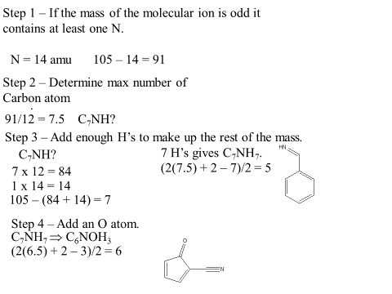

b. 1) MEDICINE: medicine the prime store of organic compounds. Though not all medicine are made of organic substance. Substances such as antibiotics, pain killer, anticancer and anesthetics are made from organic compound.
2) FOOD: food materials are solely made of carbon compounds viz. carbohydrates(CHO), proteins(NH2-CH-COOH), and fats(CH-COO-CH). Even vitamins are organic in nature.
3) CLEANSING AGENT: In industries and labs, organic solvents are widely used to clear impurities. For example, in drug extraction from plants, the fatty matter from the pulp is removed using petroleum ether.
4) STERILIZING AGENT : Most of the sterilizing agents and disinfectants like phenol, formaldehyde etc are carbon compounds. Due to their properties like solubility, pH, they can kill microbes and even human body cells.
5) VALUABLES: Diamonds, graphite, petroleum. Interestingly these carbon atoms are found to be highly valuable, durable and hardest substance in the world.
c. DIFFERENCE BETWEEN HOMOCYCLIC AND HETEROCYCLIC COMPOUNDS
Homocyclic compounds | Heterocyclic compounds
i: Ring of homocyclic compounds is made up of carbon atoms only. | Ring of heterocyclic compounds is made up of more than one kind of atoms.
ii: Contains atoms of the same element bonded to each other forming a ring | Contain atoms of at least different elements bonded to each other forming a ring
iii: Ring contains atom of the same element | Ring contains atoms of different elements
iv: Examples include benzene, cyclohexane, toluene etc | Example include thiocane, azocine, pyran etc

QUESTION 2

- Retardation factor (Rf) = Distance travelled by solute
Distance travelled by solvent front
Therefore, For band 2.4cm: 2.4/12.2 = 0.196
For band 5.6cm: 5.6/12.2 = 0.459
For band 8.9cm: 8.9/12.2 = 0.729

- Organic compound A belongs to the family of ALDEHYDE.
Organic compound B belongs to the family of ALKENE.

- 2,4 - dinitrophenylhydrazine test is employed to test for ALDEHYDES and KETONES.

FUNCTIONAL GROUPS | EXAMPLES
Hydroxyl | 2-butanol, ethanol
Carboxyl | 2-ethyl-4-4-dimethylpentanoic acid, ethanoic acid
Haloalkanes | Chloroethane(CH3CH2CL), 2-2-bromo-2-methylpropane
Amino | Alanine, Leucine
Ethers | Ethoxy ethane, 2-methoxy-2-methylpropane
Ester | Ethyl propanoate, Propyl methanoate
Aldehyde | Methanol, Phenylmethanal

