NAME: NASIR-AMEEN NASIR

MATRIC NUMBER: 17/ENG02/045

DEPARTMENT: COMPUTER ENGINEERING

CHM 102 ASSIGNMENT

QUESTION 1
a.) The possible formula for the molecular ion of 105 are:
M/Z= 105
105/12=8.75
The possible formula to expect are:
i) C7H7N
ii) C6H3NO
for odd numbered hydrogen, Nitrogen is present.

b.) Importance of Organic compounds
i) The food that we eat is essentially a mixture of organic compounds, hence, Organic compounds are used in food production
ii) They are used in the production of Clothes; Cotton, Wool, Silk, Nylon, Rayon etc
iii) Organic compounds are good sources of fuels; Coal, Wood, Natural gas, Petrol etc
iv) They are also used in the production of medicines; Penicillin, Aspirins, Iodoform, and so on
v) They are used in producing explosives; Nitroglycerin, Nitrocellulose, T.N.B, T.N.T etc
vi) They are used in making dyes.
vii) Organic compounds are used in making Cosmetics, Perfumes, Detergents, Paints and Varnishes.
c.) Difference between Homocyclic and Heterocyclic compounds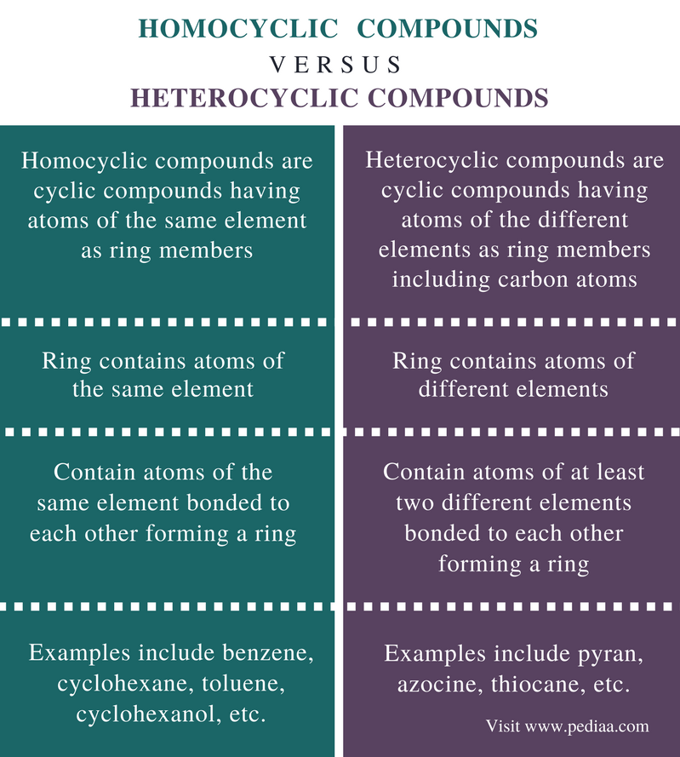

QUESTION 2
a.) Retardation factor, Rf = Distance moved by the bands / Distance moved by the solvent front
Distance moved by the solvent front = 12.2cm
Distance moved by the first band = 2.4cm
Therefore, Rf = 2.4cm /12.2cm = 0.2
Distance moved by solvent front = 12.2cm
Distance moved by second band = 5.6cm
Therefore, Rf = 5.6cm /12.2cm = 0.46
Distance moved by the solvent front = 12.2cm
Distance moved by the third band = 8.9cm
Therefore, Rf = 8.9cm /12.2cm = 0.73
b.) A belongs to Aldehydes since only aldehydes give positive test (dark grey precipitate) to Tollens test.
B belongs to Alkene since Alkenes decolorize bromine water
c.) 2,4-dinitrophenyl hydrazine is employed for the identification and characterization of Aldehydes and Ketones
d.)
FUNCTIONAL GROUP  -OH(Hydroxyl)  -COOH(Carboxyl)  -CHO(Aldehyde)  -COO(Carboxylate)  -ONO₂ (Nitrate)  -NH2(Amine)  -CO(Carbonyl) | EXAMPLES  C2H5OH; Ethanol  H3NO;Hyrdoxylamine  CH3COOH; Ethanoic acid  HCOOH; Methanoic Acid  C4H9CHO; Pentanal  CH3CH2C2CHO; Butanal  CH3COOC2H5; Ethyl Acetate  CH3CH(OH)COO⁻; Lactate Ion  CH3(CH2)4ONO2;1-nitrooxypentane  GaNO9;Gallium(III)nitrate  C2H5NH2; Ethyl amine  CH3NH2; Methylamine  C3H7F; Fluoropropane  CH3COCH3; Propanone

