SHALDAS USIJU SHALDAS
17/MHS01/296
MBBS
1.a. Molecular Ion formula
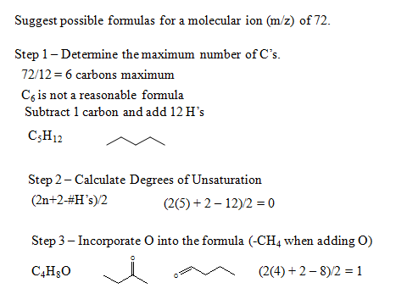
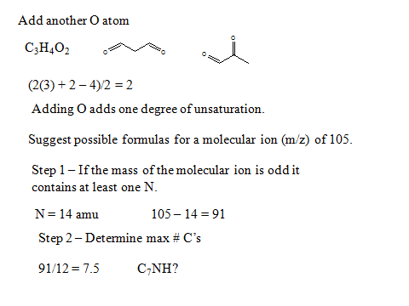
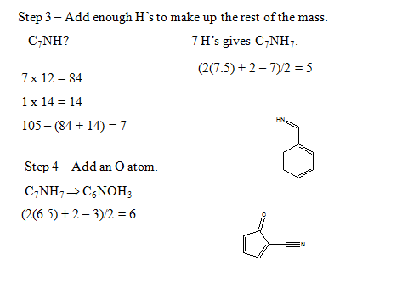

1.b. Importance Of Organic Compounds;
ganic compounds play an important role in our daily activities. There is hardly any walk of life where we do not need the organic compounds. The food that we eat is essentially a mixture of organic compounds. The changes which the food undergoes in our bodies are organic chemical reactions. The clothes that we wear whether of cotton or synthetic fiber all are organic in character. The soap, cosmetics, perfume, oils, plastics, explosives, rubber, dyestuffs, paper, insecticides, etc., are all organic compounds. In the medicinal field, organic compounds are indispensable. Antibiotics, sulpha drugs, alkaloids, aspirin, iodoform, etc., are organic compounds. There is hardly any industry which is not dependent on organic compounds. The following list clearly illustrates the importance of organic compounds.
1. Food: Carbohydrate, Proteins, Fats, vitamins, Enzymes, etc.
2. Clothes: - Cotton, Silk, Wool, Nylon, Rayon, Dacron, etc.
3. Fuels: - coal, Wood, Natural gas, Petrol, etc.
4. Medicines: - Penicillin, Streptomycin, Chloromycetin, Sulphadiazine, Morphine, Aspirin, Iodoform, Cocaine, etc.
5. Explosives: - Nitroglycerine, Nitrocellulose, T.N.B, T. N.T, etc.
6. Dyes: - Indigo, Malachite green, Alizarin, etc.
7. Insecticides: - D.D.T, Gammexane, Malathion, etc.
8. Household and other common articles:- soaps, Cosmetics, Perfumes, Detergents, paper, Rubber, Plastics, Leather, Resins, Inks, Paints, Varnishes, Photographic films, etc.
1.c. Homocyclic vs Heterocyclic Compounds
Homocyclic Compounds | Heterocyclic Compounds
Homocyclic Compound ring contains only one types of atom. | Heterocyclic Compound ring contains at least two different types of atoms including carbon.
Homocyclic Compounds have 100% carbon atoms in their ring. | Heterocyclic Compounds have mainly carbon and, in addition, heteroatoms such as nitrogen, oxygen, and sulphur are found in their ring.
Alicyclic homocyclic and Aromatic homocyclic | Alicyclic heterocyclic and Aromatic heterocyclic
Examples
Phenol, Toluene, Naphthalene, and Anthracene | Tetrahydrofuran, Piperidine, Pyridine, Furan, and Pyrrole

Summary – Homocyclic vs Heterocyclic Compounds

Based on the nature of the ring structure, cyclic organic compounds are classified as homocyclic compounds, in which the ring consists of only one type of atom, and heterocyclic compounds, in which the ring consists of at least two different types of atoms including carbon. In heterocyclic compounds, carbon atoms make the major portion of the ring, while the rest is made by heteroatoms, which often includes nitrogen, oxygen, and sulphur. This is the difference between homocyclic compounds and heterocyclic compounds.
2.a. Retardation factor
Solvent front = 12.2 cm
Rf = distance moved by substance/distance moved by solvent front
Rfa = 2.4cm/12.2cm = 0.196
Rfb = 5.6cm/12.2cm = 0.459
Rfc = 8.9cm/12.2cm = 0.729
2.b. Qualitative Analysis
Compound A belongs to the aldehyde family.
Compound B belongs to the alkene family.
2.c. Test Reagent
2,4-Dinitrophenylhydrazine test is employed for qualitatively detecting the carbonyl functionality of a ketone or aldehyde functional group. A positive test is signalled by the formation of a yellow, orange or red precipitate (known as a dinitrophenylhydrazone).
2.d. Organic Compounds
- Halo alkanes/ Alkylhalides (R-X) e.g. CH3-F; Fluoromethane , CCl4; Tetrachloromethane
- Alcohol/ Alkanol (R OH) e.g. Ethanol; C2H5OH, Butan-2-ol; C4H9OH
- Aldehyde/ Alkanal (R C-R =O) e.g. Propanal; C2H5CHO, 2-Methylpropanal; C3H7CHO
- Ethers (R OR) e.g. CH3CH2OCH3; Methoxyethane, CH3CH2OCH2CH3; Diethyl ether
- Acid Halides (R CO-X) e.g. CH3CH2CH2Br; 1-bromopropane, (CH3)2CHCl; 2-chloropropane
- Ketones/ Alkanones (R – O- R’ =O) e.g. C3H8CO; Butanone, C2H6CO; Propanone
- Esters (R COOR’) e.g. EthylPropanoate, Butylmethanoate

