Name: Ayeni Ifeoluwa Ayomide
Matric no:17/MHS01/074
College: MHS
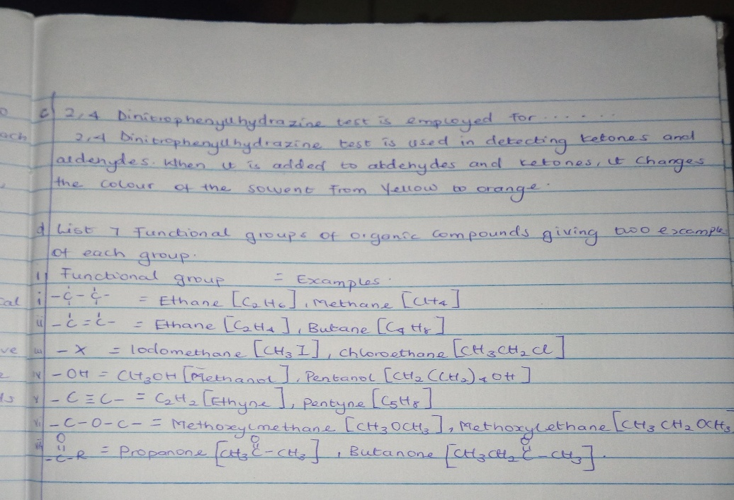
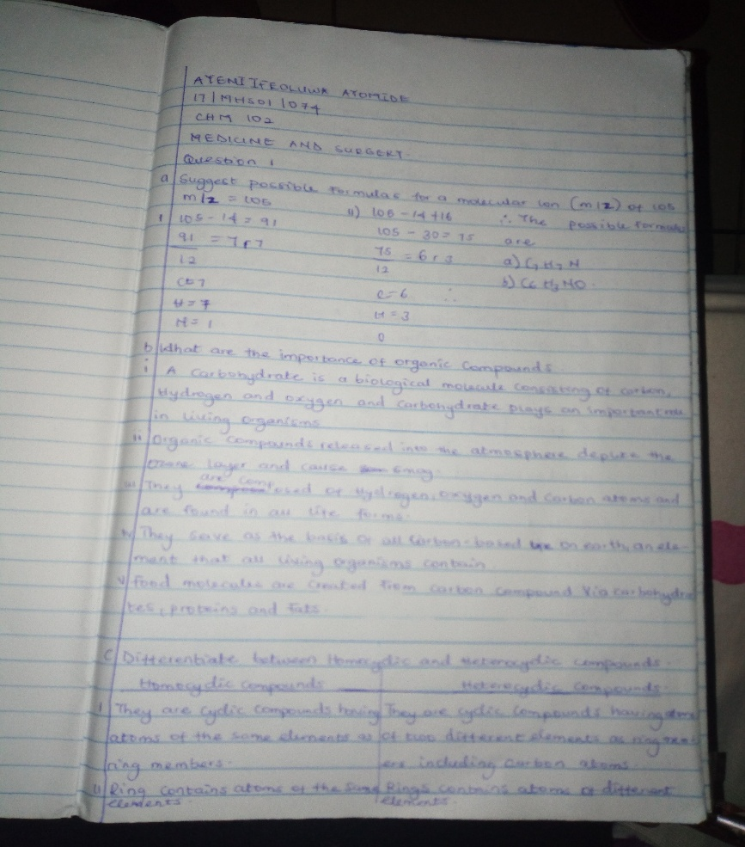
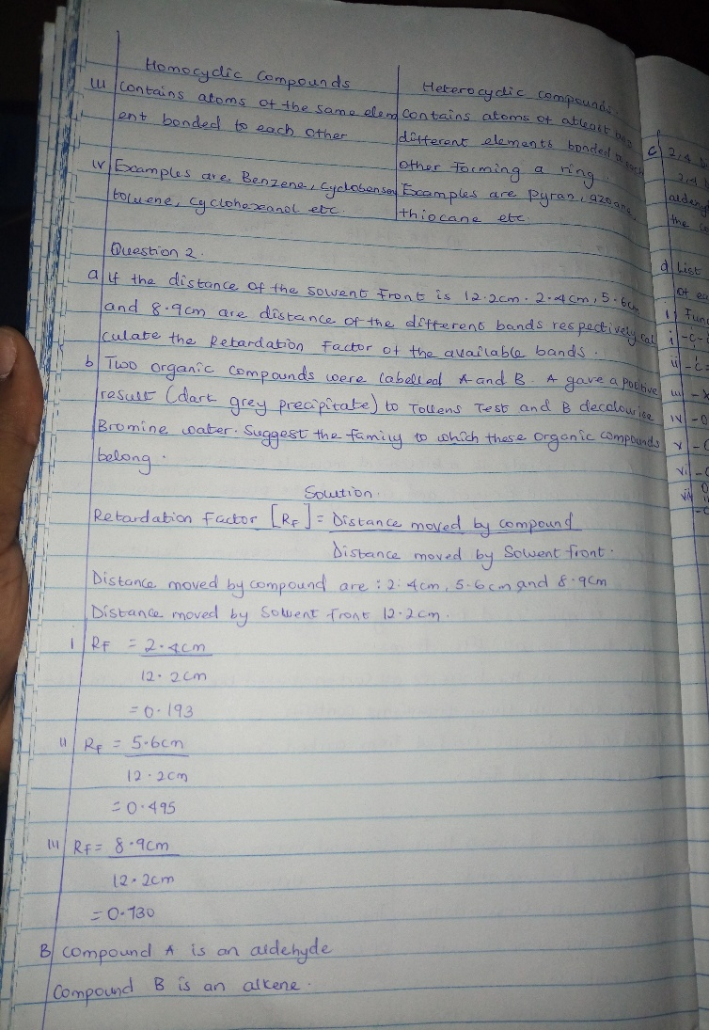
Department: medicine and surgery

