Name: Balogun Demilade Ayooluwa
Matric No.: 17/MHS01/080
Dept.: MBBS
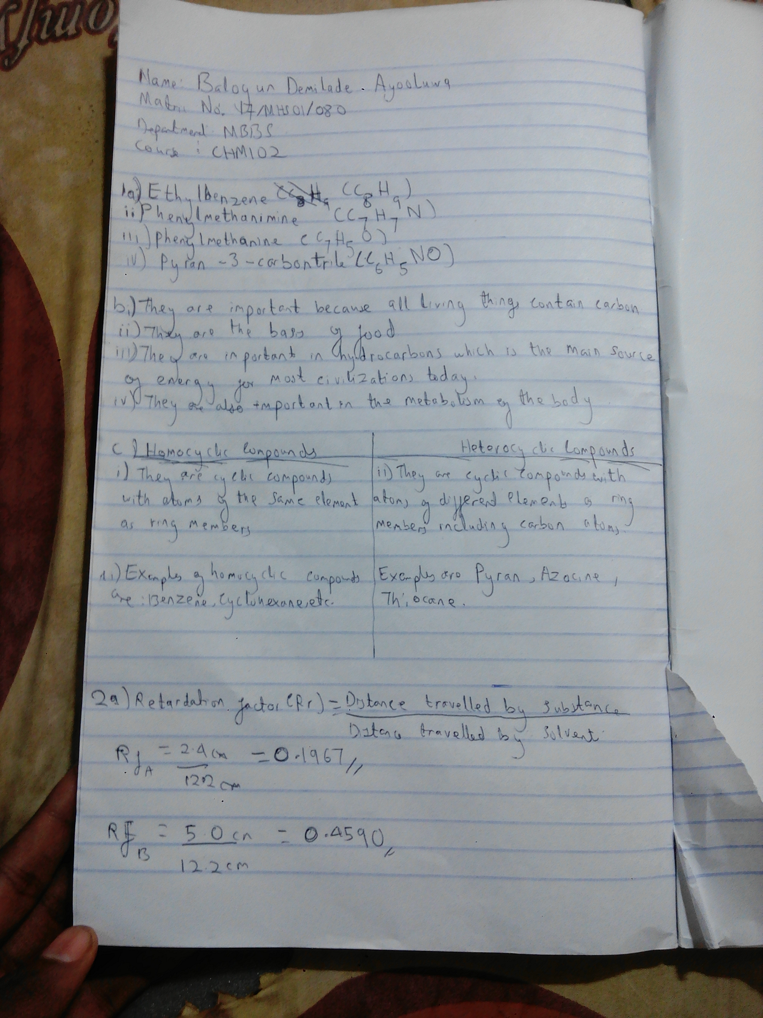
Course: CHM102 ASSIGNMENT



