NAME: OLOFINTOYE ODUNAYO CHRISTIANAH
DEPARTMENT: NURSING
MATRIC NO: 17/MHS02/072
COURSE CODE: CHM 102
LEVEL: 100
DATE: 8-04-2018

- A. STEP 1: If the mass of the molecular ion is odd, it contains at least one Nitrogen (N)
N= 14 a.m.u
105-14 = 91
STEP 2: Determine the maximum number of carbon atoms (C=12)
$\frac{91}{12}=7.583$
Maximum number of carbon is 7 = C₇N
STEP 3: Add Hydrogen
$12×7=84$
No of hydrogen =$105-\left(84+14\right)=7$
= C₇H₇N
STEP 4: Find the IHD
IHD= $\frac{\left(2×7\right)+2-7+1}{2}=\frac{10}{2}=5$
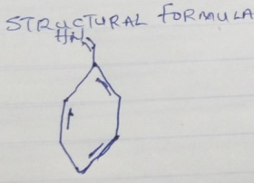
STEP 5: Add one oxygen atom
C₇H₇N; to add one oxygen atom we remove one carbon and four hydrogen atom
$12+\left(4×1\right)=16$

The atomic mass number for oxygen is 16, therefore, we have C₆H₃NO
IHD= $\frac{\left(2×6\right)+2-3+1}{2}=\frac{12}{2}=6$
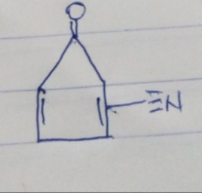

B. The importance of organic compounds are:
- Carbohydrates, an organic compound give life forms the energy needed to maintain cellular function.
- Organic compounds released into the atmosphere deplete ozone layers and cause smog.
- Ancient life forms buried beneath the surface of the Earth turned into hydrocarbons that form the basis of humanity’s mechanical energy consumption.
- Organic compounds serve as the basis of all carbon based life on Earth, an element that all living organisms contain.
- Organic compounds create energy production in biological life.
C. Differences between homocyclic and heterocyclic compounds are as follows:
HOMOCYCLIC COMPOUNDS | HETEROCYCLIC COMPOUNDS
Homocyclic compound ring contains only one type of atom. | Heterocyclic compound ring contains at least two different types of atom including carbon.
They have 100% composition of carbon atom in their rings. | Heterocyclic have mainly carbon atoms and, in addition, heteroatom such as nitrogen, oxygen, and sulphur are found in their ring.
They are sub-divided into alicyclic homocyclic and aromatic homocyclic. | They are sub-divided into alicyclic heterocyclic and aromatic heterocyclic.
Examples are phenol, toluene, naphthalene and anthracene. | Examples are tetrahydrofuran, pyridine, furan, pyrrole, and piperidine.

- A. R_{F} =$\frac{distance moved by the substance}{distance moved by the solvent front}$
R_{Fa=} $\frac{2.4cm}{12.2cm}=0.1967≅0.20$
R_{Fb=}$\frac{5.6cm}{12.2cm}=0.459≅0.50$
R_{Fc=}$\frac{8.9cm}{12.2cm}=0.729≅0.73$
B. Organic compound A which gave a positive test result to Tollens test belongs to the ALDEHYDE family.
Organic compound B which decolourizes Bromine water belongs to the ALKENE family.
C. 2, 4-Dinitrophenylhydrazine test is employed for Ketones and Aldehydes.
D. Functional groups of organic compounds and their examples are as follows;
FUNCTIONAL GROUPS | EXAMPLES
Alkanol / Alcohols (-OH) | Ethanol, Propanol.
Alkanone / Ketones (-C=O) | Hexanone, Pentanone.
Alkyl halides / Haloalkanes(-F, -Cl, -Br, -I) | 2- Iodopropane, 1, 2-dichloroethane.
Ethers (-OR) | Diphenyl ether, Diethyl ether.
Aldehydes / Alkanals (-COH) | Phenylmethanal, Propanal.
Amines (-NH₂) | Diphenylamine, Trimethylamine.
Carboxylic acid / Alkanoic acid | Pentanoic acid, Propanoic acid.

