NAME; EHIE-BISHOP GINA
DEPARTMENT; NURSING SCIENCE
MATRIC NO; 17/MHS02/037
COURSE CODE; CHEM 102

1.A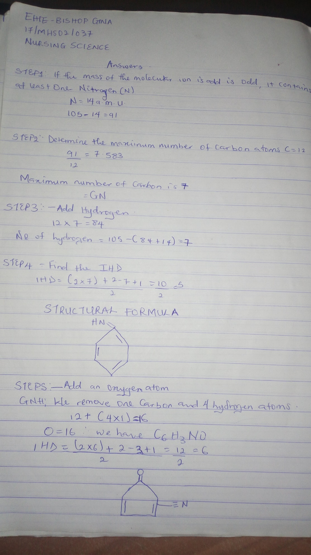
B. The Importance of organic compounds
- Organic compounds are released into the atmosphere deplete ozone layers and cause smog.
- Organic compounds create energy production in biological life.
- It also serves as the basis of all carbon based life on earth, an element that all living organisms contain.
- Carbohydrates, an organic compound give life forms the energy needed to maintain cellular functions.
- They can be used for sterilizing various objects e.g. phenol, formaldehyde due to their properties like solubility.
- It can also be used as cleansing agents for example in the extraction of drugs from plants, the fatty matter from the pulp is removed using petroleum ether.

HOMOCYCLIC COMPOUNDS | HETEROCYCLIC COMPOUNDS
These are cyclic compounds having atoms of the same element as ring members. | These are cyclic compounds having atoms of different elements as ring members, including carbon atoms .
Ring contains atom of the same element . | Ring contains atoms of different element.
It contains atoms of the same element bonded to each other forming a ring e.g. benzene, cyclohexane, toluene, cyclohexanol etc. | It contains atoms of at least two different elements bonded to each other forming a ring. e.g. pyridine, piperidine, pyrrole, etc.
They are sub-divided into alicyclic homocyclic and aromatic homocyclic. | They are sub-divided into alicyclic heterocyclic and aromatic heterocyclic.

2. A. R_{f =} $\frac{distance moved by a the substance}{distance moved by the solvent front}$
R_{Fa} = $\frac{2.4cm}{12.2cm}=0.1967≅0.20$
R_{Fb} =$\frac{5.6cm}{12.2cm} =0.459≅0.50$
R_{Fc} = $\frac{8.9cm}{12.2cm} =0.729≅0.73$
B. Organic compounds A which gave a positive test result to Tollen test belongs to the ALDEHYDE family.
ii. Organic compounds B which decolorizes Bromine water belongs to the ALKENE family.
C. 2,4- Dinitrophenyl hydrazine test is employed for Ketones and Aldehydes.
D. Functional groups of organic compounds and their examples are as follows;
FUNCTIONAL GROUPS | EXAMPLES
Alkanol / Alcohols (-OH) | Ethanol, propanol.
Alkanone / Ketones (-C=O) | Hexanone, Pentanone
Alkyl halides / Halo alkanes (-F, -Cl, -Br, -I) | 2- Iodopropane, 1, 2 -dichloroethane
Ethers (-OR) | Diethyl ether, methoxyethane( methyl ethyl ether)
Aldehydes / Alkanals (-COH) | Methanal, Propanal
Amines (-NH₂) | Diphenylamine, Trimethylamine
Carboxylic acid / Alkanoic acid | Pentanoic acid, Propanoic acid

