NAME: OMIGIE EHIZEMEN O.
DEPARTMENT: NURSING
MATRIC NO: 17/MHS02/075
COURSE CODE: CHEM 102
QUESTION 1.
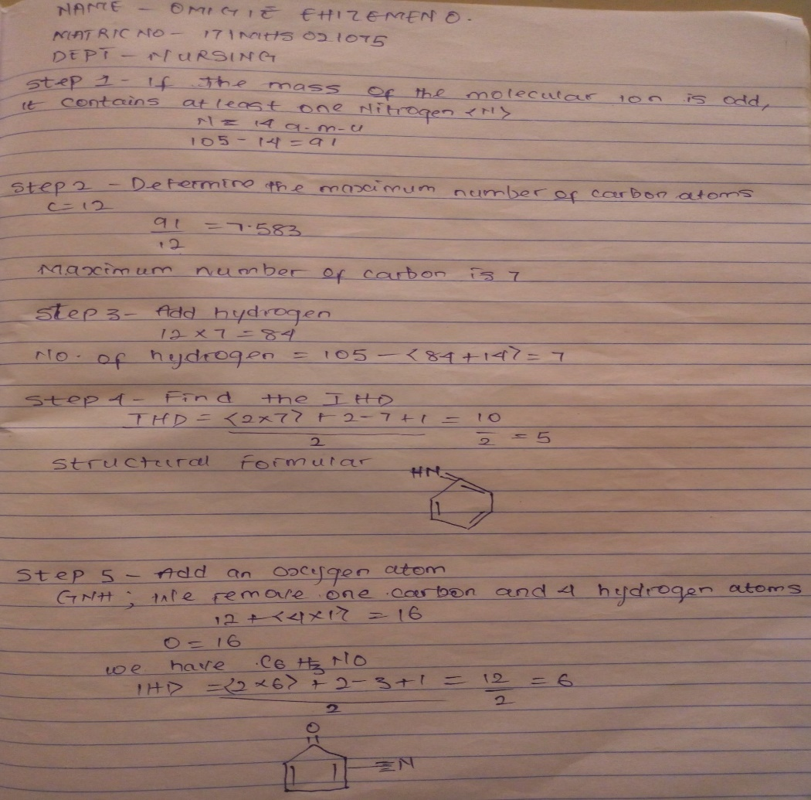

- Importance of organic compounds

- They are used in the field of medicine to produce drugs e.g penicillin, aspirin, iodoform, etc.
- They can be used as cleansing agents for example in the extraction of drugs from plants, the fatty matter from the pulp is removed using petroleum ether.
- They can be used for sterilizing various objects e.g phenol, formaldehyde due to their properties like solubility.
- They serve as an analytic substance, most substances like drugs and pesticides are analysed qualitatively and quantitatively using organic compounds

- Differences between homocyclic and heterocyclic compounds.
Homocyclic compounds | Heterocyclic compounds
- Ring contains one type of atom. | Ring contains at least 2 different types of atoms including carbon.
- They have 100% carbon atoms in their ring. | They have mainly carbon, in addition, heteroatoms, such as nitrogen, oxygen and sulphur are in their ring.
- Examples are; toluene, phenol, naphthalene, anthracene etc. | Examples are; tetra hydrofuran, piperadine, pyrrole, furan etc.

Question 2
- R_{f=}$\frac{distance moved by the substance}{distance moved by the solvent font}$
R_{f=}$\frac{2.4}{12.2}=$ 0.1967
R_{f=}$\frac{5.6}{12,2}=$ 0.4590
R_{f=}$\frac{8.9}{12.2}=$0.7295
- For the tollens test, the family of organic compound suggested is the Aldehyde.
For the decolourization of bromine water, the family of organic compound is the Alkene.
- 2,4-Dinitrophenylhydrazine test is employed for Keytones and Aldehydes.
- Seven functional groups and 2 examples each.
Functional groups | Examples.
- –OH alkanols | Propan-1-ol, pentanol.
- -OR ethers | Di methyl ether, ethyl methyl ether.
- –COOH carboxylic acid | Ethanoic acid, butanoic acid.
- RX alkyl halides | 2-bromo butane, 2-iodo propane.
- C=C | But-1-ene, pentene.
- –NH2 amines | Dimethyl amine,diphenylamine.
- –COH | Pentanal, hexanal.

