NAME: OKIEMUTE WATERWAY
DEPARTEMT: CIVIL ENGINEERING
MATRIC NO:17/ENG03/056
COURSE CODE: ENG 281

ASSIGNMENT
- Given that a function to be as f(x)=π
Find lim f(x)
x 3
Solution

Lim f(x) = lim π
x 3 x 3

- The model of a system has been developed by an engineer to be given in the equation.
F(x)=5x-21

Given that δ=0.1, and using a step of 0.01, demonstrate in a tabular form of the model as x 6
is equal to a

Solution

Lm | a - δ | 6 | a + δ | Lm
8.5 | 5.90 |  | 6.1 | 9.5
8.55 | 5.91 |  | 6.09 | 9.45
8.60 | 5.92 |  | 6.08 | 9.40
8.65 | 5.93 |  | 6.07 | 9.35
8.70 | 5.94 |  | 6.06 | 9.30
8.75 | 5.95 |  | 6.05 | 9.25
8.80 | 5.96 |  | 6.04 | 9.20
8.85 | 5.97 |  | 6.03 | 9.15
8.90 | 5.98 |  | 6.02 | 9.10
8.95 | 5.99 |  | 6.01 | 9.05
9.00 | 6.00 |  | 6.00 | 9.00

Since the right hand limit and left hand limit are equal to a therefore
$$\lim_{x→6}\left(5x-21\right)=9$$

- Find the limit of the model equation given as

$\lim_{x→3^{+}}{\frac{3-x}{\left|3-x\right|}}$

Solution

$\lim_{x→3^{+}}{\frac{3-x}{\left|3-x\right|}}$ = $\lim_{8→0}{\frac{3-(3-x)}{3-\left|3-x\right|}}$

$\frac{3-3-x}{\left|3-3+x\right|}$ = $\frac{-8}{8}$ = -1

- Evaluate the limit of the model given as $\lim_{x→3}{\frac{x-3}{(x-3)}}$
Solution
$$\lim_{x→3}{\frac{x-3}{(x-3)}}$$

=$\frac{3-3}{\left|3-3\right|}$
=$\frac{0}{0}$
= undefined
The unit does not exists

- Show that the function given on the equation below is continuous on the interval [4 , 8]

Solution

x | f(x) = $\sqrt{x-4}$
4 | 0
5 | 1
6 | 1.4
7 | 1.7
8 | 2.0

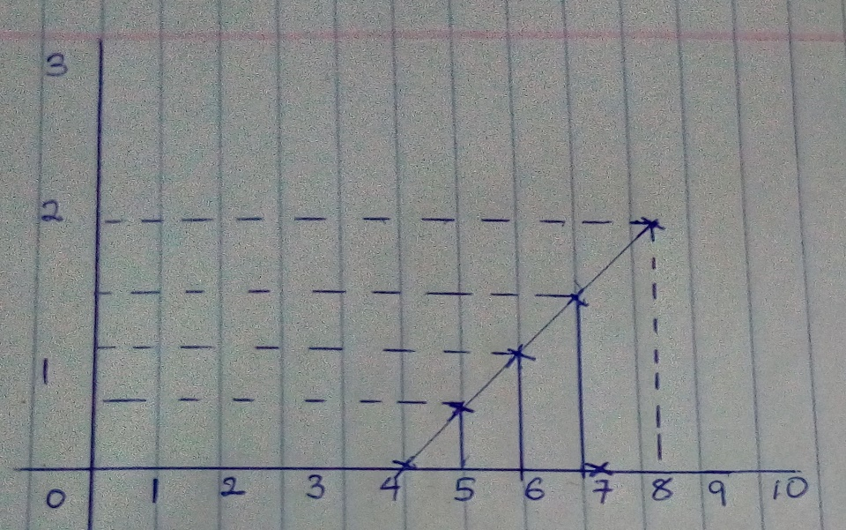

The graph above shows that the function f(x) = $\sqrt{x-4}$ at interval [4 , 8] is continuous because there was no point where the function was unidentified

