1.0 OCCURRENCE AND PROPORTION OF WATER RESOURCES OF THE EARTH
Water is distributed across earth. Most water in the Earth's atmosphere and crust comes from the world ocean's saline seawater, while freshwater accounts for only 2.5% of the total. Because the oceans that cover roughly 78% of the area of the Earth reflect blue light, the Earth appears blue from space, and is often referred to as the blue planet and the Pale Blue Dot. An estimated 1.5 to 11 times the amount of water in the oceans may be found hundreds of miles deep within the Earth's interior, although not in liquid form.

The oceanic crust is young, thin and dense, with none of the rocks within it dating from any older than the breakup of Pangaea. Because water is much denser than any gas, this means that water will flow into the "depressions" formed as a result of the high density of oceanic crust. (On a planet like Venus, with no water, the depressions appear to form a vast plain above which rise plateaux). Since the low-density rocks of the continental crust contain large quantities of easily eroded salts of the alkali and alkaline earth metals, salt has, over billions of years, accumulated in the oceans as a result of evaporation returning the fresh water to land as rain and snow.

As a result, the vast bulk of the water on Earth is regarded as saline or salt water, with an average salinity of 35‰ (or 3.5%, roughly equivalent to 34 grams of salts in 1 kg of seawater), though this varies slightly according to the amount of runoff received from surrounding land. In all, water from oceans and marginal seas, saline groundwater and water from saline closed lakes amount to over 97% of the water on Earth, though no closed lake stores a globally significant amount of water. Saline groundwater is seldom considered except when evaluating water quality in arid regions.

The remainder of the Earth's water constitutes the planet's fresh water resource. Typically, fresh water is defined as water with a salinity of less than 1 percent that of the oceans - i.e. below around 0.35‰. Water with a salinity between this level and 1‰ is typically referred to as marginal water because it is marginal for many uses by humans and animals. The ratio of salt water to fresh water on Earth is around 40 to 1.

The planet's fresh water is also very unevenly distributed. Although in warm periods such as the Mesozoic and Paleogene when there were no glaciers anywhere on the planet all fresh water was found in rivers and streams, today most fresh water exists in the form of ice, snow, groundwater and soil moisture, with only 0.3% in liquid form on the surface. Of the liquid surface fresh water, 87% is contained in lakes, 11% in swamps, and only 2% in rivers. Small quantities of water also exist in the atmosphere and in living beings. Of these sources, only river water is generally valuable.

Most lakes are in very inhospitable regions such as the glacial lakes of Canada, Lake Baikal in Russia, Lake Khövsgöl in Mongolia, and the African Great Lakes. The North American Great Lakes, which contain 21% of the world's fresh water by volume, are the exception. They are located in a hospitable region, which is heavily populated. The Great Lakes Basin is home to 33 million people. The Canadian cities of Toronto, Hamilton, Ontario, St. Catharines, Niagara, Oshawa, Windsor, and Barrie, and the United States cities of Duluth, Milwaukee, Chicago, Gary, Detroit, Cleveland, Buffalo, and Rochester, are all located on shores of the Great Lakes.

Although the total volume of groundwater is known to be much greater than that of river runoff, a large proportion of this groundwater is saline and should therefore be classified with the saline water above. There is also a lot of fossil groundwater in arid regions that has never been renewed for thousands of years; this must not be seen as renewable water.

However, fresh groundwater is of great value, especially in arid countries such as India. Its distribution is broadly similar to that of surface river water, but it is easier to store in hot and dry climates because groundwater storages are much more shielded from evaporation than are dams. In countries such as Yemen, groundwater from erratic rainfall during the rainy season is the major source of irrigation water.

Because groundwater recharge is much more difficult to accurately measure than surface runoff, groundwater is not generally used in areas where even fairly limited levels of surface water are available. Even today, estimates of total groundwater recharge vary greatly for the same region depending on what source is used, and cases where fossil groundwater is exploited beyond the recharge rate (including the Ogallala Aquifer) are very frequent and almost always not seriously considered when they were first developed.

DISTRIBUTION OF SALINE AND FRESH WATER
The total volume of water on Earth is estimated at 1.386 billion km³ (333 million cubic miles), with 97.5% being salt water and 2.5% being fresh water. Of the fresh water, only 0.3% is in liquid form on the surface. In addition, the lower mantle of inner earth may hold as much as 5 times more water than all surface water combined (all oceans, all lakes, all rivers).
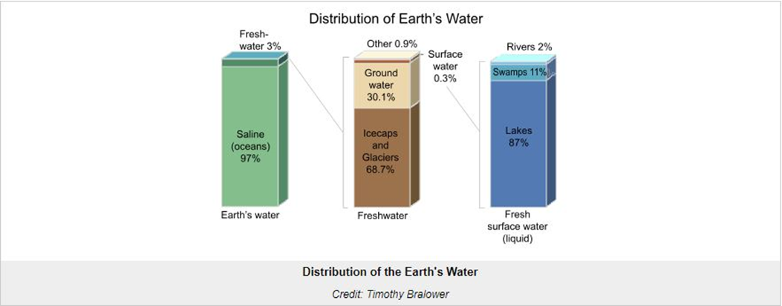

DISTRIBUTION OF WATER IN THE OCEANS
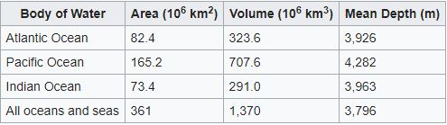

2.0 BRIEF ON THE CURRENT FLOOD SITUATION IN NIGERIA
Heavy rainfall has caused the Niger and Benue rivers to overflow, displacing thousands across 12 states as of late August (DG ECHO 16/09/2018; 21/09/2018). The National Emergency Management Agency has declared an emergency in Kogi, Niger, Delta and Anambra states, and is monitoring eight other states in central and southern Nigeria (Floodlist 19/09/2018). In addition to river flooding, flash floods have occurred in central and northern Nigeria since July, affecting Katsina, Kano, Jigawa and Sokoto states. Thousands of houses have been destroyed across all affected states and the affected population has lost household and personal belongings. The floods have caused considerable damage to farmland across Nigeria. There is an urgent need for shelter, NFI, food and livelihood assistance.
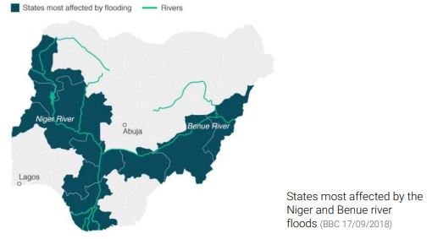
ANTICIPATED SCOPE AND SCALE
The main rainy season in Nigeria is expected to continue until October and heavy rainfall is predicted for the next three weeks. This could lead to further flooding in affected communities and floods in previously unaffected areas.
The extensive crop damage is likely to aggravate food insecurity in the region and to affect livelihoods. Flooding can have a long-term health impact on communities that are already exposed to conflict and displacement.

CAUSES OF FLOODING IN NIGERIA
Rains
Each time there are more rains than the drainage system can take, there can be floods. Sometimes, there is heavy rain for a very short period that result in floods. In other times, there may be light rain for many days and weeks and can also result in floods.
River overflow
Rivers can overflow their banks to cause flooding. This happens when there is more water upstream than usual, and as it flows downstream to the adjacent low-lying areas (also called a floodplain), there is a burst and water gets into the land.
Strong winds in coastal areas
Sea water can be carried by massive winds and hurricanes onto dry coastal lands and cause flooding. Sometimes this is made worse if the winds carry rains themselves. Sometimes water from the sea resulting from a tsunami can flow inland to cause damage.
Dam breaking (raptured dam or levee)
Dams are man-made blocks mounted to hold water flowing down from a highland. The power in the water is used to turn propellers to generate electricity. Sometimes, too much water held up in the dam can cause it to break and overflow the area. Excess water can also be intentionally released from the dam to prevent it from breaking and that can also cause floods. An example was the release of water from the Lagdo Dam in Camerron causing devastating flooding in Nigeria.
On the other side, there are some activities by man that can lead to flooding.
Development and infrastructure in flood-prone areas
The development and building of infrastructure in flood-prone areas, such as along rivers, near ocean shorelines, or near river deltas, has led to an increase in vulnerability to flooding because the natural resiliency of the area to flood has been compromised by the development.
Blocked and narrow drainage systems
Dumping of refuse inside drainages can cause them to become narrower and then blocked leading to overflowing of and the area. Also, when the drainages are not properly directed or are made too narrow, it does not solve the problem of flood in the area but rather aggravates it.
Erection of buildings over flood drains and across canals
Construction of buildings over flood drains or water canals defeats the reason for the construction of the flood drains as they eject a huge amount of water from rainfall runoff back into the land and causing the area to become flooded.
Infrastructure failures
Floods can be caused by a breaking of an infrastructure that can cause large quantities of water to flood a local area. An example is when dams break due to faulty construction or maintenance, or when they are overwhelmed due to heavy rainfalls.
Deforestation
When the natural vegetation of an area is indiscriminately removed by cutting down the trees and hoeing of the area to remove grasses, there are no more trees to help soak up the water and reduce water flow over the landscape. Without these natural protections, the risk of flooding and erosion is increased whenever it rains.

Impermeable surfaces
In developed areas, like urban towns and cities, there are usually many impermeable surfaces like roads, concrete drainage basins, and other concrete structures that do not allow water to soak back into the soil. When large amounts of rain fall on these surfaces, the water then gathers and increase in volume thereby and leading to flooding of the low-lying areas if the runoff is not directed properly through a drainage that can handle the volume of accumulated water.
Bridges
Sometimes, bridges that have been built over rivers can slow the discharge of water and reduce the river’s capacity to hold more water.

2.1 MEAN MONTHLY RAINFALL IN NIGERIA FROM 1901 – 2018
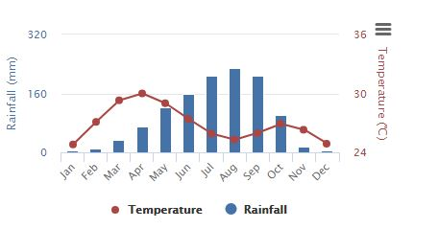

Flooding in Nigeria usually occurs between the months of July and October. The last major flooding disaster occurred in 2012. Plateau State is usually the state most affected by flooding due to rain fall, with the most casualties recorded there. Below is a graph of the average rainfall in Jos, Plateau State (state capital) with data gathered over the years.
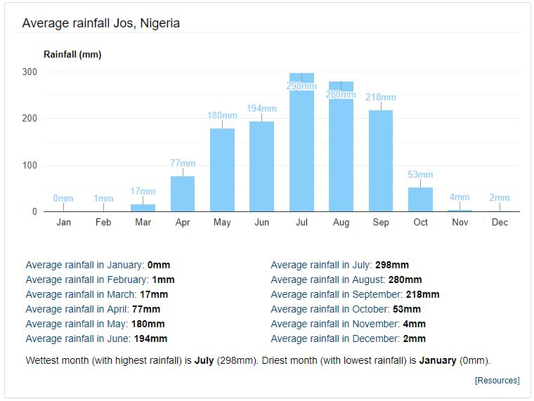
Similar data is recorded in neighboring states affected by flooding.

3.0 HISTORY OF FLOODING IN NIGERIA
Historically, Nigeria typically experiences light to moderate flooding annually in those affected areas between the months of July and October. Due to government negligence, no solution has been carried out over the years. In 2012, flooding in these regions reached historic levels- the worst in the previous 40 years.
2012 NIGERIA FLOODS
The 2012 Nigeria floods began in early July 2012, and killed 363 people and displaced over 2.1 million people as of 5 November 2012. According to the National Emergency Management Agency (NEMA), 30 of Nigeria's 36 states were affected by the floods. The floods were termed as the worst in 40 years, and affected an estimated total of seven million people. The estimated damages and losses caused by the floods were worth N2.6 trillion

July
On 2 July 2012, many Nigerian coastal and inland cities experienced heavy rains, and residents of Lagos were "gasping for breath" due to the flooding. In addition, there was a gridlock on major roads, causing people to cancel or postpone appointments they may have had. Thousands of stranded commuters had to pay increased fares for the few bus drivers who were willing to risk travelling on the roads, and construction of work by the Nigerian government on the inner Oke-Afa Road took a "heavy toll."

In mid-July 2012, flooding in the Ibadan metropolis caused some residents at Challenge, Oke-Ayo, and Eleyele to flee from their residences and save their lives. The flooding also prevented some Christians from attending churches in the morning, while a few bridges caved in. The Nigerian government said that certain structures on waterways had to be demolished as a result of the flooding, while Commissioner for Information and Orientation, Bosun Oladele, announced that there weren't any casualties from the flooding.

In late July 2012, at least 39 people were killed due to flooding in the central Nigerian Plateau state. Heavy rainfall caused the Lamingo dam to overflow near Jos, sweeping across a number of neighborhoods in Jos, and approximately 200 homes were submerged or destroyed. In addition, at least 35 people were missing, while Manasie Phampe, the head of the Red Cross in the state, announced that relief efforts were ongoing. The floods left 3,000 people homeless, many of whom are taking refuge in government buildings in Jos.
August
In mid-August, flooding killed at least 33 people in central Nigeria's Plateau state, and co-ordinator of the National Emergency Management Agency in central Nigeria Abdussalam Muhammad said that homes were destroyed while roads and bridges were washed away, obstructing relief efforts. Over 12,000 people were affected by the flooding in six districts of the state, while hundreds were rendered homeless.
September
Release of water from the Lagdo Reservoir in Cameroon caused the death of 30 people in Benue State.
October
In early-October, the floods spread to Delta State and Bayelsa State and rendered about 120,000 people homeless, according to state authorities and the Nigerian Red Cross. Several temporary displacement sites set up were also flooded forcing people to flee. In Yenagoa, 3,000 people were sleeping at the Ovom State Sports Complex. In Delta State, among the buildings destroyed by the floods were 20 health clinics, five hospitals, many schools, churches and government buildings. Schools were either closed or occupied by internally displaced persons. The floods also spread across Benue State where a local river overflowed causing the displacement of over 25,000 people.

On 9 October, Nigerian President Goodluck Jonathan released 17.6 billion naira (US$111 million) to various states and agencies for damage response, flood relief and rehabilitation.

Kogi State was the worst affected with 623,900 people being displaced and 152,575 hectares of farmland destroyed, according to a NEMA coordinator. President Goodluck Jonathan called these floods "a national disaster".

4.0 METHODS OF FLOOD PREVENTION
Sea / Coastal Defence Walls
Sea walls and tide gates have been built in some places to prevent tidal waves from pushing the waters up ashore. In some areas too, sand bags are made and placed in strategic areas to retain floodwaters.
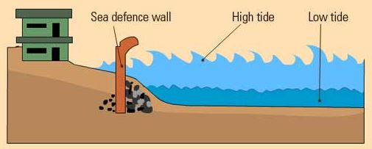
Retaining walls
In some places, retaining walls levees, lakes, dams, reservoirs or retention ponds have been constructed to hold extra water during times of flooding.
Town planning
It is important that builders acquire permission before buildings are erected. This will ensure that waterways are not blocked. Also, drainage systems must be covered and kept free from objects that chock them. This way, water can quickly run through if it rains and minimize any chance of town flooding. Drainage systems should also be covered to prevent litter from getting into them.
Vegetation
Trees, shrubs and grass help protect the land from erosion by moving water. People in low-lying areas must be encouraged to use a lot of vegetation to help break the power of moving flood water and also help reduce erosion.

Education
In many developing countries, drainage systems are chocked with litter and people have little knowledge of the effects that can have during a rain. When it rains, waterways and culverts are blocked by massive chunks of litter and debris, and water finds its way into the streets and into people's homes. Education is therefore very important, to inform and caution people about the dangers of floods, what causes floods, and what can be done to minimize its impact.
Detention basin
These are small reservoirs built and connected to waterways. They provide a temporary storage for floodwaters. This means in an event of flooding, water is drained into the basin first, giving people more time to evacuate. It can also reduce the magnitude of downstream flooding.

5.0 RECENT FLOODING IN INTERNATIONAL COMMUNITIES

UNITED STATES – HURRICANE HARVEY
Hurricane Harvey started as a tropical wave off the African coast on Sunday, August 13th and tracked westward across the Atlantic and on August 17th become a tropical storm which moved into the Caribbean Sea where Harvey become disorganized. Harvey was then downgraded to a tropical wave which entered the Gulf of Mexico on the 22nd. On the morning of the 23rd, Harvey was upgraded again to tropical depression as the Bay of Campeche and the Western Gulf of Mexico had very warm waters. Over the next 48 hours Harvey would undergo a period of rapid intensification from a tropical depression to a category 4 hurricane. Harvey made landfall along the Texas coast near Port Aransas around 10:00 p.m. on August 25th as a cat 4 and brought devastating impacts. As Harvey moved inland, it’s forward motion slowed to near 5mph after landfall and then meandered just north of Victoria, TX by the 26th. Rain bands on the eastern side of the circulation of Harvey moved into southeast Texas on the morning of the 25th and continued through much of the night and into the 26th. A strong rainband developed over Fort Bend and Brazoria Counties during the evening hours of the 26th and spread into Harris County and slowed while training from south to north. This resulted in a rapid development of flash flooding between 10:00 p.m. and 1:00 a.m. as tremendous rainfall rates occurred across much of Harris County. The morning of the 27th saw additional rain bands continued to develop and produced additional excessive rainfall amounts. As the center of Harvey slowly moved east-southeast and back offshore heavy rainfall continued to spread through much of the 29th and the 30th exacerbating the ongoing widespread and devastating flooding. All of this rainfall caused catastrophic drainage issues and made rivers rise greatly. Only around 10 percent of the river forecast points in southeast Texas remained below flood stage due to the event, and approximately 46 percent of the river forecast points reached new record levels. Harvey maintained tropical storm intensity the entire time while inland over the Texas coastal bend and southeast Texas. After moving offshore, Harvey made a third landfall just west of Cameron, Louisiana on the morning of the 30th and brought more heavy rainfall to the Northern Gulf States.
CAUSE OF HURRICANE HARVEY
Although it started off the African coast like the typical hurricanes experienced in Texas, Hurricane Harvey had a much higher impact than usual and is tied with 2005’s Hurricane Katrina as the most destructive of all time.
Climate change made Hurricane Harvey more powerful and increased its deadly flooding, according to new research released as major storms may be driving more Americans to worry about global warming.
Human-caused climate change caused the storm to drop significantly more rain than storms would have before atmospheric carbon dioxide levels spiked from the consumption of fossil fuels, according to research published yesterday. Meanwhile, a new poll suggests that witnessing that type of damage and the suffering of those affected has also seemed to move public opinion slightly toward an acceptance of the risk that it poses to a large segment of the U.S. population.
Before the storm, climate scientists speculated global warming could intensify climate change. They pointed to a warmer atmosphere, which carries more water vapor to worsen rainstorms, as well as to higher ocean surface temperatures, which intensify hurricanes.
PREVENTION
Unfortunately, hurricanes that cause deadly flooding cannot be prevented. Attempts by scientists to prevent them have led to devastating consequences.
Controversial schemes to modify the weather have been attempted by many countries, but critics often doubt their success due to the relatively poor knowledge about the mechanisms that cause weather in the first place. Some of these controversial schemes are listed below:
1. Russian military pilots have admitted that they seeded rain clouds to wash out radioactive fallout from the air in an attempt to protect the capital Moscow in the wake of the Chernobyl nuclear disaster.
2. A recent cloud seeding operation to clear the skies of rain ahead of public holidays this month went wrong when cement dropped from one of the aircraft failed to fragment and smashed through the roof of a house in Moscow.
3. The United States has tried seeding clouds using silver iodide released from aircraft in a bid to beat droughts and increase crop yields. Despite millions of dollars of investment, the techniques effectiveness have never been proved. The US military also attempted to use cloud seeding in Vietnam in an attempt to spark floods that would destroy Vietcong supply routes in an operation known as Project Popeye.
4. The Chinese authorities have said they intend weather modification to protect outdoor venues from rain during the Olympic Games later this year. They claim they have perfected a technique that reduces the size of rain drops and can delay rainfall.
5. Declassified documents have confirmed the UK's Ministry of Defence conducted experiments with rain clouds in 1952, code named Operation Cumulus. After the experiment, a destructive rain storm destroyed the village of Lynmouth, Devonshire and killed 35 people.
Instead, the best way to reduce the damage would be to evacuate the area before the storm and create more drainage channels for smoother flow of the water.
2018 JAPAN FLOODING
In late June through mid-July 2018, successive heavy downpours in southwestern Japan resulted in widespread, devastating floods and mudflows. The event is officially referred to as Heisei san-jū-nen shichi-gatsu gōu (平成30年7月豪雨, "Heavy rain of July, Heisei 30") by the Japan Meteorological Agency. As of 20 July, 225 people were confirmed dead across 15 prefectures with a further 13 people reported missing. More than 8 million people were advised or urged to evacuate across 23 prefectures. It is the deadliest freshwater flood-related disaster in the country since the 1982 Nagasaki flood (ja) when 299 people died.
Approximately 54,000 members of the Japan Self-Defense Forces, police and firefighters have been searching for the people trapped or injured in landslides and flooding triggered by the heavy rain, while the Japanese government has set up a liaison unit at the crisis management center of the prime minister's office to gather information.
IMPACT
On 28 June 2018, a seasonal Meiyu front extending west from a non-tropical low near Hokkaido became stationary over Japan. Multiple rounds of heavy rain occurred in the subsequent days, primarily in northern Kyushu. On 3 July Typhoon Prapiroon brought heavy rains and winds to southwestern Japan. The surge of moisture brought north by the typhoon interacted with and enhanced precipitation along the front in Kyushu, Shikoku, and western and central Honshu. Enhanced rainfall extended as far west as Okinawa Prefecture. Large swathes of these areas saw 10-day rainfall accumulations in excess of 400 mm (16 in). Deadly floods began on 5 July, primarily in Kansai region which was struck by a deadly earthquake three weeks prior. Accumulations peaked at 1,852.5 mm (72.93 in) in Shikoku.

Multiple areas saw their greatest one-hour and three-day rainfall totals on record. Some areas were hit by more than 1,000 mm (39 in) of rain, prompting the Japan Meteorological Agency (JMA) to issue emergency heavy rain warnings[note 1] for eight prefectures: Okayama, Hiroshima, Tottori, Fukuoka, Saga, Nagasaki, Hyogo, and Kyoto. This marked the largest issuance of these warnings since their implementation. An official at the JMA described the event as "heavy rain at a level we've never experienced".

The torrential rain triggered landslides and flash flooding, with water levels reaching 5 m (16 ft) in the worst hit areas. Motoyama, Kōchi, saw 584 mm (23.0 in) of rain between 6 and 7 July. One town in Kōchi measured 263 mm (10.4 in) of rain in two hours. Mount Ontake observed its greatest three-day rainfall on record at 655.5 mm (25.81 in). Although the Yura River remained within its banks in northern Kyoto Prefecture, an embankment built after Typhoon Tokage in 2004 prevented runoff from flowing into the river. This inadvertently led to flooding in Maizuru after the flood gate was closed.

As the rain lessened on July 9, high temperatures reaching 30 °C (86 °F), coupled with some 11,200 households without electricity, raised concerns over heatstroke and unsafe drinking water.
CAUSES OF FLOODING
In some cases, flooding is not preventable, but the damage can be reduced. These are some of the reasons why flooding in Japan has been so deadly.
Extreme weather
Remnants of Typhoon Prapiroon fed into a seasonal rainy weather front fuelled by warm air from the Pacific Ocean - a pattern similar to one that caused flooding in southwestern Japan exactly a year ago that killed dozens of people.
The recent rainfall was unprecedented and disaster experts said torrential rains are becoming more frequent, possibly due to global warming.
Risk awareness
Municipalities in Japan have been required since 2005 to create and publicise "hazard maps" showing the risk of flooding and landslides. By 2013, 95 percent of municipalities had produced flood hazard maps and 81 percent for landslides, according to the land ministry.
However, experts say many homes in Japan were built in risky areas before the 2001 requirement to distribute hazard maps.
Kurashiki city in Okayama prefecture, where the Mabi district was especially hard hit by this week's floods, distributed a hazard map in 2016, the Yomiuri newspaper said.
Despite orders and advisories to evacuate, which may have been issued too late, some residents appear to have ignored the warnings because they did not know where to go or how to get to safety.
Quakes not floods
Japan, one of the most seismically-active places in the world, has stressed earthquake preparedness and regulations to make buildings quake-proof, but it has done less about potential flood disasters, said Okuma from Niigata University.
After several smaller disasters in recent years, the Ministry of Land, Infrastructure, Transport and Tourism has drafted plans to improve flood control and evacuation planning.
Land use
The government monitors weather conditions and issues early warnings, but the nation remains vulnerable to disasters because much of the country outside major cities is mountainous and construction takes place on virtually every bit of usable land.
Reforestation policies after World War Two saw many mountains logged and replanted with trees that have roots that are less able to retain water. That has contributed to the danger of landslides, which accounted for many of the deaths in this latest disaster.
PREVENTION
Japan also has the world’s biggest infrastructure for flood prevention: a gigantic main reserve tank, five containment silos and a network of more than six kilometres of underground pipes of a diameter of 10.6 metres.
The system collects water, drains flooding from four rivers and spurts out up to 200 cubic metres of water per second into the region’s main river, near Tokyo.

6.0 WATER RESOURCE AGENCIES IN NIGERIA
Nigeria Hydrological Services Agency (NIHSA)
Nigerian Integrated Water Resources Commission
National Water Resources Institute (NWRI)
River Basin Development Authorities (RBDA's)

