ASSIGNMENT ON WATER RESOURCES MANAGEMENT
PREPARED BY
ADEBISI CHRISTIANA OLUBUKUNMI
14/ENG03/001
SUBMITTED TO
DEPARTMENT OF CIVIL ENGINEERING,
COLLEGE OF ENGINEERING,
AFE BABALOLA UNIVERSITY, ADO EKITI,
EKITI STATE, NIGERIA.
IN PARTIAL FUFILLMENT OF THE REQUIREMENT FOR THE
AWARD OF THE BACHELOR OF ENGINEERING (B.ENG)
DEGREE IN CIVIL ENGINEERING

OCTOBER, 2018.

- WRITE A 2 OR MORE PAGE ON THE OCCURRENCE AND PROPORTION OF WATER RESOURCES OF THE EARTH.
Occurrence: Water exists as scattered humidity and as spatially limited water formations below, on, and above the Earth's surface. Water resources are water formations, which can be utilized by human society. Water and water formations are dynamic; they are always in motion and their state of aggregation is forever changing. These processes continue without interruption, change in space and time, and transform the natural environment. In the important part of the natural environment, which constitutes the object of the present investigation it is possible to distinguish: (a) Abiotic systems, created by water, soil, and air elements; (b) biotic-biological systems (ecosystems), originating with the development of living matter in a defined part of the abiotic environment; and (c) socioeconomic systems—that is, administrative, economic, and technical systems originating with the formation of human society and possessing important interconnections with the above two systems.
Proportion: The Earth is a watery place. But just how much water exists on, in, and above our planet? About 71 percent of the Earth's surface is water-covered, and the oceans hold about 96.5 percent of all Earth's water. Water also exists in the air as water vapor, in rivers and lakes, in icecaps and glaciers, in the ground as soil moisture and in aquifers, and even in you and your dog.
The vast majority of water on the Earth's surface, over 96 percent, is saline water in the oceans. The freshwater resources, such as water falling from the skies and moving into streams, rivers, lakes, and groundwater, provide people with the water they need every day to live. Water sitting on the surface of the Earth is easy to visualize, and your view of the water cycle might be that rainfall fills up the rivers and lakes. But, the unseen water below our feet is critically important to life, also. How do you account for the flow in rivers after weeks without rain? In fact, how do you account for the water flowing down a driveway on a day when it didn't rain? The answer is that there is more to our water supply than just surface water, there is also plenty of water beneath our feet.
Even though you may only notice water on the Earth's surface, there is much more freshwater stored in the groundthan there is in liquid form on the surface. In fact, some of the water you see flowing in rivers comes from seepage of groundwater into river beds. Water from precipitation continually seeps into the ground to recharge aquifers, while at the same time water in the ground continually recharges rivers through seepage.
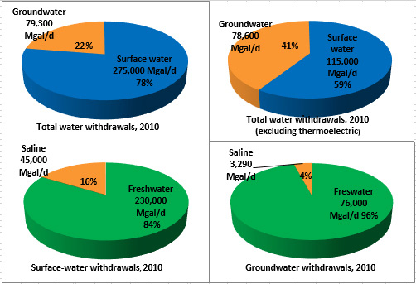
Humans are happy this happens because we make use of both kinds of water. In the United States in 2010, we used about 275 billion gallons of surface water per day,and about 79.3 billion gallons of groundwater per day. Although surface water is used more to supply drinking water and to irrigate crops, groundwater is vital in that it not only helps to keep rivers and lakes full, it also provides water for people in places where visible water is scarce, such as in desert towns of the western United States. Without groundwater, people would be sand-surfing in Palm Springs, California instead of playing golf.

How much water is there on (and in) the Earth? Here are some numbers you can think about:
- If all of Earth's water (oceans, icecaps and glaciers, lakes, rivers, groundwater, and water in the atmosphere was put into a sphere, then the diameter of that water ball would be about 860 miles (about 1,385 kilometers), a bit more than the distance between Salt Lake City, Utah to Topeka, Kansas. The volume of all water would be about 332.5 million cubic miles (mi³), or 1,386 million cubic kilometers (km³). A cubic mile of water equals more than 1.1 trillion gallons. A cubic kilometer of water equals about 264 billion gallons.
- About 3,100 mi³ (12,900 km³) of water, mostly in the form of water vapor, is in the atmosphere at any one time. If it all fell as precipitation at once, the Earth would be covered with only about 1 inch of water.
- The 48 contiguous (lower 48 states) United States receives a total volume of about 4 mi³ (17.7 km³) of precipitation each day.
- Each day, 280 mi³ (1,170 km³)of water evaporate or transpire into the atmosphere.
- If all of the world's water was poured on the contiguous United States, it would cover the land to a depth of about 107 miles (145 kilometers).
- Of the freshwater on Earth, much more is stored in the ground than is available in lakes and rivers. More than 2,000,000 mi³ (8,400,000 km³) of freshwater is stored in the Earth, most within one-half mile of the surface. But, if you really want to find freshwater, most is stored in the 7,000,000 mi³ (29,200,000 km³) of water found in glaciers and icecaps, mainly in the polar regions and in Greenland.

Where is Earth's water located?
For a detailed explanation of where Earth's water is, look at the data table below. Notice how of the world's total water supply of about 332.5 million mi³ of water, over 96 percent is saline. Of total freshwater, over 68 percent is locked up in ice and glaciers. Another 30 percent of freshwater is in the ground. Rivers are the source of most of the fresh surface water people use, but they only constitute about 300 mi³ (1,250 km³), about 1/10,000th of one percent of total water.
Note: Percentages may not sum to 100 percent due to rounding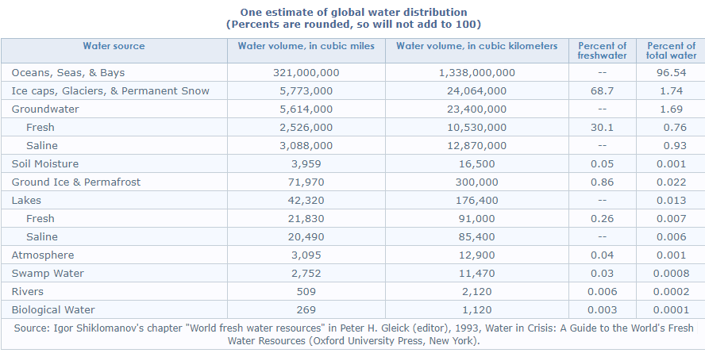

- WRITE A 2 OR MORE-PAGE BRIEF ON THE CURRENT FLOOD DISASTER IN NIGERIA. WHAT ARE THE CAUSATIVE FACTORS? PLOT A MEAN MONTHLY RAINFALL FOR NIGERIA AND THE AFFECTED STATE CAPITALS AND ANY LINKS BETWEEN RAINFALL AND FLOODING FOR THESE STATES
July greeted Nigerians with torrential downpours. The meteorologists said that the south western Nigeria, and Lagos in particular, had 4 to 6 inches of rain in the period from July 2 to July 8. After a very heavy rain that fell over the south western states over the weekend, a flood alert in Nigeria has been in full force.
The heaviest rain hit Suleja, a Niger State city located near Abuja. Most people did not expect the rainfall to be this long and excessive, so they were trapped in their homes. Many buildings collapsed as a result of the heavy rain. One man reported that his family perished under the debris of their house. His six children and two wives were stuck under the destroyed building.
Lagos State also suffered greatly from the flood. Because of the faulty drainage system, the city began to drown after several hours of incessant downpour. Victoria Island, Lekki, Ikoyi and several other expensive neighbourhoods in Lagos were left without electricity. There have been reports that dangerous animals, such as crocodiles, have been found in the flooded streets. The good news is that there are no reported casualties.
Flood in Nigeria today
This flood is not yet as deadly and disastrous as the ones that happened in 2012 and 2016. We should remind you that in 2012, almost 6000 houses were destroyed, 7.7 million people suffered from the aftermath, and 2 million people were unaccounted for. Nevertheless, the authorities are still struggling to deal with the aftermath of this year’s flood.
Flood in Nigeria news keep coming in. The number of casualties in Suleja rose from two reported cases to thirteen. This figure might grow even bigger over time, as the search for survivors and deceased continues. Many people have not been found or recovered; hospitals are struggling to treat all those affected by the flood.
The latest reports say that in Suleja, 500 people are missing, and no less than 90 buildings collapsed. The rain did not stop for 10 hours, and many feeble structures fell apart due to the pressure. Lagos suffered less, and most of the damage were to personal belongings of many citizens. However, the city’s infrastructure is left in shambles, as the roads are too flooded for the cars to be able to drive through.
The government officials warn people against leaving their homes until the water settles. Those who are stranded might have to find refuge in the nearest schools and hospitals. Medics warn people against consuming any food that has been touched by the flooded waters, and to wash their hands after coming into contact with it. The police are patrolling the territories around destroyed houses to prevent looting.
Causative Factors
This flood in Nigeria is a terrifying result of negligence from the government and relevant authorities. Nigeria has been suffering from flooding since the 1950s. Since then, not many improvements have been made in terms of preventing the floods from happening. Currently, everyone is spending more and more time on research of the outcomes of floods. It would be better if some of this time should be spent on researching the ways of flood prevention and implementing those methods.
Flood prone areas in Nigeria are mostly those that are located in the deltas of rivers Benue, Hadeja and Niger, as well as the coastal areas in the lowest parts of the country. This includes the states of Akwa-Ibom, Adamawa, Bayelsa, Cross River, Jigawa, Kaduna, Kano, Kebbi, Lagos, Ondo, and Oyo. The floods usually come between the months of July and October.
The enormous level of destruction is also linked to the poor planning of the urban areas. The recent changes in climate led to heavier downpours, and the houses that are too close to the large bodies of water are the ones that suffer the most. As the coastal areas attract the most people, the aftermaths of the floods are so severe.
The importance of a working drainage system cannot be overlooked. The problem of cities like Lagos is that the people dump waste in the drain. It blocks the drainage, so the excess water, instead of going away, collects in large quantities and spills out on the streets.
Nigeria is currently among 20 countries that will be negatively impacted by flooding in the future. If no changes are made, the country will have to face terrible consequences of the climate change
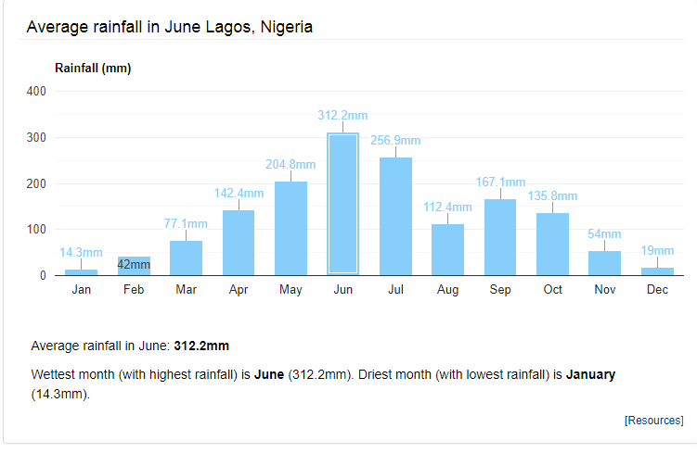

- PROFFER MODALITY TO PREVENT RE-OCCURRENCE OF FLOODING IN THESE STATES IN NIGERIA
- Introduce better flood warning systems. ...
- Modify homes and businesses to help them withstand floods. ...
- Construct buildings above flood levels
- Tackle climate change. ...
- Increase spending on flood defences
- Protect wetlands and introduce plant trees strategically. ...
- Restore rivers to their natural courses. ...
- Introduce water storage areas.

1. Introduce better flood warning systems
The UK must "improve our flood warning systems", giving people more time to take action during flooding, potentially saving lives, the deputy chief executive of the Environment Agency, David Rooke, said. Advance warning and pre-planning can significantly reduce the impact from flooding.

2. Modify homes and businesses to help them withstand floods
The focus should be on “flood resilience” rather than defence schemes, according to Laurence Waterhouse, director of civil engineering flood consultancy Pell Frischmann. He advised concreting floors and replacing materials such as MDF and plasterboard with more robust alternatives. “We are going to have to live with flooding. It's here to stay,” Mr Waterhouse said. “We need to be prepared." His recommendations were echoed by Mr Rooke, who suggested waterproofing homes and businesses and moving electric sockets higher up the walls to increase resilience.

Read more

3. Construct buildings above flood levels
Britain should construct all new buildings one metre from the ground to prevent flood damage, the former president of the Institution of Civil Engineers has suggested. Professor David Balmforth, who specialises in flood risk management, said conventional defences had to be supplemented with more innovative methods to lower the risk of future disasters.

4. Tackle climate change
Climate change has contributed to a rise in extreme weather events, scientists believe. Earlier this month the leader of the Green Party, Natalie Bennett, welcomed the landmark Paris Agreement, whereby governments from 195 countries pledged to “pursue efforts” to limit the increase in global average temperatures to 1.5°C above pre-industrial levels. “It is now crucial that world leaders deliver on the promise of Paris,” Ms Bennett said. “The pressure is now on the British government to reverse its disastrous environmental policy-making.”

5. Increase spending on flood defences
Figures produced by the House of Commons library suggest that real terms spending on flood defences has fallen by 20 per cent since David Cameron came to power. Yesterday [MON] the Prime Minister rejected this allegation, insisting the amount being spent had risen. Mr Cameron promised to review spending on flood defences after chairing a conference call of the government's emergency Cobra committee at the weekend.

6. Protect wetlands and introduce plant trees strategically
The creation of more wetlands – which can act as sponges, soaking up moisture – and wooded areas can slow down waters when rivers overflow. These areas are often destroyed to make room for agriculture and development, the WWF said. Halting deforestation and wetland drainage, reforesting upstream areas and restoring damaged wetlands could significantly reduce the impact of climate change on flooding, according to the conservation charity.

7. Restore rivers to their natural courses
Many river channels have been historically straightened to improve navigability. Remeandering straightened rivers by introducing their bends once more increases their length and can delay the flood flow and reduce the impact of the flooding downstream.

8. Introduce water storage areas
Following the severe flooding of 2009 a £5.6 million flood alleviation scheme was established in Thacka Beck, on the outskirts of Penrith, Cumbria. More than 675 metres of culverts underneath the streets of Penrith were replaced and a 76,000m³ flood storage reservoir – the equivalent of 30 Olympic sized swimming pools – was constructed upstream to hold back flood water. The risk of flooding from the beck was reduced from a 20 per cent chance in any given year to a one per cent chance, according to Cumbria Wildlife Trust.

9. Improve soil conditions
Inappropriate soil management, machinery and animal hooves can cause soil to become compacted so that instead of absorbing moisture, holding it and slowly letting it go, water runs off it immediately. Well drained soil can absorb huge quantities of rainwater, preventing it from running into rivers.

10. Put up more flood barriers
The Environment Agency uses a range of temporary or “demountable” defences in at-risk areas. These can be removed completely when waters recede. Temporary barriers can also be added to permanent flood defences, such as raised embankments, increasing the level of protection. “As the threat and frequency of flood risk increases, the use of passive flood defence has to be the only realistic long term solution,” Frank Kelly, CEO of UK Flood Barriers claimed earlier this month in Infrastructure Intelligence, a magazine for the infrastructure sector. Mr Kelly’s company was responsible for designing a self-activating flood barrier he said had proved to be “invaluable” in protecting properties close to the River Cocker.

- WRITE ON RECENT FLOODING IN OTHER PARTS OF THE WORLD: USA, JAPAN, INDIA ETC. CHOOSE ANY 2 COUNTRIES OR REGIONS OF THE WORLD. PROVIDE THE CAUSATIVE FACTOR FOR THE FLOOD. WRITE ALSO ON THE METHODS USED TO CHECK, AMELIORATE OR PREVENT THE RE-OCCURRENCE OF FLOODING IN THE LOCATIONS

History of flooding in USA- Much of the severe flood in American history has occurred around the Mississippi River in Texas. The flood in 2017 killed about 116people in the states. This was known as the catastrophic flood, a metaphor for “cleansing of humanity sins”.

History of flood in Japan; In later June through mid-July, 2018 successive heavy downpour in south-western Japan resulted in widespread, devastating floods and mudflows. The event is officially referred to as Heisei san-jū-nen shichi-gatsu gōu (平成30年7月豪雨, "Heavy rain of July, Heisei 30") by the Japan Meteorological Agency. As of 20 July, 225 people were confirmed dead across 15 prefectures with a further 13 people reported missing. More than 8 million people were advised or urged to evacuate across 23 prefectures. It is the deadliest freshwater flood-related disaster in the country since the 1982 Nagasaki flood when 299 people died.
Approximately 54,000 members of the Japan Self-Defense Forces, police and firefighters have been searching for the people trapped or injured in landslides and flooding triggered by the heavy rain, while the Japanese government has set up a liaison unit at the crisis management center of the prime minister's office to gather information

Methods used to check flood include;
- Construction of Dams
- Division Canals
- River defenses
- Flood plains and ground water replenishment.

6. PROVIDE NAMES OF WATER AND WEATHER RESOURCES AGENCIES AND ORGANISATIONS AT THREE
i) Local/state
ii) National
iii) international

Local/state
- Lagos State- The Lagos State Environmental Protection Agency (LASEPA)
- Oyo state- Oyo State Environmental Protection Commission
- Abia state- Abia State Environmental Protection Agency

National
- National Emergency Management Agency (NEMA)
- Nigeria Hydrological Services Agency (NIHSA)
- River basin Authority (Federal Ministry of Water Resources)
International
USA- U.S Environmental Protection Agency (EPA)
Japan- Japan Water Agency

