NAME: TAKIM-OJUA PRAISE BARONG
MATRIC NUMBER: 15/ENG03/058
DEPARTMENT: CIVIL ENGINEERING

- Occurrence and proportion of water resources of the earth
Water is distributed across earth. Most water in the Earth's atmosphere and crust comes from the world ocean's saline seawater, while freshwater accounts for only 2.5% of the total. Because the oceans that cover roughly 78% of the area of the Earth reflect blue light, the Earth appears blue from space, and is often referred to as the blue planet and the Pale Blue Dot. An estimated 1.5 to 11 times the amount of water in the oceans may be found hundreds of miles deep within the Earth's interior, although not in liquid form.
The oceanic crust is young, thin and dense, with none of the rocks within it dating from any older than the breakup of Pangaea. Because water is much denser than any gas, this means that water will flow into the "depressions" formed as a result of the high density of oceanic crust. (On a planet like Venus, with no water, the depressions appear to form a vast plain above which rise plateaux). Since the low density rocks of the continental crust contain large quantities of easily eroded salts of the alkali and alkaline earth metals, salt has, over billions of years, accumulated in the oceans as a result of evaporation returning the fresh water to land as rain and snow.
As a result, the vast bulk of the water on Earth is regarded as saline or salt water, with an average salinity of 35‰ (or 3.5%, roughly equivalent to 34 grams of salts in 1 kg of seawater), though this varies slightly according to the amount of runoff received from surrounding land. In all, water from oceans and marginal seas, saline groundwater and water from saline closed lakes amount to over 97% of the water on Earth, though no closed lake stores a globally significant amount of water. Saline groundwater is seldom considered except when evaluating water quality in arid regions.
The remainder of the Earth's water constitutes the planet's fresh water resource. Typically, fresh water is defined as water with a salinity of less than 1 percent that of the oceans - i.e. below around 0.35‰. Water with a salinity between this level and 1‰ is typically referred to as marginal water because it is marginal for many uses by humans and animals. The ratio of salt water to fresh water on Earth is around 40 to 1.
The planet's fresh water is also very unevenly distributed. Although in warm periods such as the Mesozoic and Paleogene when there were no glaciers anywhere on the planet all fresh water was found in rivers and streams, today most fresh water exists in the form of ice, snow, groundwater and soil moisture, with only 0.3% in liquid form on the surface. Of the liquid surface fresh water, 87% is contained in lakes, 11% in swamps, and only 2% in rivers. Small quantities of water also exist in the atmosphere and in living beings. Of these sources, only river water is generally valuable.
Most lakes are in very inhospitable regions such as the glacial lakes of Canada, Lake Baikal in Russia, Lake Khövsgöl in Mongolia, and the African Great Lakes. The North American Great Lakes, which contain 21% of the world's fresh water by volume,^{[2][3][4]} are the exception. They are located in a hospitable region, which is heavily populated. The Great Lakes Basin is home to 33 million people.^{[5]} The Canadian cities of Toronto, Hamilton, Ontario, St. Catharines, Niagara, Oshawa, Windsor, and Barrie, and the United States cities of Duluth, Milwaukee, Chicago, Gary, Detroit, Cleveland, Buffalo, and Rochester, are all located on shores of the Great Lakes.
Although the total volume of groundwater is known to be much greater than that of river runoff, a large proportion of this groundwater is saline and should therefore be classified with the saline water above. There is also a lot of fossil groundwater in arid regions that has never been renewed for thousands of years; this must not be seen as renewable water.
However, fresh groundwater is of great value, especially in arid countries such as India. Its distribution is broadly similar to that of surface river water, but it is easier to store in hot and dry climates because groundwater storages are much more shielded from evaporation than are dams. In countries such as Yemen, groundwater from erratic rainfall during the rainy season is the major source of irrigation water.
Because groundwater recharge is much more difficult to accurately measure than surface runoff, groundwater is not generally used in areas where even fairly limited levels of surface water are available. Even today, estimates of total groundwater recharge vary greatly for the same region depending on what source is used, and cases where fossil groundwater is exploited beyond the recharge rate (including the Ogallala Aquifer^{[6]}) are very frequent and almost always not seriously considered when they were first developed.

Distribution of saline and fresh water
The total volume of water on Earth is estimated at 1.386 billion km³ (333 million cubic miles), with 97.5% being salt water and 2.5% being fresh water. Of the fresh water, only 0.3% is in liquid form on the surface.^{[7][8][9]} In addition, the lower mantle of inner earth may hold as much as 5 times more water than all surface water combined (all oceans, all lakes, all rivers).^{[10]}
Source of water | Volume of water  in km³ (cu mi) | % total  water | % salt  water | % fresh  water | % liquid surface  fresh water
Oceans | 1,338,000,000 (321,000,000) | 96.5 | 99.0
Pacific Ocean | 669,880,000 (160,710,000) | 48.3 | 49.6
Atlantic Ocean | 310,410,900 (74,471,500) | 22.4 | 23.0
Indian Ocean | 264,000,000 (63,000,000) | 19.0 | 19.5
Southern Ocean | 71,800,000 (17,200,000) | 5.18 | 5.31
Arctic Ocean | 18,750,000 (4,500,000) | 1.35 | 1.39
Ice and snow | 24,364,000 (5,845,000) | 1.76 |  | 69.6
Glaciers | 24,064,000 (5,773,000) | 1.74 |  | 68.7
Antarctic ice sheet | 21,600,000 (5,200,000) | 1.56 |  | 61.7
Greenland ice sheet | 2,340,000 (560,000) | 0.17 |  | 6.68
Arctic islands | 83,500 (20,000) | 0.006 |  | 0.24
Mountain ranges | 40,600 (9,700) | 0.003 |  | 0.12
Ground ice and permafrost | 300,000 (72,000) | 0.022 |  | 0.86
Groundwater | 23,400,000 (5,600,000) | 1.69
Saline groundwater | 12,870,000 (3,090,000) | 0.93 | 0.95
Fresh groundwater | 10,530,000 (2,530,000) | 0.76 |  | 30.1
Soil moisture | 16,500 (4,000) | 0.0012 |  | 0.047
Lakes | 176,400 (42,300) | 0.013
Saline lakes | 85,400 (20,500) | 0.0062 | 0.0063
Caspian Sea | 78,200 (18,800) | 0.0056 | 0.0058
Other saline lakes | 7,200 (1,700) | 0.00052 | 0.00053
Fresh water lakes | 91,000 (22,000) | 0.0066 |  | 0.26 | 87.0
African Great Lakes | 30,070 (7,210) | 0.0022 |  | 0.086 | 28.8
Lake Baikal | 23,615 (5,666) | 0.0017 |  | 0.067 | 22.6
North American Great Lakes | 22,115 (5,306) | 0.0016 |  | 0.063 | 21.1
Other fresh water lakes | 15,200 (3,600) | 0.0011 |  | 0.043 | 14.5
Atmosphere | 12,900 (3,100) | 0.00093 |  | 0.037
Swamps | 11,470 (2,750) | 0.00083 |  | 0.033 | 11.0
Rivers | 2,120 (510) | 0.00015 |  | 0.0061 | 2.03
Biological water | 1,120 (270) | 0.000081 |  | 0.0032

Distribution of river water
The total volume of water in rivers is estimated at 2,120 km³ (510 cubic miles), or 2% of the surface fresh water on Earth.^{[7]} Rivers and basins are often compared not according to their static volume, but to their flow of water, or surface runoff. The distribution of river runoff across the Earth's surface is very uneven.
Continent or region | River runoff (km³/year) | Percent of world total
North America | 7,800 | 17.9
South America | 12,000 | 27.6
Europe | 2,900 | 6.7
Middle East and North Africa | 140 | 0.3
Sub-Saharan Africa | 4,000 | 9.2
Asia (excluding Middle East) | 13,300 | 30.6
Australia | 440 | 1.0
Oceania | 6,500 | 14.9
There can be huge variations within these regions. For example, as much as a quarter of Australia's limited renewable fresh water supply is found in almost uninhabited Cape York Peninsula.^{[11]} Also, even in well-watered continents, there are areas that are extremely short of water, such as Texas in North America, whose renewable water supply totals only 26 km³/year in an area of 695,622 km², or South Africa, with only 44 km³/year in 1,221,037 km².^{[11]} The areas of greatest concentration of renewable water are:
- The Amazon and Orinoco Basins (a total of 6,500 km³/year or 15 percent of global runoff)
- East Asia
  - Yangtze Basin - 1,000 km³/year
- South and Southeast Asia, with a total of 8,000 km³/year or 18 percent of global runoff
  - Brahmaputra Basin - 900 km³/year
  - Irrawaddy Basin - 500 km³/year
  - Mekong Basin - 450 km³/year
- Canada, with over 10 percent of world's river water and large numbers in lakes
  - Mackenzie River - over 250 km³/year
  - Yukon River - over 150 km³/year
- Siberia
  - Yenisey - over 5% of world's fresh water in basin - second largest after the Amazon
  - Ob River - over 500 km³/year
  - Lena River - over 450 km³/year
- New Guinea
  - Fly and Sepik Rivers - total over 300 km³/year in only about 150,000 km² of basin area.

Area, volume, and depth of the world ocean
Body of Water | Area (10⁶ km²) | Volume (10⁶ km³) | Mean Depth (m)
Atlantic Ocean | 82.4 | 323.6 | 3,926
Pacific Ocean | 165.2 | 707.6 | 4,282
Indian Ocean | 73.4 | 291.0 | 3,963
All oceans and seas | 361 | 1,370 | 3,796

Variability of water availability
Variability of water availability is important both for the functioning of aquatic species and also for the availability of water for human use: water that is only available in a few wet years must not be considered renewable. Because most global runoff comes from areas of very low climatic variability, the total global runoff is generally of low variability.
Indeed, even in most arid zones, there tends to be few problems with variability of runoff because most usable sources of water come from high mountain regions which provide highly reliable glacier melt as the chief source of water, which also comes in the summer peak period of high demand for water. This historically aided the development of many of the great civilizations of ancient history, and even today allows for agriculture in such productive areas as the San Joaquin Valley.
However, in Australia and Southern Africa, the story is different. Here, runoff variability is much higher than in other continental regions of the world with similar climates.^{[12]} Typically temperate (Köppen climate classification C) and arid (Köppen climate classification B) climate rivers in Australia and Southern Africa have as much as three times the coefficient of variation of runoff of those in other continental regions.^{[13]} The reason for this is that, whereas all other continents have had their soils largely shaped by Quaternary glaciation and mountain building, soils of Australia and Southern Africa have been largely unaltered since at least the early Cretaceous and generally since the previous ice age in the Carboniferous. Consequently, available nutrient levels in Australian and Southern African soils tend to be orders of magnitude lower than those of similar climates in other continents, and native flora compensate for this through much higher rooting densities (e.g. proteoid roots) to absorb minimal phosphorus and other nutrients. Because these roots absorb so much water, runoff in typical Australian and Southern African rivers does not occur until about 300 mm (12 inches) or more of rainfall has occurred. In other continents, runoff will occur after quite light rainfall due to the low rooting densities.
Climate type (Köppen^{[14]}) | Mean annual rainfall | Typical runoff ratio  for Australia and Southern Africa | Typical runoff ratio  for rest of the world
BWh | 250 mm (10 inches) | 1 percent (2.5 mm) | 10 percent (25 mm)
BSh (on Mediterranean fringe) | 350 mm (14 inches) | 3 percent (12 mm) | 20 percent (80 mm)
Csa | 500 mm (20 inches) | 5 percent (25 mm) | 35 percent (175 mm)
Caf | 900 mm (36 inches) | 15 percent (150 mm) | 45 percent (400 mm)
Cb | 1100 mm (43 inches) | 25 percent (275 mm) | 70 percent (770 mm)
The consequence of this is that many rivers in Australia and Southern Africa (as compared to extremely few in other continents) are theoretically impossible to regulate because rates of evaporation from dams mean a storage sufficiently large to theoretically regulate the river to a given level would actually allow very little draft to be used. Examples of such rivers include those in the Lake Eyre Basin. Even for other Australian rivers, a storage three times as large is needed to provide a third the supply of a comparable climate in southeastern North America or southern China. It also affects aquatic life, favouring strongly those species able to reproduce rapidly after high floods so that some will survive the next drought.
Tropical (Köppen climate classification A) climate rivers in Australia and Southern Africa do not, in contrast, have markedly lower runoff ratios than those of similar climates in other regions of the world. Although soils in tropical Australia and southern Africa are even poorer than those of the arid and temperate parts of these continents, vegetation can use organic phosphorus or phosphate dissolved in rainwater as a source of the nutrient. In cooler and drier climates these two related sources tend to be virtually useless, which is why such specialised means are needed to extract the most minimal phosphorus.
There are other isolated areas of high runoff variability, though these are basically due to erratic rainfall rather than different hydrology. These include:^{[13]}
- Southwest Asia
- The Brazilian Nordeste
- The Great Plains of the United States

Water in Earth's mantle
It is estimated an additional 1.5 to eleven times the amount of water in the oceans is contained in the Earth's interior,^{[15]} and some scientists have hypothesized that the water in the mantle is part of a "whole-Earth water cycle".^{[16]} The water in the mantle is dissolved in various minerals near the transition zone between Earth's upper and lower mantle. At temperatures of 1,100 °C (2,010 °F) and extreme pressures found deep underground, water breaks down into hydroxyls and oxygen.^{[17]} The existence of water was experimentally predicted in 2002,^{[18]} and direct evidence of the water was found in 2014 based on tests on a sample of ringwoodite.^{[19]} Further evidence for large quantities of water in the mantle was found in observations of melting in the transition zone from the USArray project.^{[20]} Liquid water is not present within the ringwoodite, rather the components of water (hydrogen and oxygen) are held within as hydroxide ions.
- FLOOD IN NIGERIA
July greeted Nigerians with torrential downpours. The meteorologists said that the southwestern Nigeria, and Lagos in particular, had 4 to 6 inches of rain in the period from July 2 to July 8. After a very heavy rain that fell over the southwestern states over the weekend, a flood alert in Nigeria has been in full force.
The heaviest rain hit Suleja, a Niger State city located near Abuja. Most people did not expect the rainfall to be this long and excessive, so they were trapped in their homes. Many buildings collapsed as a result of the heavy rain. One man reported that his family perished under the debris of their house. His six children and two wives were stuck under the destroyed building.
Lagos State also suffered greatly from the flood. Because of the faulty drainage system, the city began to drown after several hours of incessant downpour. Victoria Island, Lekki, Ikoyi and several other expensive neighborhoods in Lagos were left without electricity. There have been reports that dangerous animals, such as crocodiles, have been found in the flooded streets. The good news is that there are no reported casualties.
Flood in Nigeria today
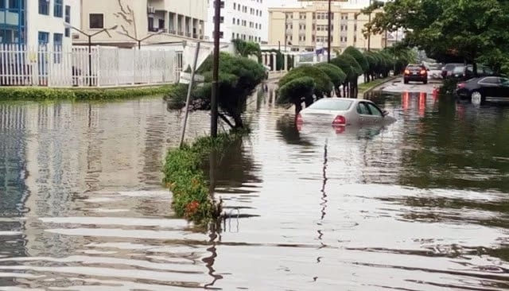
This flood is not yet as deadly and disastrous as the ones that happened in 2012 and 2016. We should remind you that in 2012, almost 6000 houses were destroyed, 7.7 million people suffered from the aftermath, and 2 million people were unaccounted for. Nevertheless, the authorities are still struggling to deal with the aftermath of this year’s flood.
Flood in Nigeria news keep coming in. The number of casualties in Suleja has risen from two reported cases to thirteen. This figure might grow even bigger over time, as the search for survivors and deceased continues. Many people have not been found or recovered; hospitals are struggling to treat all those affected by the flood.
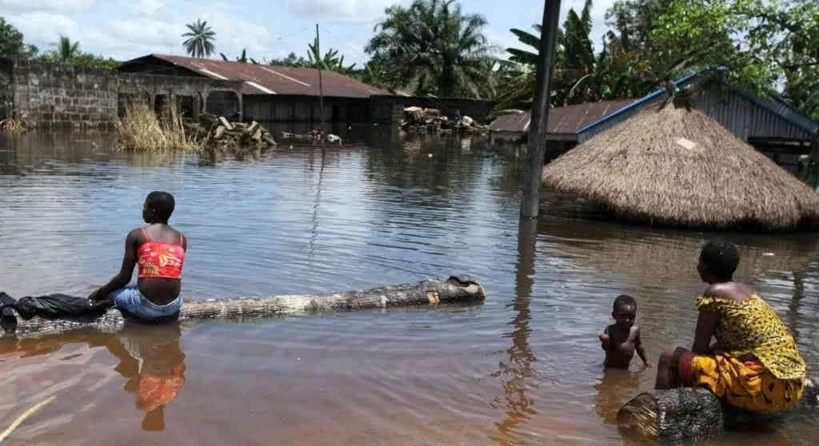
The latest reports say that in Suleja, 500 people are missing, and no less than 90 buildings collapsed. The rain did not stop for 10 hours, and many feeble structures fell apart due to the pressure. Lagos suffered less, and most of the damage were to personal belongings of many citizens. However, the city’s infrastructure is left in shambles, as the roads are too flooded for the cars to be able to drive through.
The government officials warn people against leaving their homes until the water settles. Those who are stranded might have to find refuge in the nearest schools and hospitals. Medics warn people against consuming any food that has been touched by the flooded waters, and to wash their hands after coming into contact with it. The police are patrolling the territories around destroyed houses to prevent looting.
What is the cause of the flood?
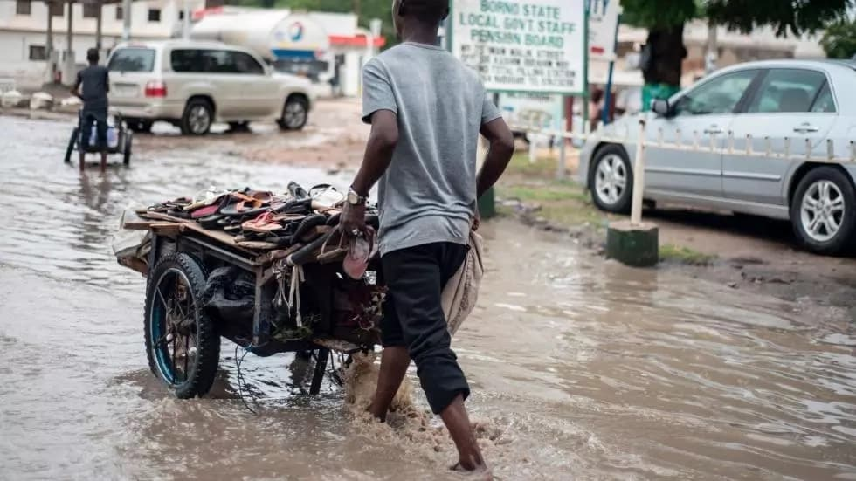
This flood in Nigeria is a terrifying result of negligence from the government and relevant authorities. Nigeria has been suffering from flooding since the 1950s. Since then, not many improvements have been made in terms of preventing the floods from happening. Currently, everyone is spending more and more time on research of the outcomes of floods. It would be better if some of this time should be spent on researching the ways of flood prevention and implementing those methods.
Flood prone areas in Nigeria are mostly those that are located in the deltas of rivers Benue, Hadeja and Niger, as well as the coastal areas in the lowest parts of the country. This includes the states of Akwa-Ibom, Adamawa, Bayelsa, Cross River, Jigawa, Kaduna, Kano, Kebbi, Lagos, Ondo, and Oyo. The floods usually come between the months of July and October.
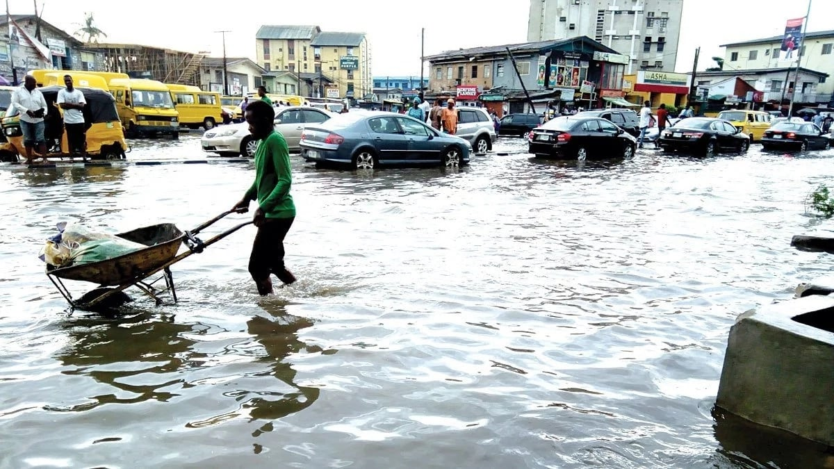
The enormous level of destruction is also linked to the poor planning of the urban areas. The recent changes in climate led to heavier downpours, and the houses that are too close to the large bodies of water are the ones that suffer the most. As the coastal areas attract the most people, the aftermaths of the floods are so severe.
The importance of a working drainage system cannot be overlooked. The problem of cities like Lagos is that the people dump waste in the drain. It blocks the drainage, so the excess water, instead of going away, collects in large quantities and spills out on the streets.
Nigeria is currently among 20 countries that will be negatively impacted by flooding in the future. If no changes are made, the country will have to face terrible consequences of the climate change. We hope that this particular flood would be dealt with soon, and that no one else will have to suffer from this natural disaster. Our prayers are with those who were affected by it. May God help us all!
Mean monthly rainfall data of 28 meteorological stations in Nigeria for the period 1911–1980 are analysed to examine trends in precipitation patterns in the country. Specifically, four 40-year periods (1911–50, 1921–60, 1931–70 and 1941–80) have been studied in detail.
Results show three prominent features. First, both the amount and area of the secondary rainfall maximum at 9°–10°N latitude in Nigeria has depreciated with time. Second, the belt of relative minimum rainfall, with its east-west axis almost coincident with the channels of the rivers Niger and Benue, appears to be expanding with time. Last, while places north of 8°N latitude (the mean axis of the belt of relative minimum rainfall) receive 90–100% of the annual total rainfall from April to October, fluctuations of the wet or rainy season contribution to total annual rainfall further south is about 84–88%.
These aberrations, which imply a decrease in the dry season contribution to the annual rainfall, suggest a drier environment in the long-term, especially if drought spells of the type 1969–73 and 1979–84 become a regular feature in West Africa. The planning implications are discussed in relation to water-use problems.

- History of flood in the affected states
The most horrifying Nigeria floods happened in July 2012. It killed 363 people. Over 2.1 million people were displaced.
This flood was referred to as the most harmful one experienced in the last 40 years. It affected about 7 million citizens. Losses and damages caused by the floods were up to N2.6 trillion.

On July 2 2012, there was a severe flood, which killed 35 people. The Plateau state suffered the effect the most. Heavy rains washed the dam, which caused the flooding of the local river. More than 1.5 inhabitants were without a roof. About 200 houses were destroyed.
In August, a number of floods which were caused by heavy rain storms in central Nigeria, killed 28 citizens. A high number of houses, bridges,and grounds were destroyed. About 1500 residents were evacuated.
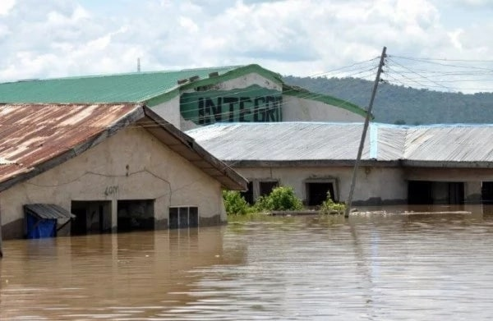
In October the northern state of Taraba could not escape from this sad fate. At least, 19 people died in flooded settlements.
In the Northern State of Sokoto, Nigeria in September, 2010, Flooding in a place called Kagara which is a small village near Goronyo town, worsened significantly. Basically the inhabitants of the village had had their village and all their homes and all their crops and all their storage of food completely destroyed. The reason that Kagara had been flooded, we believe, is because people had opened the gates on the dam to release the pressure so that the dam didn’t fail, but the spillway from the dam had completely failed and so the consequences of that was Kagara getting flooded. The water came very rapidly, demolishing houses, demolishing the buildings that people use to store their food, and destroying the crops. Tens of thousands of people have been displaced, roads, trees, buildings etc were submerged,
In the last three decades, the impacts of flooding have increasingly assumed from significant to threatening proportions, resulting in loss of lives and properties. Though detailed statistics are not available regarding the losses sustained by the urban dwellers and flood victims, it is obvious from the available records (table 1) that irreparable havocs have been sustained by the citizen of Nigeria due to what has become perennial natural disaster in our cities. Apart from houses that collapse by flooding, schools buildings and bridges sometimes collapse as well. Markets places and farmlands are submerged for weeks and sometimes are washed away.
The devastating effect of floods was not limited to houses and people. Many farmlands both arable and agro-forestry were swept away when schools and market places were submerged for weeks. Some animals lost their lives to flooding when many bridges collapsed and electric poles destroyed.
The effects could be classified as follows;
Cause, aggravate and precipitate diarrhea water-borne diseases, destroy farms, food and cash crops. Make the individual, communities and nation poor through disruption of services and the degradation of agriculture land Destroy human life, animal life and properties Damage and destroy buildings, bridges, dams, embankments, drains, roads, railways etc. Degrade the environment, spread infestations, soil and water are polluted by chemicals. Cause soil infertility through leaching and erosion of rich top soil Cause fire outbreaks.
- Modality to prevent reoccurrence of flooding
When Looking for Plots for building and Construction;
Find out if the area suffers often from floods. Find out how serious, or the level of the previous highest flood. Check if there are dams up, or close to where you are going to build or live. Seek expert advice and use appropriate building materials, in flood prone areas and build only in the approved way and in approved areas.
As a responsible citizen,
Help in every way to construct drains and ditches or embankments, to protect buildings, constructions, utilities etc. Never put refuse or solid materials in drains, and discourage others from doing so. Always help to desilt or clean gutters or drains and encourage others to do the same. Identify a higher place where you can run to during floods. Prevent becoming a victim to floods Know that no amount of sympathy and relief can make up for the pain, grief and the losses you will surfer from flood disaster. Educate yourself and others about floods, know the signals and behave as you are directed. Don’t remove plants or trees unnecessarily, help to replant burnt or cleared forests.
Measures to be taken by the State and Federal Government
Constantly monitor the risk of flooding; or find a means of measuring or checking water levels of rivers, streams and dams. Set up effective information or warning systems and centers for the population, especially against dam burst. Issue and strictly enforce regulations banning building and residing in flood prone zones or areas Build and develop infrastructure which will prevent or limit floods and protect the population. Form, train and equip management and rescue teams or provide spill off water to lower the water level dams. Systematically spill off water (after due warnings) to control the level of water in dams. Identify cause and plan to prevent its recurrence Arrange for and provide relief (food, water, clothing, shelter etc) Check for related water – borne diseases and immunize residents or offer preventive and curative treatments if need be. Desilt drains; or construct drains where needed. Remove or demolish all structures obstructing drainage Demolish badly damaged or destroyed structures and building that can obstruct free
TS06J - Hydrography and the Environment Innocent Chirisa, Zimbabwe Inclusive Cities and Housing: Analysis of stewardship instruments in Epworth, Zimbabwe
FIG Working Week 2011 Bridging the Gap between Cultures Marrakech, Morocco, 18-22 May 2011
14/15
flow of water Enact or enforce regulations, laws or bye laws to prevent/ mitigate flooding in the area.
- Recent flooding in other parts of the world
Flooding doesn’t just affect Nigeria as a country but also other parts of the world. Since one is in Nigeria, the cases of flooding were directed to Her alone. Flooding can be seen in other countries like I said earlier. I will be taken just two countries; India and Bangladesh.
India is another country that is prone to this disaster. It has the most GDP exposed at $14.3 billion. Also, Bangladesh is a distant second from India at $5.4 million.
Some 800,000 people have been displaced by the worst flooding in a century in southern India's Kerala state, as authorities rushed to bring drinking water to the most affected areas, officials said. Death tolls of more than 200 to 350 were reported by various news agencies. At least two trains carrying about 400,000 gallons of water moved to the flooded areas from the neighboring states of Madhya Pradesh and Maharashtra, Indian railway official Milind Deouskar said, according to the Press Trust of India news agency. After one of the trains arrived, P.H. Kurian, a top disaster management official in Kerala, said authorities had largely restored the state's water supply systems. "What we need right now is bottled water, which is easy to transport to remote and isolated places, where some people are still stranded," Kurian said. Officials have called it the worst flooding in Kerala in a century, with rainfall in some areas well over double that of a typical monsoon season. Rains were finally diminishing in parts of Kerala state Monday morning.
Thousands of rescuers were continuing efforts to reach out to stranded people and get relief supplies to isolated areas by hundreds of boats and nearly two dozen helicopters, Kurian said. He said weather conditions had improved considerably and expected the nearly 10,000 people still stranded to be rescued by Monday. An estimated 800,000 people have taken shelter in some 4,000 relief camps across Kerala, Kurian said. The downpours that started Aug. 8 have triggered floods and landslides and caused homes and bridges to collapse across Kerala, a picturesque state known for its quiet tropical backwaters and beautiful beaches.
In several villages in the suburbs of Chengannur, one of the worst-affected areas, carcasses of dead cattle were seen floating in muddy waters on Sunday as water began receding. However, vast rice fields continued to be marooned and many vehicles were submerged. In some villages, the floodwaters had entered homes.
Rescuers in a motorboat reached a hamlet where they tried in vain to persuade an 80-year-old woman, Bhavani Yamma, to be taken to a government-run shelter from her partially submerged single-story house.
"I will not come. This is my home and I will die here," said Yamma, who lives alone.
The team later rescued a 61-year-old kidney ailment patient, Raveendran, who needs dialysis twice a week.
One of the rescuers, Rajagopal, a police constable who uses only one name, said initially "we didn't anticipate it would be such a big disaster." But he said that by Wednesday, "we realized it's really big. "Officials estimate that more than 6,000 miles of roads have been damaged. One of the state's major airports, in the city of Kochi, was closed this past Tuesday because of the flooding. It is scheduled to remain closed until Aug. 26. The Indian government opened a naval air base in Kochi for commercial flights starting Monday morning. The first flight landed Monday morning at the naval air station in the city of Kochi, where the commercial airport has been closed for nearly a week. The Air India flight came from Bangalore in the nearby state of Karnataka, Suresh Prabhu, the minister of civil aviation, said on Twitter.
Other air bases in the region should open to commercial traffic soon, he said. Officials have put initial storm damage estimates at nearly $3 billion. In Vatican City on Sunday, Pope Francis held a moment of silence during his noontime blessing to pray for Kerala flood victims. "I am close to the church in Kerala, which is on the front lines in providing aid to the people," Francis said. He called for solidarity and "the concrete assistance of the international community."Kerala has a sizeable and ancient Christian community. Francis had hoped to visit India last year when he visited Bangladesh, but preparations fell apart in New Delhi and the Vatican added Myanmar to his trip instead.
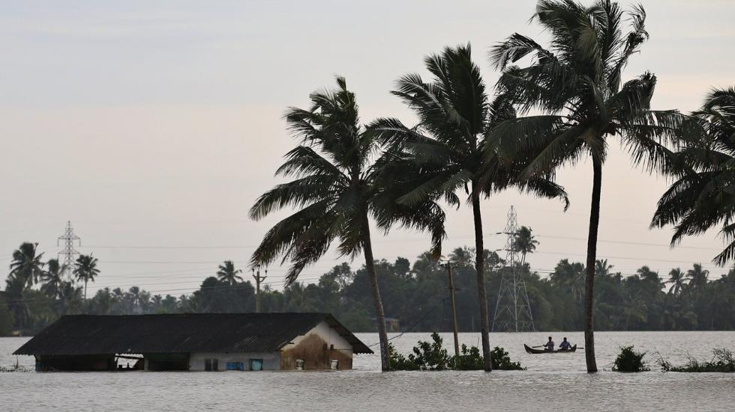

Floods in Bangladesh
Bangladesh is prone to flooding due to being situated on the Ganges Delta and the many distributaries flowing into the Bay of Bengal. Coastal flooding, combined with the bursting of river banks is common, and severely affects the landscape and society of Bangladesh. 80% of Bangladesh is floodplain, and it has an extensive sea coastline, rendering the nation very much at risk of periodic widespread damage. Whilst more permanent defences, strengthened with reinforced concrete, are being built, many embankments are composed purely of soil and turf and made by local farmers. Flooding normally occurs during the monsoon season from June to September. The convectional rainfall of the monsoon is added to by relief rainfall caused by the Himalayas. Meltwater from the Himalayas is also a significant input.

References
  - ^ USGS - Earth's water distribution
  - ^ "Great Lakes – U.S. EPA". Epa.gov. 2006-06-28. Retrieved 2011-02-19.
  - ^ "LUHNA Chapter 6: Historical Landcover Changes in the Great Lakes Region". Biology.usgs.gov. 2003-11-20. Archived from the original on 2012-01-11. Retrieved 2011-02-19.
  - ^ Ghassemi, Fereidoun (2007). Inter-basin water transfer. Cambridge, Cambridge University Press. ISBN 0-521-86969-2.
  - ^ "Archived copy". Archived from the original on 2015-11-01. Retrieved 2015-10-29.
  - ^ Reisner, Marc; Cadillac Desert: The American West and its Disappearing Water; pp. 438-442. ISBN 0-14-017824-4
  - ^ ª ^{b} Where is Earth's water?, United States Geological Survey.
  - ^ Eakins, B.W. and G.F. Sharman, Volumes of the World's Oceans from ETOPO1, NOAA National Geophysical Data Center, Boulder, CO, 2010.
  - ^ Water in Crisis: Chapter 2, Peter H. Gleick, Oxford University Press, 1993.
  - ^ Harder, Ben. "Inner Earth May Hold More Water Than the Seas". National Geographic. Retrieved 14 November 2013.
  - ^ ª ^{b} Brown, J. A. H.; Australia’s surface water resources. ISBN 978-0-644-02617-8.
  - ^ McMahon, T.A. and Finlayson, B.L.; Global Runoff: Continental Comparisons of Annual Flows and Peak Discharges. ISBN 3-923381-27-1.
  - ^ ª ^{b} Peel, Murray C.; McMahon, Thomas A. & Finlayson, Brian L. (2004). "Continental differences in the variability of annual runoff: update and reassessment". Journal of Hydrology. 295 (1–4): 185–197. Bibcode:2004JHyd..295..185P. doi:10.1016/j.jhydrol.2004.03.004.
  - ^ This section uses a slightly modified version of the Köppen system found in The Times Atlas of the World, 7th edition. ISBN 0-7230-0265-7
  - ^ Crocket, Christopher (5 September 2015). "Quest to trace origin of Earth's water is 'a complete mess'". Science News. Retrieved 1 October 2015.
  - ^ Melissa Davey (12 Jun 2014). "Earth may have underground 'ocean' three times that on surface". The Guardian. Retrieved 13 Mar 2015.
  - ^ "Earth found hiding huge reservoirs of water 400 miles below...but not water as we know it : SCIENCE : Tech Times". Tech Times. 16 June 1015. Retrieved 13 October 2015.
  - ^ Ben Harder (7 Mar 2002). "Inner Earth May Hold More Water Than the Seas". National Geographic. Retrieved 13 Mar 2015.
  - ^ ª ^{b} Becky Oskin (12 Mar 2014). "Rare Diamond Confirms That Earth's Mantle Holds an Ocean's Worth of Water". Scientific American. Retrieved 13 Mar 2015.
  - ^ HENRY FOUNTAIN (6 Jun 2014). "The Earth's Hidden Ocean". New York Times. Retrieved 13 Mar 2015.

