Question 4a
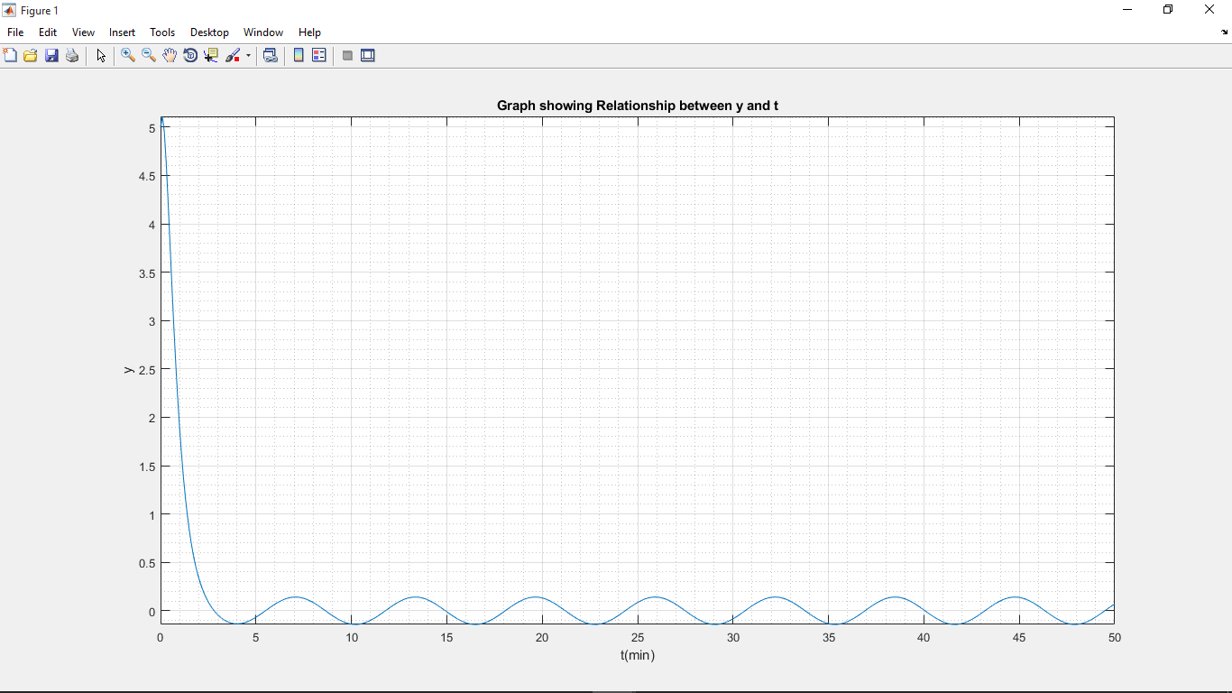
The code for 4a
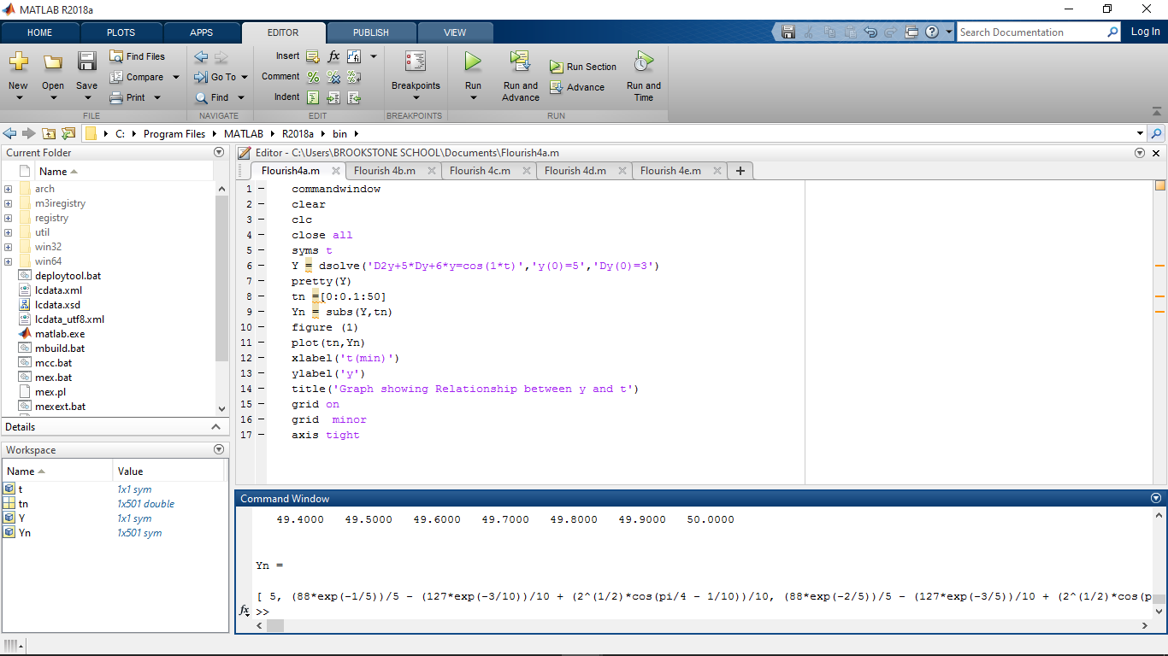

Question 4b Code and solution
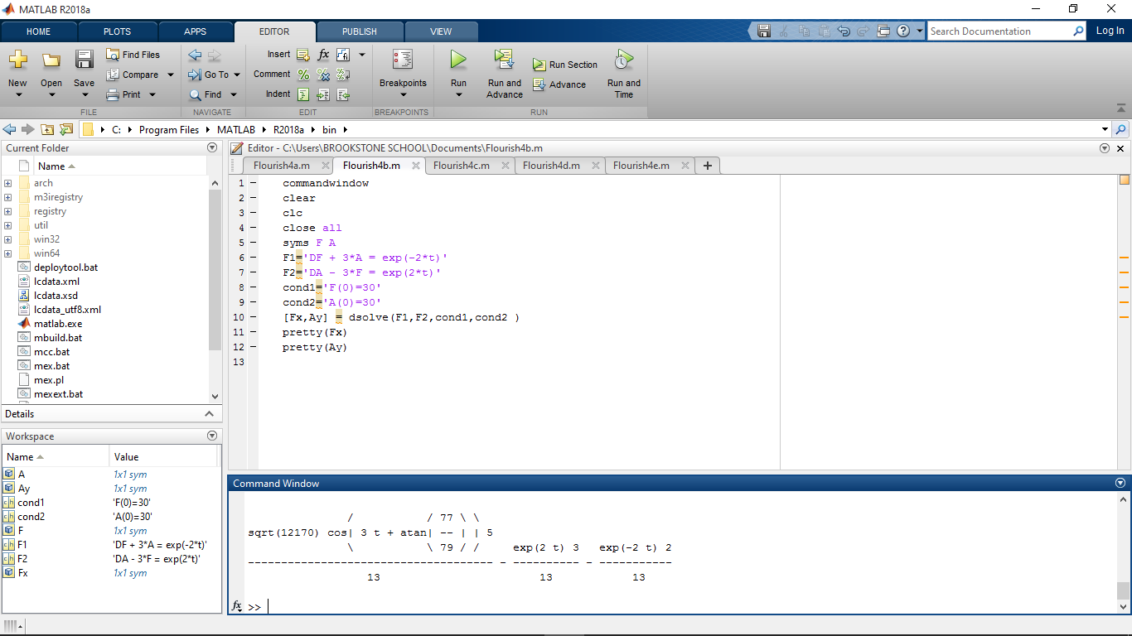
Question 4c Code and solution
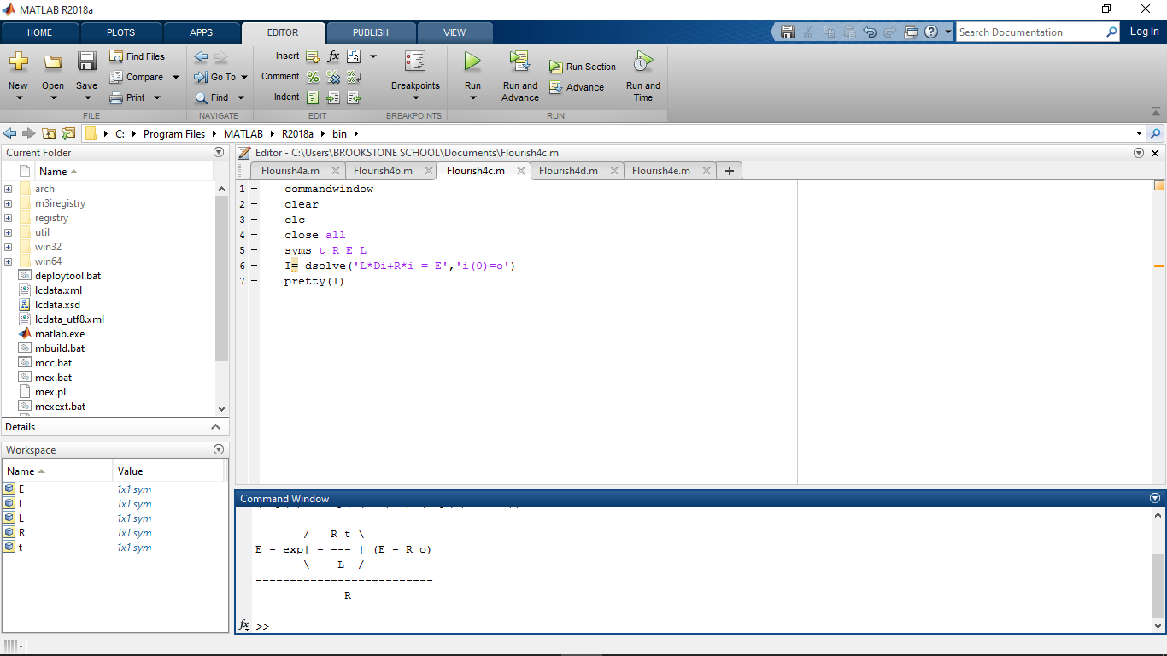

Question 4d Code and Solution
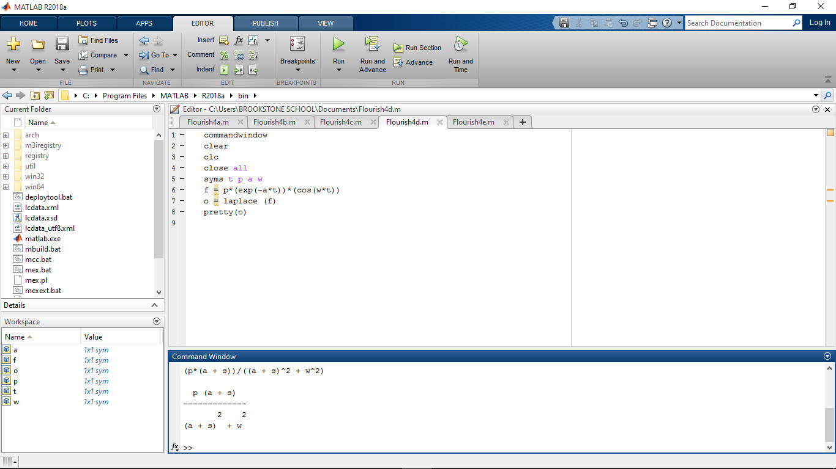
Question 4e Code and solution
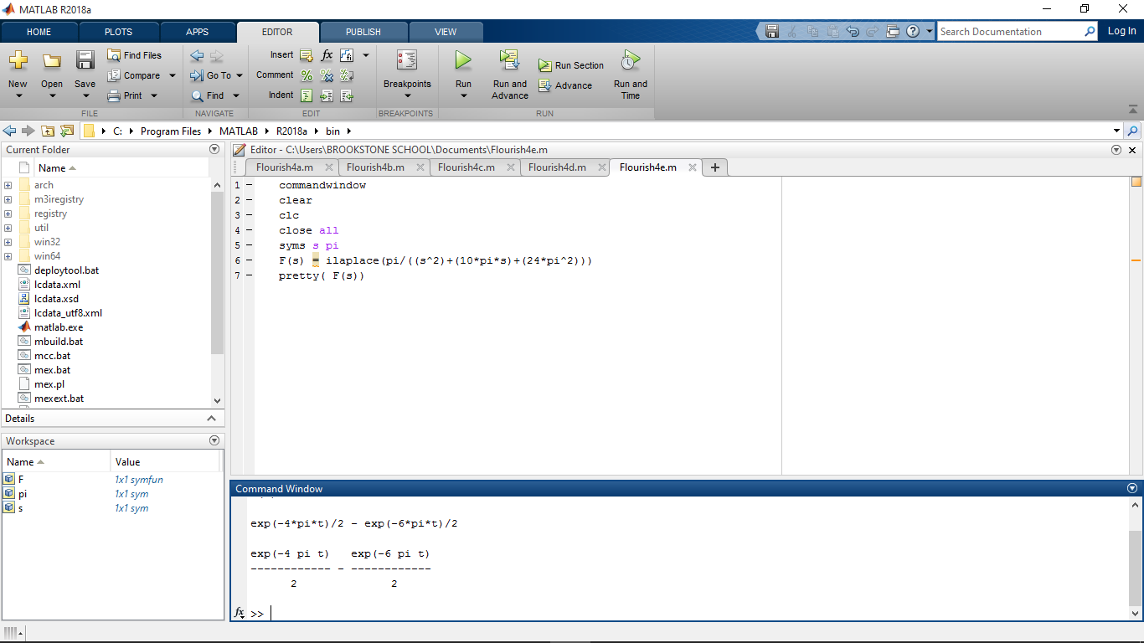

CODES
4a

commandwindow
clear
clc
close all
syms t
Y = dsolve('D2y+5*Dy+6*y=cos(1*t)','y(0)=5','Dy(0)=3')
pretty(Y)
tn =[0:0.1:50]
Yn = subs(Y,tn)
figure (1)
plot(tn,Yn)
xlabel('t(min)')
ylabel('y')
title('Graph showing Relationship between y and t')
grid on
grid minor
axis tight

4B
commandwindow
clear
clc
close all
syms F A
F1='DF + 3*A = exp(-2*t)'
F2='DA - 3*F = exp(2*t)'
cond1='F(0)=30'
cond2='A(0)=30'
[Fx,Ay] = dsolve(F1,F2,cond1,cond2 )
pretty(Fx)
pretty(Ay)

4C
commandwindow
clear
clc
close all
syms t R E L
I= dsolve('L*Di+R*i = E','i(0)=o')
pretty(I)

4D
commandwindow
clear
clc
close all
syms t p a w
f = p*(exp(-a*t))*(cos(w*t))
o = laplace (f)
pretty(o)

4E
commandwindow
clear
clc
close all
syms s pi
F(s) = ilaplace(pi/((s^2)+(10*pi*s)+(24*pi^2)))
pretty( F(s))

