14/ENG01/014
OLOWOMEYE, Emmanuel Olamide
CHEMICAL ENGINEERING
CHE 532:
ASSIGNMENT 1

GAS CHROMATOGRAPHY–MASS SPECTROMETRY
According to Wikipedia, Gas chromatography–mass spectrometry (GC-MS) is an analytical method that combines the features of gas-chromatography and mass spectrometry to identify different substances within a test sample. Applications of GC-MS include drug detection, fire investigation, environmental analysis, explosives investigation, and identification of unknown samples, including that of material samples obtained from planet Mars during probe missions as early as the 1970s. GC-MS can also be used in airport security to detect substances in luggage or on human beings. Additionally, it can identify trace elements in materials that were previously thought to have disintegrated beyond identification. It allows analysis and detection even of tiny amounts of a substance. GC-MS has been regarded as a "gold standard" for forensic substance identification because it is used to perform a 100% specific test, which positively identifies the presence of a particular substance. A nonspecific test merely indicates that any of several in a category of substances is present. Although a nonspecific test could statistically suggest the identity of the substance, this could lead to false positive identification.
The GC-MS is composed of two major building blocks: the gas chromatograph and the mass spectrometer. The schematic of a typical GC MS system in given in Figure 1 below.
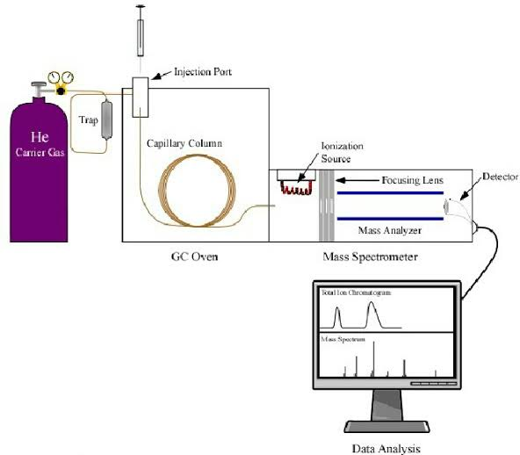
Figure 1: Schematic of GC MS system

GAS CHROMATOGRAPHY
Gas chromatography (GC) is a common type of chromatography used in analytical chemistry for separating and analyzing compounds that can be vaporized without decomposition. Typical uses of GC include testing the purity of a particular substance, or separating the different components of a mixture (the relative amounts of such components can also be determined). In some situations, GC may help in identifying a compound. In preparative chromatography, GC can be used to prepare pure compounds from a mixture. In gas chromatography, the mobile phase (or "moving phase") is a carrier gas, usually an inert gas such as helium or an unreactive gas such as nitrogen. Helium remains the most commonly used carrier gas in about 90% of instruments although hydrogen is preferred for improved separations. The stationary phase is a microscopic layer of liquid or polymer on an inert solid support, inside a piece of glass or metal tubing called a column (an homage to the fractionating column used in distillation). The instrument used to perform gas chromatography is called a gas chromatograph (or "aerograph", "gas separator"). The gaseous compounds being analyzed interact with the walls of the column, which is coated with a stationary phase. This causes each compound to elute at a different time, known as the retention time of the compound. The comparison of retention times is what gives GC its analytical usefulness. The schematic of a typical GC system is given in Figure 2 below.
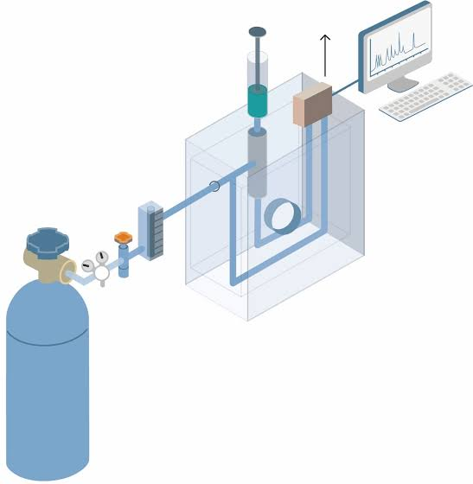
Figure 2: Schematic of GC system

COMPARISON BETWEEN GC AND GCMS
The gas chromatography technique is used to separate different molecule (containing different weight, size, binding affinity to the column) on the basis of their volatility.
The inert gases used as mobile phase, assist molecules to move. Many times gas chromatography does not give appropriate separation results because of their close molecular weight, no speed difference, same/close affinities in column. To overcome this situation gas chromatograph adjunct with Mass Spectrometry detector is used, which ionizes chemical species and sorts the ions based on their mass-to-charge ratio.

REFERENCES
- https://en.wikipedia.org/wiki/Gas_chromatography
- https://en.wikipedia.org/wiki/Gas_chromatography%E2%80%93mass_spectrometry

