NAME: ABBEY FLOURISH OBARI-AKASE
MATRIC NUMBER: 16/ENG04/001
DEPARTMENT: ELECTRICAL/ELECTRONICS ENGINEERING
COURSE: ENG382
ASSIGNMENT 3

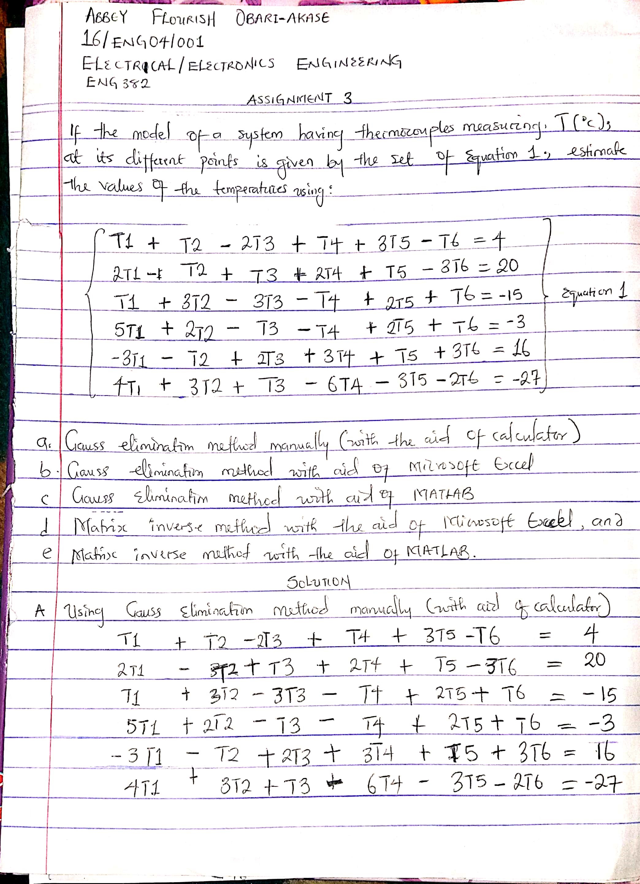
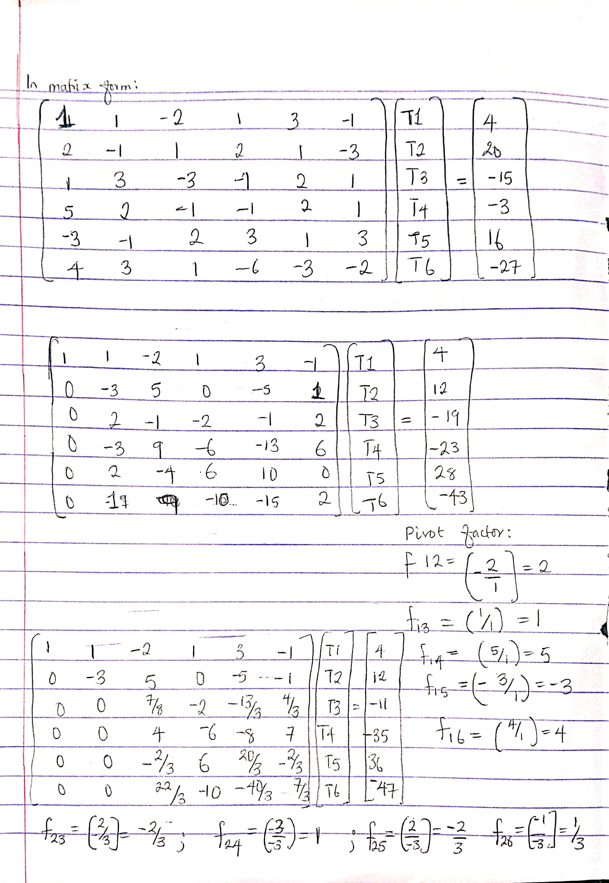
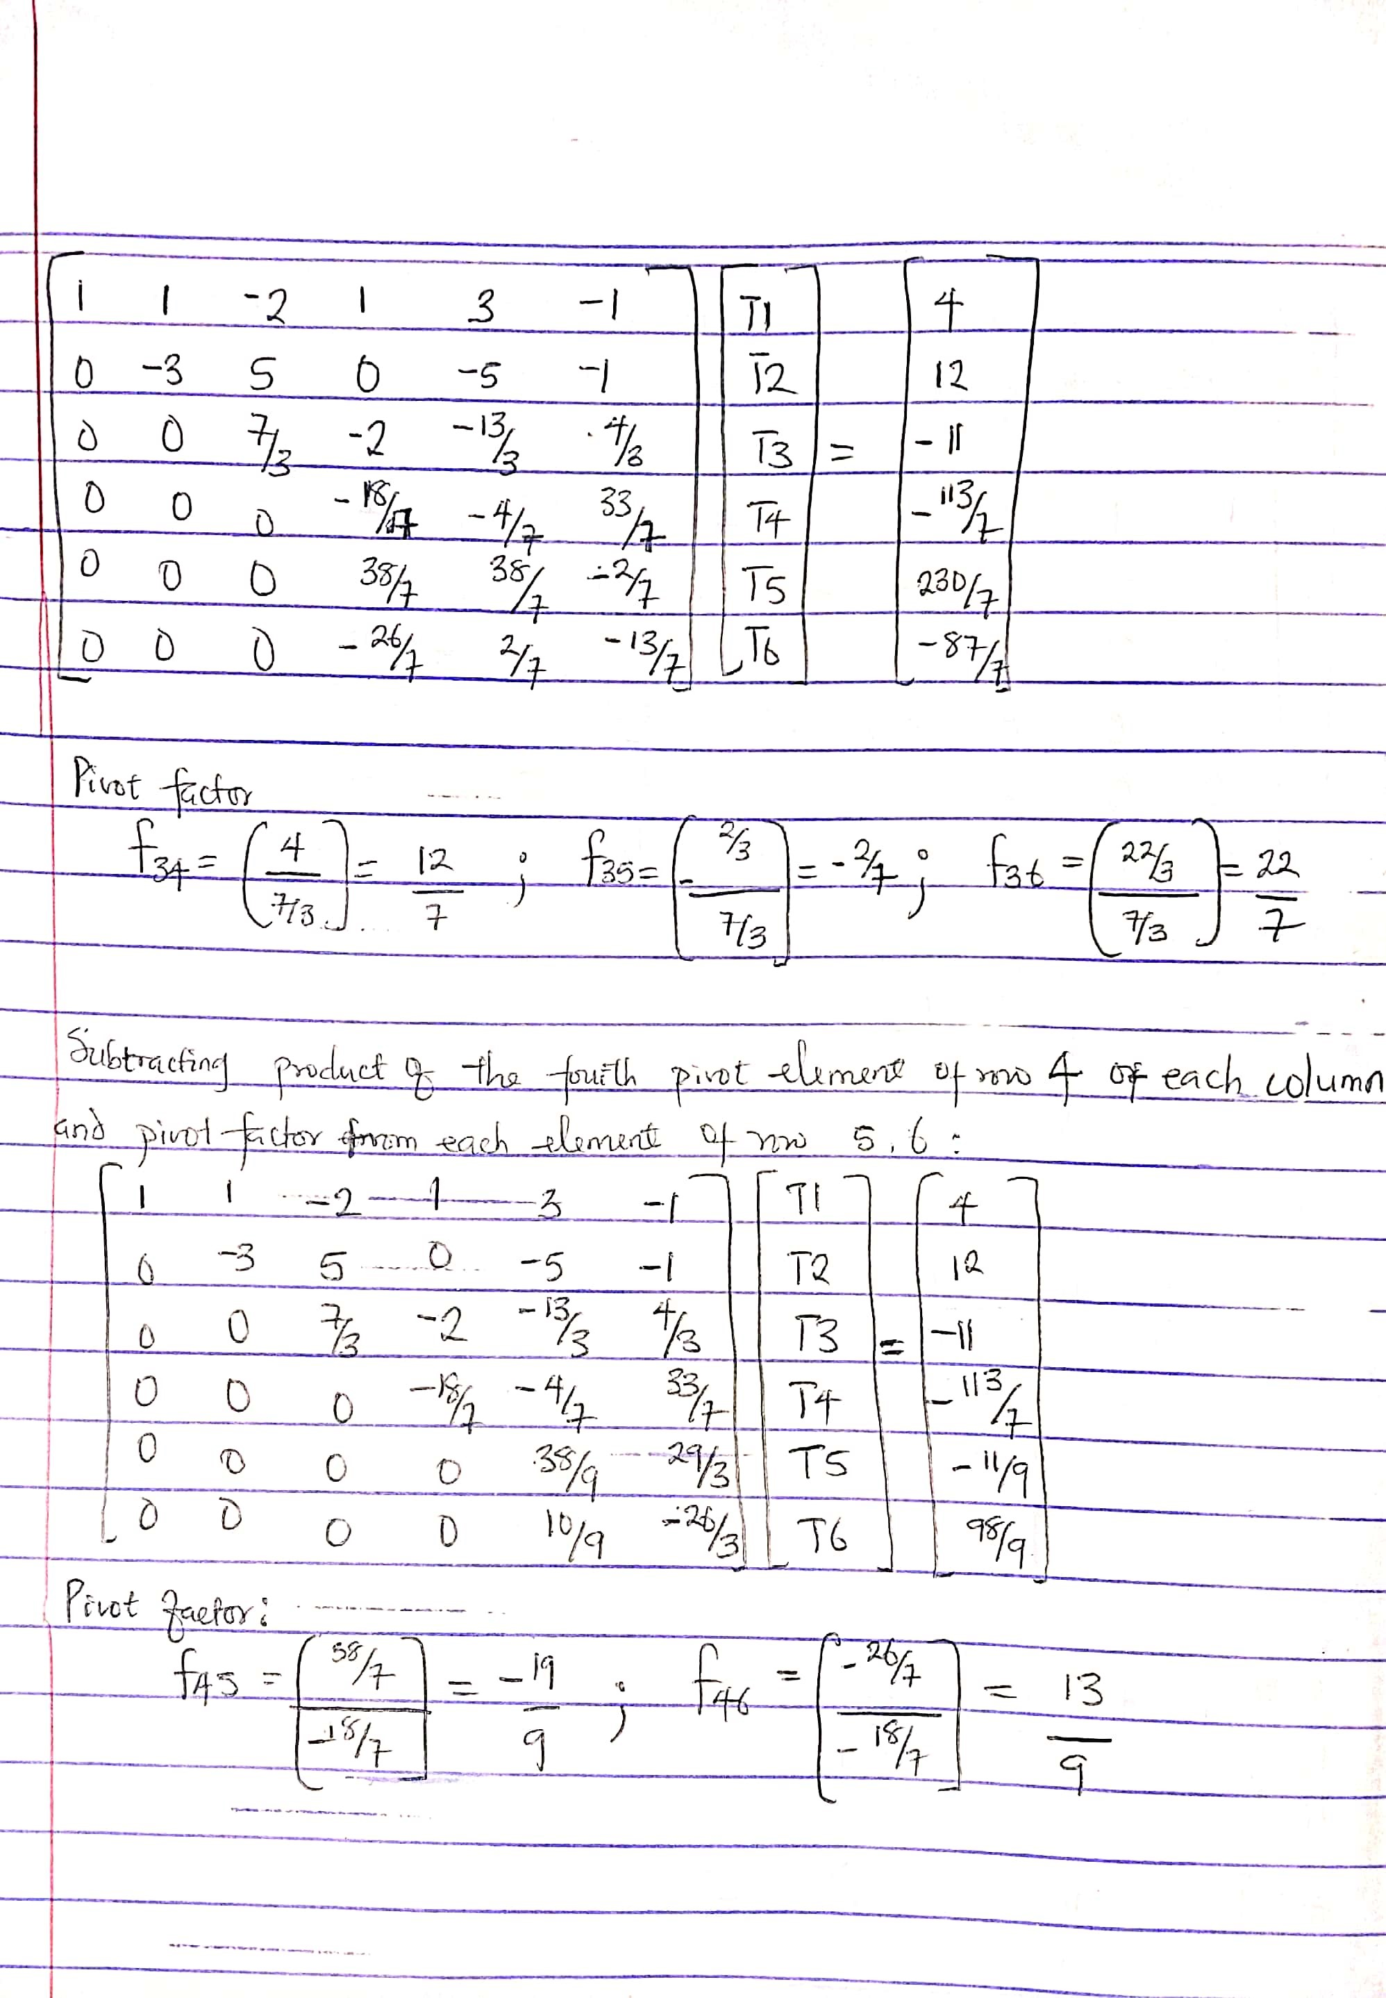
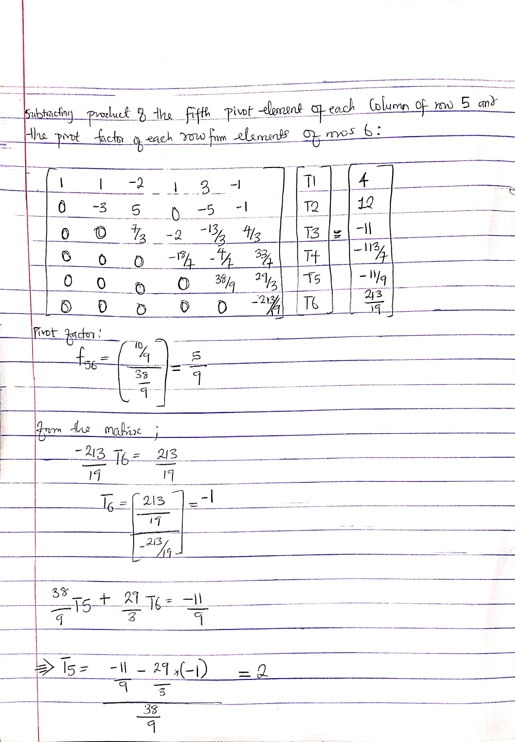
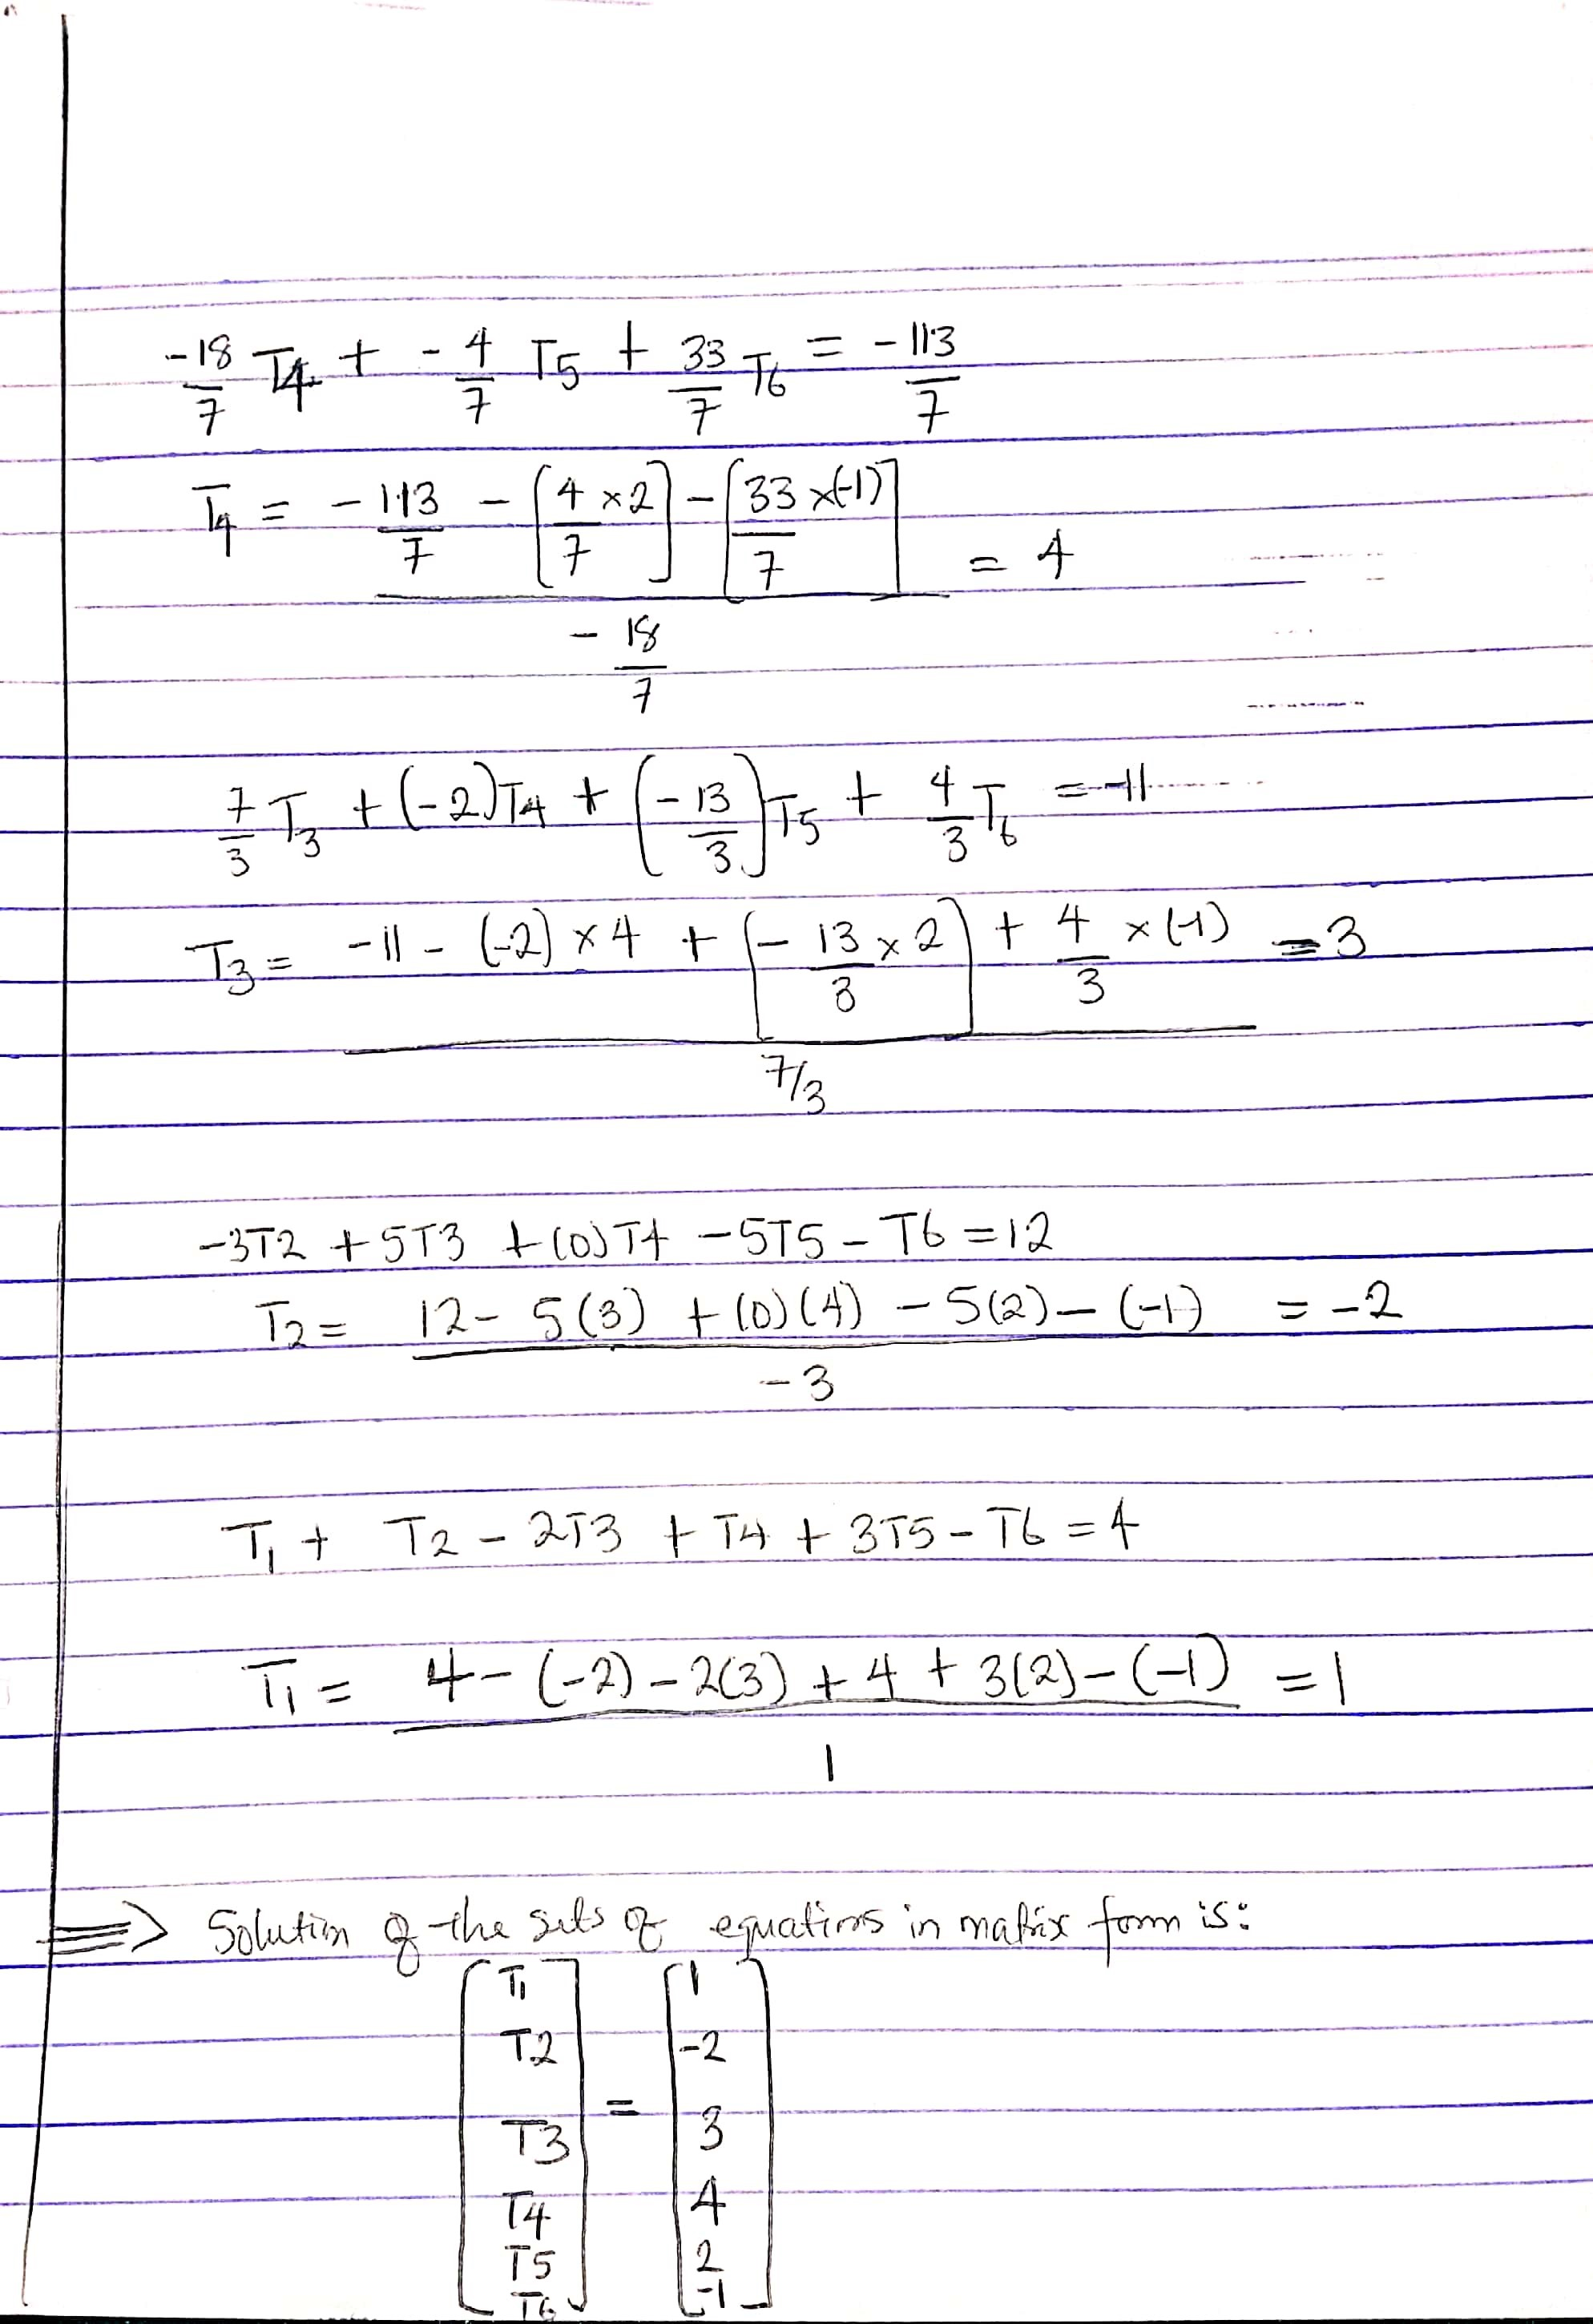
SOLUTION 2
MS EXCEL
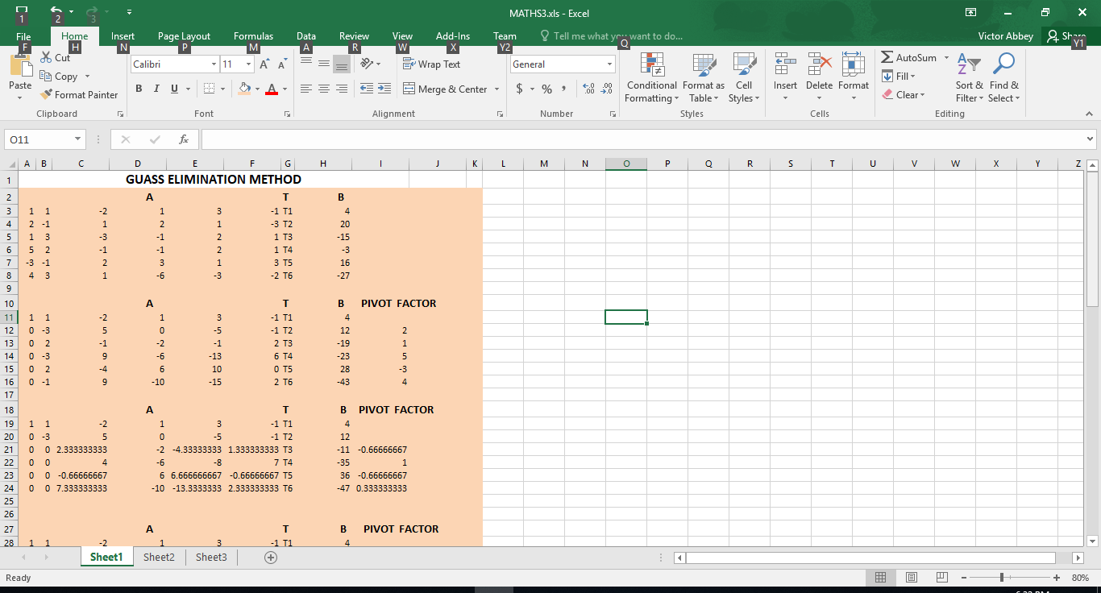
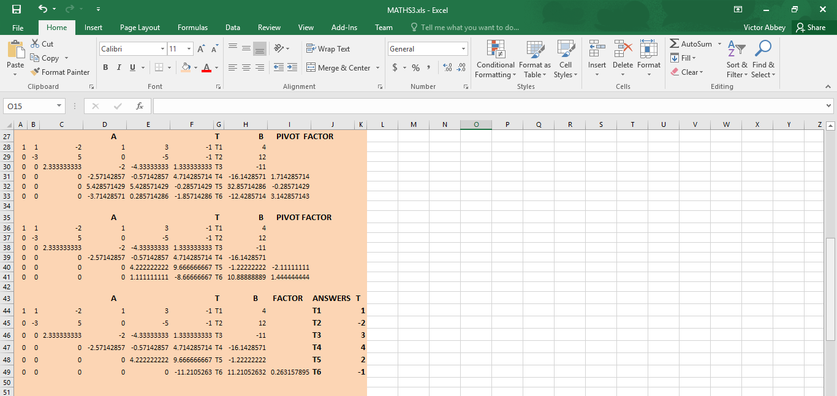

SOLUTION 3
MATLAB CODE:
commandwindow
clear
clc
close all
format long g
A = [1 1 -2 1 3 -1
2 -1 1 2 1 -3
1 3 -3 -1 2 1
5 2 -1 -1 2 1
-3 -1 2 3 1 3
4 3 1 -6 -3 -2];
A = [A(1,1), A(1,2), A(1,3),A(1,4), A(1,5) A(1,6)
A(2,1), A(2,2), A(2,3),A(2,4), A(2,5) A(2,6)
A(3,1), A(3,2), A(3,3) A(3,4), A(3,5) A(3,6)
A(4,1), A(4,2), A(4,3) A(4,4), A(4,5) A(4,6)
A(5,1), A(5,2), A(5,3) A(5,4), A(5,5) A(5,6)
A(6,1), A(6,2), A(6,3) A(6,4), A(6,5) A(6,6)]
B =[4
20
-15
-3
16
-27];
B = [B(1,1)
B(2,1)
B(3,1)
B(4,1)
B(5,1)
B(6,1)]

f12= A(2,1)/A(1,1)
f13= A(3,1)/A(1,1)
f14= A(4,1)/A(1,1)
f15= A(5,1)/A(1,1)
f16= A(6,1)/A(1,1)

C = [A(1,1), A(1,2), A(1,3), A(1,4), A(1,5) A(1,6)
A(2,1)-f12*A(1,1), A(2,2)-f12*A(1,2), A(2,3)-f12*A(1,3),A(2,4)-f12*A(1,4), A(2,5)-f12*A(1,5), A(2,6)-f12*A(1,6)
A(3,1)-f13*A(1,1), A(3,2)-f13*A(1,2), A(3,3)-f13*A(1,3),A(3,4)-f13*A(1,4), A(3,5)-f13*A(1,5), A(3,6)-f13*A(1,6)
A(4,1)-f14*A(1,1), A(4,2)-f14*A(1,2), A(4,3)-f14*A(1,3),A(4,4)-f14*A(1,4), A(4,5)-f14*A(1,5), A(4,6)-f14*A(1,6)
A(5,1)-f15*A(1,1), A(5,2)-f15*A(1,2), A(5,3)-f15*A(1,3),A(5,4)-f15*A(1,4), A(5,5)-f15*A(1,5), A(5,6)-f15*A(1,6)
A(6,1)-f16*A(1,1), A(6,2)-f16*A(1,2), A(6,3)-f16*A(1,3),A(6,4)-f16*A(1,4), A(6,5)-f16*A(1,5), A(6,6)-f16*A(1,6)
]

D = [B(1,1)
B(2,1)-f12*B(1,1)
B(3,1)-f13*B(1,1)
B(4,1)-f14*B(1,1)
B(5,1)-f15*B(1,1)
B(6,1)-f16*B(1,1)]

f23= C(3,2)/C(2,2)
f24= C(4,2)/C(2,2)
f25= C(5,2)/C(2,2)
f26= C(6,2)/C(2,2)

E = [C(1,1), C(1,2), C(1,3), C(1,4), C(1,5) C(1,6)
C(2,1), C(2,2), C(2,3), C(2,4), C(2,5) C(2,6)
C(3,1), C(3,2)-f23*C(2,2), C(3,3)-f23*C(2,3),C(3,4)-f23*C(2,4), C(3,5)-f23*C(2,5), C(3,6)-f23*C(2,6)
C(4,1), C(4,2)-f24*C(2,2), C(4,3)-f24*C(2,3),C(4,4)-f24*C(2,4), C(4,5)-f24*C(2,5), C(4,6)-f24*C(2,6)
C(5,1), C(5,2)-f25*C(2,2), C(5,3)-f25*C(2,3),C(5,4)-f25*C(2,4), C(5,5)-f25*C(2,5), C(5,6)-f25*C(2,6)
C(6,1), C(6,2)-f26*C(2,2), C(6,3)-f26*C(2,3),C(6,4)-f26*C(2,4), C(6,5)-f26*C(2,5), C(6,6)-f26*C(2,6)
]
F = [D(1,1)
D(2,1)
D(3,1)-f23*D(2,1)
D(4,1)-f24*D(2,1)
D(5,1)-f25*D(2,1)
D(6,1)-f26*D(2,1)]

f34= E(4,3)/E(3,3)
f35= E(5,3)/E(3,3)
f36= E(6,3)/E(3,3)

G = [E(1,1), E(1,2), E(1,3), E(1,4), E(1,5) E(1,6)
E(2,1), E(2,2), E(2,3), E(2,4), E(2,5) E(2,6)
E(3,1), E(3,2), E(3,3),E(3,4), E(3,5), E(3,6)
E(4,1), E(4,2), E(4,3)-f34*E(3,3),E(4,4)-f34*E(3,4), E(4,5)-f34*E(3,5), E(4,6)-f34*E(3,6)
E(5,1), E(5,2), E(5,3)-f35*E(3,3),E(5,4)-f35*E(3,4), E(5,5)-f35*E(3,5), E(5,6)-f35*E(3,6)
E(6,1), E(6,2), E(6,3)-f36*E(3,3),E(6,4)-f36*E(3,4), E(6,5)-f36*E(3,5), E(6,6)-f36*E(3,6)]

H = [F(1,1)
F(2,1)
F(3,1)
F(4,1)-f34*F(3,1)
F(5,1)-f35*F(3,1)
F(6,1)-f36*F(3,1)]

f45= G(5,4)/G(4,4)
f46= G(6,4)/G(4,4)
I = [G(1,1), G(1,2), G(1,3), G(1,4), G(1,5) G(1,6)
G(2,1), G(2,2), G(2,3), G(2,4), G(2,5) G(2,6)
G(3,1), G(3,2), G(3,3), G(3,4), G(3,5), G(3,6)
G(4,1), G(4,2), G(4,3), G(4,4), G(4,5), G(4,6)
G(5,1), G(5,2), G(5,3), G(5,4)-f45*G(4,4), G(5,5)-f45*G(4,5), G(5,6)-f45*G(4,6)
G(6,1), G(6,2), G(6,3), G(6,4)-f46*G(4,4), G(6,5)-f46*G(4,5), G(6,6)-f46*G(4,6)]

J = [H(1,1)
H(2,1)
H(3,1)
H(4,1)
H(5,1)-f45*H(4,1)
H(6,1)-f46*H(4,1)]

f56= I(6,5)/I(5,5)
K = [I(1,1), I(1,2), I(1,3),I(1,4), I(1,5) I(1,6)
I(2,1), I(2,2), I(2,3),I(2,4), I(2,5) I(2,6)
I(3,1), I(3,2), I(3,3),I(3,4), I(3,5),I(3,6)
I(4,1), I(4,2), I(4,3),I(4,4), I(4,5),I(4,6)
I(5,1), I(5,2), I(5,3),I(5,4), I(5,5),I(5,6)
I(6,1), I(6,2), I(6,3),I(6,4), I(6,5)-f56*I(5,5), I(6,6)-f56*I(5,6)]

L = [J(1,1)
J(2,1)
J(3,1)
J(4,1)
J(5,1)
J(6,1)-f56*J(5,1)]

T6 = L(6,1)/K(6,6)
T5 =(L(5,1)-(K(5,6)*T6))/K(5,5)
T4 =(L(4,1)-(K(4,5)*T5+ K(4,6)*T6))/K(4,4)
T3 =(L(3,1)-(K(3,4)*T4+ K(3,5)*T5+ K(3,6)*T6))/K(3,3)
T2 =(L(2,1)-(K(2,3)*T3+ K(2,4)*T4+ K(2,5)*T5+ K(2,6)*T6))/K(2,2)
T1 =(L(1,1)-(K(1,2)*T2+ K(1,3)*T3+ K(1,4)*T4+ K(1,5)*T5+ K(1,6)*T6))/K(1,1)

T = [ T1; T2; T3; T4; T5; T6]
CODE RESULT:

A =

1 1 -2 1 3 -1
2 -1 1 2 1 -3
1 3 -3 -1 2 1
5 2 -1 -1 2 1
-3 -1 2 3 1 3
4 3 1 -6 -3 -2

B =

4
20
-15
-3
16
-27

f12 =

2

f13 =

1

f14 =

5

f15 =

-3

f16 =

4

C =

1 1 -2 1 3 -1
0 -3 5 0 -5 -1
0 2 -1 -2 -1 2
0 -3 9 -6 -13 6
0 2 -4 6 10 0
0 -1 9 -10 -15 2

D =

4
12
-19
-23
28
-43

f23 =

-0.666666666666667

f24 =

1

f25 =

-0.666666666666667

f26 =

0.333333333333333

E =

Columns 1 through 4

1 1 -2 1
0 -3 5 0
0 0 2.33333333333333 -2
0 0 4 -6
0 0 -0.666666666666667 6
0 0 7.33333333333333 -10

Columns 5 through 6

3 -1
-5 -1
-4.33333333333333 1.33333333333333
-8 7
6.66666666666667 -0.666666666666667
-13.3333333333333 2.33333333333333

F =

4
12
-11
-35
36
-47

f34 =

1.71428571428571

f35 =

-0.285714285714286

f36 =

3.14285714285714

G =

Columns 1 through 4

1 1 -2 1
0 -3 5 0
0 0 2.33333333333333 -2
0 0 0 -2.57142857142857
0 0 0 5.42857142857143
0 0 0 -3.71428571428571

Columns 5 through 6

3 -1
-5 -1
-4.33333333333333 1.33333333333333
-0.571428571428571 4.71428571428571
5.42857142857143 -0.285714285714285
0.285714285714288 -1.85714285714286

H =

4
12
-11
-16.1428571428571
32.8571428571429
-12.4285714285714

f45 =

-2.11111111111111

f46 =

1.44444444444444

I =

Columns 1 through 4

1 1 -2 1
0 -3 5 0
0 0 2.33333333333333 -2
0 0 0 -2.57142857142857
0 0 0 0
0 0 0 0

Columns 5 through 6

3 -1
-5 -1
-4.33333333333333 1.33333333333333
-0.571428571428571 4.71428571428571
4.22222222222222 9.66666666666667
1.11111111111111 -8.66666666666667

J =

4
12
-11
-16.1428571428571
-1.22222222222223
10.8888888888889

f56 =

0.263157894736842

K =

Columns 1 through 4

1 1 -2 1
0 -3 5 0
0 0 2.33333333333333 -2
0 0 0 -2.57142857142857
0 0 0 0
0 0 0 0

Columns 5 through 6

3 -1
-5 -1
-4.33333333333333 1.33333333333333
-0.571428571428571 4.71428571428571
4.22222222222222 9.66666666666667
0 -11.2105263157895

L =

4
12
-11
-16.1428571428571
-1.22222222222223
11.2105263157895

T6 =

-1

T5 =

2

T4 =

4

T3 =

3

T2 =

-2

T1 =

1

T =

1
-2
3
4
2
-1

>> MATHS3

SOLUTION 4
MS EXCEL
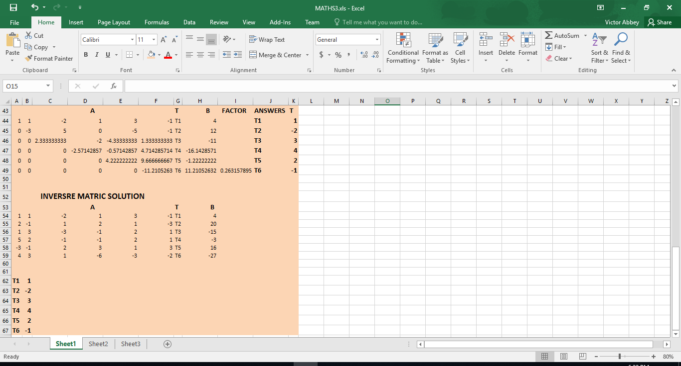

SOLUTION 5
MATLAB CODE:
commandwindow
clear
clc
close all
format short g

A = [1 1 -2 1 3 -1
2 -1 1 2 1 -3
1 3 -3 -1 2 1
5 2 -1 -1 2 1
-3 -1 2 3 1 3
4 3 1 -6 -3 -2]

B =[4
20
-15
-3
16
-27]
C = inv(A)
F = C * B
T1 = F(1,1);
T2 = F(2,1);
T3 = F(3,1);
T4 = F(4,1);
T5 = F(5,1);
T6 = F(6,1);
T = [T1
T2
T3
T4
T5
T6]
CODE RESULT
