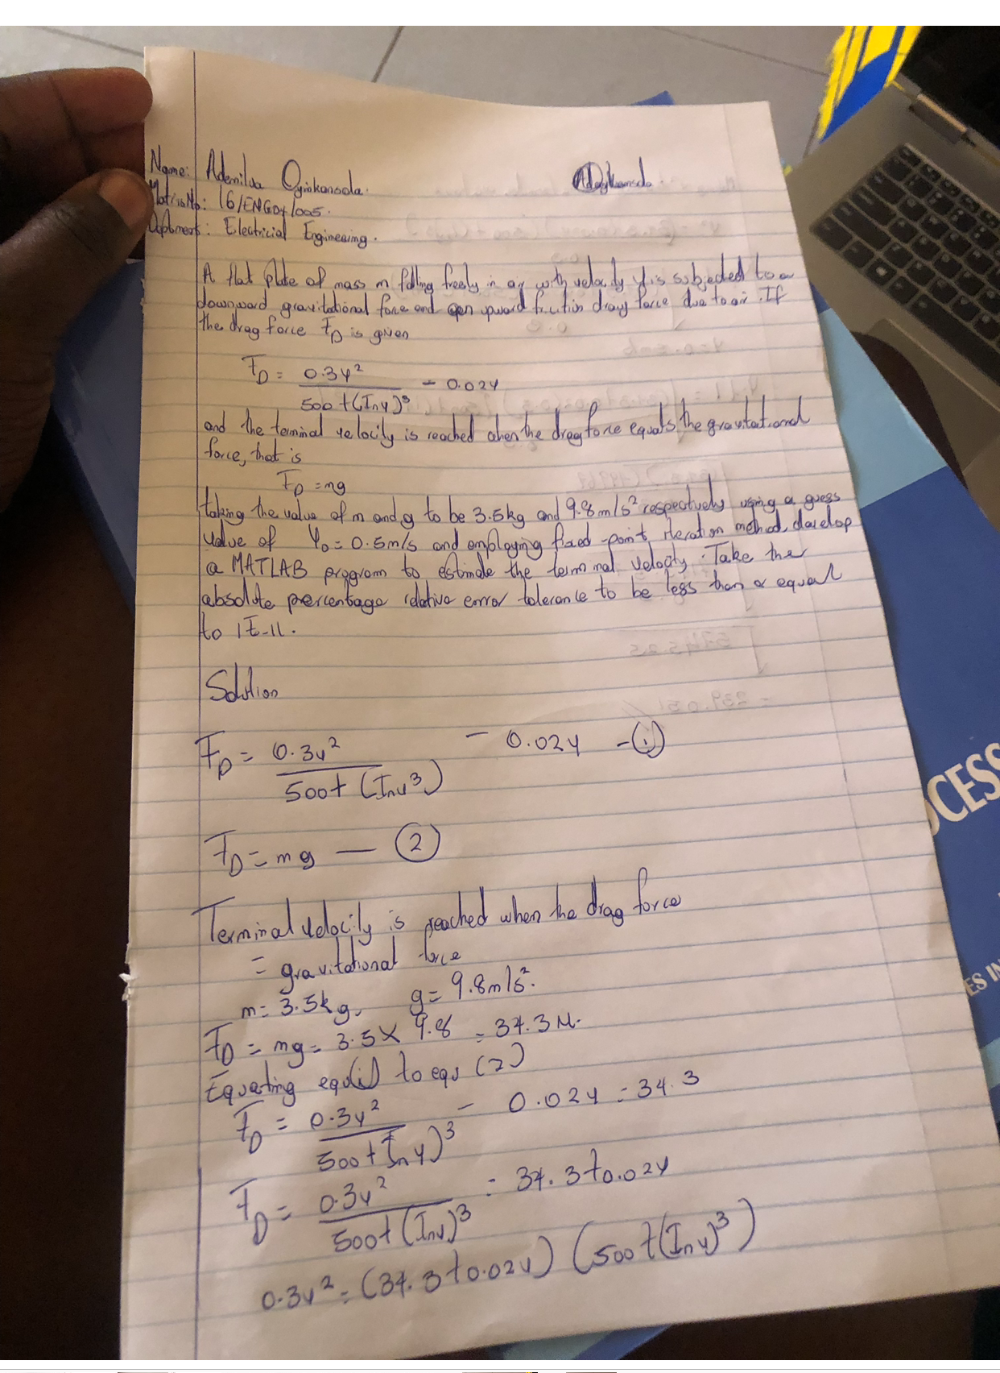

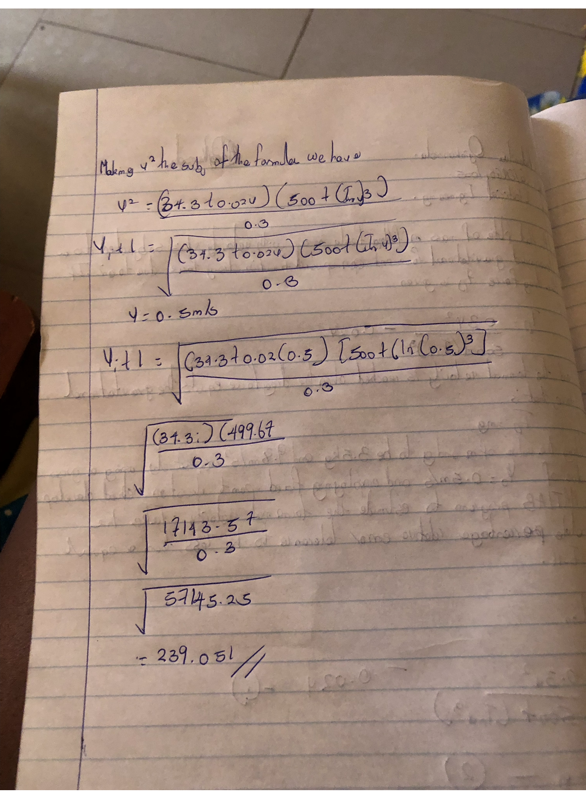
Ademilua Oyinkansola
16ENG04005
ASSIGNMENT 1
Code:
commandwindow
clear
clc
format short g
syms v
v = 0.5
for f = 1:20
iter(f+1) = f;
v(f+1) = sqrt(10/3*(34.3+0.02*v(f))*(500+log(v(f))^3));
Ea(f+1)=(abs(v(f+1)-v(f))/v(f+1))*100;
if Ea(f+1)<=1E-11
break
end
end
table(iter',v',Ea')

Command window:
v =

0.5

ans =

18×3 table

Var1 Var2 Var3
____ ______ __________

0 0.5 0
1 239.05 99.791
2 294.17 18.736
3 302.61 2.7894
4 303.85 0.40992
5 304.04 0.060144
6 304.06 0.0088222
7 304.07 0.0012941
8 304.07 0.00018981
9 304.07 2.7842e-05
10 304.07 4.0838e-06
11 304.07 5.9902e-07
12 304.07 8.7865e-08
13 304.07 1.2888e-08
14 304.07 1.8904e-09
15 304.07 2.7729e-10
16 304.07 4.0679e-11
17 304.07 5.9635e-12

