NAME: Ademilua Oyinkansola
MATRIC NO: 16/ENG04/005
DEPT: Electrical ENGINEERING
ASSIGNMENT 2 SOLUTION
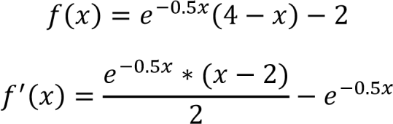

Using the formulas below and a guess value of 0.5
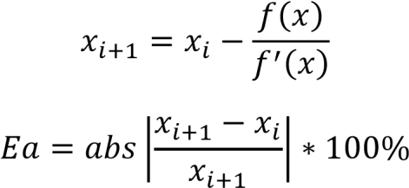

i | x | Ea
0 | 0.5 | 0
1 | 1.119232 | 55.32649
2 | 0.72982 | 53.35725
3 | 0.983396 | 25.78576
4 | 0.821969 | 19.63902
5 | 0.926229 | 11.2564
6 | 0.859516 | 7.761741
7 | 0.90246 | 4.75853
8 | 0.874922 | 3.147392
9 | 0.892624 | 1.983086
10 | 0.881263 | 1.289159

Ademilua Oyinkansola
16ENG04005
ASSIGNMENT 2
Code:
commandwindow
clear
clc
format short g
syms x
h = exp(-0.5*x)*(4-x)-2
g = diff(h)
% x =0.5;
% for f=1:7
% iter(f+1) = f;
% v(f+1) = exp(-0.5*x)*(4-x)-2
% Ea(f+1)=(abs(v(f+1)-v(f))/v(f+1))*100;
% if Ea(f+1) =(abs(v(f+1)-v(f)/v(f+1)*100;
% If Ea(f+1)
% break
% end
% end
% iter'
% xf'
% Ea'
% tableau =[iter', x', Ea']

x = 0.5;
for i =1:7
iter(i+1)=i
xf(i) = x
x = double(subs(x-(h/g)));
xf(i+1) = x
Ea(i+1)=(abs(xf(i+1)-xf(i))/xf(i+1))*100;
if Ea(i+1)<=-1E-9
break
end
end
iter'
xf'
Ea'
tableau =[iter', xf', Ea']

Command window:

h =

- exp(-x/2)*(x - 4) - 2

g =

(exp(-x/2)*(x - 4))/2 - exp(-x/2)

iter =

0 1

xf =

0.5

xf =

0.5 0.83889

iter =

0 1 2

xf =

0.5 0.83889

xf =

0.5 0.83889 0.88496

iter =

0 1 2 3

xf =

0.5 0.83889 0.88496

xf =

0.5 0.83889 0.88496 0.88571

iter =

0 1 2 3 4

xf =

0.5 0.83889 0.88496 0.88571

xf =

0.5 0.83889 0.88496 0.88571 0.88571

iter =

0 1 2 3 4 5

xf =

0.5 0.83889 0.88496 0.88571 0.88571

xf =

0.5 0.83889 0.88496 0.88571 0.88571 0.88571

iter =

0 1 2 3 4 5 6

xf =

0.5 0.83889 0.88496 0.88571 0.88571 0.88571

xf =

0.5 0.83889 0.88496 0.88571 0.88571 0.88571 0.88571

iter =

0 1 2 3 4 5 6 7

xf =

0.5 0.83889 0.88496 0.88571 0.88571 0.88571 0.88571

xf =

0.5 0.83889 0.88496 0.88571 0.88571 0.88571 0.88571 0.88571

ans =

0
1
2
3
4
5
6
7

ans =

0.5
0.83889
0.88496
0.88571
0.88571
0.88571
0.88571
0.88571

ans =

0
40.397
5.2054
0.084972
2.2247e-05
1.5293e-12
0
0

tableau =

0 0.5 0
1 0.83889 40.397
2 0.88496 5.2054
3 0.88571 0.084972
4 0.88571 2.2247e-05
5 0.88571 1.5293e-12
6 0.88571 0
7 0.88571 0

