A TERM PAPER

ON

CASCADE CONTROL

PREPARED BY

 | CHEMICAL ENGINEERING 500 LEVEL
S/N | Name | Matric No
1 | Asiwaju Oluwatodimu | 14/ENG01/002
2 | Bankole Daniel Ayodeji | 14/ENG01/004
3 | Dagogo Ibinabo Mary | 14/ENG01/005
4 | Olajide Abimbola Olamorin | 14/ENG01/013
5 | Olowomeye Emmanuel Olamide | 14/ENG01/014

COURSE CODE: CHE 532
COUSRE TITLE: PROCESS DYNAMICS AND CONTROL II

SUBMITTED TO
ENGR. PROF. ABDULWAHAB GIWA

DATE OF SUBMISSION: 13TH MARCH 2019.

ABSTRACT
Cascade control structure has two feedback controllers with the output of the primary controller changing the set point of the secondary of control. Cascade control may be applied to any process where a measurable secondary variable directly influences the primary controlled variable through some dynamics. Cascade control has two main objectives: to suppress the effect of disturbances on the primary process output, and to reduce the sensitivity of the primary process variable to gain variations. To apply cascade control, the output of each of these processes must be measured. The input to the first process is directly manipulated. Since the output of each process is the primary input in the next process, any change in the manipulated input to the first process will impact the output of the other processes. The introduction of cascade control to a process system decreases the overall response time due to decrease in time constant. There are several examples of this concept e.g. the hydraulic motor, DC motor, control valve etc. Cascade control, with all its obvious benefits, also has some drawbacks, the most notable being extra costs and increased complexity as much more tuning is required.

TABLE OF CONTENTS
ABSTRACT ii
LIST OF FIGURES iv
LIST OF EQUATION v
1 INTRODUCTION 1
1.1 CASCADE CONTROL 1
2 STRUCTURE OF CASCADE CONTROL SYSTEM 3
2.1 RESPONSE TIME OF A CASCADE CONTROLLER 4
2.2 STABILITY OF A CASCADE CONTROLLER 5
2.3 CASCADE CONTROL ADVANTAGES 6
2.4 CASCADE CONTROL DISADVANTAGES 6
2.5 EXAMPLES OF CASCADE CONTROL 7
2.6 APPLICATION OF CASACADE CONTROL 8
2.7 CHALLENGES 13
2.8 BENEFITS 13
REFERENCE 15

LIST OF FIGURES
Figure 1-1: cascade control block diagram 1
Figure 1-2: Cascade control system 2
Figure 1-3: Cascade Control Structure 3
Figure 1-4: A traditional single-measurement single-controller feedback loop tries to maintain the temperature of the water in the tank by manipulating the steam flow valve 11
Figure 1-5: A cascade control system uses two measurements, two controllers, and the same valve to maintain the temperature of water in the tank more efficiently than a single controller can 12

LIST OF EQUATION
(2-1) 3
(2-2) 3
(2-3) 3
(2-4) 3
(2-5) 4
(2-6) 4
(2-7) 4
(2-8) 5
(2-9) 5
(2-10) 5

INTRODUCTION

CASCADE CONTROL
Cascade control is a control algorithm in which the output of one control loop provides the target for another loop. It is a vital concept in advanced control. This structure has two feedback controllers with the output of the primary controller changing the set point of the secondary of control.

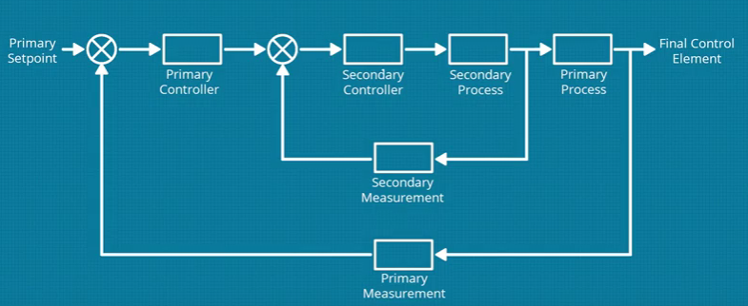
Figure 1-1: cascade control block diagram
Cascade control is an alternative approach that can significantly improve the dynamic response to disturbances by employing a secondary measurement and a secondary feedback controller. The secondary measurement point is located so that it recognizes the upset condition sooner than the controlled variable, but the disturbance is not necessarily measured.
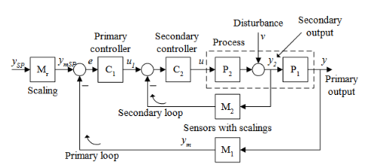
Figure 1-2: Cascade control system
The (first) loop inside the primary loop is called the secondary loop ,and the controller in this loop is called the secondary controller (or slave controller). The outer loop is called the primary loop, and the controller in this loop is called the primary controller (or master-controller). The control signal calculated by the primary controller is the setpoint of the secondary controller. In most applications the purpose of the secondary loop is to compensate quickly for the disturbance so that its response in the primary output variable of the process is small. For this to happen the secondary loop must register the disturbance

STRUCTURE OF CASCADE CONTROL SYSTEM
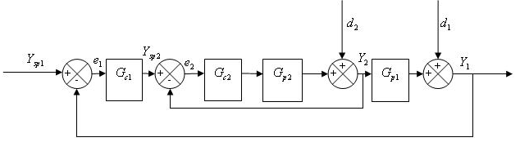
Figure 1-3: Cascade Control Structure

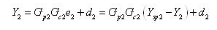 | (2-1)
Simplifying
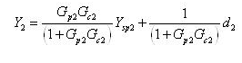 | (2-2)
Similarly
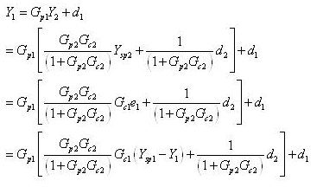 | (2-3)
(2-4)
Again simplifying the above eqn:
Now see what happens if the secondary loop is absent. In that case:
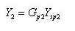 | (2-5)
And
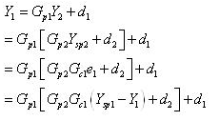 | (2-6)
Simplifying
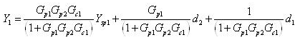 | (2-7)

RESPONSE TIME OF A CASCADE CONTROLLER
First analyze the secondary loop:
In absence of the secondary loop and the slave controller
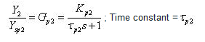
In presence of the secondary loop and the slave controller (say a pure gain controller)
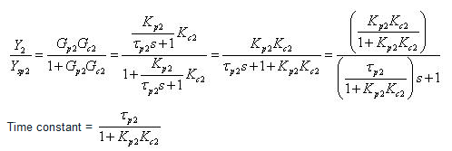 | (2-8)
Clearly there is a decrease in time constant in presence of slave loop. This will guarantee that the time constant of the overall process decreases when a secondary loop is introduced to the system. Eventually that decreases the overall response time.

STABILITY OF A CASCADE CONTROLLER
The stability part can also be explained in general derivation, but it will become too cumbersome. So let us take a simple example.
Let us take, 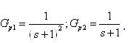. Thus overall system is third order.
In absence of the secondary loop the characteristic equation of the overall process is:
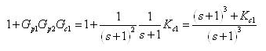 | (2-9)
In presence of the secondary loop the characteristic equation of the overall process is:
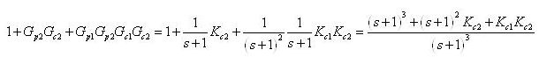 | (2-10)

CASCADE CONTROL ADVANTAGES
- Allows inner loop to handle non-linear valve and other final control element problems.
- Allows operator to directly control inner loop during certain modes of operation (such as startup).
- Allows controller to respond quickly to the faster inner loop.

CASCADE CONTROL DISADVANTAGES
- Cost of measurement of the secondary variable (assuming it is not measured for other reasons).
- Additional complexity.
- Corrective action for disturbances does not begin until after the controlled variable deviates from the set point.
- Cascade control systems are also more complex than single-measurement controllers, requiring twice as much tuning
Requirements for Cascade Control:
Naturally, a cascade control system can’t solve every feedback control problem, but it can prove advantageous if under the right circumstances:
- The inner loop has influence over the outer loop. The actions of the secondary controller must affect the primary process variable in a predictable and repeatable way or else the primary controller will have no mechanism for influencing its own process.
- The inner loop is faster than the outer loop. The secondary process must react to the secondary controller’s efforts at least three or four times faster than the primary process reacts to the primary controller. This allows the secondary controller enough time to compensate for inner loop disturbances before they can affect the primary process.
- The inner loop disturbances are less severe than the outer loop disturbances. Otherwise, the secondary controller will be constantly correcting for disturbances to the secondary process and unable to apply consistent corrective efforts to the primary process.
- Inner loop system dynamics must be significantly faster (such as four times faster) than the outer loop system dynamics. If the inner loop is not faster than the outer loop, then the cascade will not offer any significant improvement in the system control.
- Inner loop must have influence over the outer loop.
- Inner loop must be measured and controllable.

EXAMPLES OF CASCADE CONTROL
- DC-motor:
Primary loop: Speed control based on measurement of the rotational speed using a tachometer as speed sensor.

Secondary loop: Control of armature current which compensates for nonlinearities of the motor, which in turn may give more linear speed control.
- Hydraulic motor:
Primary loop: Positional control of the cylinder

Secondary loop: Control of the servo valve position (the servo valve controls the direction of oil flow into the cylinder), which results in a more linear valve movement, which in turn gives a more precise control of the cylinder.

- Control valve:
The primary loop: Flow control of the liquid or the gas through the valve.

Secondary loop: Positional control of the valve stem, which gives a proportional valve movement, which in turn may give a more precise flow control. Such an internal positional control system is called positioner.

APPLICATION OF CASACADE CONTROL
To better understand the architecture and benefits of Cascade Control it can help to consider it in the context of an industrial process. As Shown in the tank system below. A shared header supporting multiple lines allows liquid to flow into the tank. Liquid simultaneously exits through a port at the bottom. Using Single Loop Control the tank level is controlled by adjusting a valve and either increasing or decreasing the rate of fluid that flows into the tank. Whereas the exit stream is predictable, the inlet stream from the header can vary dramatically due to changes in pressure associated with demand from other lines. Due to the process’ dynamics the level controller may be unable to respond adequately to such changes in liquid feed. The slow response can result in a level – whether too high or too low – that is either inefficient or even dangerous.
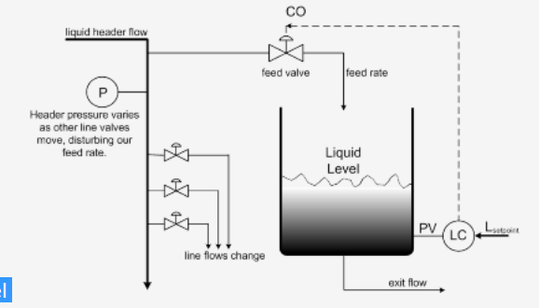

Now consider a similar tank system that employs the Cascade Control architecture. As before the control objective is to maintain level within the tank. However, a second control loop is effectively “nested” within the architecture outlined above to improve control. Here a secondary flow controller is added that uses the Controller Output of the level controller as its Set Point. As level shifts within the tank the slower level controller establishes a new Set Point for the faster responding flow controller. Because the flow loop is closer to the disturbance it both experiences and rejects any pressure disturbances before they can have an appreciable impact on the tank’s level.

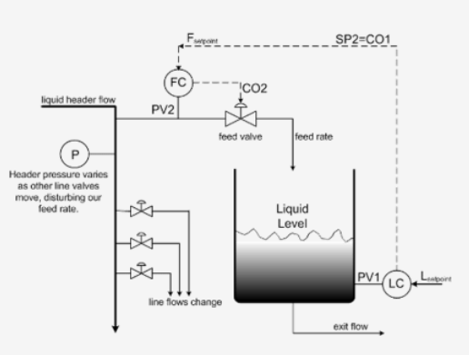

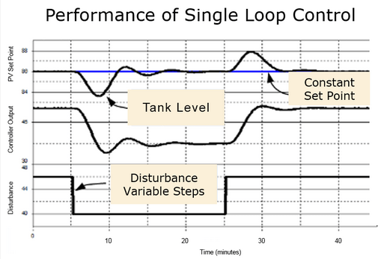
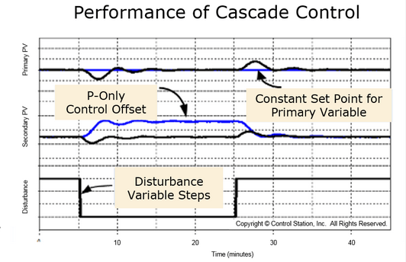
Another application
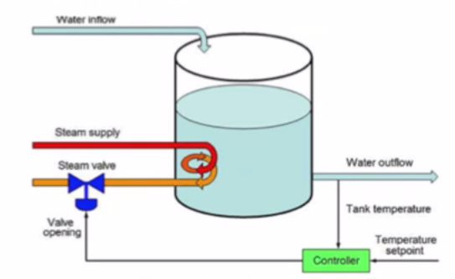
Figure 1-4: A traditional single-measurement single-controller feedback loop tries to maintain the temperature of the water in the tank by manipulating the steam flow valve
In Figure 1-4, a traditional controller is shown measuring the temperature inside the tank and manipulating the steam valve opening to add more or less heat as inflowing water disturbs the tank temperature. This arrangement works well enough if the steam supply and the steam valve are sufficiently consistent to produce another X% change in tank temperature every time the controller calls for another Y% change in the valve opening.
However, several factors could alter the ratio of X to Y or the time required for the tank temperature to change after a control effort. The pressure in the steam supply line could drop while other tanks are drawing down the steam supply they share, in which case the controller would have to open the valve more than Y% in order to achieve the same X% change in tank temperature.
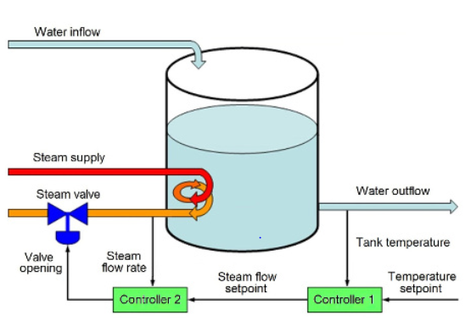
Figure 1-5: A cascade control system uses two measurements, two controllers, and the same valve to maintain the temperature of water in the tank more efficiently than a single controller can
In Figure 1-5 where a second controller has taken over responsibility for manipulating the valve opening based on measurements from a second sensor monitoring the steam flow rate. Instead of dictating how widely the valve should be opened, the first controller now tells the second controller how much heat it wants in terms of a desired steam flow rate.
The second controller then manipulates the valve opening until the steam is flowing at the requested rate. If that rate turns out to be insufficient to produce the desired tank temperature, the first controller can call for a higher flow rate, thereby inducing the second controller to provide more steam and more heat (or vice versa).

CHALLENGES OF CASCADE CONTROL
Cascade control, with its many advantages, can also have its limitations. Most notably, the extra sensor and controller tend to increase overall equipment costs. Cascade control systems are also more complex than single-measurement controllers, requiring twice as much tuning. Then again, the tuning procedure is reasonably straightforward: the secondary controller is tuned first, then the primary controller using the same tuning tools applicable to single-measurement controllers.
However, if the inner loop tuning is too aggressive and the two processes operate on similar time scales, the two controllers might compete with each other to the point of driving the closed-loop system unstable. Luckily, this is unlikely if the inner loop is inherently faster than the outer loop or the tuning forces it to be.
Also, it is not always clear when cascade control will be worth the extra effort and cost. There are several typical examples that characteristically benefit from cascade control—but it is usually easier to envisage when a cascade control system won’t help than predict when it will.

BENEFITS OF CASCADE CONTROL
One of the main reasons for implementing cascade control is that the PID at each point in the cascade can react quickly to disturbance inputs to its associated process. If the PID responds quickly enough, changes introduced by disturbance inputs will have little or no impact on the downstream processes. For example, the rule of thumb when applying dual loop cascade control is that the process associated with the slave loop should have a response time that is at least four times faster than the process associated with the master loop.
Cascade control may be implemented in some cases to compensate for the non-linear installed characteristic of a regulating valve. For example, the slave loop of a cascade might be associated with a flow process where the installed characteristic of the valve is non-linear. Since the flow process is capable of very fast changes in flow rate, the slave loop could be tuned to quickly adjust the valve to achieve the flow rate set point requested by the master loop. The non-linear installed characteristic of the valve would have no impact on the tuning or response of the master loop. This is a real benefit if the process associated with the master loop is very slow to change. For example, control performance of a slow responding temperature process could be improved by the application of cascade control since a non-linear installed characteristic and any disturbances to the flow process have no impact on the master loop.
As with feedforward control, the added cost of implementing cascade control is associated with the purchase, installation, and maintenance of one or more transmitters to measure process outputs that may not be available or required for single-loop control. More time is required to engineer and commission a cascade control strategy. Also, time may be required to train operators on how to interact with a cascade control strategy. The process improvements that may be achieved using cascade control must vindicate this additional outlay.

REFERENCE
- https://deltamotion.com/support/webhelp/rmctools/Controller_Features/Control_Modes/Advanced_Control/Cascaded_Loops.htm
- https://www.controleng.com/articles/fundamentals-of-cascade-control/
- https://nptel.ac.in/courses/
- https://controlstation.com/overview-cascade-control/

