A TERM PAPER
ON
CASCADE CONTROL

PREPARED BY

IGBOMEZIE CHIAMAKA OGECHI - 15/ENG01/024
WOHOH FAVOUR WOBURUOKE - 14/ENG01/015
ATSEGBUA JOSHUA OSILAMAH - 14/ENG01/003
EKPENYONG MBANG OTU – 15/ENG01/023
ISHAKU MUSA GARBA – 14/ENG01/010

SUBMITTED TO THE DEPARTMENT OF CHEMICAL
ENGINEERING

COURSE CODE: CHE 532
COURSE TITLE: PROCESS DYNAMICS AND CONTROL

DATE: 12TH MARCH 2019

Table of Contents
LIST OF FIGURES iii
1.0 CASCADE CONTROL 1
1.1 EXAMPLE OF CASCADE CONTROL 2
1.2 CASCADE DESIGN CRITERIA 5
1.3 CONTROLLER ALGORITHM AND TUNING 6
1.4 IMPLEMENTATION ISSUE 7
1.5 ADVANTAGES AND DISADVANTAGES OF CASCADE CONTROL 8
1.6 FURTHER CASCADE EXAMPLES 10
REFERENCES 13

LIST OF FIGURES
Figure 1: Cascade Control System 1
Figure 2: stirred tank heat exchanger control 3
Figure 3: Dynamic response of stirred-tank heat exchanger to a disturbance in oil pressure: (a) with single-loop control; 4
Figure 4: Single-loop packed-bed reactor control. 10
Figure 5: cascade packed bed reactor control 11
Figure 6: Cascade control design for outlet temperature. 12

CASCADE CONTROL

Cascade control is one of the most successful methods for enhancing single-loop control performance. It can dramatically improve the performance of control strategies, reducing both the maximum deviation and the integral error for disturbance responses. Since the calculations required are simple, cascade control can be implemented with a wide variety of analog and digital equipment. This combination of ease of implementation and potentially large control performance improvement has led to the widespread application of cascade control for many decades.
The standard feedback control loop sometimes does not provide a performance good enough for processes with long time delays and strong disturbances. Cascade control loops can be used and are a common feature in the process control industries for the control of temperature, flow and pressure loops.
Cascade control (CC), which was first introduced many years ago by Franks and Worley, is one of the strategies that can be used to improve the system performance particularly in the presence of disturbances. In conventional single feedback control, the corrective action for disturbances does not begin until the controlled variable deviates from the set point. A secondary measurement point and a secondary controller, G_{c}2, in cascade to the main controller, G_{c}1, as shown in Fig. 1, can be used to improve the response of the system to load changes.
.
Figure 1: Cascade Control System

y

1
r
D
2

_
+

+

G
c2
G
p2
G
c1

G
p1
+

D

1
_
+

y
2

A cascade control strategy can be used to achieve better disturbance rejections. However, if a long time delay exists in the outer loop the cascade control may not give satisfactory closed loop responses for set point changes.

EXAMPLE OF CASCADE CONTROL

The best way to introduce cascade control is with reference to a simple process example, which will be the stirred-tank heat exchanger shown in Figure below .The goal is to provide tight control of the exit temperature. The conventional feedback controller, with integral mode, attempts to maintain the exit temperature near its set point in response to all disturbances and ensures zero steady-state offset for step like disturbances. Suppose that one particularly frequent and large disturbance is the heating oil pressure. When this pressure increases, the initial response of the oil flow and the heat transferred is to increase. Ultimately, the tank exit temperature increases, and the feedback controller reduces the control valve opening to compensate for the increased pressure. While the effect of the disturbance is ultimately compensated by the single-loop strategy, the response is slow because the exit temperature must be disturbed before the feedback controller can respond. Cascade control design considers the likely disturbances and tailors the control system to the disturbance(s) that strongly degrades performance. Cascade control uses an additional, "secondary" measured process input variable that has the important characteristic that it indicates the occurrence of the key disturbance. For the stirred-tank heat exchanger, all measured variables are shown in Figure 14.1.The secondary variable is selected to be the heating oil flow, because it responds in a predictable way to the disturbances in the oil pressure, which is not measured in this case. The control objective (tight control of the outlet temperature) and the final element are unchanged. The manner in which the additional measurement is used is shown in Figure14.2. The control system employs two feedback controllers, both of which can use the standard PID controller algorithm.
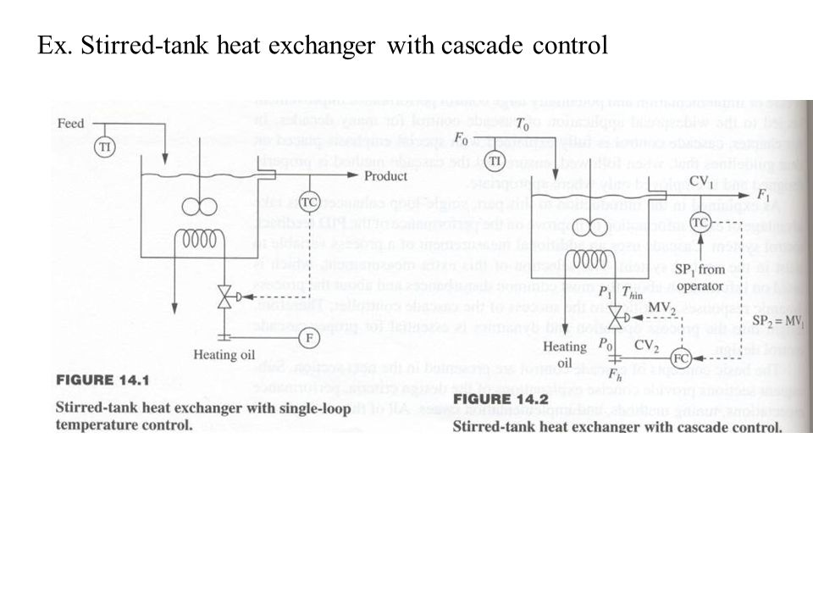
Figure 2: stirred tank heat exchanger control

The important feature in the cascade structure is the way in which the controllers are connected. The output of the exit temperature controller adjusts the set point of the flow controller in the cascade structure; that is, the secondary controller set point is equal to the primary controller output. Thus, the secondary flow control loop is essentially the manipulated variable for the primary temperature controller. The net feedback effect is the same for single-loop or cascade control; in either case, the heating oil valve is adjusted ultimately by the feedback. Therefore, the ability to control the exit temperature has not been changed with cascade. As described previously, the single-loop structure makes no correction for the oil pressure disturbance until the tank exit temperature is upset. The cascade structure makes a much faster correction, which provides better control performance. The reason for the better performance can be seen by analyzing the initial response of the cascade system to an oil pressure increase. The valve position is initially constant; therefore, the oil flow increases. The oil flow sensor quickly detects the increased flow. Since the flow controller set point would be unchanged, the controller would respond by closing the valve to return the flow to its desired value. Because the sensor and valve constitute a very fast process, the flow controller can rapidly achieve its desired flow of oil. By responding quickly to the pressure increase and compensating by closing the control valve, the secondary controller corrects for the disturbance before the tank exit temperature is significantly affected by the disturbance. Typical dynamic responses of the single-loop and cascade control systems are given in Figure below for a decrease in oil pressure. A few important features of the cascade structure should be emphasized. First, the flow controller is much faster than the temperature controller. The improvement results from the much shorter dead time in the secondary loop than in the original single-loop system; shorter dead times improve single loop control. If the controller were not faster, the cascade design would have no advantage.
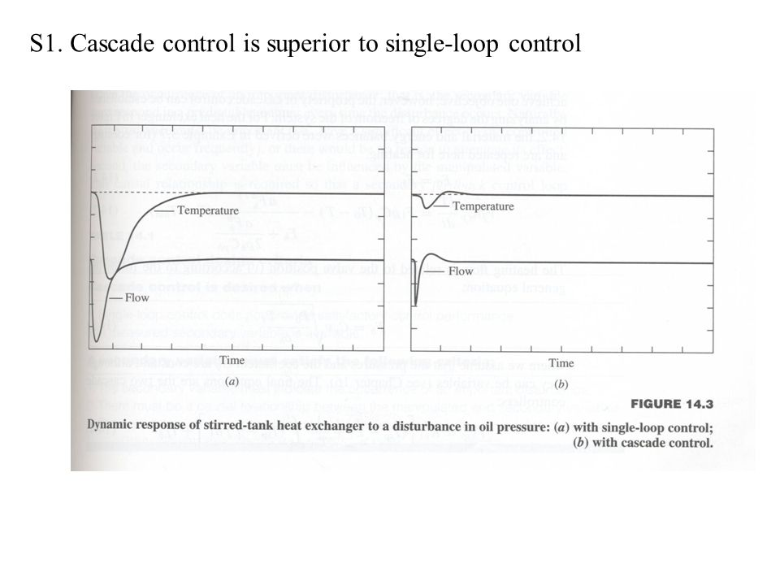
Figure 3: Dynamic response of stirred-tank heat exchanger to a disturbance in oil pressure: (a) with single-loop control;

Second, the temperature controller with an integral mode remains in the design to ensure zero offset for all disturbance sources. The primary con-Cascade Control trailer is essential, because
- the secondary variable may not totally eliminate the effect of the disturbance,
- other disturbances that are not affected by the cascade will also occur, and
- The ability to change the primary set point must be retained.
Remember that the secondary variable is selected for one (or a few) common disturbances; in the example, a heat exchanger feed temperature disturbance would affect the tank outlet temperature but does not influence the heating oil measurement. Finally, the judicious selection of the secondary variable has made the improvement possible without using a model of the effect of pressure on exit temperature in the control calculation; the only models used were the process models used to tune the two feedback controllers. As a result, cascade control is not strongly sensitive to modelling errors, although large errors could lead to oscillations or instability in one of the feedback controllers. The two controllers in the cascade are referred to by various names. The three pairs of names in the most commonly used terminology are presented as they would be applied to the stirred-tank heat exchanger:

CASCADE DESIGN CRITERIA

The principles of cascade control have been introduced with respect to the example stirred-tank heater. The design criteria are summarized in a concise form so that they can be applied in general. Adherence to these criteria ensures that cascade control is designed properly and used only where appropriate. The first two items address the selection of cascade control. Naturally, only when single loop control does not provide acceptable control performance is an enhancement such as cascade control necessary. Single-loop control provides good performance when the dynamics are fast, the fraction dead time is small, and disturbances are small and slow. Also, the second criterion requires an acceptable measured secondary variable to be available or added at reason able cost. A potential secondary variable must satisfy three criteria. First, it must indicate the occurrence of an important disturbance; that is, the secondary variable must respond in a predictable manner every time the disturbance occurs. Naturally, the disturbance must be important (i.e., have a significant effect on the controlled variable and occur frequently), or there would be no reason to attenuate its effect. Second, the secondary variable must be influenced by the manipulated variable.
This causal relationship is required so that a secondary feedback control loop functions properly. Finally, the dynamics between the final element and the secondary must be much faster than the dynamics between the secondary variable and the primary controlled variable. The secondary must be relatively quick so that it can attenuate a disturbance before the disturbance affects the primary controlled variable. A general guideline is that the secondary should be three times as fast as the primary. This could be roughly interpreted as the secondary reaching its steady state in one-third the time of the primary after an open-loop step change in the manipulated variable. A more proper comparison is the critical frequency of each loop; cascade is recommended when the critical frequency of the secondary is at least three times that of the primary. Using critical frequencies accounts for differences in the fraction dead time as well as the speed of response.

CONTROLLER ALGORITHM AND TUNING

Cascade control can use the standard feedback control PID algorithm; naturally, the correct modes must be selected for each controller. The secondary must have the proportional mode, but it does not require the integral mode, because the overall control objective is to maintain the primary variable at its set point. However, integral mode is often used in the secondary, for two reasons. First, since a proportional-only controller results in offset, the secondary must have an integral mode if it is to attenuate the effect of a disturbance completely, preventing the disturbance from propagating to the primary. Second, the cascade is often operated in a partial manner with the primary controller not in operation, for example, when the primary sensor is not functioning or is being calibrated. A negative side of including integral mode in the secondary controller is that it tends to induce oscillatory behavior in the cascade system, but the result is not significant when the secondary is much faster than the primary. Studies have demonstrated the effectiveness of the integral mode in the secondary loop (Krishnaswamy et al., 1992). The secondary may have derivative mode if required, but the fast secondary loop almost never has a large enough fraction dead time to justify a derivative mode. The modes of the primary controller are selected as for any feedback PID controller. It is again emphasized that the integral mode is essential for zero offset of the primary variable. The cascade strategy is tuned in a sequential manner. The secondary controller is tuned first, because the secondary affects the open-loop dynamics of the primary, CV₁(s)/SP(s). During the first identification experiment (e.g., process reaction curve), the primary controller is not in operation (i.e., the primary controller is in manual or the cascade is "open"), which breaks the connection between the primary and secondary controllers. The secondary is tuned in the conventional manner. This involves a plant experiment, initial tuning calculation, and fine tuning based on a closed-loop dynamic response. When the secondary has been satisfactorily tuned, the primary can be tuned. The initial plant experiment perturbs the variable that the primary controller adjusts; in this case, the secondary set point is perturbed in a step for the process reaction curve. The calculation of the initial tuning constants and the fine tuning follow the conventional procedures. Naturally, the secondary must be tuned satisfactorily before the primary can be tuned.

1.4 IMPLEMENTATION ISSUE

When properly displayed for the operator, cascade control is very easy to understand and to monitor. Since it uses standard PID control algorithms, the operator displays do not have to be altered substantially. The secondary controller requires one additional feature: a new status termed "cascade" in addition to automatic and manual. When the status switch is in the cascade position (cascade closed), the secondary set point is connected to the primary controller output; in this situation the operator cannot adjust the secondary set point. When the status switch is in the automatic or manual positions (cascade open), the secondary set point is provided by the operator; in this situation the cascade is not functional. Cascade control is shown in a very straightforward way in engineering drawings. Basically, each controller is drawn using the same symbols as a single-loop controller, with the difference that the primary controller output is directed to the secondary controller as shown in Figure below. Often, the signal from the primary controller output is annotated with "reset" or "SP" to indicate that it is adjusting or resetting the secondary set point. The calculations required for cascade control, basically a PID control algorithm, are very simple and can be executed by any commercial analog or digital control system. Two special features contribute to the success of cascade. The first is anti-reset windup. The potential exists for any controller in a cascade to experience integral windup due to a limitation in the control loop. Analysis for the secondary is the same as for a single-loop design; however, reset windup can occur for one of several reasons in the primary controller. The primary controller output can fail to move the valve because of limits on (1) the secondary set point, (2) the secondary controller output, or (3) the valve (fully opened or closed). Thus, the potential for reaching limits and encountering reset windup, along with the need for anti-reset windup, is much greater in cascade designs. The second feature is "bumpless" initialization. Note that changing the secondary status switch to and from the cascade position could immediately change the value of the secondary set point, which is not desired. The desired approach is to recalculate the primary controller output to be equal to the secondary set point on initialization. Many commercial controllers include calculations to ensure that the secondary set point is not immediately changed (bumplessly transferred) when the secondary mode switch is changed.
Digital control equipment can use the standard forms of the PID algorithm for cascade control. In addition to the execution period of each controller, the scheduling of the primary and secondary influences cascade control performance. To reduce delays due to control processing, the secondary should be scheduled to execute immediately after the primary. Naturally, it makes no sense to execute the primary controller at a higher frequency (i.e., with a shorter period) than the secondary, because the primary can affect the process (move the valve) only when the secondary is executed.
The cascade control system uses more control equipment—two sensors and controllers—than the equivalent single-loop system. Since the cascade requires all of this equipment to function properly, its reliability can be expected to be lower than the equivalent single-loop system, although the slightly lower reliability is not usually a deterrent to the use of cascade. If feedback control must be maintained when the secondary sensor or controller is not functioning, the flexibility to bypass the secondary and have the primary output directly to the valve can be included in the design. This option is shown in Figure below, where the positions of both switches are coordinated. Since the cascade involves more equipment, it costs slightly more than the single-loop system. The increased costs include a field sensor and transmission to the control house (if the variable were not already available for monitoring purposes), a controller (whose cost may be essentially zero if a digital system with spare capacity is used), and costs for installation and documentation. These costs are not usually significant compared to the benefits achieved through a properly designed cascade control strategy.

1.5 ADVANTAGES AND DISADVANTAGES OF CASCADE CONTROL

As shared previously Cascade Control is an advanced application of Single Loop Control. Through the use of a secondary and faster PID control loop, practitioners can improve a given process’ ability to correct for known disturbances. Although it is considered an advanced strategy, Cascade Control is commonly used across the process industries.
Once the fundamental requirements are understood an important next step is to determine whether or not Cascade Control is the right solution for a given process. The decision to implement Cascade Control can be evaluated simply in terms of Pros and Cons. To help with an assessment consider the following:
ADVANTAGES
The goal of Cascade Control is to improve process performance by reducing – or even eliminating – the effects of a known disturbance through control of an early warning variable. The following benefits are achievable through the application of Cascade Control:
- Loops that correctly employ the cascade architecture respond more effectively to disturbances. This is because the inner loop is both closer to the source of the disturbance and faster than the outer loop. That combination allows the process to correct for upsets more quickly.
- The inner loop helps to correct for nonlinearities such as Stiction that are associated with the Final Control Element (FCE). Recall that the inner and outer loops rely on the same FCE. Due to its faster dynamics the inner loop adjusts for FCE nonlinearities ahead of the outer loop, thereby minimizing negative affects to the process.
- A faster inner loop reduces the overall variability experienced by the process. Since the inner loop is able to respond more quickly to disturbances than the outer loop, it reduces the severity of a given disturbance and limits the degree of variability that would otherwise impact the process.
- The outer loop can be tuned more conservatively. Since the inner loop makes more rapid adjustments the outer loop no longer needs to be nimble. The steadier control benefits downstream processes.
DISADVANTAGES
The downside of this advanced control schema can be summarized in terms of cost and complexity. The following represent the negative aspects of Cascade Control:
- Instrumentation costs nearly double with the implementation of Cascade Control. The architecture requires the installation and use of a second sensor to measure the inner process variable.
- Configuration costs are nearly double as well. The added hardware costs must be complimented by increased installation and configuration costs. Tuning the two PID controllers to deliver optimal responsiveness can take considerable time and effort.
- There is potential for increased wear and tear on the process’ FCE as the inner controller is typically tuned aggressively to enhance disturbance rejection. This cost can be difficult to calculate as it depends on the configuration of the two controllers (i.e. P-Only, PI, etc.) and the work that the FCE is required to perform due to cascade.
Beyond the potential for smoother final process performance there are other financial and support considerations that should be considered. Most training workshops focused on process control cover this along with other basic and advanced applications of the PID. They often provide other, valuable insights for assessing the pros and cons of Cascade Control.

1.6 FURTHER CASCADE EXAMPLES
The concept of cascade control is consolidated and a few new features are presented through further examples below

1. Packed-bed reactor.
The first example is the packed-bed reactor shown in the Figure below
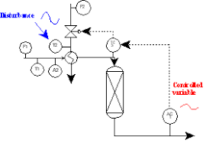
Figure 4: Single-loop packed-bed reactor control.

The goal is to tightly control the exit concentration measured by AC-1. Suppose that the single loop controller does not provide adequate control performance and that the most significant disturbance is the heating medium temperature, T2. The goal is to design a cascade control strategy for this process using the sensors and manipulated variables given. Since we are dealing with a cascade control strategy, the key decision is the selection of the secondary variable. Since all of the criteria must be satisfied for a variable to be used as a secondary, only the reactor inlet temperature, T3, is a satisfactory secondary variable. The resulting cascade control strategy is shown in Figure below.
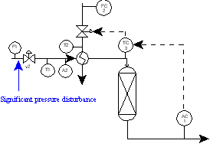

Figure 5: cascade packed bed reactor control

Given the cascade design, an interesting and important question is, "How well does it respond to other disturbances for which it was not specifically designed?" Several disturbances are discussed qualitatively in the following paragraphs.
Feed temperature, Tf. A change in the feed temperature affects the outlet concentration through its influence on the reactor inlet temperature, T3. Therefore, the cascade controller is effective in attenuating the feed temperature disturbance.
Heating oil pressure (not measured). A change in the oil pressure influences the oil flow and, therefore, the heat transferred. As a result the reactor inlet temperature, T3, is affected. Again, the cascade controller is effective in attenuating the oil pressure disturbance.
Feed flow rate, F1. A change in the feed flow rate influences the reactor outlet concentration in two ways: it changes the inlet temperature T3, and it changes the residence time in the reactor. The cascade controller is effective in attenuating the effect of the disturbance on T3 but is not effective in compensating for the residence time change. The residence time effect must be compensated by the primary controller, AC-1.
Feed composition, A2. A change in the feed composition clearly changes the reactor outlet concentration. The cascade has no effect on the feed composition disturbance, because the composition does not influence T3. Therefore, this disturbance must be totally compensated by the primary feedback controller, AC-1.

2. Fired heater
Another typical cascade design is given in the Figure below for furnace control.
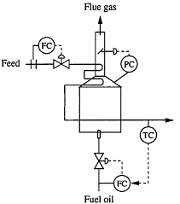
Figure 6: Cascade control design for outlet temperature.
A single-loop temperature controller would adjust the fuel valve directly, making the fuel ﬂow subject to pressure disturbances. A cascade control strategy is possible that satisﬁes all of the design criteria. In the cascade, the outlet temperature of the ﬂuid in the coil is controlled tightly by adjusting the fuel ﬂow controller set point, which adjusts the valve position. An additional advantage of the cascade becomes apparent when considering the performance of many real control valves; the valve does not always move exactly the amount directed by the controller, because friction occasionally causes sticking, which degrades control performance. The cascade design with a ﬂow controller as its fast secondary corrects quickly for both fuel pressure disturbances and the effects of a sticking valve and substantially improves control performance over the single-loop strategy.

REFERENCES

- Buckley, P., "A Control Engineer Looks at Control Valves," in Lovett, O.(ed.), Paper 2.1, Final Control Elements, First ISA Final Control Elements Symposium, May 14-16, 1970.
- Krishnaswamy, P., and G. Rangaiah, "Role of Secondary Integral Action in Cascade Control," Trans. IChemE, 70, 149-152 (1992).
- Krishnaswamy, P., G. Rangaiah, R. Jha, and P. Despande, "When to Use Cascade Control," IEC Res., 29, 2163-2166 (1990).
- Verhaegen, S., "When to Use Cascade Control," In. Tech., 38-40 (October 1991).
- Franks, R., and C. Worley, "Quantitative Analysis of Cascade Control," IEC, 48, 1074(1956).
- Process Disturbances with Cascade Control, “Control Eng., 8. 8, 63(1961)

