EKPENYONG MBANG OTU
15/ENG01/023
CHE 532: PROCESS DYNAMICS AND CONTROL
GAS CHROMATOGRAPHY AND GAS CHROMATOGRAPHY MASS SPECTROMETRY
- GAS CHROMATOGRAPHY:
It is an analytical instrument used to measure the content of various components in a sample through gas chromatography, also used in analytical chemistry for separating and analyzing compounds that can be vaporized without decomposition, testing for purity of a particular substance, or separating the different component mixture. In some situation it could be used in identifying a compound and can also be used to prepare pure compounds from a mixture
In gas chromatography, the mobile phase or the moving phase is a carrier gas, usually an inert gas such as helium or an unreactive gas such as nitrogen. Helium remains the most commonly used carrier gas in about 90% of instrument although hydrogen is preferred for improved separations. It is similar to column chromatography but has several differences such as the process of separating the compounds in a mixture is carried out between a liquid stationary phase and a gas mobile phase, whereas in column chromatography the stationary phase is a solid and the mobile phase is liquid.
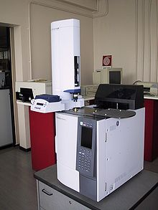
Figure 1: AN EXAMPLE OFA GAS CHOMATOGRAPHY WITH A HEADSPACE SAMPLER
- GAS CHROMATOGRAPHY-MASS SPECTROMETRY (GC-MS):
It is an analytical method that combines the features of gas chromatography and mass spectrometry to identify different substances within a test sample. It is applied in drug detection, fire investigation, environmental analysis, environmental analysis, explosive investigation and so on. It can be used to identify trace elements in materials that were previously thought to have disintegrated beyond identification. Like liquid chromatography mass spectrometry, it allows analysis and detection even of tiny amounts of substance.
Gas chromatography coupled with mass spectrometry is a versatile tool to separate, quantify and identify unknown substances. GC-MS has been regarded as a gold standard for forensic substance identification because it is used to perform a 100% specific test, which positively identifies the presence of a particular substance.
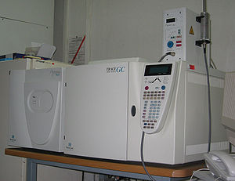
Figure 2: AN EXAMPLE OF A GS-MS INSTRUMENT

