NAME: IGBOMEZIE CHIAMAKA OGECHI
MATRIC NO: 15/ENG01/024
DEPT: CHEMICAL ENGINEERING
COURSE CODE: CHE S32
COURSE TITLE: PROCESS DYNAMICS AND CONTROL II

ASSIGNMENT 1
Describe in detail, compare and contrast gas chromatography and gas chromatography- mass spectroscopy.

ANSWERS
Gas chromatography
Gas chromatography (GC) is a common type of chromatography used in analytical chemistry for separating and analyzing compounds that can be vaporized without decomposition. In gas chromatography, the mobile phase (or "moving phase") is a carrier gas, usually an inert gas such as helium or an unreactive gas such as nitrogen. Helium remains the most commonly used carrier gas in about 90% of instruments although hydrogen is preferred for improved separations. The stationary phase is a microscopic layer of liquid or polymer on an inert solid support, inside a piece of glass or metal tubing called a column (an homage to the fractionating column used in distillation). The instrument used to perform gas chromatography is called a gas chromatograph (or "aerograph", "gas separator").
The gaseous compounds being analyzed interact with the walls of the column, which is coated with a stationary phase. This causes each compound to elute at a different time, known as the retention time of the compound. The comparison of retention times is what gives GC its analytical usefulness.
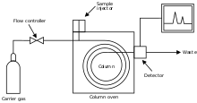
Figure 1: Gas chromatograph

Gas chromatography- mass spectroscopy
Gas chromatography-mass spectroscopy (GC-MS) is one of the so-called hyphenated analytical techniques. As the name implies, it is actually two techniques that are combined to form a single method of analyzing mixtures of chemicals. Gas chromatography separates the components of a mixture and mass spectroscopy characterizes each of the components individually. By combining the two techniques, an analytical chemist can both qualitatively and quantitatively evaluate a solution containing a number of chemicals.

Figure 2: Gas chromatography- Mass spectroscopy

In general, chromatography is used to separate mixtures of chemicals into individual components. Once isolated, the components can be evaluated individually.
In all chromatography, separation occurs when the sample mixture is introduced (injected) into a mobile phase. In liquid chromatography (LC), the mobile phase is a solvent. In gas chromatography (GC), the mobile phase is an inert gas such as helium.
The mobile phase carries the sample mixture through what is referred to as a stationary phase. The stationary phase is usually a chemical that can selectively attract components in a sample mixture. The stationary phase is usually contained in a tube of some sort called a column. Columns can be glass or stainless steel of various dimensions.
The mixture of compounds in the mobile phase interacts with the stationary phase. Each compound in the mixture interacts at a different rate. Those that interact the fastest will exit (elute from) the column first. Those that interact slowest will exit the column last. By changing characteristics of the mobile phase and the stationary phase, different mixtures of chemicals can be separated. Further refinements to this separation process can be made by changing the temperature of the stationary phase or the pressure of the mobile phase.
Our GC has a long, thin fused silica column containing a thin interior coating of a solid stationary phase (5% phenyl-, 95% dimethyl siloxane polymer). This 0.25 mm diameter column is referred to as a capillary column. This particular column is used for semi-volatile, non-polar organic compounds. The compounds must me in an organic solvent.
The capillary column is held in an oven that can be programmed to increase the temperature gradually (or ramped), this helps separation. As the temperature increases, those compounds that have low boiling points elute from the column sooner than those that have higher boiling points. Therefore, there are actually two distinct separating forces, temperature and stationary phase interactions mentioned previously.
As the compounds are separated, they elute from the column and enter a detector. The detector is capable of creating an electronic signal whenever the presence of a compound is detected; the greater the concentration in the sample, the bigger the signal. The signal is then processed by a computer. The time from when the injection is made (time zero) to when elution occurs is referred to as the retention time (RT).
Mass spectroscopy
As the individual compounds elute from the GC column, they enter the electron ionization (mass spec) detector. There, they are bombarded with a stream of electrons causing them to break apart into fragments. These fragments can be large or small pieces of the original molecules.
The gas molecules exiting the GC are bombarded by a high-energy electron beam (70 eV). An electron which strikes a molecule may impart enough energy to remove another electron from that molecule. Methanol, for example, would undergo the following reaction in the ionizing region:
CH₃OH + 1 e⁻ CH₃OH^{+.} + 2 e⁻
(The symbols ^{+.} indicate that a radical cation was formed)
Electron impact Ionization (EI) usually produces singly charged ions containing one unpaired electron. A charged molecule which remains intact is called the molecular ion. Instability in a molecular ion, due to the energy imparted by the electron impact, can cause that ion to break into smaller pieces (fragments). The methanol ion may fragment in various ways, with one fragment carrying the charge and one fragment remaining uncharged. For example:
CH₃OH^{+.} (molecular ion) CH₂OH⁺ (fragment ion) + H.
(or) CH₃OH^{+.} (molecular ion) CH₃⁺ (fragment ion) + .OH
The fragments are charged ions with a certain mass. The mass of the fragment divided by the charge is called the mass to charge ratio (m/z). Since fragments produced by EI have a charge of +1, the m/z represents the molecular weight of the fragment.
Ions created in the EI source are focused into the ion trap. The trap consists of two hyperbolic metal electrodes with their focii facing each other and a hyperbolic ring electrode halfway between the other two electrodes. The ions are trapped in the space between these three electrodes by AC ~1MHz and DC (non-oscillating, static) electric fields. The AC radio frequency voltage oscillates between the two hyperbolic metal electrodes at the 'top' and 'bottom' of the trap ('top' and 'bottom' are in phase) and the hyperbolic ring electrode that forms the 'side' of the trap. The ions are first pulled up and down axially while being pushed in radially. The ions are then pulled out radially and pushed in axially (from the top and bottom). In this way the ions move in a complex motion that generally involves the cloud of ions being long and narrow and then short and wide, back and forth, oscillating between the two states.

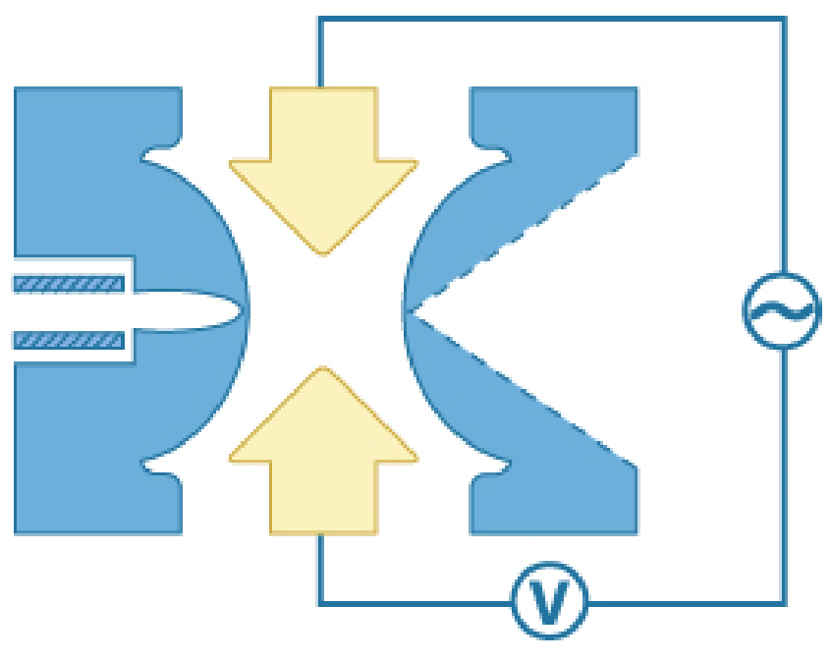
Figure 3: Ion trap
The time during which ions are allowed into the trap, termed the "ionization period", is set to maximize signal while minimizing space-charge effects. The ion trap is typically filled with helium to a pressure of about 1 mtorr. Collisions with helium dampen the kinetic energy of the ions and serve to quickly focus trajectories toward the center of the ion trap, enabling trapping of injected ions. Ion traps are unique in their ability to perform multiple stages of mass spectrometry (MS^{n}), enormously increasing the amount of information obtainable from a molecule. Waveforms are constructed to isolate an ion, induce its fragmentation, then isolate one of the products, induce its fragmentation, etc. Finally, the resultant ions from all of the manipulations are ejected from the trap and detected.
The dynamic range of ion traps is limited because, when there are too many ions in the trap, space charge effects lead to diminished performance. Automated scans are used to rapidly count the ions before they go into the trap so that the time ions are allowed to enter the trap is dependent on the ion flux. This ensures only a certain number of ions get in. This can be a problem when trace elements in particularly dirty matrices are analyzed because the trap fills with both matrix ions (large number) and trace sample ions (very small number).
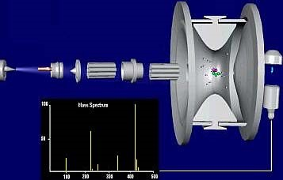
Figure 4: Mass spectroscope
The mass spectrum produced by a given chemical compound is essentially the same every time. Therefore, the mass spectrum is essentially a fingerprint for the molecule. This fingerprint can be used to identify the compound. Following is some general information which will aid EI mass spectra interpretation:
- Molecular ion (M^{.+}): If the molecular ion appears, it will be the highest mass in an EI spectrum (except for isotope peaks discussed below). This peak will represent the molecular weight of the compound. Its appearance depends on the stability of the compound. Double bonds, cyclic structures and aromatic rings stabilize the molecular ion and increase the probability of its appearance.
- Fragmentation: General rules of fragmentation exist and are helpful to predict or interpret the fragmentation pattern produced by a compound. Functional groups and overall structure determine how some portions of molecules will resist fragmenting, while other portions will fragment easily. A detailed discussion of those rules is beyond the scope of this introduction, and further information may be found in mass spectrometry reference books.
- Isotopes: Isotopes occur in compounds analyzed by mass spectrometry in the same abundances that they occur in nature. A few of the isotopes commonly encountered in the analyses of organic compounds are below along with an example of how they can aid in peak identification.

When GC is combined with MS, a powerful analytical tool is created. A researcher can take an organic solution, inject it into the instrument, separate the individual comp onents, and identify each of them. Furthermore, the researcher can determine the quantities (concentrations) of each of the components after careful calibration.

GC | GC-MS
The gas chromatography is a method that separates the different molecule types according to their weight, therefore size, and their affinity to the column used, since the gas used is inert. the problem with GC separation is that if the molecules are close is weight, so no significant difference in the speed of their trip through the column, and if their affinities are close, so the molecules aren't well separated as well, there is no way to identify them according to the retention time, nor to achieve a good separation. | The addition of the MS detector makes the identification process easier, as the detector decomposes the molecule into ions identified according to their mass, and using the retention times, since we would have a certain idea about the probable molecules we have, we can know which molecules exist in the solution we analyzed or in the gas we analyzed.
GC does not positively identify most samples; and not all substances in a sample will necessarily be detected. It is often needed to check the results of the sample against a GC analysis of a reference sample containing only the suspected substance. | GC-MS can identify trace elements in materials that were previously thought to have disintegrated beyond identification.
Gas chromatography is the technique to separate different molecule (containing different weight, size, binding affinity to the column) on the basis of their volatility.  The inert gases used as mobile phase, assist molecules to move. Many times gas chromatography does not give appropriate separation results because of their close molecular weight, no speed difference, same/close affinities in column. | To over-come from this situation gas chromatography adjunct with Mass Spectrometry detector, which ionizes chemical species and sorts the ions based on their mass-to-charge ratio. Therefore, MS detector makes the identification process easier. In simpler terms, a mass spectrum measures the masses within a sample.

