NAME: ABBEY FLOURISH OBARI-AKASE
MATRIC NUMBER: 16/ENG04/001
DEPARTMENT: ELECTRICAL/ELECTRONICS ENGINEERING
COURSE: ENG382
ASSIGNMENT 5
The dynamic model of a system is as given in Equation (1). If the initial value of the response is 1.4, using Euler’s method, obtain the dynamic response of the system, both in tabular and graphical forms, for time t = 0 – 0.5 hr with a step time of 0.1 hr with the aid of:
(i) Spreadsheet
(ii) MATLAB

$$\frac{dy}{dt}=2t+y^{2}$$

Using Eulers method:
(y’)₀=2t + y²
y(0)=1.4
t=0
h=0.1
y=y(0) + h*(y’)

EXCEL SPREADSHEET SOLUTION
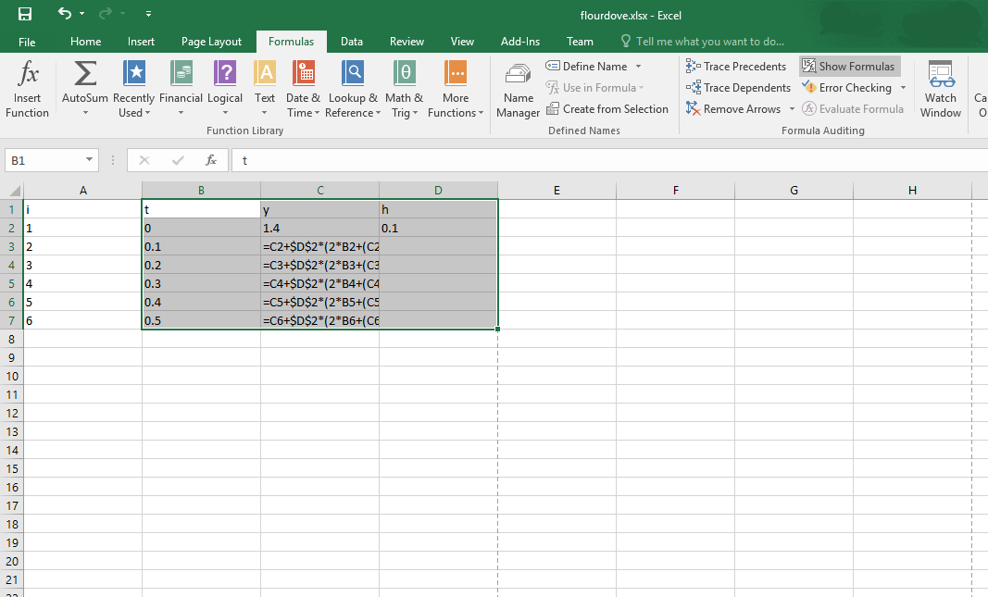
CODE:

RESULT:
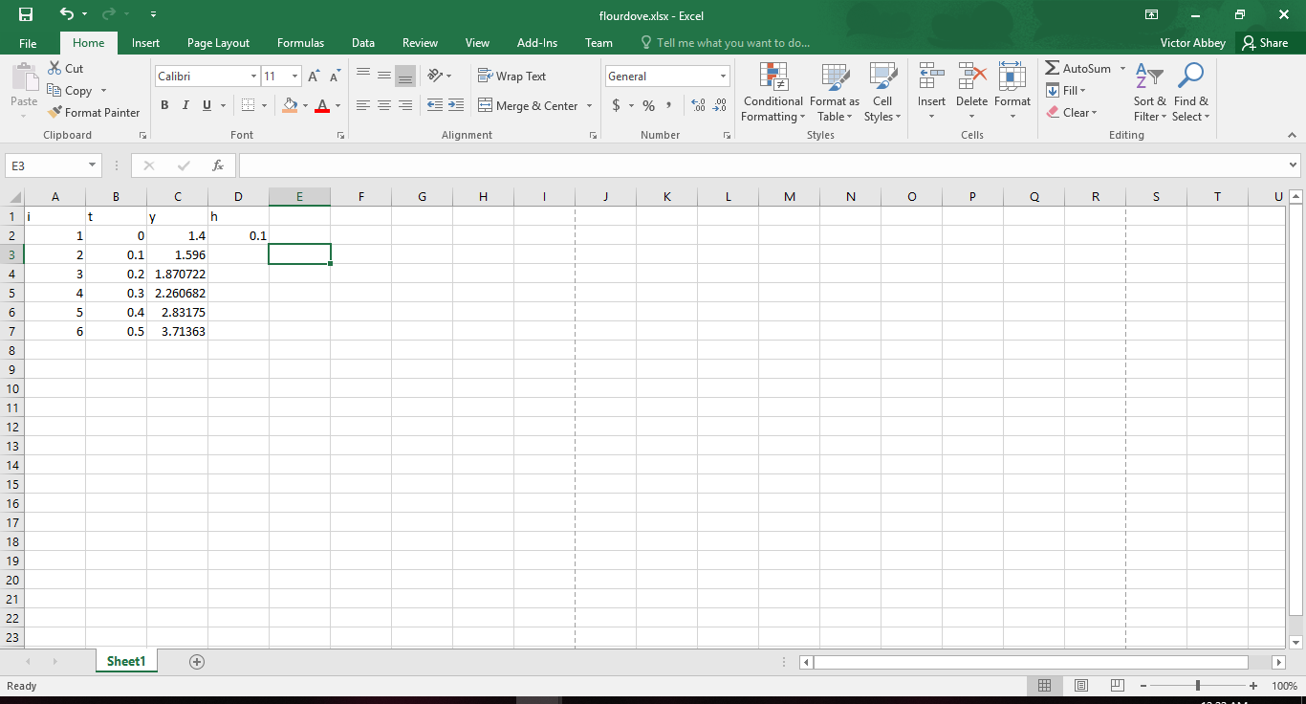
MATLAB CODE AND CODE RESULT{COMMANDWINDOW}
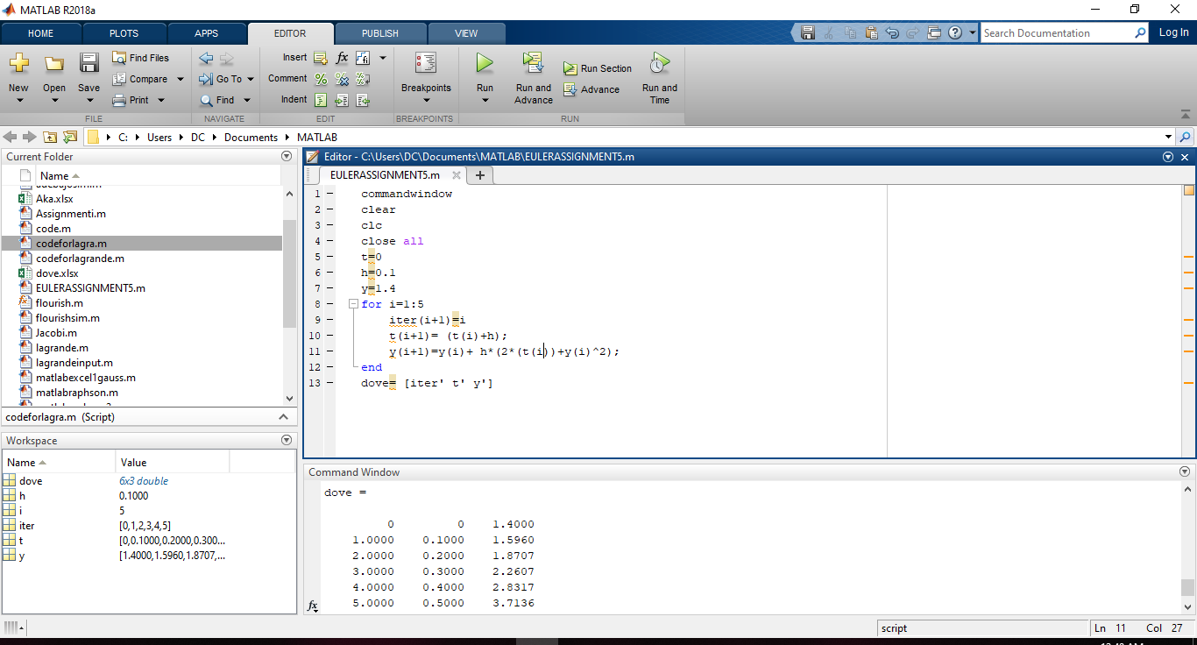
commandwindow
clear
clc
close all
t=0
h=0.1
y=1.4
for i=1:5
iter(i+1)=i
t(i+1)= (t(i)+h);
y(i+1)=y(i)+ h*(2*(t(i))+y(i)^2);
end
dove= [iter' t' y']

SOLUTION
dove =
0 0 1.4000
1.0000 0.1000 1.5960
2.0000 0.2000 1.8707
3.0000 0.3000 2.2607
4.0000 0.4000 2.8317
5.0000 0.5000 3.7136
QUESTION 2
The dynamic models of oil quantities in three interconnecting tanks with one inlet and one outlet streams are as given in Equation (2)
$$\left\{\begin{aligned}\frac{dQ_{1}}{dt}=-\frac{15}{500}Q_{1}+\frac{5}{1000}Q_{2}+1 \\ \frac{dQ_{2}}{dt}=\frac{15}{500}Q_{1}-\frac{18}{1000}Q_{2}+\frac{3}{400}Q_{3} \\ \frac{dQ_{3}}{dt}=\frac{13}{1000}Q_{2}-\frac{13}{400}Q_{3}\end{aligned}\right\}$$

Q1 , Q2 and Q3 are the quantities of the oil in tanks 1, 2 and 3, respectively, at any time t. If at time t = 0, Q1 = Q2 = Q3 = 0 m³, with the aid of MATLAB, taking the simulation period to be from t_{initial} = 0 min to t_{final} = 1200 min, plot the dynamic responses of Q1 , Q2 and Q3 on the same graph. Also, write the steady state values.
SOLUTION
MATLAB CODE:
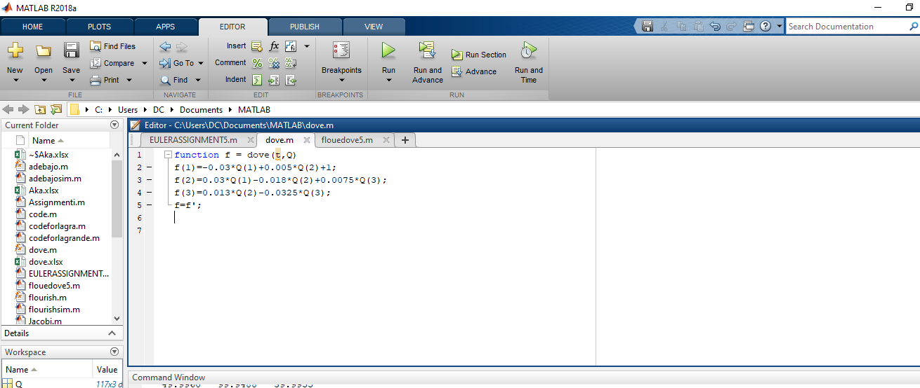
CODE2:
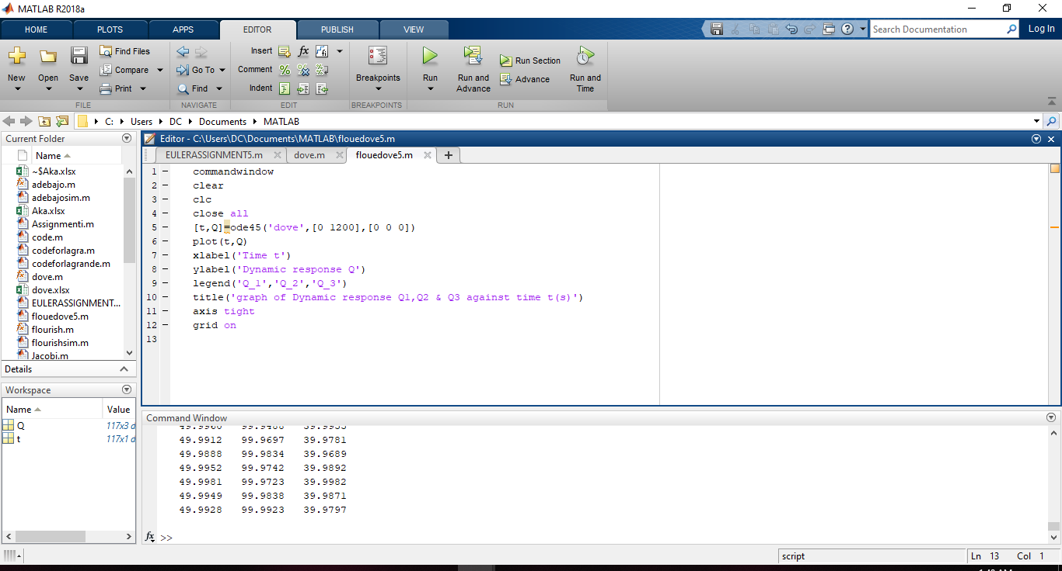
GRAPH RESULT: 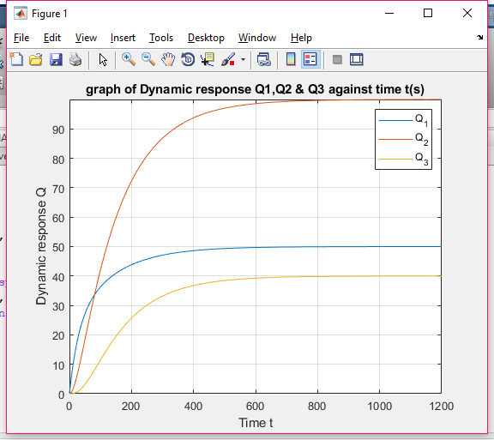
From the graph, the steady states values are:
For Q1: 100
For Q2: 50
For Q3: 40

WRITTEN
CODE1:
function f = dove(t,Q)
f(1)=-0.03*Q(1)+0.005*Q(2)+1;
f(2)=0.03*Q(1)-0.018*Q(2)+0.0075*Q(3);
f(3)=0.013*Q(2)-0.0325*Q(3);
f=f';

CODE 2:
commandwindow
clear
clc
close all
[t,Q]=ode45('dove',[0 1200],[0 0 0])
plot(t,Q)
xlabel('Time t')
ylabel('Dynamic response Q')
legend('Q_1','Q_2','Q_3')
title('graph of Dynamic response Q1,Q2 & Q3 against time t(s)')
axis tight
grid on

