Aghasili Chukwudi William
17/ENG03/007
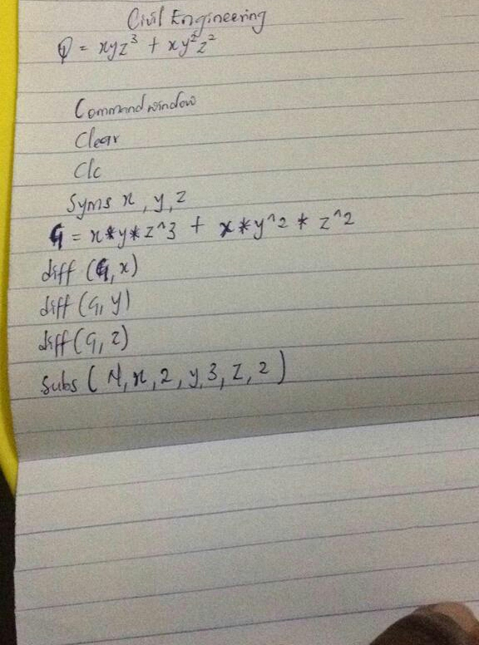
Civil Engineering

