NAME:VODINA EFEM
DEPT:CIVIL ENGINEERING
MAT NO:16/ENG03/020

Code:

QUESTION 1
commandwindow
clear
clc
format short g
h = 0.1
y = 1.4
t = 0
for i=1:inf
iter(i+1)=i;
t(i+1)=t(i)+h;
y(i+1)=y(i)+h*(2*t(i)+y(i)^2)
if t(i+1) ==0.5
break
end
end
iter'
t'
y'
tableau = table(iter', t' ,y')
figure(1)
plot(t,y,'b')
xlabel('time')
ylabel('dynamic response')
grid on
grid minor
axis tight

Command Window:

h =

0.1

y =

1.4

t =

0

Warning: Too many FOR loop iterations. Stopping after 9223372036854775806 iterations.
> In eulerassignment (line 8)

y =

1.4 1.596

y =

1.4 1.596 1.8707

y =

1.4 1.596 1.8707 2.2607

y =

1.4 1.596 1.8707 2.2607 2.8317

y =

1.4 1.596 1.8707 2.2607 2.8317 3.7136

ans =

0
1
2
3
4
5

ans =

0
0.1
0.2
0.3
0.4
0.5

ans =

1.4
1.596
1.8707
2.2607
2.8317
3.7136

tableau =

6×3 table

Var1 Var2 Var3
____ ____ ______

0 0 1.4
1 0.1 1.596
2 0.2 1.8707
3 0.3 2.2607
4 0.4 2.8317
5 0.5 3.7136

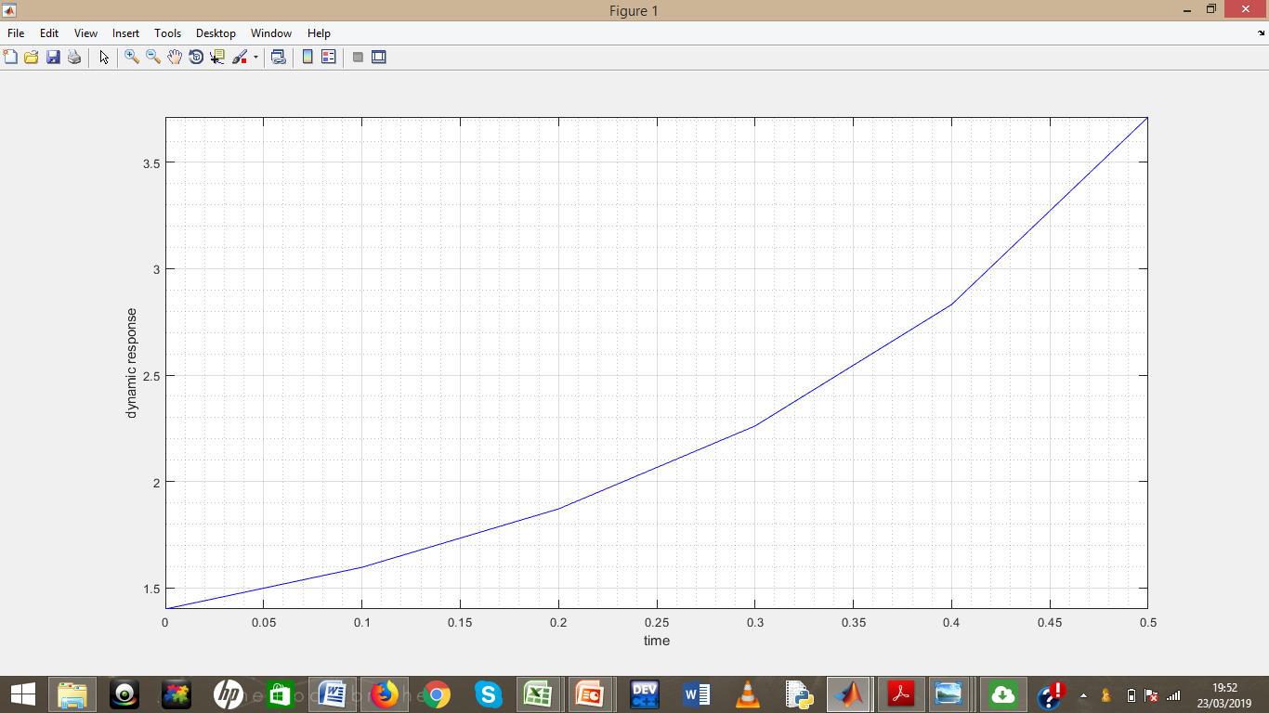

EXCEL

h |  | t | y |  | Dy |  | dy=2t+y^2 |  | y=yo+h(y1)o
0.1 |  | 0 | 1.4 |  | 1.96
 |  | 0.1 | 1.596 |  | 2.747216
 |  | 0.2 | 1.870722 |  | 3.899599
 |  | 0.3 | 2.260682 |  | 5.710681
 |  | 0.4 | 2.83175 |  | 8.818806
 |  | 0.5 | 3.71363 |  | 14.79105

No 2
file 1
function dQdt = voda(t,Q)
dQdt(1) = (-0.15*Q(1)) + (0.005*Q(2)) + 1;
dQdt(2) = (0.03*Q(1)) - (0.018*Q(2)) + (0.0075*Q(3));
dQdt(3) = (0.013*Q(2)) - (0.0325*Q(3));
dQdt = dQdt';

file 2
commandwindow
clear
clc
close all
[t,y] = ode45('voda',[0 1200],[0 0 0])
tableau = table(t,y)
plot(t,y)
xlabel('t')
ylabel('y')
grid on
grid minor
axis tight
legend('y_1','y_2')
plot(t,y(:,1),'b-')
hold on
plot(t,y(:,2),'r-')
hold on
plot(t,y(:,3),'k-')
grid on
grid minor
axis tight
legend('y_1','y_2','y_3')

STEADY STATE VALUE =y1 = 7.1417

y2 = 14.286

y3 = 5.7143

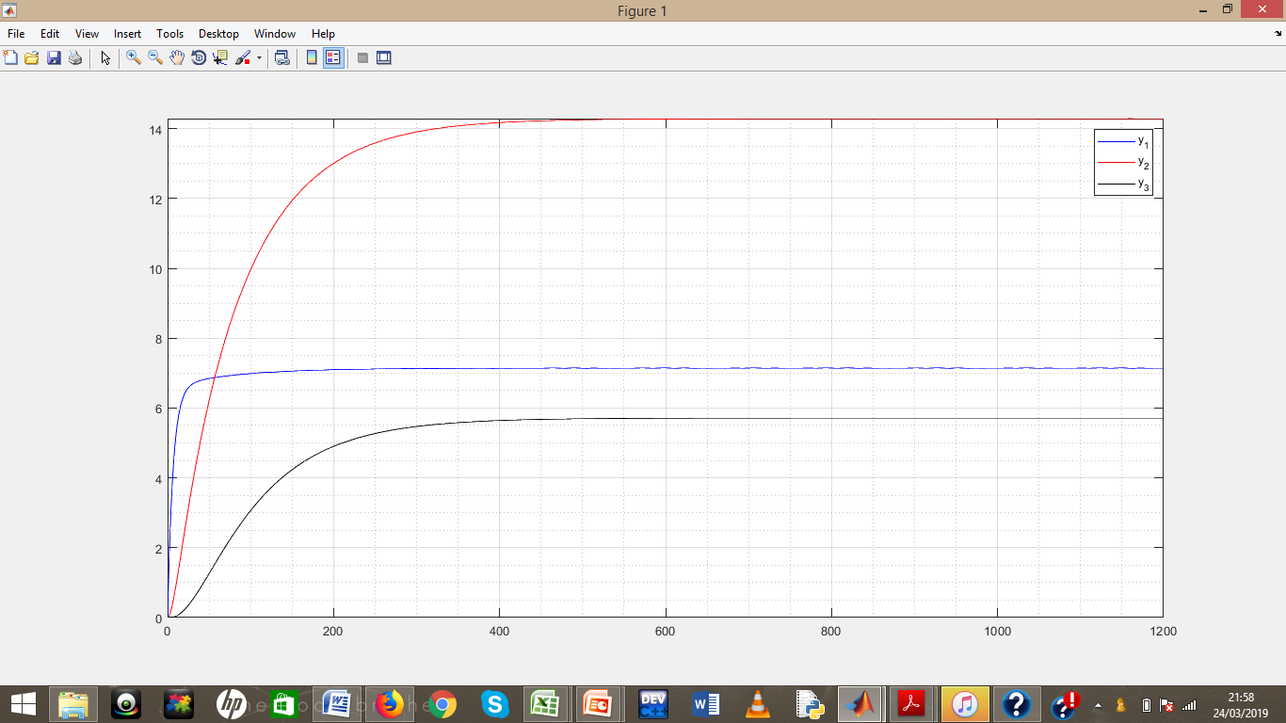

command window
tableau =

269×2 table

t y
__________ ______________________________________

0 0 0 0
5.0238e-05 5.0238e-05 3.7857e-11 8.2414e-18
0.00010048 0.00010047 1.5143e-10 6.5931e-17
0.00015071 0.00015071 3.4071e-10 2.2252e-16
0.00020095 0.00020095 6.0571e-10 5.2745e-16
0.00045214 0.00045212 3.0664e-09 6.0079e-15
0.00070333 0.00070329 7.4198e-09 2.2614e-14
0.00095452 0.00095445 1.3666e-08 5.6525e-14
0.0012057 0.0012056 2.1804e-08 1.1392e-13
0.0024616 0.0024612 9.0883e-08 9.6948e-13
0.0037176 0.0037166 2.0726e-07 3.339e-12
0.0049735 0.0049717 3.7094e-07 7.9947e-12
0.0062295 0.0062266 5.8189e-07 1.5708e-11
0.012509 0.012497 2.3456e-06 1.2715e-10
0.018789 0.018762 5.2898e-06 4.3073e-10
0.025069 0.025022 9.4133e-06 1.0227e-09
0.031348 0.031275 1.4715e-05 1.9993e-09
0.062747 0.062453 5.8851e-05 1.6008e-08
0.094146 0.093484 0.00013225 5.3984e-08
0.12554 0.12437 0.00023477 1.2781e-07
0.15694 0.15511 0.00036624 2.493e-07
0.31394 0.30666 0.0014526 1.9802e-06
0.47093 0.45468 0.0032404 6.6314e-06
0.62792 0.59926 0.0057112 1.5597e-05
0.78491 0.74048 0.0088471 3.0227e-05
1.2791 1.1639 0.022864 0.0001278
1.7732 1.5571 0.042782 0.00033219
2.2674 1.9223 0.068119 0.0006776
2.7615 2.2614 0.098429 0.0011951
3.2804 2.5916 0.13515 0.0019542
3.7993 2.8971 0.17646 0.0029617
4.3182 3.1799 0.22195 0.0042427
4.8371 3.4416 0.27123 0.0058195
5.593 3.7884 0.3491 0.0086858
6.3489 4.0984 0.43333 0.01227
7.1048 4.3754 0.52305 0.016611
7.8606 4.623 0.61749 0.021741
8.898 4.9209 0.7535 0.030111
9.9354 5.1765 0.8956 0.040049
10.973 5.3958 1.0425 0.05157
12.01 5.5842 1.193 0.064683
13.409 5.7976 1.4001 0.084875
14.808 5.9719 1.6102 0.10788
16.207 6.114 1.8221 0.1336
17.606 6.2305 2.0342 0.16195
19.449 6.354 2.3126 0.20313
21.292 6.4498 2.5884 0.24836
23.135 6.5237 2.8606 0.29731
24.978 6.5818 3.1282 0.34969
27.144 6.6363 3.4358 0.41523
29.31 6.6783 3.7358 0.48457
31.476 6.7107 4.028 0.55723
33.641 6.7366 4.3121 0.63278
36.323 6.7635 4.6524 0.72974
39.005 6.7851 4.9805 0.82976
41.687 6.8024 5.2968 0.93218
44.369 6.8173 5.6015 1.0364
47.786 6.8349 5.9734 1.171
51.202 6.8502 6.328 1.3067
54.618 6.8633 6.6664 1.4427
58.035 6.8755 6.9894 1.5782
62.594 6.8916 7.3974 1.7575
67.154 6.9062 7.7811 1.9339
71.713 6.9191 8.1422 2.1066
76.273 6.9312 8.4822 2.2747
82.502 6.9483 8.9147 2.4962
88.731 6.9633 9.3136 2.7075
94.96 6.9753 9.6822 2.9082
101.19 6.9868 10.023 3.0981
108.44 7.0065 10.385 3.3056
115.7 7.0203 10.716 3.4986
122.95 7.0221 11.022 3.6775
130.2 7.0273 11.3 3.8432
134.57 7.0378 11.454 3.9369
138.93 7.0455 11.6 4.0262
143.29 7.0494 11.739 4.1111
147.66 7.0531 11.871 4.1919
152.02 7.0591 11.996 4.2689
156.38 7.0641 12.114 4.3422
160.74 7.0678 12.227 4.4118
165.11 7.0714 12.333 4.478
170.97 7.0774 12.467 4.5619
176.84 7.0824 12.592 4.6402
182.7 7.0854 12.709 4.7133
188.56 7.0886 12.818 4.7814
195.7 7.0978 12.938 4.8583
202.83 7.1031 13.05 4.9289
209.96 7.1002 13.154 4.9936
217.09 7.1001 13.248 5.053
221.72 7.1062 13.304 5.089
226.35 7.1099 13.357 5.1231
230.97 7.1102 13.408 5.1552
235.6 7.1108 13.457 5.1856
240.22 7.114 13.502 5.2144
244.85 7.1163 13.544 5.2417
249.48 7.1171 13.585 5.2674
254.1 7.118 13.623 5.2917
259.99 7.1211 13.668 5.3208
265.88 7.1232 13.711 5.348
271.77 7.1231 13.751 5.3731
277.66 7.1236 13.788 5.3966
284.5 7.1298 13.827 5.422
291.34 7.1325 13.863 5.4453
298.18 7.1273 13.898 5.4665
305.01 7.1249 13.929 5.4861
309.7 7.1297 13.948 5.4988
314.39 7.1322 13.967 5.5108
319.08 7.1312 13.985 5.522
323.77 7.1305 14.001 5.5326
328.46 7.1327 14.017 5.5427
333.15 7.134 14.032 5.5522
337.84 7.1338 14.046 5.5611
342.53 7.1338 14.059 5.5696
348.37 7.1359 14.074 5.5795
354.2 7.1369 14.089 5.5887
360.04 7.1359 14.102 5.5973
365.87 7.1354 14.115 5.6052
372.57 7.1404 14.127 5.6139
379.28 7.1421 14.139 5.6217
385.98 7.1367 14.152 5.6288
392.69 7.1338 14.163 5.6354
397.46 7.138 14.169 5.6399
402.22 7.1399 14.176 5.6442
406.99 7.1384 14.182 5.648
411.76 7.1372 14.188 5.6517
416.53 7.1392 14.193 5.6553
421.3 7.1402 14.198 5.6586
426.06 7.1395 14.203 5.6617
430.83 7.1391 14.208 5.6647
436.64 7.1409 14.213 5.6681
442.45 7.1417 14.218 5.6712
448.26 7.1402 14.223 5.6741
454.07 7.1394 14.227 5.6768
460.65 7.1439 14.231 5.6798
467.23 7.1454 14.235 5.6825
473.82 7.14 14.24 5.6848
480.4 7.1369 14.244 5.687
486.37 7.1457 14.245 5.6891
492.35 7.1488 14.247 5.6909
498.32 7.1397 14.252 5.6924
504.3 7.1341 14.256 5.6937
509.12 7.1409 14.256 5.6951
513.94 7.1439 14.257 5.6962
518.77 7.1407 14.259 5.6972
523.59 7.1383 14.261 5.6981
528.07 7.141 14.262 5.699
532.55 7.1423 14.263 5.6998
537.04 7.1415 14.264 5.7006
541.52 7.1409 14.266 5.7013
546.76 7.1424 14.267 5.7021
552.01 7.143 14.268 5.7029
557.25 7.142 14.269 5.7036
562.49 7.1413 14.27 5.7042
568.86 7.1439 14.271 5.705
575.23 7.1448 14.272 5.7057
581.6 7.1417 14.273 5.7063
587.97 7.14 14.275 5.7068
594.44 7.1472 14.274 5.7076
600.92 7.1494 14.274 5.7082
607.39 7.1406 14.277 5.7084
613.87 7.1355 14.279 5.7087
619.21 7.1443 14.277 5.7093
624.54 7.1477 14.277 5.7097
629.88 7.141 14.279 5.7098
635.22 7.1365 14.281 5.71
639.69 7.141 14.28 5.7103
644.17 7.143 14.28 5.7106
648.64 7.1417 14.28 5.7107
653.12 7.1406 14.281 5.7109
657.86 7.1424 14.281 5.7111
662.59 7.1431 14.281 5.7113
667.33 7.1424 14.281 5.7115
672.07 7.1418 14.282 5.7116
677.93 7.1434 14.282 5.7118
683.79 7.144 14.282 5.712
689.64 7.1424 14.282 5.7121
695.5 7.1414 14.283 5.7122
702.17 7.146 14.282 5.7125
708.83 7.1474 14.282 5.7127
715.5 7.1414 14.284 5.7127
722.17 7.1381 14.285 5.7127
726.93 7.1421 14.284 5.7129
731.69 7.1439 14.283 5.713
736.45 7.142 14.284 5.713
741.22 7.1407 14.284 5.7131
745.98 7.1425 14.284 5.7132
750.74 7.1433 14.284 5.7133
755.5 7.1425 14.284 5.7133
760.26 7.1419 14.284 5.7133
766.07 7.1435 14.284 5.7135
771.87 7.1441 14.284 5.7135
777.67 7.1425 14.285 5.7135
783.47 7.1414 14.285 5.7136
790.05 7.1458 14.284 5.7137
796.63 7.1471 14.284 5.7138
803.21 7.1416 14.285 5.7137
809.8 7.1385 14.286 5.7137
815.78 7.1472 14.284 5.7139
821.76 7.1501 14.283 5.714
827.74 7.1409 14.286 5.7138
833.73 7.1352 14.287 5.7137
838.56 7.142 14.285 5.7139
843.38 7.1449 14.285 5.714
848.21 7.1416 14.286 5.7139
853.04 7.1391 14.286 5.7139
857.52 7.1418 14.286 5.714
862 7.1431 14.285 5.714
866.49 7.1423 14.285 5.714
870.97 7.1416 14.286 5.714
876.2 7.143 14.285 5.7141
881.44 7.1436 14.285 5.7141
886.67 7.1426 14.285 5.7141
891.91 7.1419 14.286 5.7141
898.27 7.1444 14.285 5.7142
904.63 7.1452 14.285 5.7142
911 7.1422 14.286 5.7141
917.36 7.1404 14.286 5.7141
923.84 7.1476 14.284 5.7143
930.32 7.1497 14.284 5.7143
936.8 7.1409 14.286 5.7141
943.28 7.1358 14.287 5.714
948.63 7.1446 14.285 5.7142
953.97 7.148 14.284 5.7143
959.32 7.1413 14.286 5.7142
964.67 7.1367 14.287 5.7141
969.14 7.1412 14.286 5.7142
973.62 7.1432 14.286 5.7142
978.1 7.1419 14.286 5.7142
982.57 7.1408 14.286 5.7142
987.3 7.1425 14.286 5.7142
992.04 7.1433 14.286 5.7142
996.77 7.1425 14.286 5.7142
1001.5 7.142 14.286 5.7142
1007.4 7.1436 14.285 5.7143
1013.2 7.1441 14.285 5.7143
1019 7.1425 14.286 5.7142
1024.9 7.1415 14.286 5.7142
1031.6 7.1461 14.285 5.7143
1038.2 7.1474 14.285 5.7144
1044.9 7.1415 14.286 5.7142
1051.6 7.1382 14.287 5.7141
1056.3 7.1422 14.286 5.7142
1061.1 7.1439 14.285 5.7143
1065.9 7.1421 14.286 5.7142
1070.6 7.1407 14.286 5.7142
1075.4 7.1426 14.286 5.7143
1080.2 7.1433 14.286 5.7143
1084.9 7.1425 14.286 5.7143
1089.7 7.1419 14.286 5.7142
1095.5 7.1436 14.286 5.7143
1101.3 7.1441 14.285 5.7143
1107.1 7.1425 14.286 5.7143
1112.9 7.1415 14.286 5.7142
1119.5 7.1458 14.285 5.7143
1126.1 7.1471 14.285 5.7144
1132.6 7.1416 14.286 5.7142
1139.2 7.1385 14.287 5.7142
1145.2 7.1472 14.285 5.7144
1151.2 7.1501 14.284 5.7145
1157.1 7.1409 14.286 5.7142
1163.1 7.1353 14.287 5.7141
1167.9 7.142 14.286 5.7143
1172.8 7.1449 14.285 5.7143
1177.6 7.1416 14.286 5.7142
1182.4 7.1392 14.287 5.7142
1186.8 7.1417 14.286 5.7143
1191.2 7.1429 14.286 5.7143
1195.6 7.1423 14.286 5.7143
1200 7.1417 14.286 5.7143

