NAME: GAGARIGA AYIBATONYE EBIERE
MATRIC NO: 14/ENG01/008
COURSE CODE: CHE 532
COURSE TITLE: PROCESS DYNAMICS AND CONTROL 2
ASIGNMENT
Describe in detail, compare and contrast gas chromatography and gas chromatography mass spectrometry
ANSWER
GAS CHROMATOGRAPHY –MASS SPECTROMETRY
Gas chromatography–mass spectrometry (GC-MS) is an analytical method that combines the features of gas-chromatography and mass spectrometry to identify different substances within a test sample. Applications of GC-MS include drug detection, fire investigation, environmental analysis, explosives investigation, and identification of unknown samples, including that of material samples obtained from planet Mars during probe missions as early as the 1970s. GC-MS can also be used in airport security to detect substances in luggage or on human beings. Additionally, it can identify trace elements in materials that were previously thought to have disintegrated beyond identification. Like liquid chromatography–mass spectrometry, it allows analysis and detection even of tiny amounts of a substance.
GC-MS has been regarded as a "gold standard" for forensic substance identification because it is used to perform a 100% specific test, which positively identifies the presence of a particular substance. A nonspecific test merely indicates that any of several in a category of substances is present. Although a nonspecific test could statistically suggest the identity of the substance, this could lead to false positive identification.
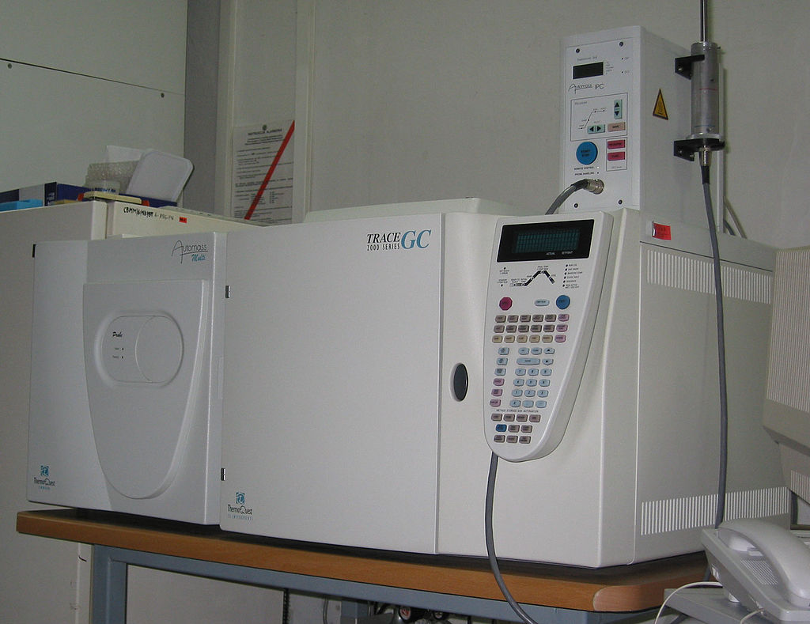
Figure 1: Example of a GC-MS instrument

GAS CHROMATOGRAPHY
It is important to understand that gas chromatography is not an analytical tool in itself: it is merely a separation technique. It is necessary to couple it to another device called a detector in order to obtain a signal, and thus data. Once coupled to a detector, such as a mass spectrometer, a full analytical technique is obtained. This chapter discusses the theory of the primary instruments used in the analysis of IL. Gas chromatography is a technique for separating compounds on the basis of their volatility. It provides both qualitative and quantitative information for individual compounds present in a sample. Compounds move through a GC column in the form of gases mainly because of two reasons: either the compounds are normally gases or they are heated and vaporized into a gaseous state. The compounds partition between a stationary phase, which can be either solid or liquid, and a mobile phase (gas). The differential partitioning into the stationary phase allows the compounds to be separated in time and space. The components of GC are injector (hollow heated glass lined cylinder, where the sample is introduced), carrier gas (usually helium, hydrogen or nitrogen, which is the mobile phase and moves the sample through the column), capillary GC column (coated with stationary phase like large molecular weight polysiloxane, polyethylene glycol, or polyester polymers of 0.1 to 2.5 micrometer film thickness), GC oven, electron capture detector (ECD) and flame ionization detector (FID).
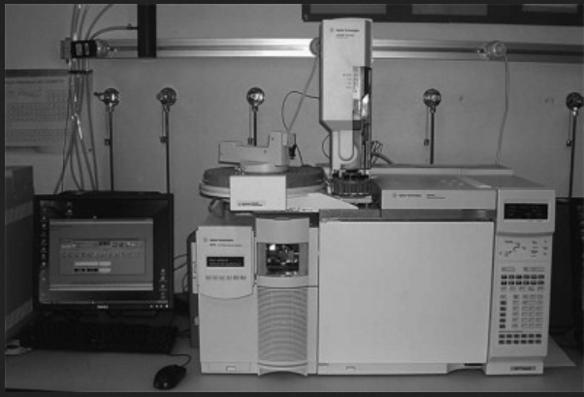
Figure 2: A gas chromatograph and its main components

