OKONJI OLUSEYE

ENG382

ASSIGNMNENT 5

Civil Engineering

16/ENG03/046

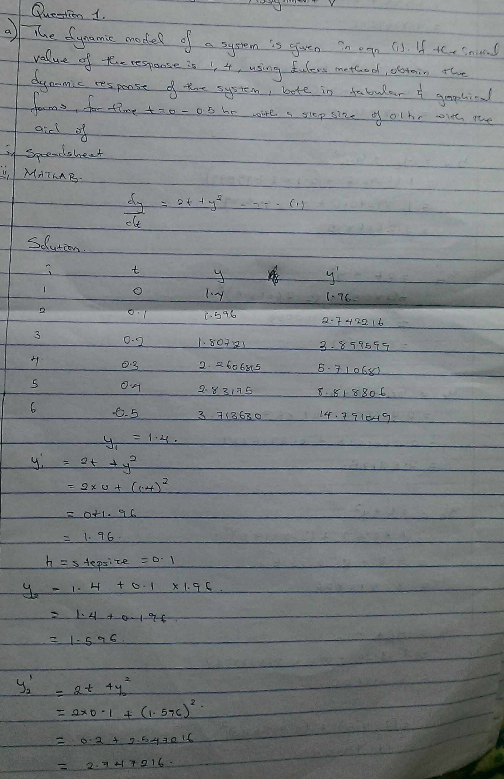  
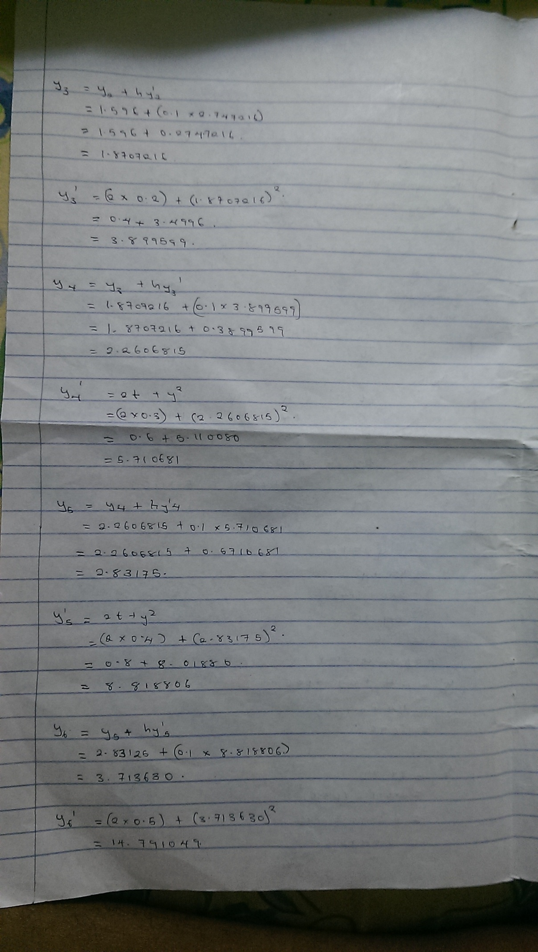

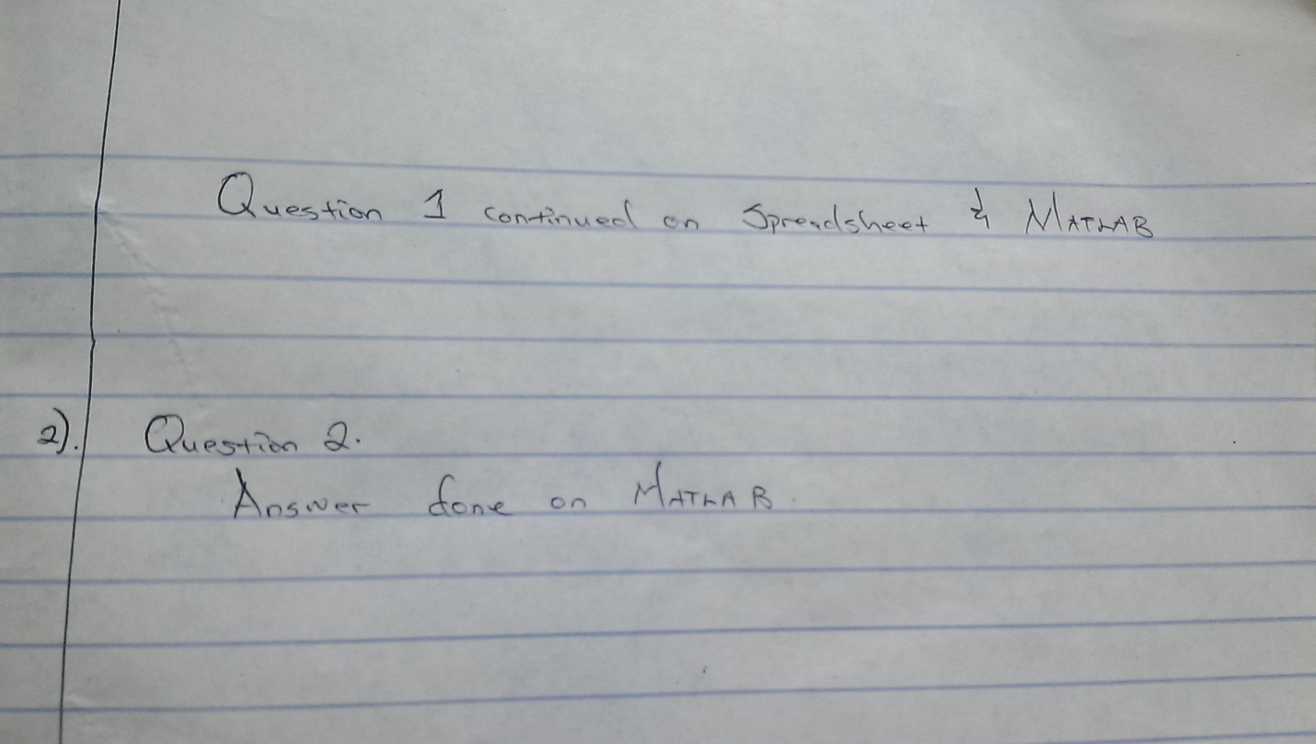

QUESTION 1

Code on MATLAB:

function taylor

t0=0;

tn=0.5;

h=0.1;

y0=1.4;

t=t0:h:tn;

y(1)=y0

n=length(t);

for i=1:n

dy=(2*t(i))+(y(i)^2)

y(i+1)=y(i)+h*dy

end

Output:

>> taylor

y =

1.4000

dy =

1.9600

y =

1.4000 1.5960

dy =

2.7472

y =

1.4000 1.5960 1.8707

dy =

3.8996

y =

1.4000 1.5960 1.8707 2.2607

dy =

5.7107

y =

1.4000 1.5960 1.8707 2.2607 2.8317

dy =

8.8188

y =

1.4000 1.5960 1.8707 2.2607 2.8317 3.7136

dy =

14.7910

y =

1.4000 1.5960 1.8707 2.2607 2.8317 3.7136 5.1927

QUESTION 2

First code on MATLAB:

function dQdt = dupeak(t,Q)

dQdt(1) = (-0.15*Q(1)) + (0.005*Q(2)) + 1;

dQdt(2) = (0.03*Q(1)) - (0.018*Q(2)) + (0.0075*Q(3));

dQdt(3) = (0.013*Q(2)) - (0.0325*Q(3));

dQdt = dQdt'

Second code on MATLAB:

commandwindow

clear

clc

close all

format short g

[t,dQ] = ode45('dupeak',[0 1200],[0 0 0])

tablee = table(t,dQ)

plot(t,dQ(:,1),'b-')

hold on

plot(t,dQ(:,2),'r-')

hold on

plot(t,dQ(:,3),'g-')

xlabel('time(min)')

ylabel('dynamic response')

grid on

grid minor

axis tight

legend('y_1','y_2','y_3')

OUTPUT:

dQ =

0 0 0

5.0238e-05 3.7857e-11 8.2414e-18

0.00010047 1.5143e-10 6.5931e-17

0.00015071 3.4071e-10 2.2252e-16

0.00020095 6.0571e-10 5.2745e-16

0.00045212 3.0664e-09 6.0079e-15

0.00070329 7.4198e-09 2.2614e-14

0.00095445 1.3666e-08 5.6525e-14

0.0012056 2.1804e-08 1.1392e-13

0.0024612 9.0883e-08 9.6948e-13

0.0037166 2.0726e-07 3.339e-12

0.0049717 3.7094e-07 7.9947e-12

0.0062266 5.8189e-07 1.5708e-11

0.012497 2.3456e-06 1.2715e-10

0.018762 5.2898e-06 4.3073e-10

0.025022 9.4133e-06 1.0227e-09

0.031275 1.4715e-05 1.9993e-09

0.062453 5.8851e-05 1.6008e-08

0.093484 0.00013225 5.3984e-08

0.12437 0.00023477 1.2781e-07

0.15511 0.00036624 2.493e-07

0.30666 0.0014526 1.9802e-06

0.45468 0.0032404 6.6314e-06

0.59926 0.0057112 1.5597e-05

0.74048 0.0088471 3.0227e-05

1.1639 0.022864 0.0001278

1.5571 0.042782 0.00033219

1.9223 0.068119 0.0006776

2.2614 0.098429 0.0011951

2.5916 0.13515 0.0019542

2.8971 0.17646 0.0029617

3.1799 0.22195 0.0042427

3.4416 0.27123 0.0058195

3.7884 0.3491 0.0086858

4.0984 0.43333 0.01227

4.3754 0.52305 0.016611

4.623 0.61749 0.021741

4.9209 0.7535 0.030111

5.1765 0.8956 0.040049

5.3958 1.0425 0.05157

5.5842 1.193 0.064683

5.7976 1.4001 0.084875

5.9719 1.6102 0.10788

6.114 1.8221 0.1336

6.2305 2.0342 0.16195

6.354 2.3126 0.20313

6.4498 2.5884 0.24836

6.5237 2.8606 0.29731

6.5818 3.1282 0.34969

6.6363 3.4358 0.41523

6.6783 3.7358 0.48457

6.7107 4.028 0.55723

6.7366 4.3121 0.63278

6.7635 4.6524 0.72974

6.7851 4.9805 0.82976

6.8024 5.2968 0.93218

6.8173 5.6015 1.0364

6.8349 5.9734 1.171

6.8502 6.328 1.3067

6.8633 6.6664 1.4427

6.8755 6.9894 1.5782

6.8916 7.3974 1.7575

6.9062 7.7811 1.9339

6.9191 8.1422 2.1066

6.9312 8.4822 2.2747

6.9483 8.9147 2.4962

6.9633 9.3136 2.7075

6.9753 9.6822 2.9082

6.9868 10.023 3.0981

7.0065 10.385 3.3056

7.0203 10.716 3.4986

7.0221 11.022 3.6775

7.0273 11.3 3.8432

7.0378 11.454 3.9369

7.0455 11.6 4.0262

7.0494 11.739 4.1111

7.0531 11.871 4.1919

7.0591 11.996 4.2689

7.0641 12.114 4.3422

7.0678 12.227 4.4118

7.0714 12.333 4.478

7.0774 12.467 4.5619

7.0824 12.592 4.6402

7.0854 12.709 4.7133

7.0886 12.818 4.7814

7.0978 12.938 4.8583

7.1031 13.05 4.9289

7.1002 13.154 4.9936

7.1001 13.248 5.053

7.1062 13.304 5.089

7.1099 13.357 5.1231

7.1102 13.408 5.1552

7.1108 13.457 5.1856

7.114 13.502 5.2144

7.1163 13.544 5.2417

7.1171 13.585 5.2674

7.118 13.623 5.2917

7.1211 13.668 5.3208

7.1232 13.711 5.348

7.1231 13.751 5.3731

7.1236 13.788 5.3966

7.1298 13.827 5.422

7.1325 13.863 5.4453

7.1273 13.898 5.4665

7.1249 13.929 5.4861

7.1297 13.948 5.4988

7.1322 13.967 5.5108

7.1312 13.985 5.522

7.1305 14.001 5.5326

7.1327 14.017 5.5427

7.134 14.032 5.5522

7.1338 14.046 5.5611

7.1338 14.059 5.5696

7.1359 14.074 5.5795

7.1369 14.089 5.5887

7.1359 14.102 5.5973

7.1354 14.115 5.6052

7.1404 14.127 5.6139

7.1421 14.139 5.6217

7.1367 14.152 5.6288

7.1338 14.163 5.6354

7.138 14.169 5.6399

7.1399 14.176 5.6442

7.1384 14.182 5.648

7.1372 14.188 5.6517

7.1392 14.193 5.6553

7.1402 14.198 5.6586

7.1395 14.203 5.6617

7.1391 14.208 5.6647

7.1409 14.213 5.6681

7.1417 14.218 5.6712

7.1402 14.223 5.6741

7.1394 14.227 5.6768

7.1439 14.231 5.6798

7.1454 14.235 5.6825

7.14 14.24 5.6848

7.1369 14.244 5.687

7.1457 14.245 5.6891

7.1488 14.247 5.6909

7.1397 14.252 5.6924

7.1341 14.256 5.6937

7.1409 14.256 5.6951

7.1439 14.257 5.6962

7.1407 14.259 5.6972

7.1383 14.261 5.6981

7.141 14.262 5.699

7.1423 14.263 5.6998

7.1415 14.264 5.7006

7.1409 14.266 5.7013

7.1424 14.267 5.7021

7.143 14.268 5.7029

7.142 14.269 5.7036

7.1413 14.27 5.7042

7.1439 14.271 5.705

7.1448 14.272 5.7057

7.1417 14.273 5.7063

7.14 14.275 5.7068

7.1472 14.274 5.7076

7.1494 14.274 5.7082

7.1406 14.277 5.7084

7.1355 14.279 5.7087

7.1443 14.277 5.7093

7.1477 14.277 5.7097

7.141 14.279 5.7098

7.1365 14.281 5.71

7.141 14.28 5.7103

7.143 14.28 5.7106

7.1417 14.28 5.7107

7.1406 14.281 5.7109

7.1424 14.281 5.7111

7.1431 14.281 5.7113

7.1424 14.281 5.7115

7.1418 14.282 5.7116

7.1434 14.282 5.7118

7.144 14.282 5.712

7.1424 14.282 5.7121

7.1414 14.283 5.7122

7.146 14.282 5.7125

7.1474 14.282 5.7127

7.1414 14.284 5.7127

7.1381 14.285 5.7127

7.1421 14.284 5.7129

7.1439 14.283 5.713

7.142 14.284 5.713

7.1407 14.284 5.7131

7.1425 14.284 5.7132

7.1433 14.284 5.7133

7.1425 14.284 5.7133

7.1419 14.284 5.7133

7.1435 14.284 5.7135

7.1441 14.284 5.7135

7.1425 14.285 5.7135

7.1414 14.285 5.7136

7.1458 14.284 5.7137

7.1471 14.284 5.7138

7.1416 14.285 5.7137

7.1385 14.286 5.7137

7.1472 14.284 5.7139

7.1501 14.283 5.714

7.1409 14.286 5.7138

7.1352 14.287 5.7137

7.142 14.285 5.7139

7.1449 14.285 5.714

7.1416 14.286 5.7139

7.1391 14.286 5.7139

7.1418 14.286 5.714

7.1431 14.285 5.714

7.1423 14.285 5.714

7.1416 14.286 5.714

7.143 14.285 5.7141

7.1436 14.285 5.7141

7.1426 14.285 5.7141

7.1419 14.286 5.7141

7.1444 14.285 5.7142

7.1452 14.285 5.7142

7.1422 14.286 5.7141

7.1404 14.286 5.7141

7.1476 14.284 5.7143

7.1497 14.284 5.7143

7.1409 14.286 5.7141

7.1358 14.287 5.714

7.1446 14.285 5.7142

7.148 14.284 5.7143

7.1413 14.286 5.7142

7.1367 14.287 5.7141

7.1412 14.286 5.7142

7.1432 14.286 5.7142

7.1419 14.286 5.7142

7.1408 14.286 5.7142

7.1425 14.286 5.7142

7.1433 14.286 5.7142

7.1425 14.286 5.7142

7.142 14.286 5.7142

7.1436 14.285 5.7143

7.1441 14.285 5.7143

7.1425 14.286 5.7142

7.1415 14.286 5.7142

7.1461 14.285 5.7143

7.1474 14.285 5.7144

7.1415 14.286 5.7142

7.1382 14.287 5.7141

7.1422 14.286 5.7142

7.1439 14.285 5.7143

7.1421 14.286 5.7142

7.1407 14.286 5.7142

7.1426 14.286 5.7143

7.1433 14.286 5.7143

7.1425 14.286 5.7143

7.1419 14.286 5.7142

7.1436 14.286 5.7143

7.1441 14.285 5.7143

7.1425 14.286 5.7143

7.1415 14.286 5.7142

7.1458 14.285 5.7143

7.1471 14.285 5.7144

7.1416 14.286 5.7142

7.1385 14.287 5.7142

7.1472 14.285 5.7144

7.1501 14.284 5.7145

7.1409 14.286 5.7142

7.1353 14.287 5.7141

7.142 14.286 5.7143

7.1449 14.285 5.7143

7.1416 14.286 5.7142

7.1392 14.287 5.7142

7.1417 14.286 5.7143

7.1429 14.286 5.7143

7.1423 14.286 5.7143

7.1417 14.286 5.7143

tablee =

269×2 table

t dQ

__________ ______________________________________

0 0 0 0

5.0238e-05 5.0238e-05 3.7857e-11 8.2414e-18

0.00010048 0.00010047 1.5143e-10 6.5931e-17

0.00015071 0.00015071 3.4071e-10 2.2252e-16

0.00020095 0.00020095 6.0571e-10 5.2745e-16

0.00045214 0.00045212 3.0664e-09 6.0079e-15

0.00070333 0.00070329 7.4198e-09 2.2614e-14

0.00095452 0.00095445 1.3666e-08 5.6525e-14

0.0012057 0.0012056 2.1804e-08 1.1392e-13

0.0024616 0.0024612 9.0883e-08 9.6948e-13

0.0037176 0.0037166 2.0726e-07 3.339e-12

0.0049735 0.0049717 3.7094e-07 7.9947e-12

0.0062295 0.0062266 5.8189e-07 1.5708e-11

0.012509 0.012497 2.3456e-06 1.2715e-10

0.018789 0.018762 5.2898e-06 4.3073e-10

0.025069 0.025022 9.4133e-06 1.0227e-09

0.031348 0.031275 1.4715e-05 1.9993e-09

0.062747 0.062453 5.8851e-05 1.6008e-08

0.094146 0.093484 0.00013225 5.3984e-08

0.12554 0.12437 0.00023477 1.2781e-07

0.15694 0.15511 0.00036624 2.493e-07

0.31394 0.30666 0.0014526 1.9802e-06

0.47093 0.45468 0.0032404 6.6314e-06

0.62792 0.59926 0.0057112 1.5597e-05

0.78491 0.74048 0.0088471 3.0227e-05

1.2791 1.1639 0.022864 0.0001278

1.7732 1.5571 0.042782 0.00033219

2.2674 1.9223 0.068119 0.0006776

2.7615 2.2614 0.098429 0.0011951

3.2804 2.5916 0.13515 0.0019542

3.7993 2.8971 0.17646 0.0029617

4.3182 3.1799 0.22195 0.0042427

4.8371 3.4416 0.27123 0.0058195

5.593 3.7884 0.3491 0.0086858

6.3489 4.0984 0.43333 0.01227

7.1048 4.3754 0.52305 0.016611

7.8606 4.623 0.61749 0.021741

8.898 4.9209 0.7535 0.030111

9.9354 5.1765 0.8956 0.040049

10.973 5.3958 1.0425 0.05157

12.01 5.5842 1.193 0.064683

13.409 5.7976 1.4001 0.084875

14.808 5.9719 1.6102 0.10788

16.207 6.114 1.8221 0.1336

17.606 6.2305 2.0342 0.16195

19.449 6.354 2.3126 0.20313

21.292 6.4498 2.5884 0.24836

23.135 6.5237 2.8606 0.29731

24.978 6.5818 3.1282 0.34969

27.144 6.6363 3.4358 0.41523

29.31 6.6783 3.7358 0.48457

31.476 6.7107 4.028 0.55723

33.641 6.7366 4.3121 0.63278

36.323 6.7635 4.6524 0.72974

39.005 6.7851 4.9805 0.82976

41.687 6.8024 5.2968 0.93218

44.369 6.8173 5.6015 1.0364

47.786 6.8349 5.9734 1.171

51.202 6.8502 6.328 1.3067

54.618 6.8633 6.6664 1.4427

58.035 6.8755 6.9894 1.5782

62.594 6.8916 7.3974 1.7575

67.154 6.9062 7.7811 1.9339

71.713 6.9191 8.1422 2.1066

76.273 6.9312 8.4822 2.2747

82.502 6.9483 8.9147 2.4962

88.731 6.9633 9.3136 2.7075

94.96 6.9753 9.6822 2.9082

101.19 6.9868 10.023 3.0981

108.44 7.0065 10.385 3.3056

115.7 7.0203 10.716 3.4986

122.95 7.0221 11.022 3.6775

130.2 7.0273 11.3 3.8432

134.57 7.0378 11.454 3.9369

138.93 7.0455 11.6 4.0262

143.29 7.0494 11.739 4.1111

147.66 7.0531 11.871 4.1919

152.02 7.0591 11.996 4.2689

156.38 7.0641 12.114 4.3422

160.74 7.0678 12.227 4.4118

165.11 7.0714 12.333 4.478

170.97 7.0774 12.467 4.5619

176.84 7.0824 12.592 4.6402

182.7 7.0854 12.709 4.7133

188.56 7.0886 12.818 4.7814

195.7 7.0978 12.938 4.8583

202.83 7.1031 13.05 4.9289

209.96 7.1002 13.154 4.9936

217.09 7.1001 13.248 5.053

221.72 7.1062 13.304 5.089

226.35 7.1099 13.357 5.1231

230.97 7.1102 13.408 5.1552

235.6 7.1108 13.457 5.1856

240.22 7.114 13.502 5.2144

244.85 7.1163 13.544 5.2417

249.48 7.1171 13.585 5.2674

254.1 7.118 13.623 5.2917

259.99 7.1211 13.668 5.3208

265.88 7.1232 13.711 5.348

271.77 7.1231 13.751 5.3731

277.66 7.1236 13.788 5.3966

284.5 7.1298 13.827 5.422

291.34 7.1325 13.863 5.4453

298.18 7.1273 13.898 5.4665

305.01 7.1249 13.929 5.4861

309.7 7.1297 13.948 5.4988

314.39 7.1322 13.967 5.5108

319.08 7.1312 13.985 5.522

323.77 7.1305 14.001 5.5326

328.46 7.1327 14.017 5.5427

333.15 7.134 14.032 5.5522

337.84 7.1338 14.046 5.5611

342.53 7.1338 14.059 5.5696

348.37 7.1359 14.074 5.5795

354.2 7.1369 14.089 5.5887

360.04 7.1359 14.102 5.5973

365.87 7.1354 14.115 5.6052

372.57 7.1404 14.127 5.6139

379.28 7.1421 14.139 5.6217

385.98 7.1367 14.152 5.6288

392.69 7.1338 14.163 5.6354

397.46 7.138 14.169 5.6399

402.22 7.1399 14.176 5.6442

406.99 7.1384 14.182 5.648

411.76 7.1372 14.188 5.6517

416.53 7.1392 14.193 5.6553

421.3 7.1402 14.198 5.6586

426.06 7.1395 14.203 5.6617

430.83 7.1391 14.208 5.6647

436.64 7.1409 14.213 5.6681

442.45 7.1417 14.218 5.6712

448.26 7.1402 14.223 5.6741

454.07 7.1394 14.227 5.6768

460.65 7.1439 14.231 5.6798

467.23 7.1454 14.235 5.6825

473.82 7.14 14.24 5.6848

480.4 7.1369 14.244 5.687

486.37 7.1457 14.245 5.6891

492.35 7.1488 14.247 5.6909

498.32 7.1397 14.252 5.6924

504.3 7.1341 14.256 5.6937

509.12 7.1409 14.256 5.6951

513.94 7.1439 14.257 5.6962

518.77 7.1407 14.259 5.6972

523.59 7.1383 14.261 5.6981

528.07 7.141 14.262 5.699

532.55 7.1423 14.263 5.6998

537.04 7.1415 14.264 5.7006

541.52 7.1409 14.266 5.7013

546.76 7.1424 14.267 5.7021

552.01 7.143 14.268 5.7029

557.25 7.142 14.269 5.7036

562.49 7.1413 14.27 5.7042

568.86 7.1439 14.271 5.705

575.23 7.1448 14.272 5.7057

581.6 7.1417 14.273 5.7063

587.97 7.14 14.275 5.7068

594.44 7.1472 14.274 5.7076

600.92 7.1494 14.274 5.7082

607.39 7.1406 14.277 5.7084

613.87 7.1355 14.279 5.7087

619.21 7.1443 14.277 5.7093

624.54 7.1477 14.277 5.7097

629.88 7.141 14.279 5.7098

635.22 7.1365 14.281 5.71

639.69 7.141 14.28 5.7103

644.17 7.143 14.28 5.7106

648.64 7.1417 14.28 5.7107

653.12 7.1406 14.281 5.7109

657.86 7.1424 14.281 5.7111

662.59 7.1431 14.281 5.7113

667.33 7.1424 14.281 5.7115

672.07 7.1418 14.282 5.7116

677.93 7.1434 14.282 5.7118

683.79 7.144 14.282 5.712

689.64 7.1424 14.282 5.7121

695.5 7.1414 14.283 5.7122

702.17 7.146 14.282 5.7125

708.83 7.1474 14.282 5.7127

715.5 7.1414 14.284 5.7127

722.17 7.1381 14.285 5.7127

726.93 7.1421 14.284 5.7129

731.69 7.1439 14.283 5.713

736.45 7.142 14.284 5.713

741.22 7.1407 14.284 5.7131

745.98 7.1425 14.284 5.7132

750.74 7.1433 14.284 5.7133

755.5 7.1425 14.284 5.7133

760.26 7.1419 14.284 5.7133

766.07 7.1435 14.284 5.7135

771.87 7.1441 14.284 5.7135

777.67 7.1425 14.285 5.7135

783.47 7.1414 14.285 5.7136

790.05 7.1458 14.284 5.7137

796.63 7.1471 14.284 5.7138

803.21 7.1416 14.285 5.7137

809.8 7.1385 14.286 5.7137

815.78 7.1472 14.284 5.7139

821.76 7.1501 14.283 5.714

827.74 7.1409 14.286 5.7138

833.73 7.1352 14.287 5.7137

838.56 7.142 14.285 5.7139

843.38 7.1449 14.285 5.714

848.21 7.1416 14.286 5.7139

853.04 7.1391 14.286 5.7139

857.52 7.1418 14.286 5.714

862 7.1431 14.285 5.714

866.49 7.1423 14.285 5.714

870.97 7.1416 14.286 5.714

876.2 7.143 14.285 5.7141

881.44 7.1436 14.285 5.7141

886.67 7.1426 14.285 5.7141

891.91 7.1419 14.286 5.7141

898.27 7.1444 14.285 5.7142

904.63 7.1452 14.285 5.7142

911 7.1422 14.286 5.7141

917.36 7.1404 14.286 5.7141

923.84 7.1476 14.284 5.7143

930.32 7.1497 14.284 5.7143

936.8 7.1409 14.286 5.7141

943.28 7.1358 14.287 5.714

948.63 7.1446 14.285 5.7142

953.97 7.148 14.284 5.7143

959.32 7.1413 14.286 5.7142

964.67 7.1367 14.287 5.7141

969.14 7.1412 14.286 5.7142

973.62 7.1432 14.286 5.7142

978.1 7.1419 14.286 5.7142

982.57 7.1408 14.286 5.7142

987.3 7.1425 14.286 5.7142

992.04 7.1433 14.286 5.7142

996.77 7.1425 14.286 5.7142

1001.5 7.142 14.286 5.7142

1007.4 7.1436 14.285 5.7143

1013.2 7.1441 14.285 5.7143

1019 7.1425 14.286 5.7142

1024.9 7.1415 14.286 5.7142

1031.6 7.1461 14.285 5.7143

1038.2 7.1474 14.285 5.7144

1044.9 7.1415 14.286 5.7142

1051.6 7.1382 14.287 5.7141

1056.3 7.1422 14.286 5.7142

1061.1 7.1439 14.285 5.7143

1065.9 7.1421 14.286 5.7142

1070.6 7.1407 14.286 5.7142

1075.4 7.1426 14.286 5.7143

1080.2 7.1433 14.286 5.7143

1084.9 7.1425 14.286 5.7143

1089.7 7.1419 14.286 5.7142

1095.5 7.1436 14.286 5.7143

1101.3 7.1441 14.285 5.7143

1107.1 7.1425 14.286 5.7143

1112.9 7.1415 14.286 5.7142

1119.5 7.1458 14.285 5.7143

1126.1 7.1471 14.285 5.7144

1132.6 7.1416 14.286 5.7142

1139.2 7.1385 14.287 5.7142

1145.2 7.1472 14.285 5.7144

1151.2 7.1501 14.284 5.7145

1157.1 7.1409 14.286 5.7142

1163.1 7.1353 14.287 5.7141

1167.9 7.142 14.286 5.7143

1172.8 7.1449 14.285 5.7143

1177.6 7.1416 14.286 5.7142

1182.4 7.1392 14.287 5.7142

1186.8 7.1417 14.286 5.7143

1191.2 7.1429 14.286 5.7143

1195.6 7.1423 14.286 5.7143

1200 7.1417 14.286 5.7143

