DOUMU TARIERE JESSICA
CHEMICAL ENGINEERING
17/ENG01/029

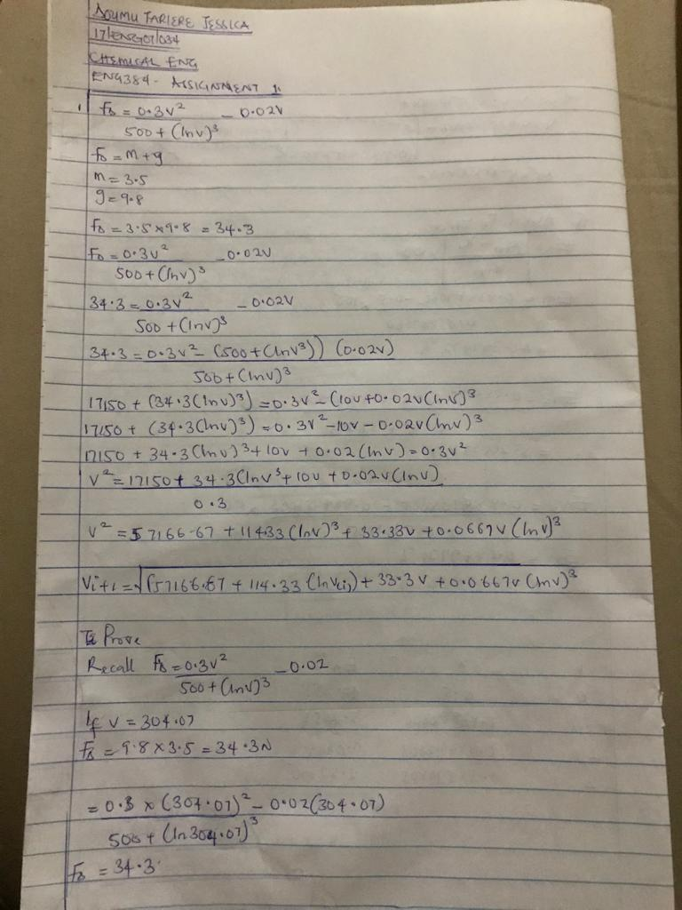

Code on matlab:
commandwindow
clear
clc
format short g
syms v
v=0.5
for i=1:inf
iter(i+1)=i
v(i+1)=sqrt((34.4+0.02*v(i))*(500+(log(v(i))^3))/0.3);
Ea(i+1)=abs((v(i+1)-v(i))/v(i+1))*100;
if Ea(i+1)<=1E-11
break
end
end
iter'
v'
Ea'
table(iter',v',Ea')

Output:
v =

0.5

Warning: Too many FOR loop iterations. Stopping after 9223372036854775806 iterations.
> In Untitled22 (line 7)

iter =

0 1

iter =

0 1 2

iter =

0 1 2 3

iter =

0 1 2 3 4

iter =

0 1 2 3 4 5

iter =

0 1 2 3 4 5 6

iter =

0 1 2 3 4 5 6 7

iter =

0 1 2 3 4 5 6 7 8

iter =

0 1 2 3 4 5 6 7 8 9

iter =

0 1 2 3 4 5 6 7 8 9 10

iter =

0 1 2 3 4 5 6 7 8 9 10 11

iter =

0 1 2 3 4 5 6 7 8 9 10 11 12

iter =

0 1 2 3 4 5 6 7 8 9 10 11 12 13

iter =

0 1 2 3 4 5 6 7 8 9 10 11 12 13 14

iter =

Columns 1 through 15

0 1 2 3 4 5 6 7 8 9 10 11 12 13 14

Column 16

15

iter =

Columns 1 through 15

0 1 2 3 4 5 6 7 8 9 10 11 12 13 14

Columns 16 through 17

15 16

iter =

Columns 1 through 15

0 1 2 3 4 5 6 7 8 9 10 11 12 13 14

Columns 16 through 18

15 16 17

ans =

0
1
2
3
4
5
6
7
8
9
10
11
12
13
14
15
16
17

ans =

0.5
239.4
294.6
303.05
304.29
304.48
304.5
304.51
304.51
304.51
304.51
304.51
304.51
304.51
304.51
304.51
304.51
304.51

ans =

0
99.791
18.737
2.7883
0.40956
0.060061
0.0088058
0.001291
0.00018927
2.7749e-05
4.0682e-06
5.9644e-07
8.7442e-08
1.282e-08
1.8795e-09
2.7555e-10
4.0396e-11
5.9362e-12

ans =

18×3 table

Var1 Var2 Var3
____ ______ __________

0 0.5 0
1 239.4 99.791
2 294.6 18.737
3 303.05 2.7883
4 304.29 0.40956
5 304.48 0.060061
6 304.5 0.0088058
7 304.51 0.001291
8 304.51 0.00018927
9 304.51 2.7749e-05
10 304.51 4.0682e-06
11 304.51 5.9644e-07
12 304.51 8.7442e-08
13 304.51 1.282e-08
14 304.51 1.8795e-09
15 304.51 2.7555e-10
16 304.51 4.0396e-11
17 304.51 5.9362e-12

